

BJP Membership App

|  |  |
| --- | --- |
| C:\Users\harikrishna.gora\Desktop\DIPL NEW LOGO 06052012\Final Word Images\arrow_M.jpg | **DHANUSH INFOTECH** |
| **Submitted to:**  **IT Head,**  **A.P BJP Party Office** |
| **Submitted by:**  C:\Users\harikrishna.gora\Desktop\DIPL NEW LOGO 06052012\LOGO_DHANUSH_NEW.jpg |
| **Dhanush InfoTech Pvt. Ltd.**  **Corporate Office:**  **Dhanush InfoTech Pvt Ltd.** #1-8-448, Lakshmi Building, 5th & 6th Floors,  Begumpet, Secunderabad A.P.  India, Pin - 500 003  Ph: +91 40 30145678  Fax: +91 40 30586061  Email: [info@dhanushinfotech.com](mailto:info@dhanushinfotech.com)  Website: [www.dhanushinfotech.com](http://www.dhanushinfotech.com) |

**REVISION HISTORY**

|  |  |  |  |  |  |
| --- | --- | --- | --- | --- | --- |
| Date | Author | Version | Change reference | Reviewed | Approved |
| 29/05/2017 | Madhavaramu N | 1.0 |  | Ganesh Margabandhu |  |
| 31/05/2017 | Madhavaramu N | 1.1 | Initial draft | Satya Murthy V |  |
| 01/06/2017 | Madhavaramu N | 1.2 | Revised draft | Ganesh Margabandhu |  |
| 06/06/2017 | Madhavaramu N | 1.2.1 | Roles, Access, privileges | Ganesh Margabandhu | Satya Murthy V |

**Table of Content**

[1 Introduction 5](#_Toc484626175)

[2 Proposed Solution 5](#_Toc484626176)

[2.1 Registration 5](#_Toc484626177)

[2.2 Administration 5](#_Toc484626178)

[3 Proposed System Functional Requirements 6](#_Toc484626179)

[3.1 Administration 6](#_Toc484626180)

[3.2 Roles 7](#_Toc484626181)

[3.3 Mobile App Functional Requirements 7](#_Toc484626182)

[3.4 Reports 8](#_Toc484626183)

[4 Use Cases 9](#_Toc484626184)

[5 Dependencies 10](#_Toc484626185)

[5.1 API 10](#_Toc484626186)

[5.2 Databases 10](#_Toc484626187)

[6 Mockup Screens 11](#_Toc484626188)

[6.1 Booth Worker Enrollment Form 11](#_Toc484626189)

[6.2 Member Login 12](#_Toc484626190)

[6.3 Report 13](#_Toc484626191)

# Introduction

The objective of the BJP Membership App is to

1. Enroll eligible Voters as a member of the party digitally for quick process
2. Reduce the labor of double entry system in conventional paper and pen work.
3. Send important notifications to Members

With this digital enrollment process, there is a quick response of enrollment and members can access Mobile App, receive regular updates about events, campaigns from the BJP team and get the opportunity to participate in local and national events.

# Proposed Solution

A hybrid Mobile App to be developed, that can be ready to install/ use on any smart phone irrespective of any mobile OS.

## Registration

### Eligible Voters can get Party Primary Membership (PM), by dialing toll free no. 1800 266 1001.

### As part of the PM eligible Voters will be assigned a Membership ID from the Party’s National Server.

### With this Membership ID, eligible Voters has to enroll as Booth Worker (BW) using the Membership Mobile App

## Administration

### All BW can update their details (name, mobile no and other demographic information)

### Party office bearers at the level of Upa Mandal, Mandal, Assembly Constituency, District and State Levels can view the enrolled Booth workers under their jurisdiction

### Party office bearers at the level of Upa Mandal, Mandal, Assembly Constituency, District and State Levels can assign the Roles (Booth President /Booth Agent /Booth In-charge) to the BWs under their jurisdiction

# Proposed System Functional Requirements

## Administration

**Hierarchy**

As per the Election commission data, we categorize the hierarchy of data structure as below. Below listed information will form part of master data, which gets setup once, make changes as, and when require for proper alignment of booth level data.

The Hierarch for General Elections in India is a generic solution for any Political campaign.

**State >> District >> AC >> Mandal >> Upa-Mandal >>** **Booth**

AC: Assembly Constituency

**Country**: It is the highest level of assignment in an election.

**State**: It is defined and assigned to country

**District**: This is represented under a state and all assembly constituencies or Parliamentary constituencies are aligned under a district.

**Assembly Constituency**: It is linked to District for a given state. Multiple Assembly constituencies gets assigned to one Parliamentary Constituency

**Mandal**: Though it is not officially aligned terminology from EC of India, it is alignment made by party for ease of coordination. Around 30 booths would constitute one Mandal. While defining Mandal, we assign it under one assembly constituency and also assign all those booths which comes under this Mandal. We need to have a flexibility to add or remove booths at any time as realignment of booths happen as per restructuring of assembly constituencies by Election commission of India.

**Upa Mandal**: This is sub division of Mandal, whereby, around 10 booths would constitute on Upa Mandal. While defining this, we assign it under a Mandal and allocate all those booths which gets monitor under this Upa Mandal. We need to have a flexibility to add or remove booths at any time as realignment of booths happen as per restructuring of assembly constituencies by Election commission of India.

**Booth**: Every booth has an address, a unique number, which is linked to Upa mandal. All workers would be aligned at booth level with their respective roles and also perform various tasks defined under the role classification.

## Roles

This App to be developed in a view to provide a single interface for all Users with Role based User access. In the master setup, we define various Roles applicable for booth workers and Roles related to Administration for office bearers. Currently following Roles and Privileges are defined in the system. Broadly, here the Roles are very limited that are based on the requirement.

1. **Super Admin**

Super Admin user is the sole proprietor of the Application, who has the privileges to Add New Roles for administration and can manage entire application.

1. **In-charge**

At each level of hierarchal office for Administration, an In-charge User can view respective jurisdiction, enrolment status and reports.

Feature available for Super Admin to add any number of Roles for administration as per the requirement.

**Booth worker Role**:

Every worker registered in the application at booth level, would be assigned a Role. These might be like

1. **Booth President**
2. **Booth Agent**
3. **Booth In-charge**

Feature available for Super Admin to add any number of Roles at booth level as per the requirement.

## Mobile App Functional Requirements

**Basic enrollment form**:

Party Booth Worker enrollment, a free form available on internet enabled devices (mobile/ tablet/ computer), a Mobile app needs to be download and installed, wherein, a user can register his/her data with below fields.

Surname, other name, Mobile Number, DOB, membership ID and booth number are mandatory fields for registration of booth level worker and other fields, which are optional like Voter ID/ Aadhaar and Photo.

If the user has been assigned with additional privileges, he/she would be able to search data, modify the data or register new users as per the privileges provided to specific user.

**Validations**

There needs to have certain validations in the system while registration like

1. 10 digits for booth number (2 digit state code, 3 digit Assembly code, 2 digit Upa Mandal code & 3 digit Booth code)
2. 10 digits for mobile number
3. 10 digits for Membership Id (Can be obtained by dialing toll free 1800 266 1001)
4. Validation for DOB, Age should be greater than or equals to 18 Years

Also, user who has been assigned additional booths as privileges, will be limited to create workers or modify workers data for those booths assigned to him/her in the profile definition at the administrative level.

**User Definition**:

Once the worker gets defined at the booth level, he/she gets automatic login credentials, wherein, mobile number is used as Username and auto generated password to be sent to defined mobile number. This can be used to view assigned data, update own profile, view notifications, meeting invite, events and interact with the Party.

At the administrative level, if we would have to give more access to defined worker at booth level, in the administrative setup, we can assign booths to those users who would get the access to workers data of all booths assigned to him/her. In the user definition, we also provide the access to user to create new registrations and modify registered user details. By default, all registered users who download and register their details will get full access for their own information only. If additional privileges needs to be provided to the registered worker, it needs to be done by Administrative user, who assigns the user with additional privileges as enumerated above.

## Reports

All possible search criteria needs to be provided for privileged users to review the data and count the numbers and download the information into excel sheets appropriately.

# Use Cases

Following use cases are to be implemented in the application

1. Party primary membership (PM) enrollment, by dialing toll free no. 1800 266 1001.
2. Party Booth Worker (BW) enrollment, a free form available on internet enabled devices (mobile/ tablet/ computer) using a Mobile app.
3. In BW enrollment form, Surname, other name, DOB, Mobile Number, Membership ID and Booth number are mandatory fields
4. Validate Membership ID with confirm Membership ID on client side and server side to avoid errors
5. Validation for DOB, Age should be greater than or equals to 18 Years
6. Validation for Phone Number is 10-digit number
7. Validation for Membership ID 10-digit number
8. Booth No 10 - digit number (State, Assembly No, Upa Mandal No & Booth No)
9. Id Proof (Aadhaar /Voter ID) and Photo are non-mandatory fields
10. Send an enrollment conformation message to the BW’s mobile No, saying that ‘Mobile No’ as ‘Username’ and system generated password
11. Every User of any level has to be registered as Booth Worker
12. Every enrolled BW can Login into the App, able to update Profile, View Notifications, Events, etc
13. Map enrolled BWs of respective Booth to booth Vistarak /(Booth In-charge/ Agent/ President) any designated authority
14. Registered Booth Worker at respective levels are assigned with designated Roles
15. Mandal level Presidents will have access to recommend Roles of Booth Worker (Booth In-charge/ Agent/ President)
16. Assembly In-charge will approve or modify the booth responsibilities
17. Below Mandal level, no one will have access to allocate Roles to Booth Worker
18. Below Mandal level, can view report of status of Booth Worker registrations in their jurisdiction
19. Assembly level and above authorities have access to over write Mandal level recommendations
20. Send a conformation message to the BW’s mobile No, about Role allotted
21. View Report: A party worker at any level (State, District, Assembly Constituency, Mandal, Upa Mandal, and Booth) can access information (enrolments) regarding booth workers below their hierarchy level
22. Scan Aadhaar Card to read and fill registration details
23. Provide feature to do registration(s) offline (in absence of Internet) and update server later when there is a an Internet connectivity
24. One Super Admin Role to manage the application

# Dependencies

## API

SMS gateway API integration is compulsory for this App, since a conformation message needs to be send in response to every successful registration and in case of forget password.

## Databases

This application database is highly dependent on the master data as mentioned below, like master databases of Electoral Hierarchical Information, Pooling Booth Voter list, and necessary information related to application master database.

**Data Required from BJP Office in AP**:

1. Information of master data as below:

Booth, Mandal, Upa Mandal, Assembly constituency, District, State for all booths in the state of AP.

1. Existing already registered users data in the below format:

Surname, other name, Booth number, Mobile number, BJP Membership Number.

1. Vistarak’s data for user creation:

Surname, other name, booth number, Mobile number, BJP Membership number, booths assigned to him/her, additional privileges required (like add, modify, assign/modify role)

# Mockup Screens

## Booth Worker Enrollment Form

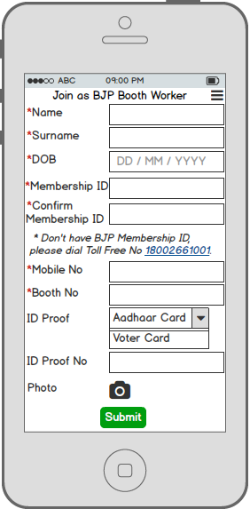

## Member Login

**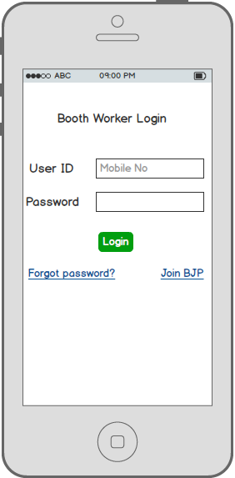**

## Report

Approval authorities comfort enrolled booth level workers Role allotment.

**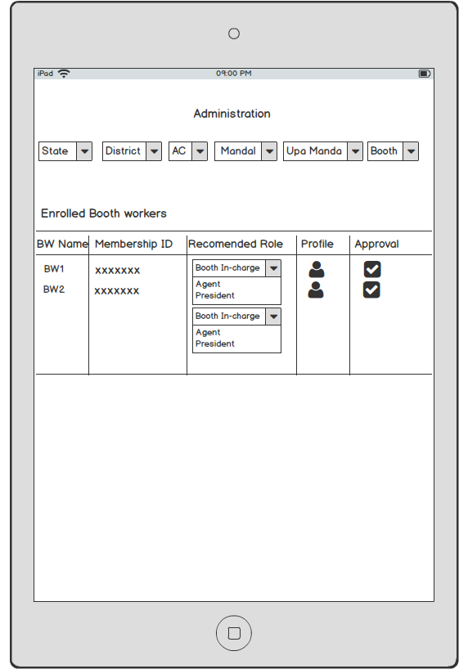**

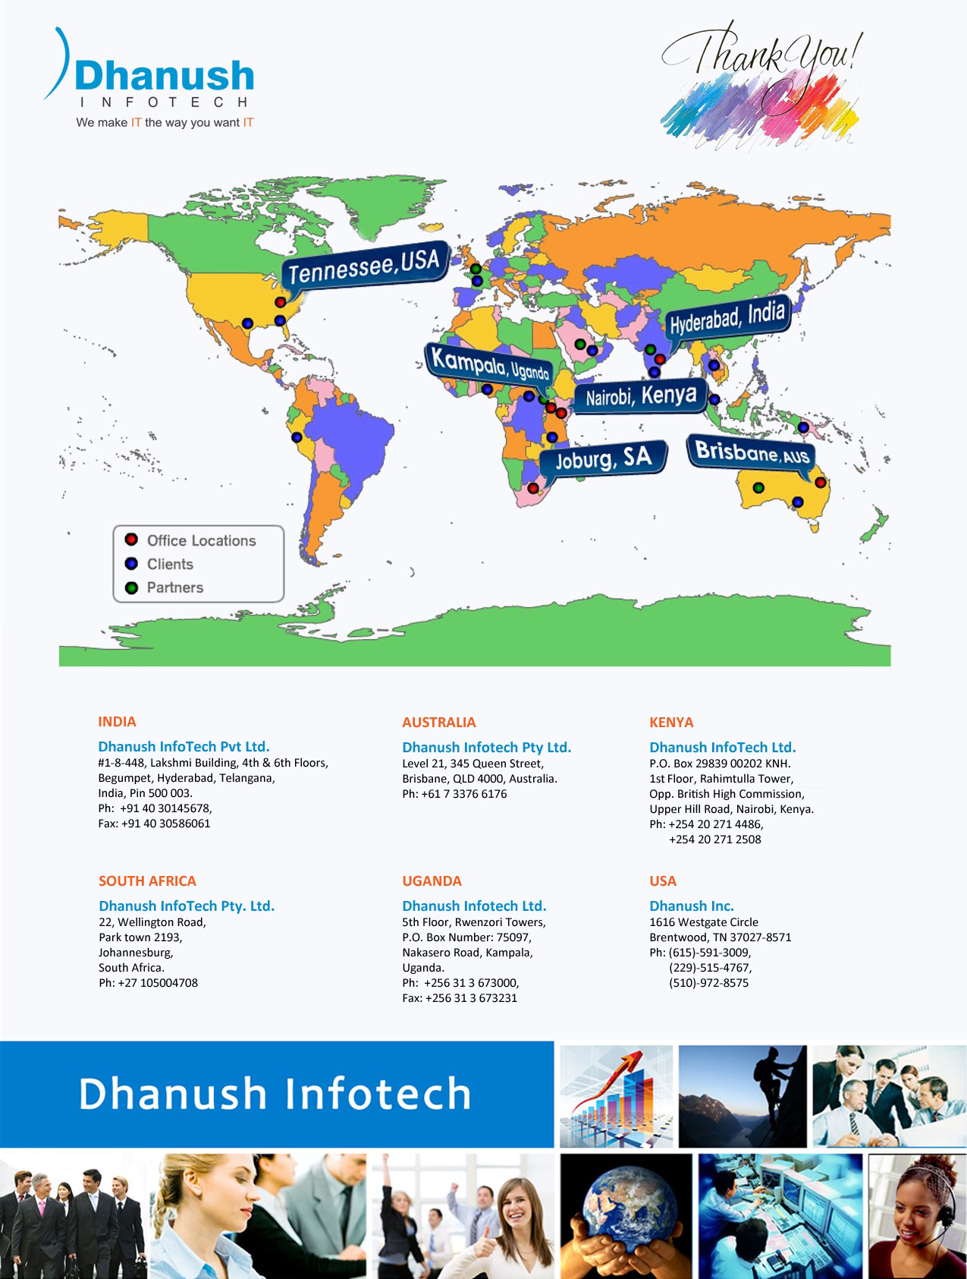

1. Did you meet Voter: YES / NO