**Simple Train Route Application**

Steps to open and using the application.

1. Open the application in visual studio or deploy the application in IIS.

Visual Studio

1. Open TrainGraph.sln

2. Build the solution and run the test cases using (Ctrl+R, T)

3. Run the application.

4. Upload the graph text file.

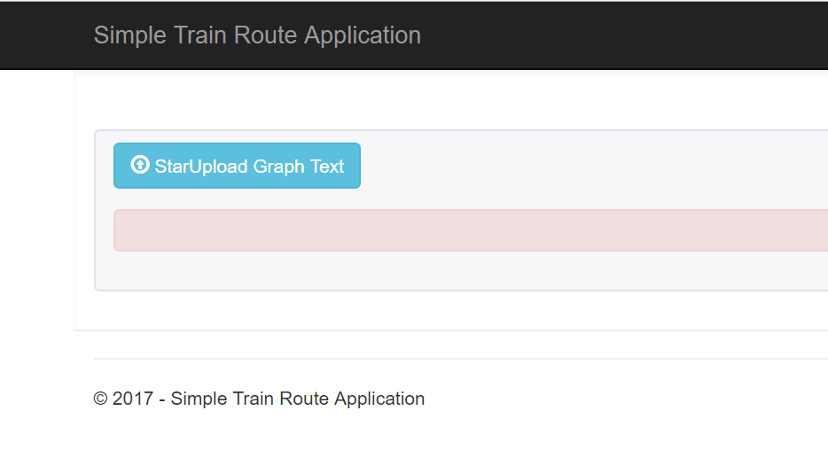

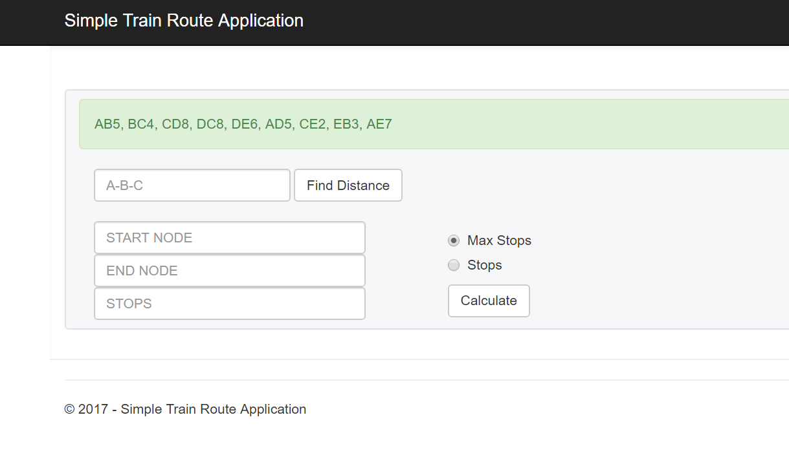

5. Calculate the Route distance as below

