- Read the total data used in GB. Calculate the internet bill using a base plan and overage charge beyond the data limit.

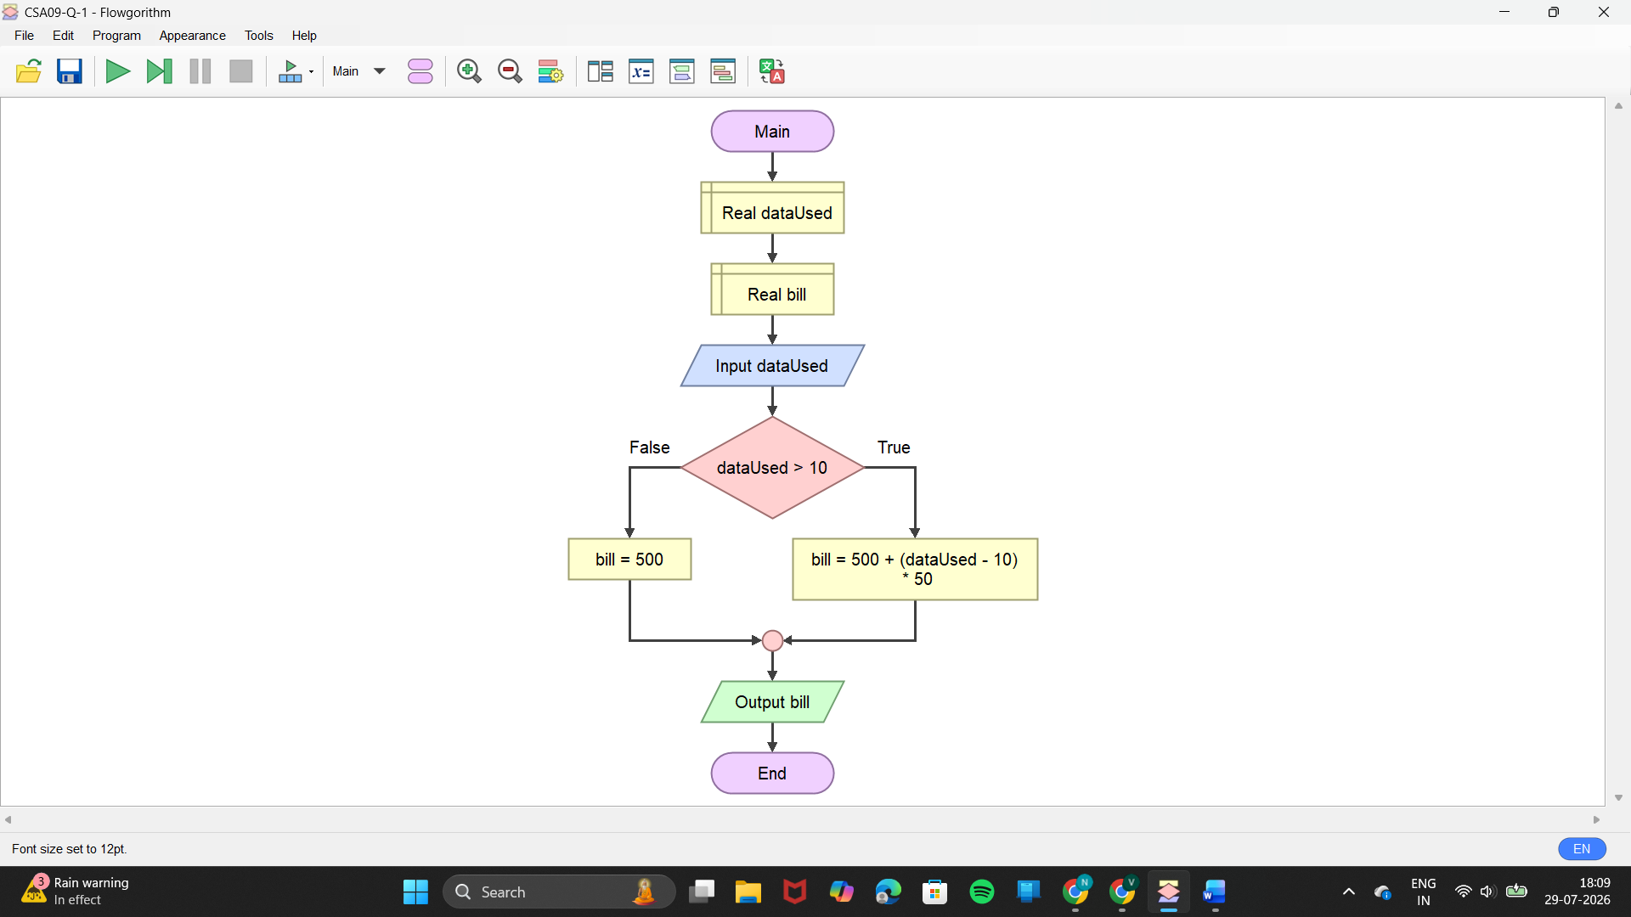

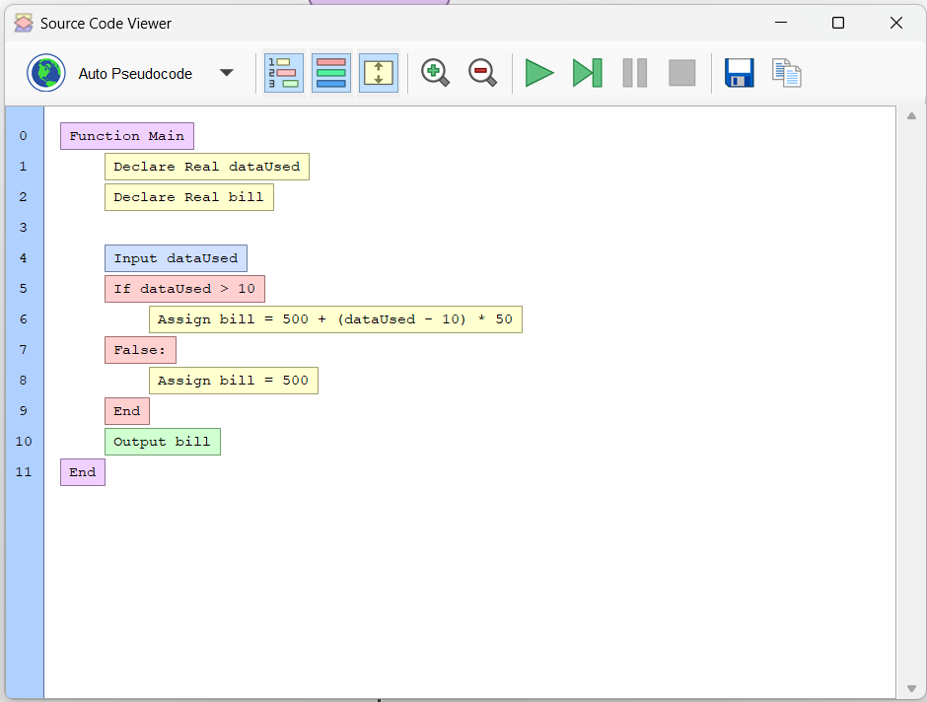

- Read N integers into an array and determine the element whose value is closest to the array average.

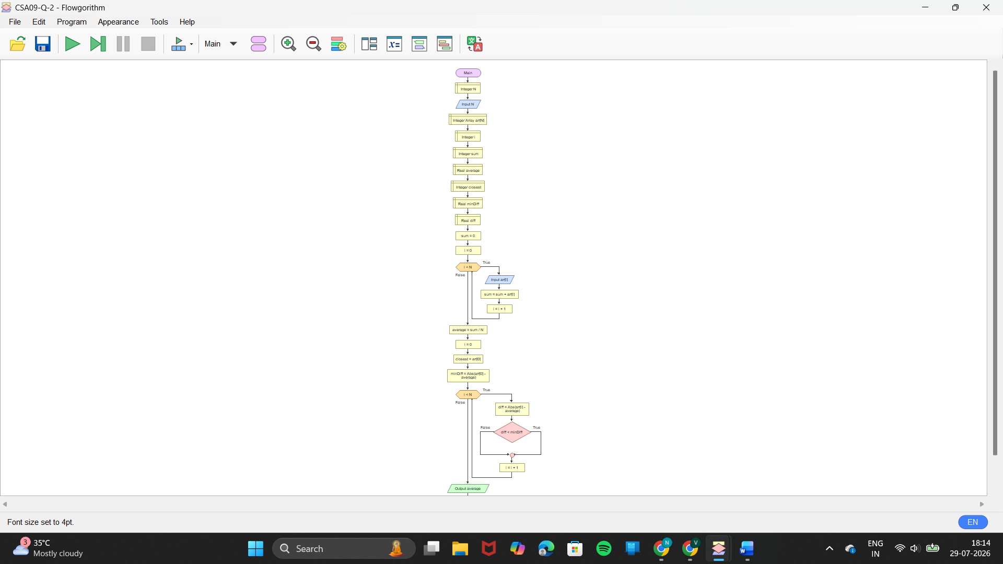

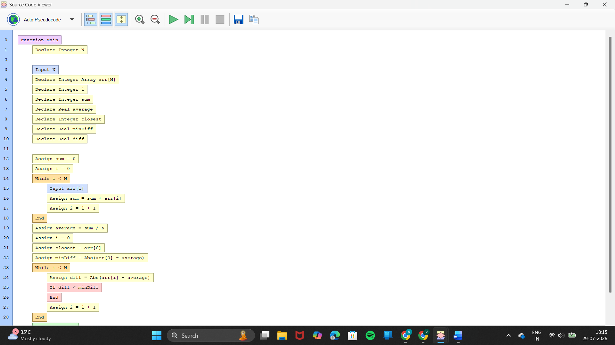

- Design a sports-score flowchart with Cricket, Football, and Basketball using different score-update rules. Relate it to method overriding.

