NAME: V. Nagendra C. CODE: CSA0918
REG.NO: 192425091 C. NAME: PROGRAMMING IN
JAVA

Thread-Safe Cache Using Concurrent HashMap

Introduction
In a high-traffic web application, many users access the system simultaneously. User session information must be stored in a shared cache so that multiple threads can read and update it efficiently. Using a normal HashMap in a multithreaded environment is unsafe because it does not provide synchronization. This can lead to data inconsistency, race conditions, and unexpected program behavior. To overcome these issues, Java provides ConcurrentHashMap, which allows multiple threads to safely access and modify the cache with high performance.

Aim
To demonstrate why HashMap is unsafe in a multithreaded environment and implement a thread-safe user session cache using ConcurrentHashMap.

Pseudocode
START
Import ConcurrentHashMap
Create a ConcurrentHashMap to store user sessions
Create Thread 1
Add session details for User1
Add session details for User2
Create Thread 2
Add session details for User3
Add session details for User4
Start both threads
Wait until both threads finish
Display all user sessions stored in the cache
END
Main Code
import java.util.Scanner;
import java.util.concurrent.ConcurrentHashMap;
public class SessionCache {
public static void main (String [] args) {
Scanner sc = new Scanner(System.in);
ConcurrentHashMap<String, String> sessionCache = new ConcurrentHashMap<>();
System.out.print("Enter the number of users: ");
int n = sc.nextInt();
sc.nextLine(); // Consume newline
for (int i = 1; i <= n; i++) {
System.out.print("Enter User Name: ");
String user = sc.nextLine();
System.out.print("Enter Session ID: ");
String session = sc.nextLine();
sessionCache.put(user, session);
}
System.out.println("\nStored User Sessions:");
for (String user : sessionCache.keySet()) {
System.out.println(user + " -> " + sessionCache.get(user));
}
sc.close();
}
}

Sample Input
Session ID: S101
User Name: Alice

Session ID: S102
User Name: Bob

Sample Output
User Sessions:
S101 -> Alice
S102 -> Bob
Session S102 belongs to: Bob
After Removing Session S101:
S102 -> Bob
S103 -> Charlie
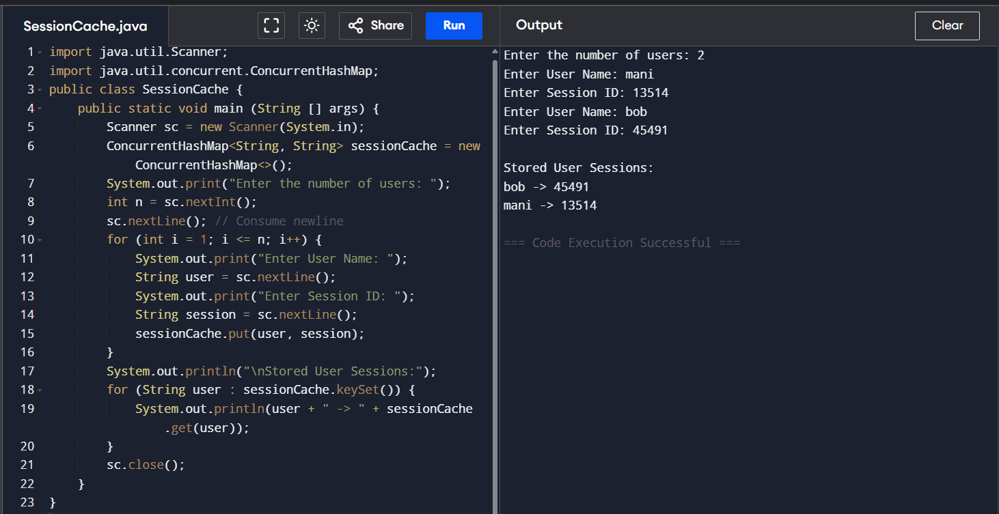

Conclusion
HashMap is not suitable for storing user sessions in a multithreaded web application because it does not provide synchronization and may lead to data inconsistency. ConcurrentHashMap is the recommended collection as it ensures thread safety, improves performance, and efficiently handles concurrent access, making it the best choice for maintaining a user session cache.

