NAME: V. Nagendra C. CODE: CSA0918
REG.NO: 192425091 C. NAME: PROGRAMMING IN
JAVA

Design a Map-Based Indexing System for a Digital Library

Introduction
A digital library stores thousands of books that need to be searched quickly and efficiently. Users may search for books using different attributes such as ISBN, author, or category. Since each search criterion is different, using a single Map is not sufficient for fast retrieval. Instead, multiple indexes should be maintained, where each index is implemented using a Map.

Aim
To design and implement a Map-based indexing system for a digital library using Java, where books can be efficiently searched by ISBN, author, and category using multiple HashMap indexes.

Pseudocode
START
Create three Maps:
isbnIndex
authorIndex
categoryIndex
Read number of books
FOR each book
Read ISBN
Read Title
Read Author
Read Category
Store book in isbnIndex
IF author not present
Create new list
ENDIF
Add book to author list
IF category not present
Create new list
ENDIF
Add book to category list
END FOR
Read ISBN to search
Display book details
Read Author to search
Display all books by author
Read Category to search
Display all books in category
STOP

Java Program
import java.util.*;
class Book {
String isbn;
String title;
String author;
String category;
Book(String isbn, String title, String author, String category) {
this.isbn = isbn;
this.title = title;
this.author = author;
this.category = category;
}
@Override
public String toString() {
return "ISBN: " + isbn +
", Title: " + title +
", Author: " + author +
", Category: " + category;
}
}
public class Main {
public static void main(String[] args) {
Scanner sc = new Scanner(System.in);
Map<String, Book> isbnIndex = new HashMap<>();
Map<String, List<Book>> authorIndex = new HashMap<>();
Map<String, List<Book>> categoryIndex = new HashMap<>();
System.out.print("Enter number of books: ");
int n = sc.nextInt();
sc.nextLine();
for (int i = 1; i <= n; i++) {
System.out.println("\nEnter Book " + i + " Details");
System.out.print("ISBN: ");
String isbn = sc.nextLine();
System.out.print("Title: ");
String title = sc.nextLine();
System.out.print("Author: ");
String author = sc.nextLine();
System.out.print("Category: ");
String category = sc.nextLine();
Book book = new Book(isbn, title, author, category);
isbnIndex.put(isbn, book);
authorIndex
.computeIfAbsent(author, k -> new ArrayList<>())
.add(book);
categoryIndex
.computeIfAbsent(category, k -> new ArrayList<>())
.add(book);
}
System.out.print("\nEnter ISBN to search: ");
String isbnSearch = sc.nextLine();
Book book = isbnIndex.get(isbnSearch);
if (book != null) {
System.out.println("Book Found:");
System.out.println(book);
} else {
System.out.println("Book not found.");
}
System.out.print("\nEnter Author name: ");
String authorSearch = sc.nextLine();
List<Book> authorBooks = authorIndex.get(authorSearch);
if (authorBooks != null) {
System.out.println("\nBooks by " + authorSearch + ":");
for (Book b : authorBooks) {
System.out.println(b);
}
} else {
System.out.println("No books found for this author.");
}
System.out.print("\nEnter Category: ");
String categorySearch = sc.nextLine();
List<Book> categoryBooks = categoryIndex.get(categorySearch);
if (categoryBooks != null) {
System.out.println("\nBooks in " + categorySearch + ":");
for (Book b : categoryBooks) {
System.out.println(b);
}
} else {
System.out.println("No books found in this category.");
}
sc.close();
}
}
Sample Input
Enter number of books: 2
Enter Book 1 Details
ISBN: 101
Title: Java Programming
Author: James
Category: Programming

Enter Book 2 Details
ISBN: 102
Title: Python Basics
Author: Mark
Category: Programming

Enter ISBN to search: 102
Enter Author name: James
Enter Category: Programming

Sample Output
Book Found:
ISBN: 102, Title: Python Basics, Author: Mark, Category: Programming
Books by James:
ISBN: 101, Title: Java Programming, Author: James, Category: Programming

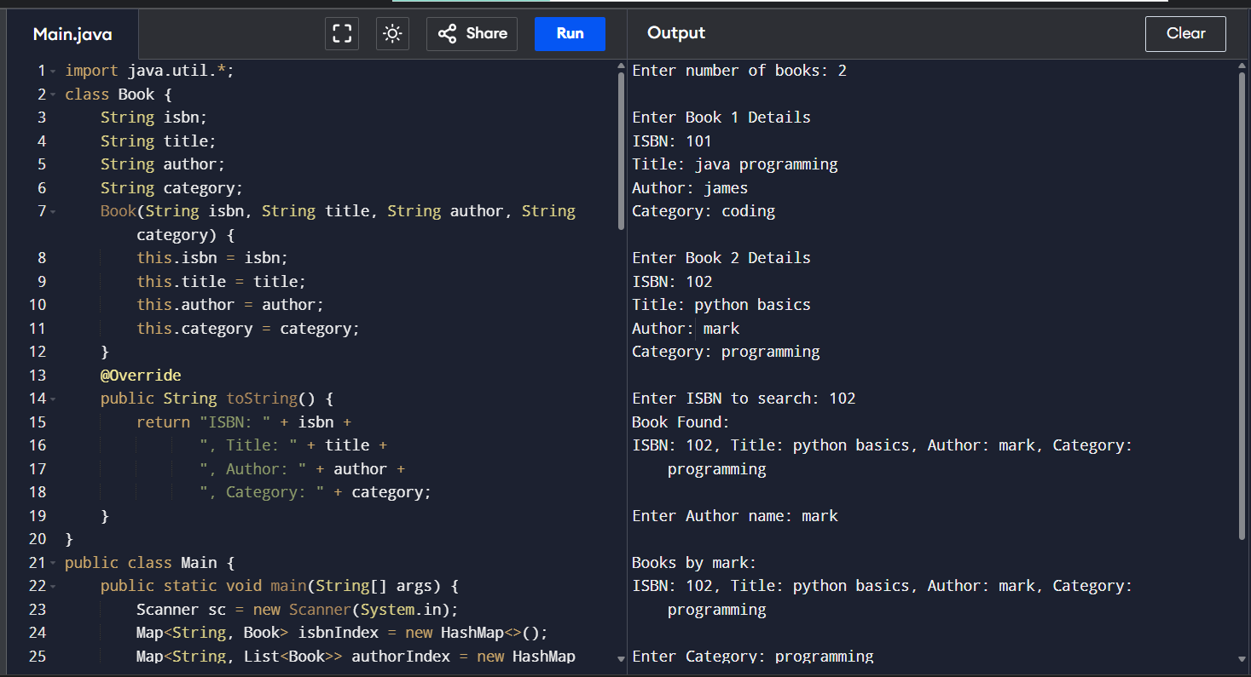
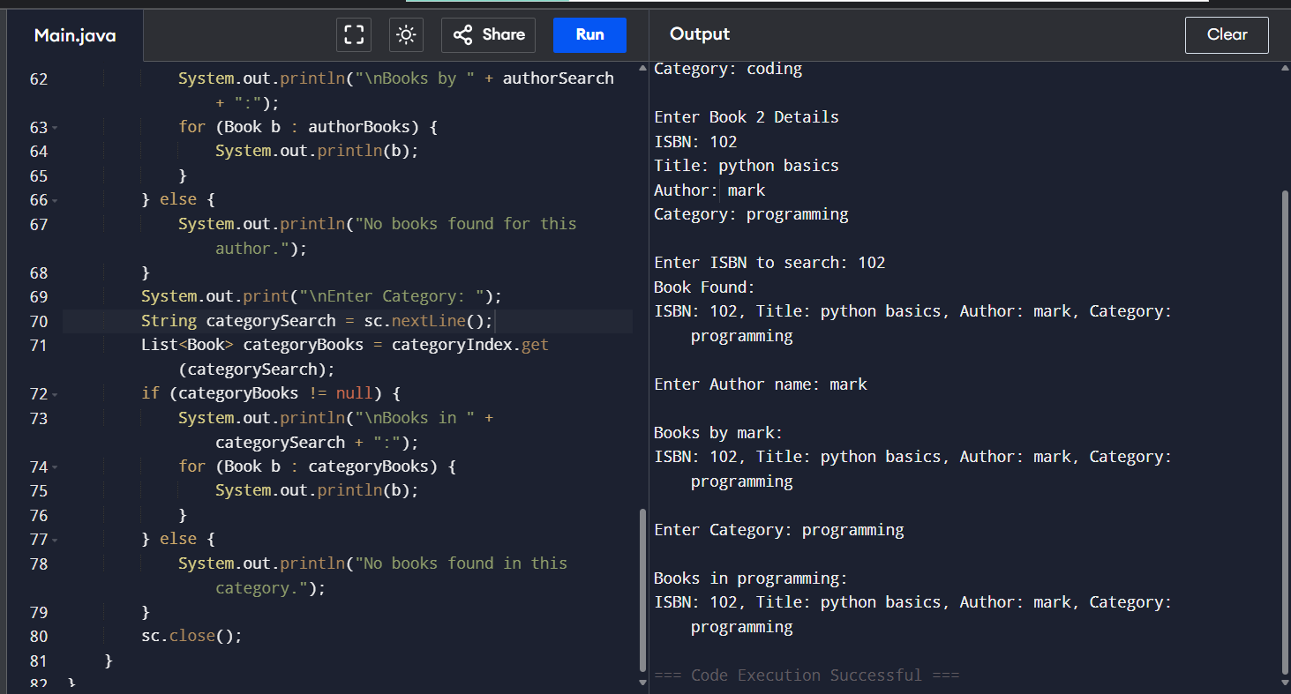

Conclusion
A digital library requires multiple Map indexes instead of a single Map because books must be searched using different attributes such as ISBN, author, and category. Using separate HashMap indexes enables fast and efficient searches, minimizes lookup time, and improves the overall performance of the library system. This design is widely used in real-world library management systems, e-commerce platforms, and database indexing applications.

