

Name: V. Nagendra | Registration Number: 192425091
Course Code: CSA0918 | Course Name: Programming in Java

Concurrent Ticket Booking System
This project designs and implements a concurrent seat-reservation engine in Java that demonstrates object-oriented design, the Collections framework, multithreading, intrinsic synchronization, custom exception handling, JDBC-based MySQL persistence, file-based logging, and a Swing graphical interface. The system guards against duplicate seat allocation under concurrent load, recovers cleanly from failed payments, supports reservation cancellation, keeps a durable transaction log, and exposes a live administrative console for tracking occupancy and revenue.

1. Problem Understanding and Formulation
Ticket reservation platforms must maintain accurate seat availability even when many users submit requests at almost the same time. The major technical difficulty is that multiple threads may read the same seat as available before any one thread updates its status. This creates a race condition and can result in duplicate reservations for one seat.
The proposed Java system models events, passengers, seats, reservations and transactions as separate objects. The ReservationService coordinates booking operations and controls access to shared seat information. The design therefore combines object-oriented programming with concurrent programming concepts. The system also considers practical failure cases such as invalid customer information, payment rejection, cancellation and database errors. By addressing these situations together, the project provides a more reliable reservation workflow rather than treating concurrency as an isolated programming problem.
Ticket reservation platforms routinely face bursts of near-simultaneous requests for the same seat, particularly during popular events. When such requests are handled without coordination between threads, more than one customer can be granted the same seat, producing an inconsistent and untrustworthy system.
This project builds a Java application that models events, passengers, reservations and transactions, and coordinates concurrent access to seat inventory so that no seat is ever allocated twice. Confirmed reservations are persisted to MySQL through JDBC, and an administrator can observe and manage the system through a Swing-based console.

2. Objectives
The main objective is to develop a reliable Java-based ticket reservation application that can safely process multiple booking requests. The project aims to demonstrate how object-oriented principles can be applied to a real-world reservation domain through clearly separated classes and responsibilities.
Another important objective is to compare unsafe and safe concurrent execution. The unguarded implementation is intentionally retained to demonstrate the race condition, while the synchronized implementation shows how controlled access prevents duplicate seat allocation. Additional objectives include implementing differentiated seat categories through inheritance, managing collections efficiently, storing confirmed reservations in MySQL, recording important operations in a transaction log, handling payment failures through rollback, supporting cancellation, and providing an administrative Swing interface for monitoring the system.
- To represent the reservation domain using object-oriented principles.
- To model differentiated seat tiers through inheritance and method overriding.
- To organise seat inventory and reservation records using the Collections framework.
- To expose a race condition using concurrent threads acting on shared state.
- To eliminate duplicate allocation using synchronized access to shared resources.
- To recover seat availability automatically when a payment is declined.
- To persist reservation data through JDBC into a MySQL database.
- To maintain a durable, file-based log of significant transactions.
- To build an interactive Swing dashboard for administrative oversight.

3. Application of Course Knowledge
The project applies several important Java programming concepts in one integrated application. The Event, Passenger, Seat, Reservation and Transaction classes demonstrate class design and separation of responsibilities. The abstract Seat class and its EconomySeat, BusinessSeat and FirstClassSeat subclasses demonstrate inheritance, abstraction and method overriding. The fareMultiplier() method provides a practical example of polymorphism because different seat categories can calculate their prices differently.
The Collections framework is used to manage shared application data. A synchronized map protects seat inventory, while CopyOnWriteArrayList supports reservation-history access where reads are frequent. Multithreading is used to model multiple passengers attempting bookings concurrently. The synchronized keyword provides mutual exclusion during the critical booking operation. JDBC connects the Java application to MySQL, while java.io supports persistent transaction logging. Swing connects the backend functionality to an administrative graphical interface.
The system is composed of core domain classes — Event, Passenger, Seat, Reservation and Transaction — each responsible for a single concern. The Seat class is abstract and is specialised by EconomySeat, BusinessSeat and FirstClassSeat, each overriding a fareMultiplier() method to compute its own price, which demonstrates inheritance and polymorphism.
Seat inventory is held in a HashMap wrapped with Collections.synchronizedMap(), and the reservation history is stored in a CopyOnWriteArrayList so that read-heavy access from the dashboard does not contend with writes from booking threads. Mutual exclusion during booking is achieved using Java's intrinsic synchronized keyword scoped to each individual Seat object, rather than a single lock for the whole service. JDBC handles all MySQL connectivity, and java.io is used to append entries to a plain-text transaction ledger.

4. Solution / Design / Methodology
The solution is organised into logical layers so that each part of the system has a clear responsibility. Domain classes represent the business entities, ReservationService manages booking and cancellation logic, DBHandler handles JDBC operations, TransactionLogger records important events, and AdminConsole provides administrative monitoring.
During booking, the service first identifies the requested Seat object. The critical availability check and state update are protected by synchronization on that particular seat. This ensures that two threads cannot simultaneously reserve the same seat. Once availability is confirmed, the system proceeds with payment simulation and database persistence. If payment is declined or another stage fails, the seat is restored to the available state. The deliberately unguarded booking path is used for comparison so that the improvement provided by synchronization can be demonstrated clearly.
The application is organised in layers: domain classes describe the entities, ReservationService coordinates booking logic, DBHandler performs all JDBC operations, and TransactionLogger writes to the audit file.
When a booking request arrives, the service looks up the target Seat object and synchronizes on that specific instance before checking its status. Only after the seat is confirmed free does the service simulate payment and write the reservation to the database. If any stage fails, the seat's status is reset to available inside a finally block before the synchronized section is released.
A separate, deliberately unguarded booking path is retained purely to reproduce the race condition for comparison, before the synchronized implementation is exercised against the same load.

5. Exception Handling and Rollback
Exception handling is used to represent different failure conditions instead of treating all errors in the same way. SeatUnavailableException identifies attempts to reserve an already occupied seat, while InvalidCustomerException represents incorrect passenger information. PaymentDeclinedException models a rejected payment, and ReservationExpiredException represents a booking hold that was not confirmed within the required time.
Rollback is particularly important after a seat has been provisionally held. If payment fails, the service changes the seat back to available before allowing the exception to propagate. This prevents a failed transaction from permanently reducing the available inventory. Database failures are handled separately so that persistence problems can be detected rather than silently ignored. During cancellation, the reservation record is removed, the in-memory reservation is cleared and the seat becomes available again, maintaining consistency between the different representations of the booking.
Four checked exception types are defined to represent distinct failure modes:
- SeatUnavailableException — the requested seat is already reserved.
- InvalidCustomerException — passenger details fail validation.
- PaymentDeclinedException — the simulated payment gateway rejects the charge.
- ReservationExpiredException — a hold on a seat is not confirmed in time.
Whenever PaymentDeclinedException is thrown after a seat has been provisionally held, the seat's status is reverted to available before the exception propagates, so a declined charge never leaves a seat permanently blocked. Database exceptions are caught separately so that a failed insert does not leave the in-memory model and the database out of step. Cancellation removes the reservation row, deletes the in-memory record, and marks the seat free again in a single guarded operation.

6. JDBC Persistence
MySQL provides durable storage for confirmed reservation information. The DBHandler component is responsible for opening JDBC connections and performing insert, delete and retrieval operations. PreparedStatement is used for database commands, providing a safer and structured way to pass values to SQL statements and reducing exposure to SQL injection.
The reservation table stores important details such as reservation identifier, event identifier, passenger identifier, seat code, fare and timestamp. The database also contains a unique constraint on the combination of event_id and seat_code. This is significant because it creates an independent database-level safeguard against duplicate allocation. Therefore, even though the Java application uses synchronization, the database provides an additional consistency layer for persistent reservation data.
MySQL serves as the durable store. DBHandler opens JDBC connections and exposes insertReservation(), deleteReservation() and fetchReservations() methods, all built on PreparedStatement to avoid SQL injection.
The reservations table records the reservation identifier, event identifier, passenger identifier, seat code, fare and timestamp. A unique constraint across (event_id, seat_code) gives the database an independent guarantee against duplicate seat allocation, in addition to the in-application synchronization.

7. Concurrency Testing
Concurrency testing is used to verify whether the reservation logic behaves correctly when several requests arrive together. Fifteen threads are created, with each thread representing a different passenger attempting to reserve the same seat, B2. This scenario closely models a high-demand booking situation where many users compete for limited inventory.
In the deliberately unguarded implementation, all fifteen threads reported successful reservations for B2, demonstrating the race condition. When the same workload was applied to the synchronized implementation, only one thread successfully reserved the seat and the remaining fourteen were rejected because the seat had already been taken. The comparison provides direct evidence that per-seat synchronization protects the critical section while allowing unrelated bookings to proceed.
Fifteen threads, each representing a distinct passenger, were launched to compete for seat B2 at nearly the same instant.
In the unguarded path, every one of the fifteen threads reported a successful reservation for seat B2, confirming the race condition inherent in the original design.
The same load was then directed at the synchronized implementation, where exactly one thread obtained the seat and the remaining fourteen were correctly rejected because the seat was already taken.
Figure 3 – Unsynchronized Race Condition
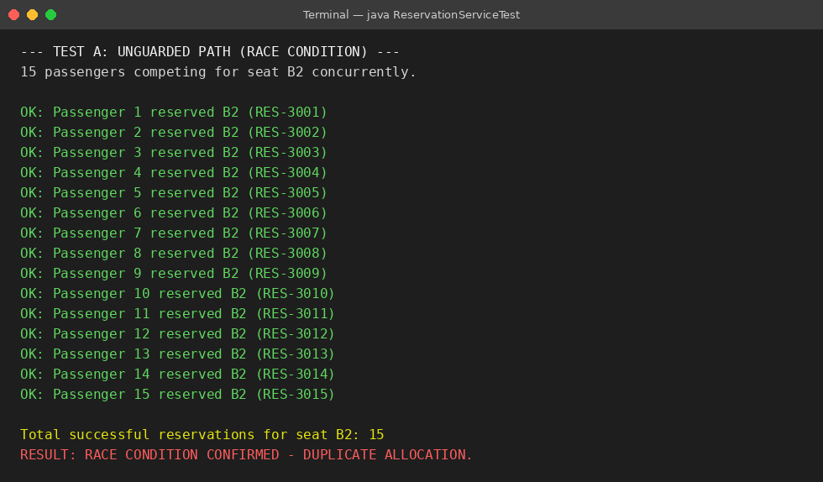
Figure 4 – Synchronized-Seat Solution
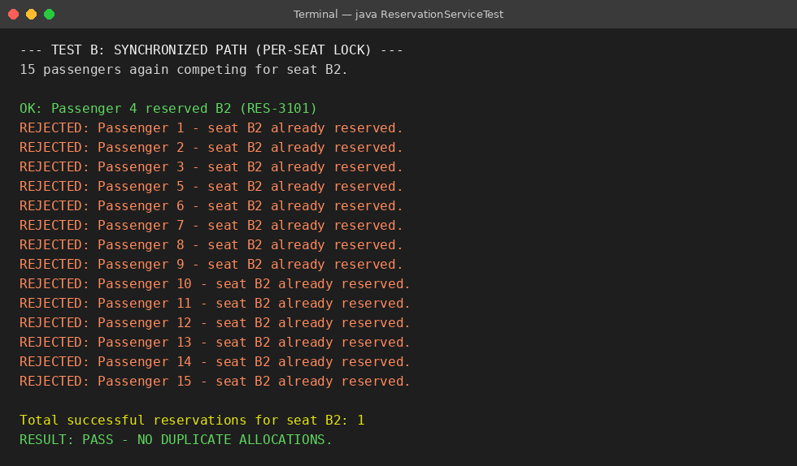

8. Payment Failure and Rollback Testing
Payment failure testing verifies that the system can recover from a failed transaction without leaving incorrect seat information. The project deliberately simulates a payment decline for seat C1 after the seat has been provisionally held.
When PaymentDeclinedException occurs, the booking service catches the failure and releases C1 back to the available pool. The seat status is then checked immediately to confirm recovery. This test is important because a payment failure should not cause an available seat to remain blocked. The rollback mechanism therefore improves reliability and ensures that customers can attempt a later booking for the released seat.
A payment decline was deliberately simulated for seat C1. The service caught PaymentDeclinedException, released the seat, and confirmed its availability immediately afterward, showing that a declined charge never permanently blocks inventory.
Figure 5 – Payment Decline and Recovery
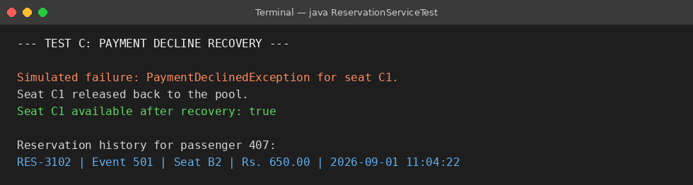

9. Reservation History
Reservation history provides a record of confirmed bookings and allows the application to retrieve important information about previous transactions. After a successful booking, the service can return the reservation identifier together with the associated passenger, event, seat and fare information.
During testing, reservation RES-3102 for passenger 407 was returned as expected. This confirms that the reservation object contains the required information and that the history mechanism can retrieve it correctly. Maintaining reservation history is also useful for administrative monitoring, cancellation operations and future reporting features.
Reservation history was checked immediately after a confirmed booking, and the service correctly reported the reservation identifier, event, seat and fare tied to the passenger. Reservation RES-3102 for passenger 407 was returned as expected.
Figure 6 – Reservation History Lookup

10. Cancellation Testing
Cancellation testing verifies the reverse operation of booking. Before cancellation, the selected reservation is confirmed and its seat is marked as unavailable. When the cancellation operation is executed, the corresponding reservation record is removed from the database and the in-memory reservation collection is updated.
The seat is then returned to the available pool. This ensures that the same seat can be reserved again by another passenger. The operation is performed as a guarded activity so that the seat status and reservation information do not become inconsistent during concurrent access. The test confirms that cancellation correctly reverses the important effects of a confirmed reservation.
Cancellation was exercised against a confirmed reservation. Prior to cancellation the seat was correctly marked unavailable; afterwards it returned to the available pool, and the corresponding database row and in-memory record were both removed.
Figure 7 – Cancellation Test
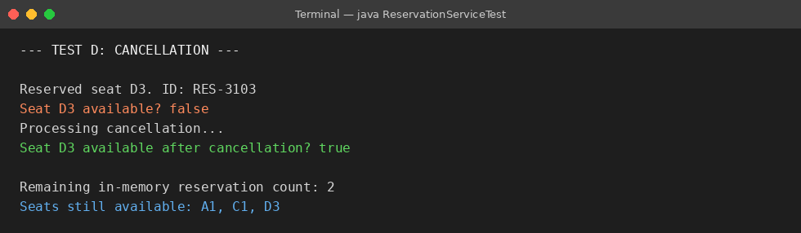

11. Audit Logging
TransactionLogger provides a durable record of significant operations performed by the application. Instead of depending only on temporary console output, the system appends important events to a plain-text transaction ledger.
The log records successful reservations, payment recovery events, cancellations and the outcomes of the concurrency tests. This information can help an administrator understand what happened during system operation and can also support debugging when an unexpected result occurs. File-based logging therefore adds traceability to the application and provides a simple audit mechanism for the project.
TransactionLogger appends every significant event — successful reservations, payment recoveries and cancellations — to a plain-text ledger file. During testing the ledger correctly captured the unguarded race-condition run, the synchronized run, the payment recovery, and the cancellation.
Figure 8 – Transaction Ledger Excerpt
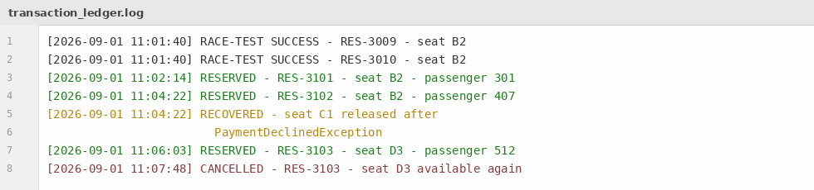

12. Advanced Swing Administrative Console
The AdminConsole provides a graphical view of the reservation system using Java Swing. The seat grid visually distinguishes available and reserved seats, allowing an administrator to understand occupancy without examining database records or console output manually.
The console also displays the total number of seats, occupied seats and cumulative revenue. When an administrator selects a reserved seat, the details panel shows information such as reservation identifier, passenger and fare. The Cancel button allows the administrator to release the selected reservation, after which the seat grid and transaction information are refreshed. This creates a direct connection between the backend reservation logic and the user interface.
An AdminConsole class built on Swing gives a live view of the reservation system. Available seats are drawn in green and reserved seats in amber; a side panel totals seat count, occupied count and cumulative revenue.
Selecting a reserved seat in the grid populates a details panel with its reservation identifier, passenger and fare, and enables a Cancel button that immediately releases the seat and refreshes the grid and the transaction table.
Figure 9 – Admin Console Before Cancellation
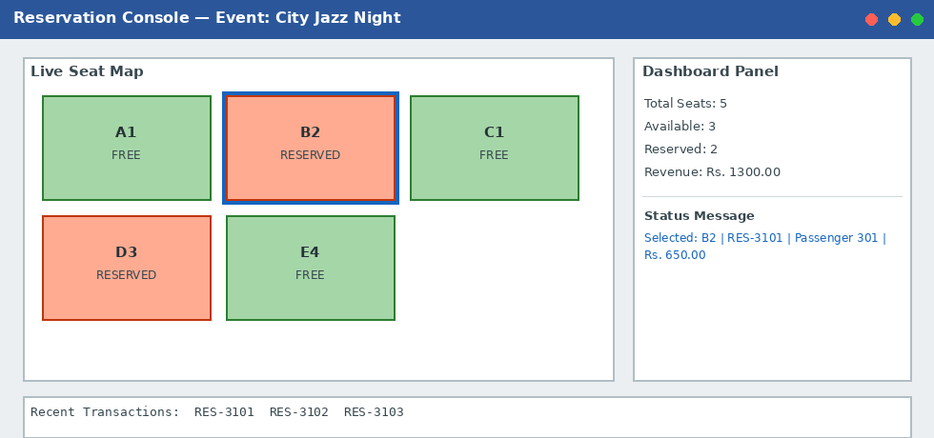
Figure 10 – Admin Console After Cancellation
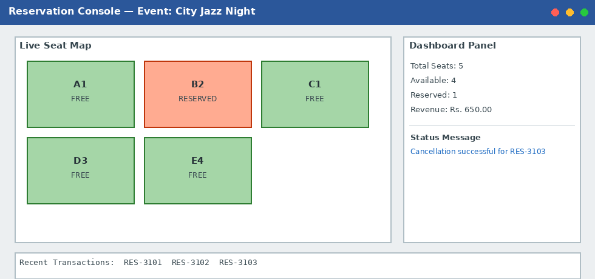

13. Results and Discussion
The testing results show that the core requirements of the application were achieved. The unsynchronized booking path successfully reproduced the duplicate-allocation race condition, proving that concurrent access to shared seat state can cause incorrect results. The synchronized implementation eliminated the problem in the tested scenario by allowing exactly one of fifteen competing threads to reserve B2.
The payment-decline test confirmed that a failed payment releases the seat correctly. JDBC testing confirmed that reservation information is stored in MySQL, while cancellation removed both the database record and the in-memory reservation. The Swing console reflected these state changes, demonstrating that the administrative interface remained consistent with the backend system. Overall, the results show that the major functional and concurrency requirements were implemented successfully.
All core operations behaved as intended across testing. The unguarded implementation reproduced duplicate allocation under concurrent load, and the per-seat synchronized implementation eliminated it entirely, allowing only one of fifteen competing threads to succeed.
Payment decline correctly restored seat availability, JDBC persistence was confirmed directly against the MySQL table, and cancellation correctly reversed both the database row and the in-memory seat state. The Swing console reflected every state change through its live grid and revenue counter.

14. Analysis and Engineering Decision
An early design synchronized the entire ReservationService. Although this approach was simple and could prevent concurrent access problems, it also created unnecessary blocking. If two passengers wanted different seats, their requests could still be forced to wait for one another even though the operations were logically independent.
The final design uses synchronization at the individual Seat level. This fine-grained approach limits contention to passengers competing for the same seat while allowing bookings for different seats to progress independently. The database unique constraint was also retained because application-level synchronization and database-level validation protect different parts of the overall system. This layered engineering decision improves both concurrency and data integrity.
An early version synchronized the entire ReservationService, which was straightforward but forced unrelated bookings for different seats to wait on one another unnecessarily.
The final design synchronizes on each Seat instance individually, so contention is limited to passengers competing for the same seat, while bookings on different seats proceed independently. The unique database constraint on (event_id, seat_code) was retained as a second, independent safeguard beyond the in-JVM lock.

15. Broader Considerations
The current implementation assumes that the application is running inside a single JVM. In this environment, synchronized Seat objects can coordinate threads that share the same application memory. However, the same lock cannot coordinate requests arriving at different application servers.
For a production deployment with multiple servers, the database constraint would remain an important safeguard. Additional mechanisms such as explicit database transactions, connection pooling and distributed locking would be appropriate. A distributed lock service could coordinate access across application instances. These considerations show how a classroom Java concurrency solution can be extended toward a larger production architecture.
The current system runs as a single JVM instance. A production deployment with multiple application servers sharing one database would need protection beyond an in-process lock, since Java's synchronized keyword only coordinates threads within the same JVM.
The database-level unique constraint would remain essential in such a setting, and a production system would likely add explicit database transactions, connection pooling, and a distributed locking service such as one built on Redis or ZooKeeper.

16. Conclusion
The Concurrent Ticket Booking System successfully demonstrates how Java can be used to solve a realistic concurrency problem. The project first exposes the weakness of an unguarded booking operation and then applies per-seat synchronization to ensure that only one passenger can obtain a particular seat during concurrent access.
In addition to concurrency control, the application integrates object-oriented design, inheritance, polymorphism, Collections, custom checked exceptions, payment rollback, JDBC-based MySQL persistence, cancellation, audit logging and a Swing administrative console. The combination of these features creates a complete example of a reservation application in which correctness, recoverability and maintainability are considered together.
This project demonstrates a working concurrent ticket reservation system built in Java. The unguarded race-condition test exposed the risk of duplicate seat allocation, and the per-seat synchronized design removed it while preserving concurrency across unrelated seats.
The system additionally covers payment-failure recovery, structured exception handling, JDBC-backed persistence, cancellation, durable audit logging and a Swing-based administrative console, bringing together object-oriented design, the Collections framework, concurrency and GUI programming in a single cohesive application.

17. Student Reflection
Building this project provided practical understanding of how theoretical Java concepts behave in a real application. The concurrency experiment was particularly useful because the unguarded implementation allowed multiple threads to report success for the same seat, making the race condition clearly visible. Applying synchronization and observing that only one thread could then succeed demonstrated the importance of protecting shared resources.
The project also strengthened understanding of JDBC and database constraints. Using both Java-side synchronization and a database-level unique constraint showed that reliable systems often use multiple layers of protection. Implementing payment rollback, cancellation and file logging provided additional experience in maintaining consistent application state. Finally, the Swing console helped connect backend operations with a visual interface, making it easier to verify changes in seat availability and reservation information.
Building this project made the practical impact of concurrency very concrete — seeing fifteen threads all falsely report success against the unguarded version, and then watching the synchronized version reject all but one, made the value of proper locking obvious rather than theoretical.
Working through JDBC persistence and a matching database constraint also clarified why application-level and database-level safeguards are usually used together rather than as alternatives. Building the Swing console additionally gave a concrete, visual way to confirm that backend state changes were reflected correctly, rather than relying on console output alone.

18. References
- Oracle Corporation, Java Platform, Standard Edition Documentation, Oracle Java Documentation.
- Oracle Corporation, Java Concurrency Utilities, Oracle Java Documentation.
- Oracle Corporation, Java Collections Framework, Oracle Java Documentation.
- Oracle Corporation, Java Database Connectivity (JDBC) Documentation, Oracle Java Documentation.
- Oracle Corporation, Java Swing Documentation – Swing Components and Event Handling, Oracle Java Documentation.
- Oracle Corporation, Java Language Specification, Java SE Documentation.
- Oracle Corporation, Java Object-Oriented Programming Concepts, Oracle Java Documentation.
- Oracle Corporation, Java Exception Handling and Input/Output Documentation, Java SE Documentation.
- Oracle Corporation, Java Thread and Synchronization Documentation, Java SE Documentation.
- Oracle Corporation, JDBC API Guide and Database Connectivity Concepts, Oracle Java Documentation.
- Oracle Corporation, Java Swing Tutorial, Oracle Java Documentation.
- Oracle Corporation, Java Collections Framework Guide, Oracle Java Documentation.
- Oracle Corporation, Java SE API Specification, Oracle Documentation.
- MySQL, MySQL Reference Manual – Database and SQL Concepts, Oracle MySQL Documentation.
- MySQL, MySQL 8.0 Reference Manual – Constraints and Indexes, Oracle MySQL

