Name: V. Nagendra Reg. No: 192425091
Course Code: CSA1413 Course Name: Compiler Design

LEX PROGRAM: IDENTIFY ASSIGNMENT OPERATORS
AIM:
To write a LEX program to identify and print assignment operators (=, +=, -=, *=, /=) used in a C statement.
PSEUDOCODE:
1. Start.
2. Include the required C header file.
3. Define LEX rules for the assignment operators =, +=, -=, *=, and /=.
4. When an assignment operator is found, print the operator.
5. Ignore all other characters in the input statement.
6. Display a prompt and scan the C statement using yylex().
7. Stop.
PROGRAM:
%{
#include <stdio.h>
%}
%%
"=" { printf("Assignment Operator: =\n"); }
"+=" { printf("Assignment Operator: +=\n"); }
"-=" { printf("Assignment Operator: -=\n"); }
"*=" { printf("Assignment Operator: *=\n"); }
"/=" { printf("Assignment Operator: /=\n"); }
.|\n ;
%%
int main()
{
printf("Enter a C statement:\n");
yylex();
return 0;
}
int yywrap()
{
return 1;
}

OUTPUT :
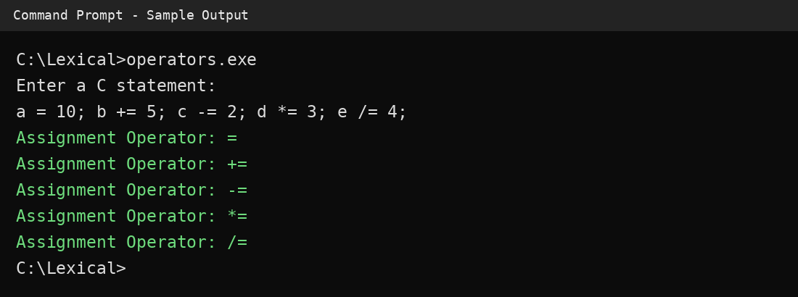
RESULT:
Thus, the LEX program to identify and print the assignment operators used in a C statement was successfully executed and the expected output was obtained.

