Name: V. Nagendra Reg. No: 192425091
Course Code: CSA1413 Course Name: Compiler Design

LEX PROGRAM: COUNT IDENTIFIERS IN A C PROGRAM
AIM:
To write a LEX program to count the identifiers in a given C source file, excluding C keywords, numbers, comments, and string or character literals.
PSEUDOCODE:
1. Start.
2. Declare a counter and an array containing the 32 C keywords.
3. Define a function to check whether a word is a keyword.
4. Accept the C source filename as a command-line argument.
5. Open the specified file; if it cannot be opened, display an error and stop.
6. Ignore comments, numeric constants, string literals, character literals, whitespace, and other symbols.
7. For each identifier-like word, check whether it is a C keyword.
8. If it is not a keyword, increment the identifier counter.
9. Display the total identifier count and close the file.
10. Stop.
PROGRAM:
%{
#include <stdio.h>
#include <string.h>
int count = 0;
char *keywords[] = {
"auto","break","case","char","const","continue",
"default","do","double","else","enum","extern",
"float","for","goto","if","int","long","register",
"return","short","signed","sizeof","static","struct",
"switch","typedef","union","unsigned","void",
"volatile","while"
};
int isKeyword(char *s)
{
int i;
for (i = 0; i < 32; i++)
if (strcmp(s, keywords[i]) == 0)
return 1;
return 0;
}
%}
%option noyywrap
%%
"//".* ;
"/*"([^*]|\*+[^*/])*\*+"/" ;
[0-9]+(\.[0-9]+)? ;
\"([^\\\"]|\\.)*\" ;
\'([^\\\']|\\.)*\' ;
[a-zA-Z_][a-zA-Z0-9_]* {
if (!isKeyword(yytext))
count++;
}
[ \t\n]+ ;
. ;
%%
int main(int argc, char *argv[])
{
if (argc != 2)
{
printf("Usage: %s program.c\n", argv[0]);
return 1;
}
yyin = fopen(argv[1], "r");
if (yyin == NULL)
{
printf("Cannot open file.\n");
return 1;
}
yylex();
printf("Number of identifiers = %d\n", count);
fclose(yyin);
return 0;
}
SAMPLE INPUT :
int main() {
int x = 10;
int y = x + 5;
return y;
}

OUTPUT :
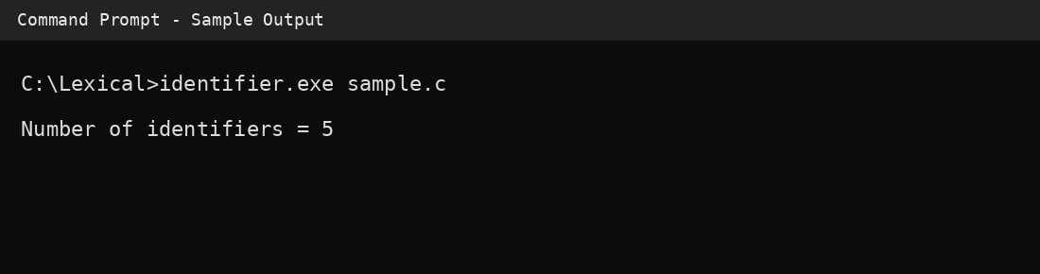
RESULT:
Thus, the LEX program to count identifiers in a C source file was documented with the expected sample output.

