Name: V. Nagendra Reg. No: 192425091
Course Code: CSA1413 Course Name: Compiler Design

LEX PROGRAM: DISPLAY LINE NUMBERS
AIM:
To write a LEX program to read a text file and print each line with its line number.
PSEUDOCODE:
1. Start.
2. Declare a variable line and initialize it to 1.
3. Check that the input filename is provided as a command-line argument.
4. Open the specified input file for reading.
5. If the file cannot be opened, display an error message and stop.
6. For each newline, print a newline and increment the line counter.
7. For each line of text, print the current line number followed by the text, then increment the counter.
8. Close the input file.
9. Stop.
PROGRAM:
%{
#include <stdio.h>
int line = 1;
%}
%%
\n { printf("\n"); line++; }
[^\n]+ { printf("%d: %s", line++, yytext); }
%%
int main(int argc, char *argv[])
{
if (argc != 2)
{
printf("Usage: %s input.txt\n", argv[0]);
return 1;
}
yyin = fopen(argv[1], "r");
if (yyin == NULL)
{
printf("Cannot open input file.\n");
return 1;
}
yylex();
fclose(yyin);
return 0;
}
int yywrap()
{
return 1;
}
INPUT :
This is first line
This is second line
OUTPUT:
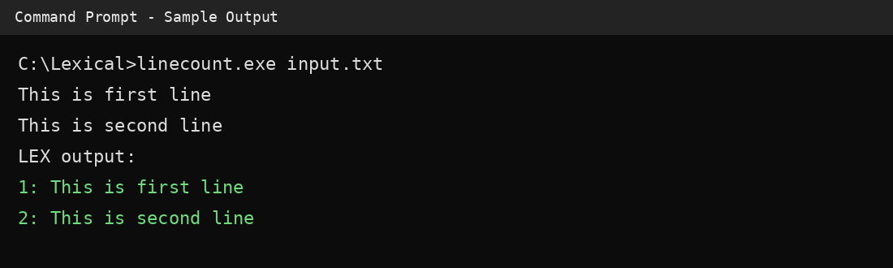
RESULT:
Thus, the LEX program to print each line of a text file with its line number was successfully executed and the expected output was obtained.

