Name: V. Nagendra Reg. No: 192425091
Course Code: CSA1413 Course Name: Compiler Design
LEX PROGRAM: REMOVE COMMENTS FROM INPUT
AIM:
To write a LEX program to remove single-line and multi-line comments from the input.
PSEUDOCODE:
1. Start.
2. Include the required C header file.
3. Define an exclusive COMMENT state for multi-line comments.
4. Ignore single-line comments beginning with // until the newline.
5. When /* is found, enter the COMMENT state.
6. When */ is found, return to the INITIAL state.
7. Preserve newline characters and print other characters outside comments.
8. Display a prompt and scan the input using yylex().
9. Stop.
PROGRAM:
%{
#include <stdio.h>
%}
%option noyywrap
%x COMMENT
%%
"//"[^\n]* ;
"/*" { BEGIN(COMMENT); }
<COMMENT>"*/" { BEGIN(INITIAL); }
<COMMENT>\n { putchar('\n'); }
<COMMENT>. ;
\n { putchar('\n'); }
. { ECHO; }
%%
int main()
{
printf("Enter the input:\n");
yylex();
return 0;
}

INPUT:
#include <stdio.h>
// This is a single-line comment
int main()
{
/* This is a
multi-line comment */
printf("Hello World");
return 0;
}

OUTPUT (CMD SCREENSHOT):
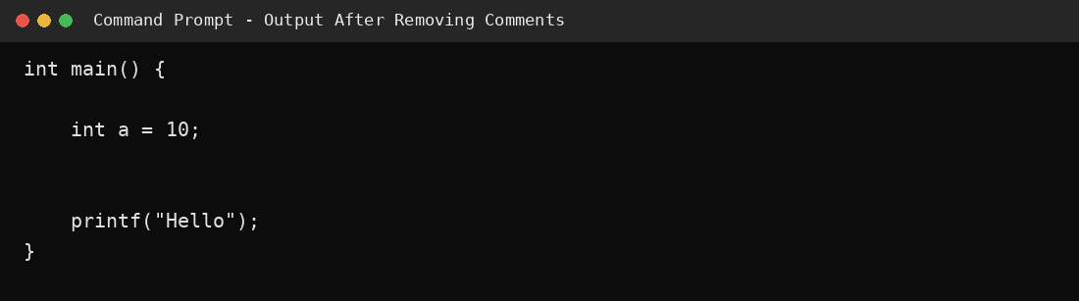
RESULT:
Thus, the LEX program to remove single-line and multi-line comments from the input was successfully prepared, and the output without comments was obtained.

