SIMATS ENGINEERING (SAVEETHA SCHOOL OF ENGINEERING)
Department of Computer Science & Engineering ASSESSMENT TOOL 1 – APPLICATION BASED QUESTIONS

Course Code | CSA4315 | Course Title | Internet Programming
CO Assessed | CO1 | Assessment | Assessment Tool 1: Application Based Questions
Weightage | 40% of CIA | Total Marks | 100
CO1 Statement | Explain the fundamentals of web architecture, client-server communication, Internet protocols, HTTP request and response messages, and configure LAMP/WAMP environments for web application development and deployment. (BL3)
Student Name | V. Nagendra | Reg. No. | 192425091
Section/Batch | Slot D / AIML | Date | 20-10-2026


Code of Conduct:
I, V. Nagendra (192425091), certify that this submission is my original work and that I have adhered to the guidelines specified for this assessment. I understand that any violation of academic integrity rules will result in disciplinary action.
Signature of the student:

Question:
A student has developed a website using localhost and wants to make it accessible to users across the Internet. Explain the steps required for deployment, including domain configuration, hosting, and networking.
Solution:

1. Introduction
A website running on localhost (127.0.0.1) is reachable only from the developer's own computer, because the address points back to that same machine. To make it available to everyone, the site must be placed on a computer that is always on and connected to the Internet (a web server), that computer must have a public IP address, and a domain name must be mapped to that address through DNS. The complete process therefore has three parts: hosting, networking and domain configuration.
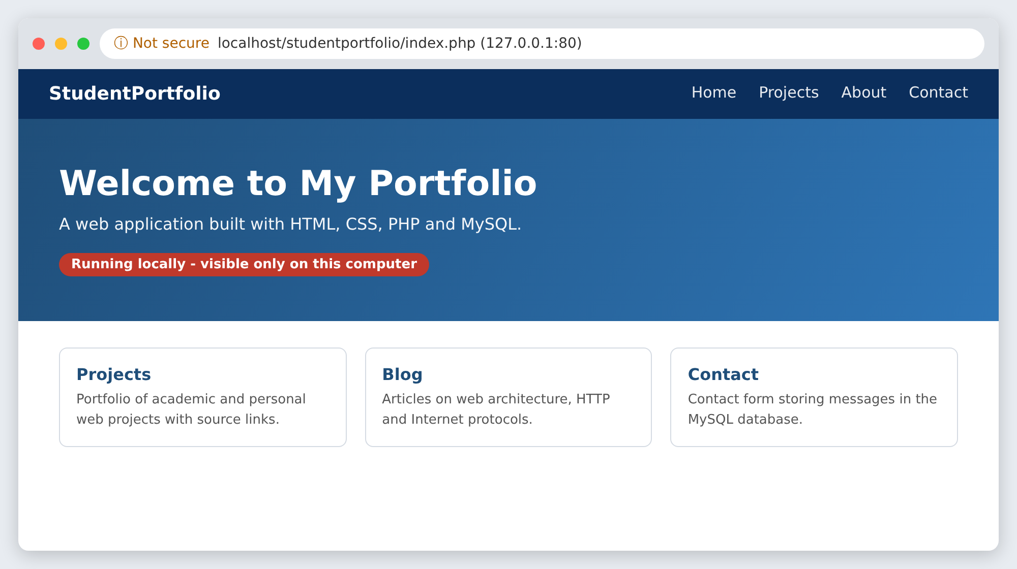
Figure 1: Website running on localhost (accessible only on the developer's computer)

2. Overall Deployment Architecture
When a visitor types the domain name, the browser asks a DNS server for the IP address, the request travels across the Internet to the server's public IP, passes the firewall on ports 80/443, and is handled by the web server, which runs the application and database and returns the page. Figure 2 shows this flow.
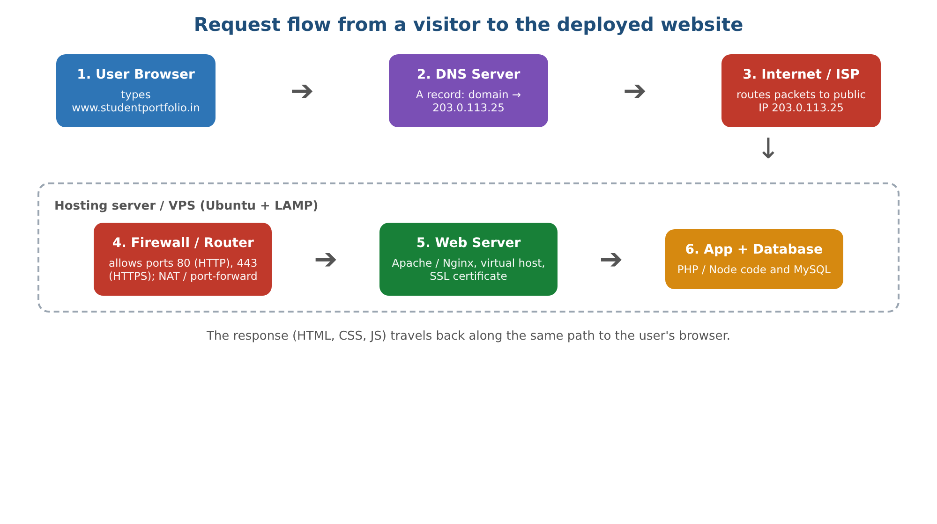
Figure 2: Request flow from the visitor to the deployed website

3. Steps Required for Deployment
Step 1: Prepare the application for production
- Finish testing and fix errors; turn off debug mode and detailed error messages.
- Replace hard-coded addresses such as http://localhost/... with relative paths or a configurable base URL.
- Move passwords, API keys and database credentials into configuration/environment files.
- Export the database (SQL dump) and list all dependencies (PHP extensions, Node/Python packages).
- Store the project in a Git repository so it can be deployed and updated easily.
Step 2: Choose the hosting option
Hosting means renting or owning a server that is permanently connected to the Internet. The common choices are:
- Shared hosting – cheapest and easiest (control panel, FTP); suitable for small PHP/MySQL sites, but with limited control.
- VPS / Cloud server (AWS EC2, Azure, DigitalOcean, etc.) – full control over the operating system and software; best for learning and for custom stacks.
- Platform-as-a-Service / static hosting (Render, Netlify, GitHub Pages, etc.) – deploy directly from Git with minimal server work.
- Self-hosting from the student's own PC or router – possible with port forwarding and a static or dynamic IP, but unreliable and less secure, so it is not recommended for real use.
Step 3: Set up the server environment
For a LAMP-based site (Linux, Apache, MySQL, PHP) the student connects to the server using SSH and installs the required software, then secures the database.
ssh ubuntu@203.0.113.25
sudo apt update && sudo apt install apache2 php mysql-server -y
sudo mysql_secure_installation

Step 4: Upload the website files and database
- Copy the project to the web root (for example /var/www/studentportfolio) using git clone, scp or SFTP/FTP.
- Create the production database and user, then import the SQL dump; update the connection settings.
- Set correct file ownership and permissions so Apache can read the files but not every file is writable.
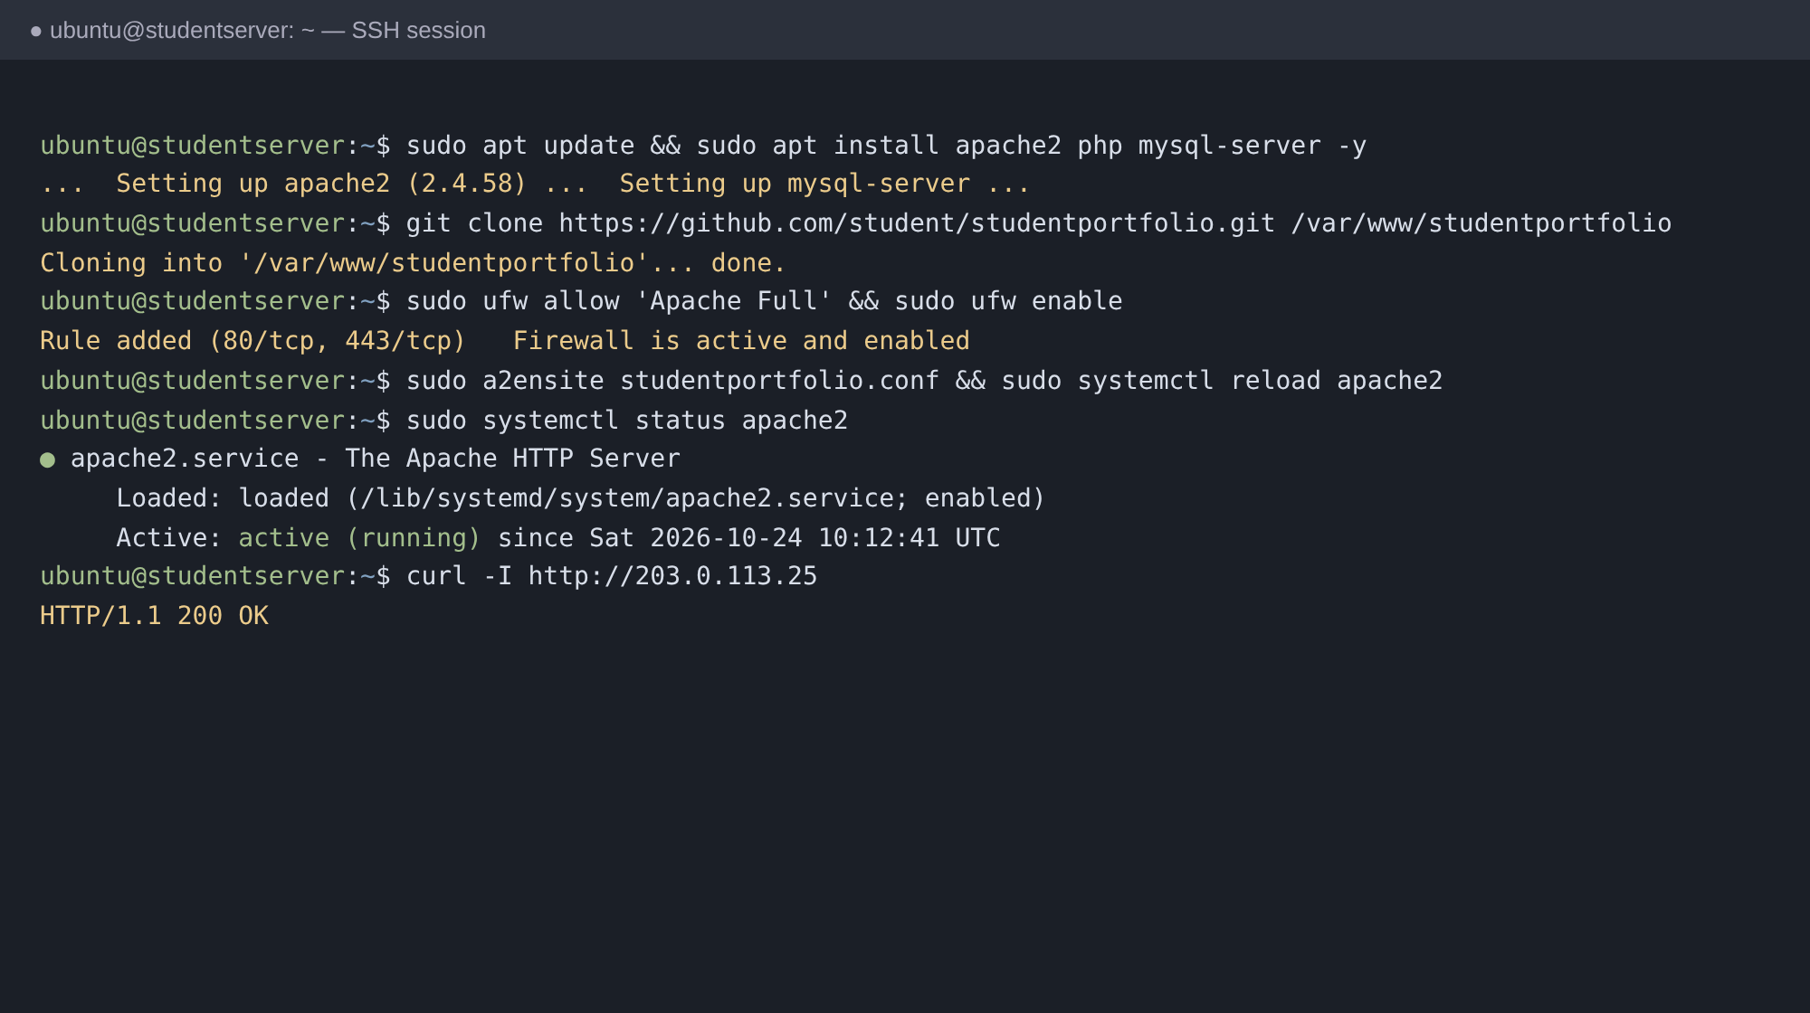
Figure 3: Installing the web server, cloning the project and verifying that Apache is running
Step 5: Configure networking
Networking makes the server reachable and safe from the Internet:
- Public IP address – the server needs a public (preferably static) IP. Cloud and VPS providers assign one automatically.
- Firewall / security group – open only the required ports: 80 (HTTP), 443 (HTTPS) and 22 (SSH); block everything else (for example ufw allow 'Apache Full').
- Port forwarding and NAT – for self-hosting, the router must forward external ports 80/443 to the server's private IP (which should be reserved through DHCP). A Dynamic DNS service is used if the ISP changes the IP address.
- Web server listening – Apache/Nginx must listen on all interfaces (0.0.0.0) instead of only 127.0.0.1.
Step 6: Register a domain and configure DNS
- Buy a domain name from a registrar (for example studentportfolio.in).
- Open the DNS management panel and create an A record (@ → server IP) and an A/CNAME record for www.
- Optionally add CNAME records for sub-domains (blog), MX records for e-mail and use the registrar's name servers (NS).
- Set a suitable TTL (for example 3600 s). DNS changes take from a few minutes up to 24–48 hours to propagate worldwide.
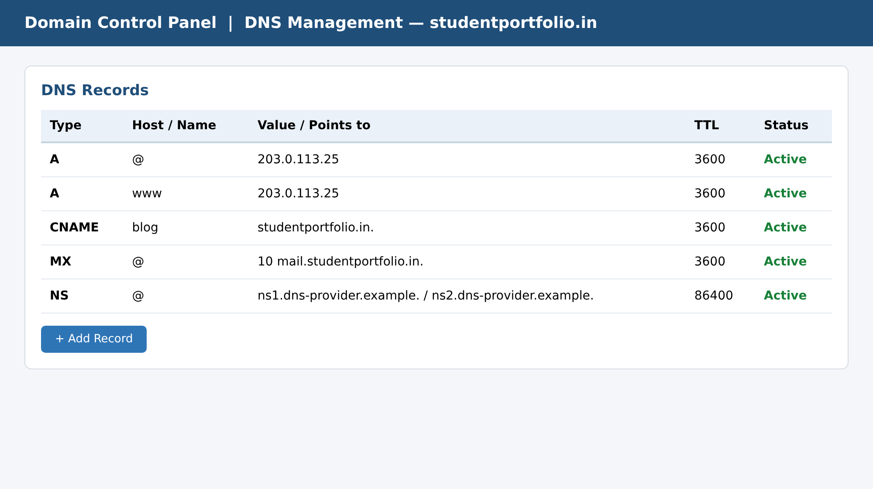
Figure 4: DNS records mapping the domain name to the server's public IP address
Step 7: Configure the virtual host and enable HTTPS
A virtual host tells the web server which folder to serve for the domain. After that, a free SSL/TLS certificate (Let's Encrypt) is installed so that traffic is encrypted and the browser shows a padlock.
<VirtualHost *:80>
ServerName studentportfolio.in
ServerAlias www.studentportfolio.in
DocumentRoot /var/www/studentportfolio
</VirtualHost>

sudo a2ensite studentportfolio.conf && sudo systemctl reload apache2
sudo certbot --apache -d studentportfolio.in -d www.studentportfolio.in

Enable automatic redirection from HTTP to HTTPS and automatic certificate renewal.
Step 8: Test and verify the deployment
- Check DNS with nslookup studentportfolio.in and connectivity with ping and curl -I.
- Open the site from another network (mobile data) and in different browsers and devices.
- Confirm that forms, database operations, images and links work and that no page still points to localhost.
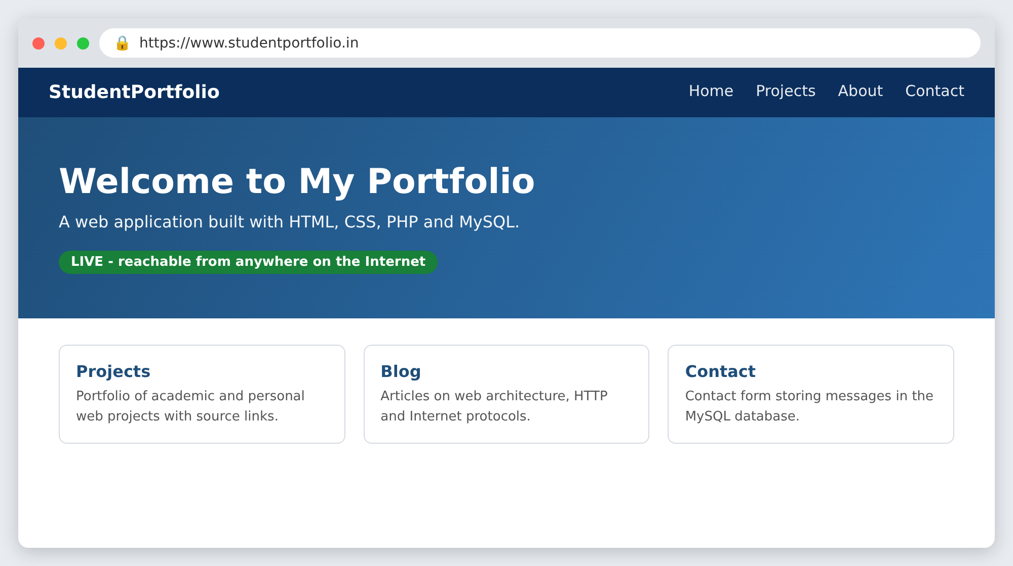
Figure 5: The deployed website opened through its domain name over HTTPS
Step 9: Security, monitoring and maintenance
- Keep the operating system and software updated; use strong passwords and SSH keys; install Fail2ban.
- Take regular backups of files and database; monitor logs and uptime.
- Optionally use a CDN/reverse proxy (such as Cloudflare) for speed and protection, and redeploy updates through Git.

4. Conclusion
To move a website from localhost to the Internet, the student must prepare the application, host it on a server with a public IP, configure the firewall and ports, register a domain and point it to the server through DNS records, and finally secure the site with HTTPS. Once DNS has propagated, anyone in the world can open the website by typing its domain name in a browser.

Criteria | Weightage | Level 4 (Exemplary) | Level 3 (Proficient) | Level 2 (Developing) | Level 1 (Beginning) | Marks

