Experiment 1: Hotel Booking Website (StayEase)
Aim
To design and develop a responsive hotel booking website using HTML, CSS and JavaScript that lets users search rooms by destination, dates and guests, register and log in, book, modify and cancel reservations, and lets an administrator manage room inventory, prices, bookings and website information.
Algorithm
- Start and load the room, user, booking and website-information data from the browser's localStorage (sample rooms are used on first run).
- Display the home page with the search form (destination, check-in, check-out, guests) and the room types.
- On search, validate that the check-in date is not in the past and the check-out is at least one night later.
- Filter rooms whose capacity fits the guests and whose availability (total rooms minus overlapping confirmed bookings) is greater than zero.
- Allow the user to register and log in; booking is permitted only for a logged-in user.
- On booking, calculate the total (nights x price per night), ask for confirmation and save the booking as "Confirmed".
- Allow modification or cancellation of a booking only up to 3 days before arrival; the booking history is shown in My Bookings.
- Admin logs in to update room price and quantity, cancel bookings and edit About, Contact, FAQ, Travel Guide and Privacy Policy text.
- Save every change to localStorage and re-render the pages. Stop.
HTML Code (Main Part)
<header><h1>StayEase</h1></header>
<nav>
<button onclick="show('home')">Home</button>
<button onclick="show('rooms')">Rooms</button>
<button onclick="show('dashboard')">My Bookings</button>
<button onclick="show('admin')">Admin</button>
</nav>

<section id="home" class="page active">
<form onsubmit="searchRooms(event)">
<input id="destination" required>
<input id="checkin" type="date" required>
<input id="checkout" type="date" required>
<input id="guests" type="number" min="1" max="10" value="2">
<button class="primary">Search Rooms</button>
</form>
<div id="homeRooms" class="grid"></div>
</section>

<script>
function occupied(roomId,checkin,checkout){
return bookings.filter(b=>b.roomId===roomId &&
b.status==="Confirmed" &&
b.checkin<checkout && b.checkout>checkin).length;
}
function available(room,ci,co){
return room.quantity-occupied(room.id,ci,co);
}
function bookRoom(id){
let total=nights(search.checkin,search.checkout)*room.price;
bookings.push({id:Date.now(),email:currentUser.email,
roomId:id,total,status:"Confirmed"});
persist(); show("dashboard");
}
</script>
Output
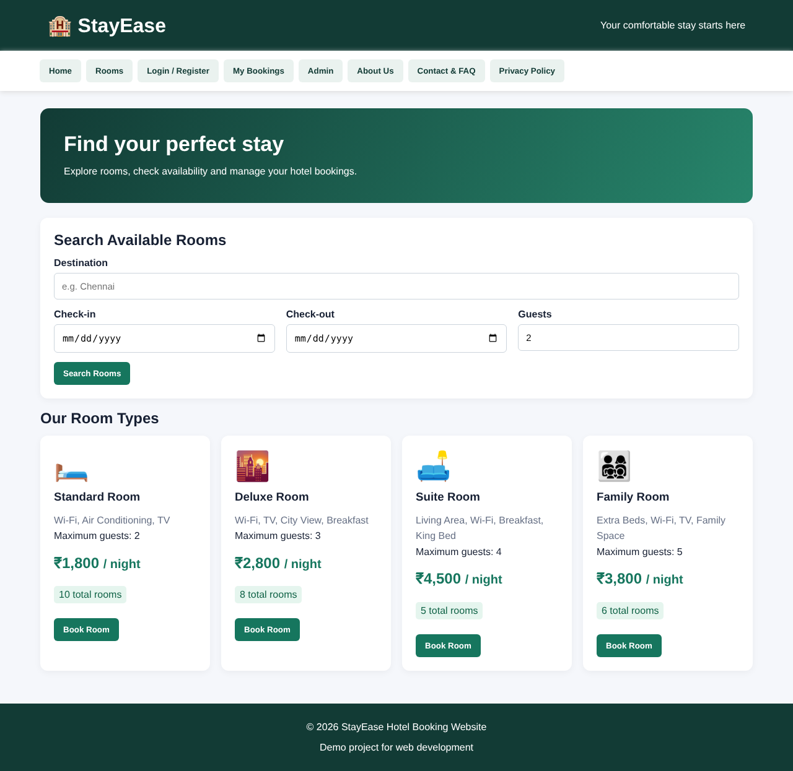
Fig. Home page (dashboard) of the website
Result
The hotel booking website (StayEase) was successfully developed and executed. Users can search available rooms, register, log in, book, modify and cancel reservations, while the administrator can manage room prices, inventory, bookings and website content. All data is stored in the browser's localStorage, and no real payment is processed since this is a demonstration project.

