Experiment 2: Library Management System (Smart Library)
Aim
To design and develop a web-based library management system using HTML, CSS and JavaScript that allows students to search the book catalog, view borrowing history and fines, and access study materials, while the librarian manages books, issues and returns books, and uploads study materials.
Algorithm
- Start and load the books, users, borrow records and study materials from localStorage (sample books are used on first run).
- Display the home page with statistics: total books, available copies and borrowed books.
- Allow a student to register and log in; the librarian logs in using the admin option.
- Search the catalog by title, author or category and show the availability of every book.
- When a student requests a book, check that it is available and not already issued to that student, then send the request to the librarian.
- The librarian issues the book: reduce the available count and record the issue date and a due date 14 days later.
- On return, record the return date and increase the available count. Fine = overdue days x Rs. 5.
- Display the student's borrow history and total outstanding fine; filter study materials by academic year and semester.
- Save all changes to localStorage and refresh the pages. Stop.
HTML Code (Main Part)
<nav>
<button onclick="showPage('home')">Home</button>
<button onclick="showPage('books')">Book Catalog</button>
<button onclick="showPage('student')">Student Dashboard</button>
<button onclick="showPage('materials')">Study Materials</button>
<button onclick="showPage('admin')">Admin Dashboard</button>
</nav>

<input id="searchInput" placeholder="Search books..."
oninput="renderBooks()">
<div id="bookList" class="book-grid"></div>

<script>
function renderBooks(){
let s=document.getElementById("searchInput").value.toLowerCase();
let filtered=books.filter(b=>
(b.title+" "+b.author+" "+b.category).toLowerCase().includes(s));
// show each book with Available: x / y
}
function issueBook(event){
let due=new Date(); due.setDate(due.getDate()+14);
records.push({id:Date.now(),email,bookId,
issueDate:formatDate(new Date()),
dueDate:formatDate(due),returnDate:""});
book.available--; saveData();
}
function calculateFine(record){
let days=Math.max(0,Math.floor((endDate-dueDate)/86400000));
return days*5; // Rs. 5 per overdue day
}
</script>
Output
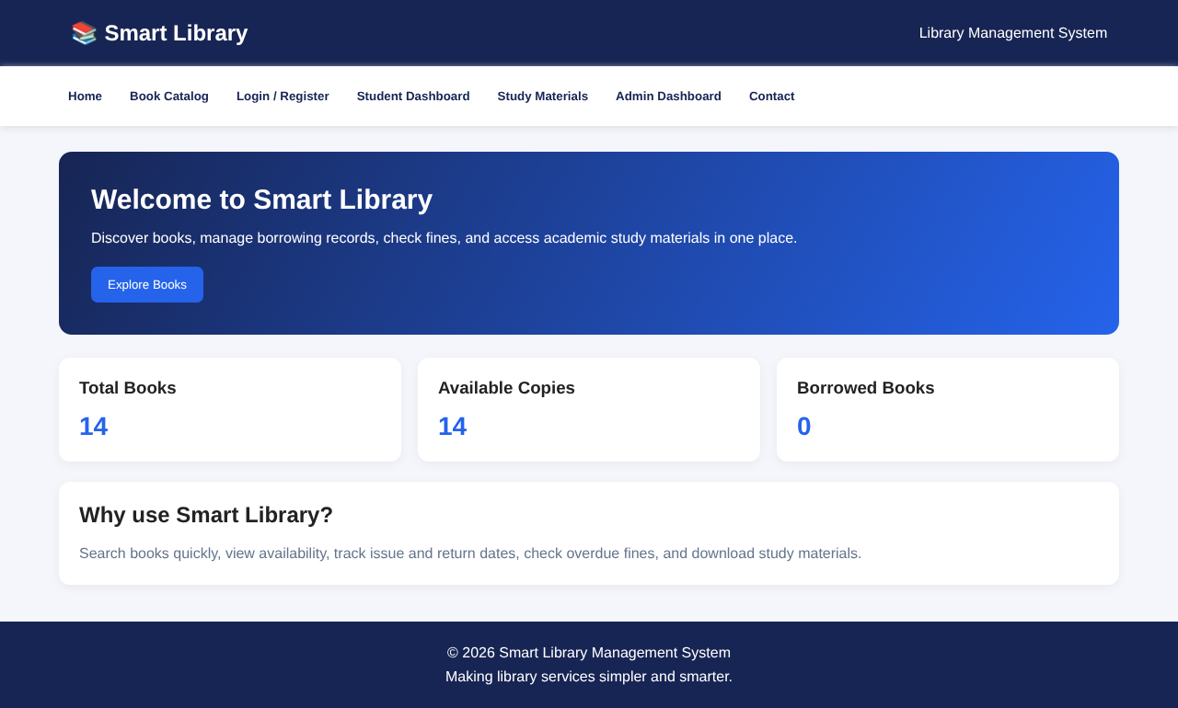
Fig. Home page (dashboard) of the website
Result
The Smart Library management system was successfully developed and executed. Students can search books, view their borrowing history, outstanding fines and study materials, and the librarian can add, edit and delete books, issue and return books, and add study materials. Fines are calculated automatically at Rs. 5 per overdue day, and the data is stored in the browser's localStorage.

