Experiment 3: Flight Reservation System (SkyBook)
Aim
To design and develop a flight reservation website using HTML, CSS and JavaScript that allows users to search flights, select cabin class and seats, book and cancel demo tickets, print e-tickets and check booking status, with an admin panel to manage flights, reservations, refunds and reports.
Algorithm
- Start and load flights, users, bookings and feedback from localStorage (four sample flights are used on first run).
- Accept origin, destination, travel date, cabin class and number of passengers; reject the same origin and destination or a past date.
- Show the matching flights with the fare for the chosen cabin (Economy x1, Business x2.2, First Class x3.8) and the seats still available.
- After login, the user selects a flight and picks one seat for each passenger from the seat grid; booked seats are disabled.
- Enter the passenger details, re-check that the seats are still free, and generate a booking reference (SKY + digits) with status "Confirmed".
- Show the e-ticket in My Tickets with an option to print; the status of any booking can be checked using its reference.
- On cancellation, set the status to "Cancelled" and calculate an 80% refund that the admin approves.
- The admin adds, edits and deletes flights, manages reservations and downloads a CSV report. Stop.
HTML Code (Main Part)
<nav>
<button onclick="show('flights')">Search Flights</button>
<button onclick="show('mytickets')">My Tickets</button>
<button onclick="show('status')">Booking Status</button>
<button onclick="show('admin')">Admin Panel</button>
</nav>

<form onsubmit="searchFlights(event)">
<input id="origin" required>
<input id="destination" required>
<input id="flightDate" type="date" required>
<select id="searchClass">...</select>
<input id="passengers" type="number" min="1" max="6" value="1">
<button class="primary">Search Flights</button>
</form>

<script>
const classes={"Economy":1,"Business":2.2,"First Class":3.8};
function fare(f,c){return Math.round(f.fare*classes[c]);}

function bookFlight(e){
let ref="SKY"+Date.now().toString().slice(-9);
bookings.push({ref,passenger,flightId:f.id,date:search.date,
cabin:c,seats:[...selectedSeats],
fare:fare(f,c)*selectedSeats.length,status:"Confirmed"});
save();
}
function cancelFlight(ref){
b.status="Cancelled";
b.refund=Math.round(b.fare*.8); // 80% refund
}
</script>
Output
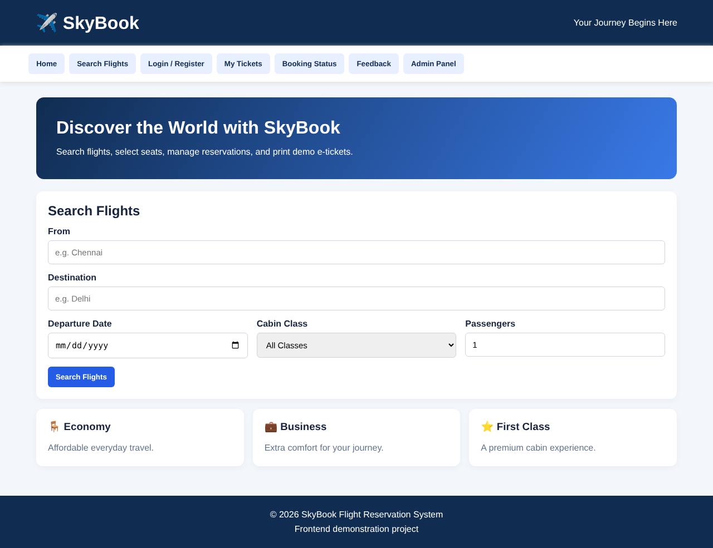
Fig. Home page (dashboard) of the website
Result
The SkyBook flight reservation website was developed and its pages were executed. The interface supports flight search, cabin class fares, seat selection, demo booking, cancellation with refund calculation, e-ticket printing, booking status check, feedback and an admin panel with a CSV report. No real payment is processed.

