Experiment 4: Bus Ticket Booking System (EasyBus)
Aim
To design and develop an online bus ticket booking website using HTML, CSS and JavaScript that allows users to search buses by route, date and category, select seats, book and cancel tickets, post comments and read travel news, with an admin panel to manage buses, users, reports and news.
Algorithm
- Start and load buses, users, bookings, comments and news from localStorage (four sample buses are used on first run).
- Accept the departure city, destination, journey date and bus category; reject identical cities or a past date.
- Filter and display the buses that match the route and category with the available seats (capacity minus booked seats) and the fare.
- After login, the user selects a bus and picks seats from the seat grid; booked seats are disabled.
- Enter the passenger name, age and e-mail; re-check that the chosen seats are still free.
- Calculate the total (number of seats x fare), save the booking as "Confirmed" and show it in My Bookings.
- Allow the user to cancel a ticket and to post a rating and comment for a bus.
- The admin adds, edits and deletes buses, views registered users and the booking report (CSV), and publishes travel news. Stop.
HTML Code (Main Part)
<nav>
<button onclick="show('buses')">Available Buses</button>
<button onclick="show('mybookings')">My Bookings</button>
<button onclick="show('comments')">Comments</button>
<button onclick="show('news')">Travel News</button>
<button onclick="show('admin')">Admin Panel</button>
</nav>

<form onsubmit="searchBuses(event)">
<input id="from" required>
<input id="to" required>
<input id="journeyDate" type="date" required>
<select id="categoryFilter">Volvo AC, Sleeper, Seater, Non-AC</select>
<button class="primary">Search Buses</button>
</form>

<script>
function seatsBooked(busId){
return bookings.filter(b=>b.busId===busId &&
b.status==="Confirmed").flatMap(b=>b.seats);
}
function confirmBooking(e){
bookings.push({id:Date.now(),email:currentUser.email,
busId:bus.id,seats:[...selectedSeats],
total:selectedSeats.length*bus.price,status:"Confirmed"});
save(); show("mybookings");
}
function cancelTicket(id){ b.status="Cancelled"; save(); }
</script>
Output
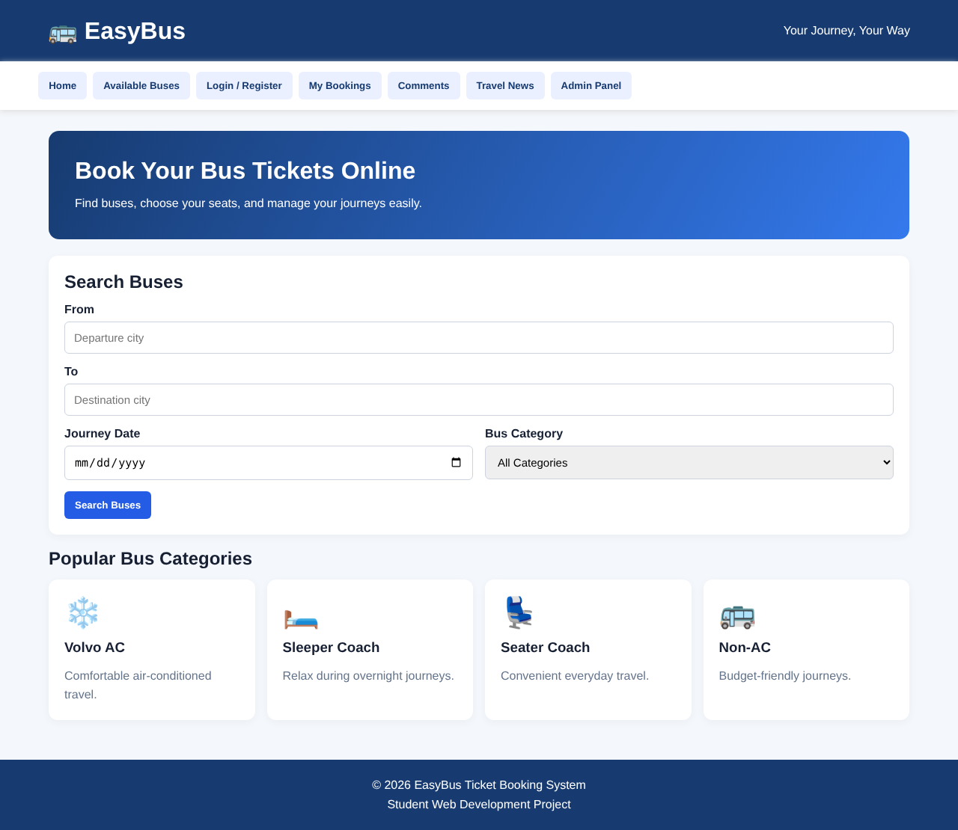
Fig. Home page (dashboard) of the website
Result
The EasyBus ticket booking website was successfully developed and executed. Users can search buses by route and category, select seats, book and cancel tickets, post comments and read travel news, and the administrator can manage buses, view users, download the booking report and publish news. All data is stored in the browser's localStorage, and no real payment is processed.

