Experiment 5: Train Reservation System (RailConnect)
Aim
To design and develop a train reservation website using HTML, CSS and JavaScript that allows passengers to search trains, choose a travel class, book and cancel tickets, print e-tickets and check PNR status, with an admin panel to manage trains, reservations, refunds and reports.
Algorithm
- Start and load trains, users and bookings from localStorage (four sample trains are used on first run).
- Accept the origin, destination, journey date and travel class; reject identical stations or a past date.
- Show the matching trains with the class fare (Sleeper x1, AC 3 Tier x1.8, AC 2 Tier x2.6, AC First Class x4) and the demo seat availability.
- After login, the passenger selects a train and enters name, age, gender, class and payment method (demo).
- Check that seats are available in the class, generate a 10-digit PNR and save the ticket with status "Confirmed".
- Show the e-ticket in My Tickets with an option to print; the status of a ticket is checked using its PNR.
- On cancellation, set the status to "Cancelled" and calculate an 80% refund that the admin approves.
- The admin adds, edits and deletes trains, manages reservations and downloads a CSV report. Stop.
HTML Code (Main Part)
<nav>
<button onclick="show('trains')">Search Trains</button>
<button onclick="show('mytickets')">My Tickets</button>
<button onclick="show('pnr')">Check PNR</button>
<button onclick="show('admin')">Admin Panel</button>
</nav>

<form onsubmit="searchTrains(event)">
<input id="origin" required>
<input id="destination" required>
<input id="journeyDate" type="date" required>
<select id="searchClass">Sleeper, AC 3 Tier, AC 2 Tier, AC First Class</select>
<button class="primary">Search Trains</button>
</form>

<script>
const multipliers={"Sleeper":1,"AC 3 Tier":1.8,
"AC 2 Tier":2.6,"AC First Class":4};
function fare(t,c){return Math.round(t.fare*multipliers[c]);}

function bookTicket(e){
let pnr=String(Date.now()).slice(-10);
bookings.push({pnr,passenger,trainId:t.id,date:search.date,
travelClass:c,fare:fare(t,c),status:"Confirmed"});
save();
}
function cancelBooking(pnr){
b.status="Cancelled";
b.refund=Math.round(b.fare*0.8); // 80% refund
}
</script>
Output
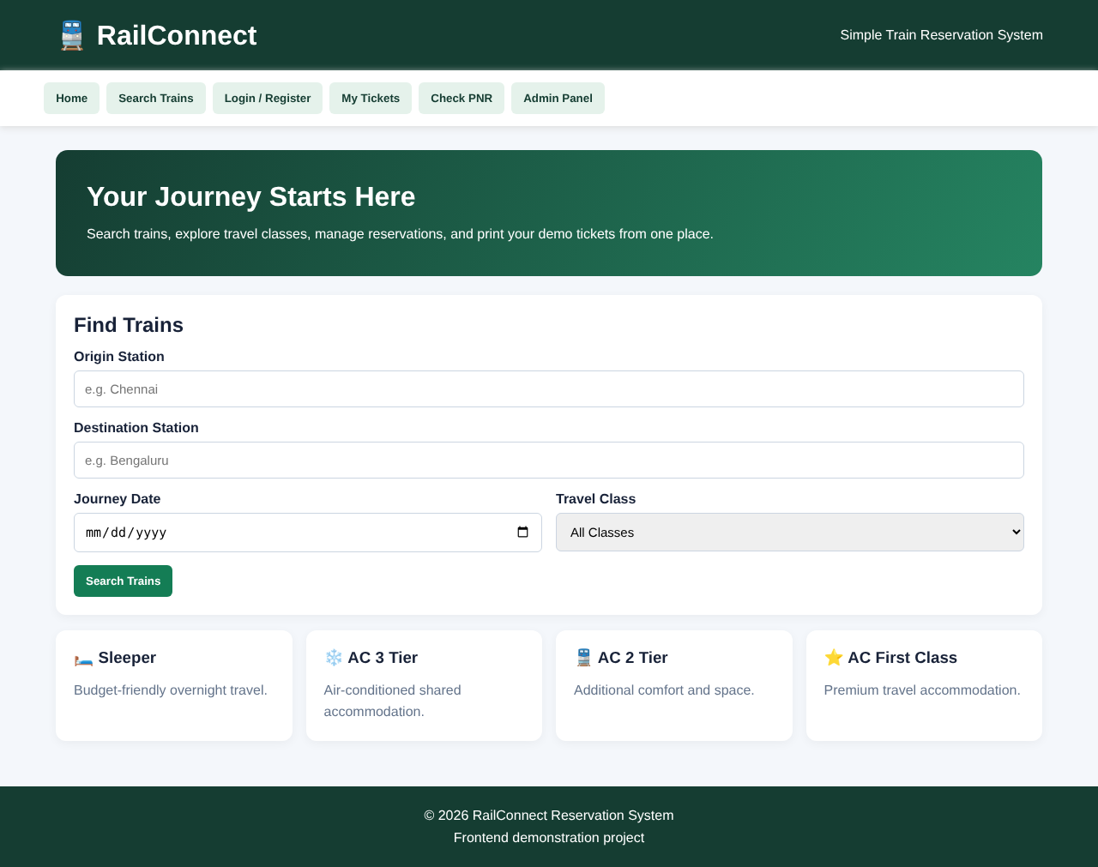
Fig. Home page (dashboard) of the website
Result
The RailConnect train reservation website was successfully developed and executed. Passengers can search trains, choose a travel class, book and cancel tickets, print e-tickets and check PNR status, and the administrator can manage trains, reservations, refunds and reports. All data is stored in the browser's localStorage, and no real payment is processed.

