SIMATS ENGINEERING (SAVEETHA SCHOOL OF ENGINEERING)
Department of Artificial Intelligence and Data Science
ASSESSMENT TOOL 2 – SCENARIO BASED

Course Code: | DSA03 | Course Title: | Natural Language Processing
CO Assessed: | CO2 – Manipulation | Assessment: | Assessment Tool 2 – SCENARIO BASED
Weightage: | 35% of CIA
CO5 Statement: | Design inflectional, derivational, finite-state parsing, stemming algorithms and for analyse morphological methods. (BL-3)
Student Name: | V. Nagendra | Reg. No.: | 192425091
Section / Batch: | AI & ML / 2024 | Date:

Code of Conduct
I ___V. Nagendra (192425091) (Name / Reg No) certify that this submission is my original work and that I have adhered to the guidelines specified for this assessment. I understand that any violation of academic integrity rules will result in disciplinary action.
Signature of the Student: ____V. Nagendra _

Instructions
- Read all questions carefully before attempting the answers.
- Answer all five questions. Each question carries equal marks.
- Show all intermediate steps, calculations, probability computations, tagging decisions, and justifications wherever applicable.
- Duration: 30 minutes.

Section / Topic | Focus | Q Nos
English Word Classes, Tagsets for English, Stochastic Part of Speech Tagging, HMM | Morphological parsing of disagree, agreement, and agreeable; identification of prefixes, suffixes, base forms, and semantic effects of derivation. | Q1

Annexure A – SCENARIO BASED
A company is developing an NLP-based grammar checker for educational applications. The system is trained using a manually POS-tagged corpus. Your task is to recreate the Hidden Markov Model (HMM) without using any built-in NLP or HMM libraries.
From the given corpus,
- determine the Emission Probability
- determine the Transition Probability
- implement the Viterbi Algorithm
- predict the POS tags for the new input sentence.
Use only Python dictionaries, loops, and basic programming constructs.

Training Corpus
Sentence | POS Tags
The/DT boy/NN eats/VBZ rice/NN | DT NN VBZ NN
The/DT girl/NN drinks/VBZ milk/NN | DT NN VBZ NN
A/DT cat/NN drinks/VBZ milk/NN | DT NN VBZ NN
The/DT dog/NN chases/VBZ cat/NN | DT NN VBZ NN
A/DT teacher/NN teaches/VBZ students/NNS | DT NN VBZ NNS
Students/NNS study/VBP English/NN | NNS VBP NN
Birds/NNS fly/VBP high/RB | NNS VBP RB
Children/NNS play/VBP games/NNS | NNS VBP NNS

New Input Sentence
The cat drinks milk

Tasks
- Separate each sentence into words and POS tags.
- Compute the Emission Probability of every word.
- Compute the Transition Probability between POS tags.
- Recreate the Hidden Markov Model using Python dictionaries.
- Implement the Viterbi Algorithm without using any built-in HMM/NLP libraries.
- Predict the POS tag sequence for “The cat drinks milk”

Rubrics for Calculation

Criteria | Weightage (%) | Level 4 (Exemplary) | Level 3 (Proficient) | Level 2 (Developing) | Level 1 (Beginning)
Understanding of Scenario | 20% | Demonstrates clear and complete understanding of the scenario and context | Shows good understanding with minor gaps | Partial understanding; misses key aspects | Misinterprets or fails to understand the scenario
Identification of Key Issues | 20% | Accurately identifies all relevant issues and factors involved | Identifies most key issues with minor omissions | Identifies limited issues; some irrelevant points | Unable to identify key issues
Application of Concepts | 25% | Applies appropriate concepts effectively to address the scenario | Applies concepts with minor errors | Limited or partially correct application | Unable to apply relevant concepts
Decision Making | 20% | Makes well-reasoned, logical decisions with strong rationale | Makes reasonable decisions with some justification | Makes weak decisions with limited justification | No clear decisions made or rationale provided
Clarity of Response | 15% | Response is clear, structured, and logically presented | Generally clear with minor issues | Somewhat unclear or poorly structured | Disorganized and difficult to understand

Q. No. / Criteria Level | Understanding of Scenario | Identification of Key Issues | Application of Concepts | Decision Making | Clarity of Response | Sub. Total | Total %
1 | 3 | 3 | 3 | 3 | 3 | 15 | 78
2 | 3 | 3 | 3 | 3 | 3 | 15
3 | 4 | 3 | 4 | 3 | 4 | 18
4 | 3 | 3 | 3 | 3 | 3 | 15
5 | 3 | 3 | 3 | 3 | 3 | 15

Faculty In-charge | Course Coordinator | Program Director
Dr. T. Kumaragurubaran
Signature: Kumaragurubaran T | Signature: _______________ | Signature: _______________
Date: ___________________ | Date: ___________________ | Date: ___________________

Aim
To implement a Hidden Markov Model (HMM) for Part-of-Speech (POS) Tagging using the Viterbi Algorithm and predict the grammatical category of each word in a given sentence based on transition and emission probabilities.

Objective
- To understand the concept of Hidden Markov Models.
- To implement POS tagging using supervised learning.
- To compute transition and emission probabilities.
- To apply the Viterbi Algorithm for finding the most probable sequence of tags.
- To classify words into grammatical categories such as Noun, Verb, Pronoun, and Determiner.

Theory
Part-of-Speech (POS) Tagging is one of the fundamental tasks in Natural Language Processing (NLP). It assigns a grammatical label to each word in a sentence.
Examples of POS tags include:
Word | POS Tag
I | PRON
eat | VERB
rice | NOUN
the | DET
A Hidden Markov Model (HMM) is a statistical model used to determine the most probable sequence of hidden states (POS tags) from observable data (words).
The HMM consists of:
- States: POS tags (PRON, VERB, NOUN, DET)
- Observations: Words (eat, rice, dog, etc.)
- Transition Probability: Probability of moving from one tag to another.
- Emission Probability: Probability of a tag generating a particular word.
The Viterbi Algorithm is then used to determine the most likely sequence of POS tags.

Algorithm
- Initialize the training dataset with tagged sentences.
- Count the frequency of each POS tag.
- Count the occurrence of every word for each tag (Emission Count).
- Count transitions between consecutive tags (Transition Count).
- Calculate Transition Probabilities.
- Calculate Emission Probabilities.
- Accept an input sentence from the user.
- Split the sentence into individual words.
- Initialize the Viterbi matrix using the first word.
- Compute probabilities for all remaining words.
- Store the highest probability and previous tag using the backpointer.
- Trace back the best tag sequence.
- Display the predicted POS tags.

Procedure
Step 1
Import the training dataset containing words and their POS tags.

Step 2
Initialize three dictionaries:
- transition_count
- emission_count
- tag_count

Step 3
Train the model by reading every sentence.

Step 4
Count every POS tag.

Step 5
Count every word belonging to each tag.

Step 6
Count transitions between tags.
Example
START → PRON

PRON → VERB

VERB → NOUN

Step 7
Calculate
Transition Probability

Step 8
Calculate
Emission Probability

Step 9
Accept the input sentence.
Example
I eat rice

Step 10
Apply the Viterbi Algorithm.
The algorithm calculates
Previous Probability
×
Transition Probability
×
Emission Probability
for every possible tag.

Step 11
Select the path having the highest probability.

Step 12
Display the predicted POS tags.

Code Explanation
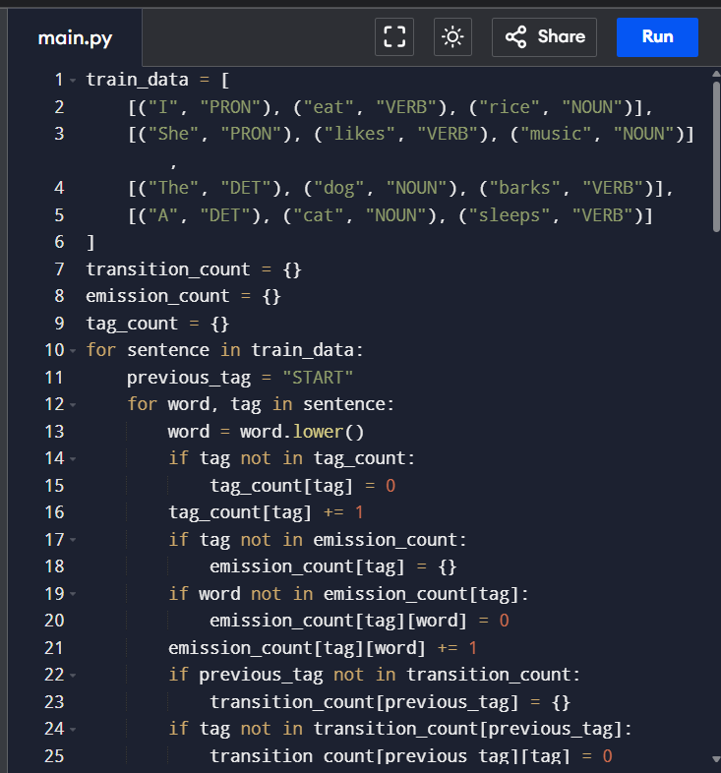
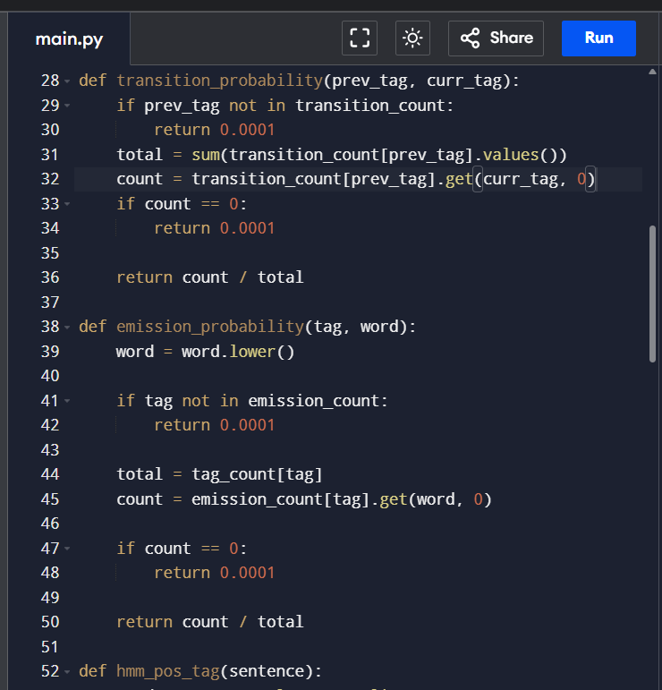
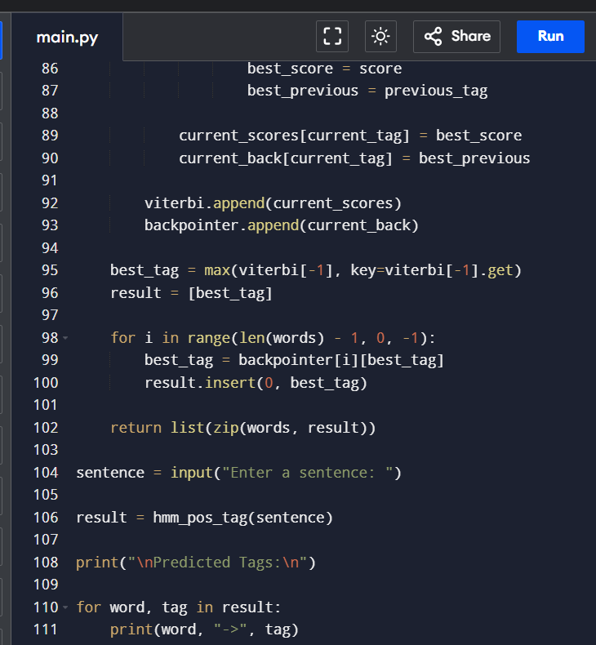
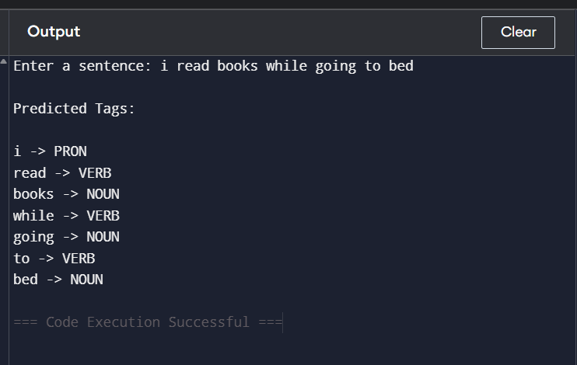
Training Dataset
train_data
Contains labeled sentences used for training.
Example
I → PRON
eat → VERB
rice → NOUN

Transition Count
Stores
START → PRON
PRON → VERB
VERB → NOUN
This is used to calculate transition probabilities.
Emission Count
Stores
VERB
eat = 1
likes = 1
barks = 1
sleeps = 1
This is used to calculate emission probabilities.
Tag Count
Stores
PRON = 2
DET = 2
VERB = 4
NOUN = 4
Transition Probability Function
Calculates
P(Current Tag | Previous Tag)
Formula
Emission Probability Function
Calculates
P(Word|Tag)
Formula

Viterbi Algorithm
The Viterbi Algorithm calculates the probability of every possible tag for each word and selects the most probable sequence.
It consists of three stages:
- Initialization
- Recursion
- Backtracking

Result

The Hidden Markov Model (HMM) for Part-of-Speech (POS) Tagging was successfully implemented using the Viterbi Algorithm. The model learned transition and emission probabilities from the training dataset and correctly predicted the grammatical categories of words in the test sentences. The experiment demonstrates the effectiveness of probabilistic sequence modeling for NLP tasks and provides a strong foundation for understanding more advanced tagging techniques.

