SIMATS ENGINEERING
ASSESSMENT TOOL 3
ANALYTICAL PROBLEM-SOLVING ASSESSMENT
Course Code | MLA03
Course Name | Reinforcement Learning for Environment and Agent
Course Outcome | CO5: Implement policy-based reinforcement learning methods to develop efficient solutions for complex environments. (BL2, BL3, BL6)
Assessment Tool Weightage | 30%
Faculty | Dr. DUMPALA PRASANTH
Student Name | V. Nagendra
Register Number | 192425091
Questions: 10 | Total Marks: 50 | Duration: 1 Hour

1. Warehouse Robot – Dynamic Programming and Value Iteration

Scenario Understanding
A warehouse robot needs to move goods from a starting location to a destination while avoiding shelves and obstacles. The problem can be represented as a finite Markov Decision Process. Each grid cell is a state, movement directions are actions, and the reward encourages progress while penalizing collisions and unnecessary movement.

Analytical Solution
Use Dynamic Programming through Value Iteration. Initialize V(s), then repeatedly apply the Bellman optimality equation: V(s)=max_a Σ P(s'|s,a)[R(s,a,s')+γV(s')]. After convergence, choose the action with the highest expected value at every state. Obstacles are blocked states or transitions.
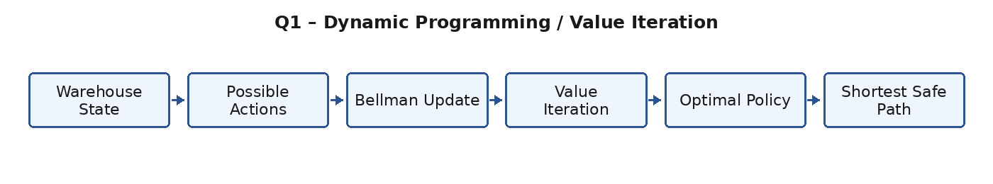
Figure 1.1: Analytical solution workflow.

Expected Output
The expected output is a stable policy that chooses a short, collision-free route. The illustrative graph shows average path length decreasing as value iteration progresses.
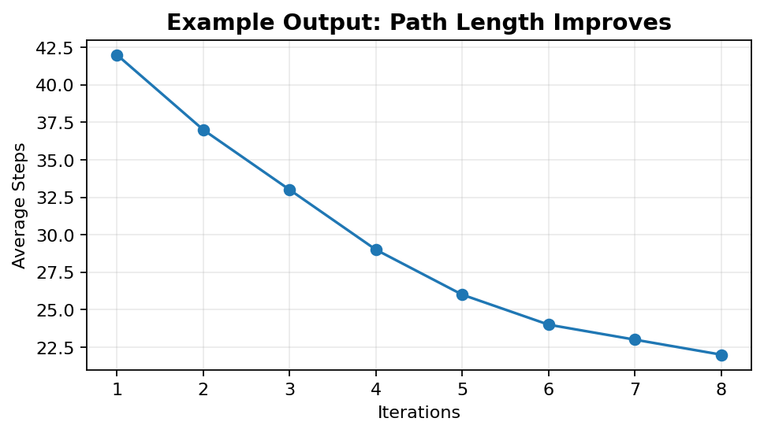
Figure 1.2: Example output/result visualization.

Result Analysis
Value iteration is appropriate because the warehouse model is small and structured. It provides an optimal policy when the transition and reward model are known.

Key Evaluation Points
• Correct identification of the RL problem and its states, actions and rewards.
• Correct application of the selected algorithm or analytical method.
• Logical interpretation of the expected output and performance.
• Consideration of limitations, safety, fairness or ethical issues where relevant.

2. Recommendation System – Monte Carlo Control

Scenario Understanding
Customer interactions across multiple sessions can be treated as episodes. A state can contain recent clicks, viewed categories and user context. Actions are candidate recommendations, while rewards can represent clicks, useful consumption, satisfaction or retention.

Analytical Solution
Use Monte Carlo Control by allowing an episode to complete and calculating the return Gt for visited state-action pairs. Update Q(s,a) toward the observed return and improve the policy using an ε-greedy strategy. Repeated sessions provide experience for better recommendations.
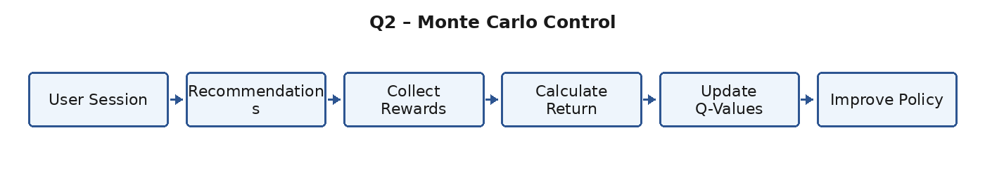
Figure 2.1: Analytical solution workflow.

Expected Output
The expected output is an increase in average return over sessions. The example graph illustrates learning from accumulated customer experience.
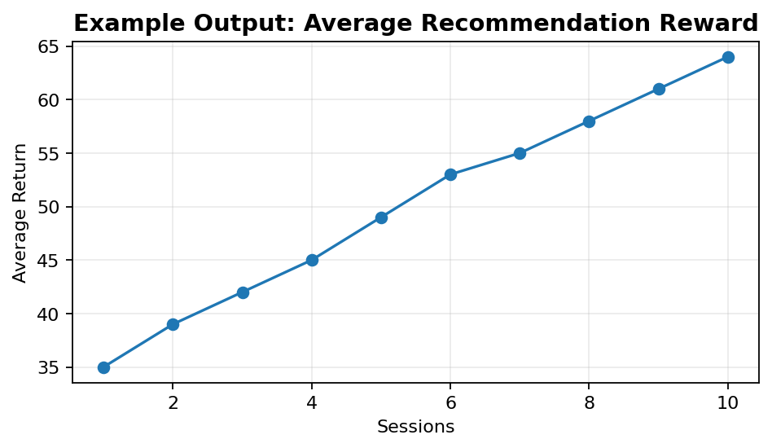
Figure 2.2: Example output/result visualization.

Result Analysis
Monte Carlo Control is useful when the outcome of a recommendation can be evaluated after a session. Its limitation is that updates wait until an episode or session provides a return.

Key Evaluation Points
• Correct identification of the RL problem and its states, actions and rewards.
• Correct application of the selected algorithm or analytical method.
• Logical interpretation of the expected output and performance.
• Consideration of limitations, safety, fairness or ethical issues where relevant.

3. Delivery Robot – SARSA

Scenario Understanding
The robot operates in an uncertain environment where obstacles or travel costs may change. States include position, nearby obstacles, battery and destination. Actions are movements, and rewards encourage safe progress and successful delivery.

Analytical Solution
SARSA updates its action-value function using the action actually chosen by the current policy: Q(s,a)←Q(s,a)+α[r+γQ(s',a')−Q(s,a)]. Because SARSA is on-policy, it learns the consequences of the behavior policy, including exploration.
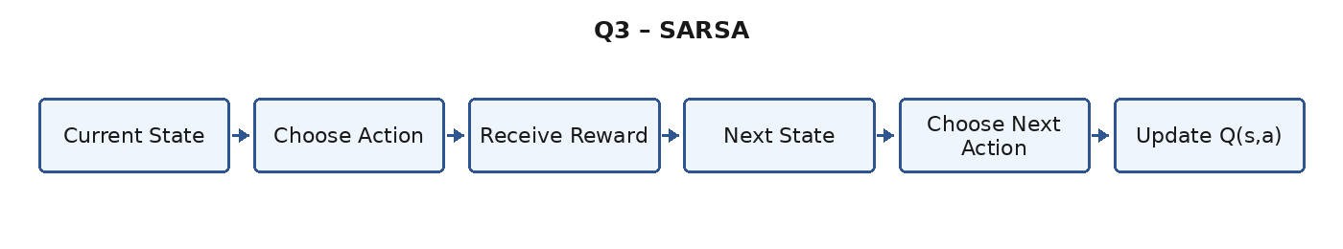
Figure 3.1: Analytical solution workflow.

Expected Output
The example output shows success improving over episodes, with a temporary change when the environment changes. The policy can adapt by learning new action values.
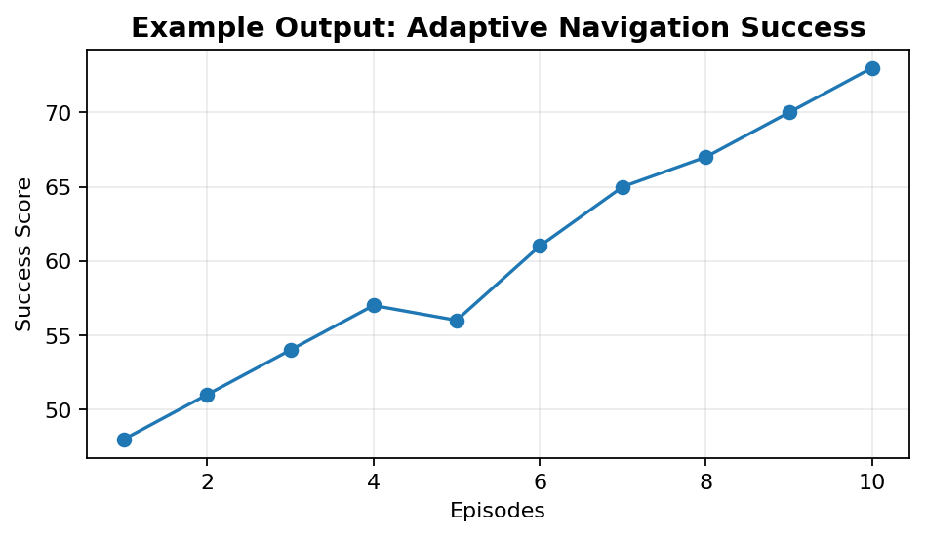
Figure 3.2: Example output/result visualization.

Result Analysis
SARSA is suitable when the behavior during learning should influence the learned policy, especially when exploration has safety or cost implications.

Key Evaluation Points
• Correct identification of the RL problem and its states, actions and rewards.
• Correct application of the selected algorithm or analytical method.
• Logical interpretation of the expected output and performance.
• Consideration of limitations, safety, fairness or ethical issues where relevant.

4. Robotic Arm – REINFORCE

Scenario Understanding
A robotic arm performs continuous object manipulation. The state includes joint positions, velocities and object position. The policy produces actions or action distributions, and the reward reflects task completion, precision and safety.

Analytical Solution
REINFORCE is a Monte Carlo policy-gradient method. For a trajectory, calculate return Gt and update θ using θ←θ+α∇θ logπθ(at|st)Gt. A baseline can reduce variance. Action limits and safety constraints should be enforced.
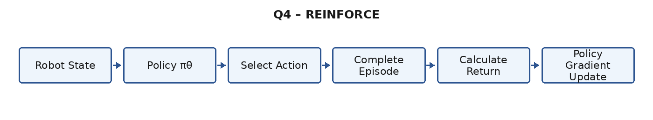
Figure 4.1: Analytical solution workflow.

Expected Output
The expected output is increasing manipulation accuracy as successful trajectories receive stronger reinforcement.
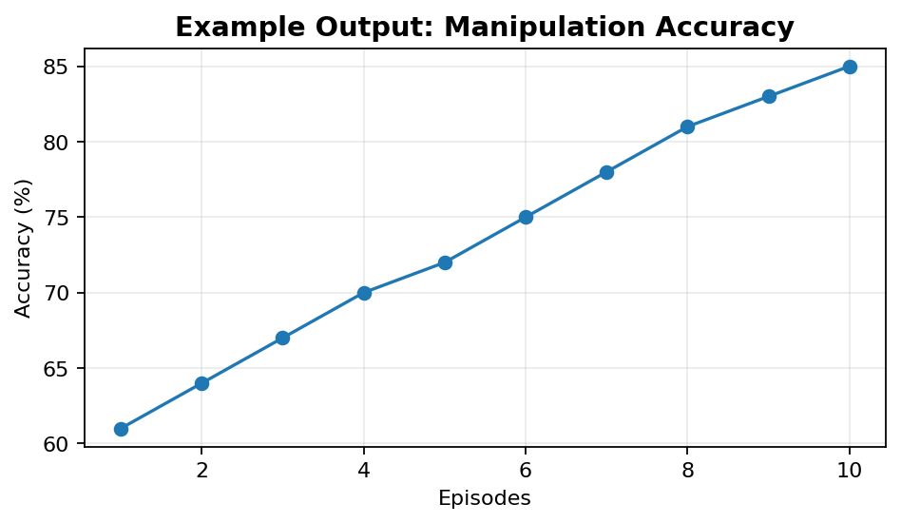
Figure 4.2: Example output/result visualization.

Result Analysis
REINFORCE directly optimizes the policy and can handle stochastic policies, but it can have high gradient variance and may require many episodes.

Key Evaluation Points
• Correct identification of the RL problem and its states, actions and rewards.
• Correct application of the selected algorithm or analytical method.
• Logical interpretation of the expected output and performance.
• Consideration of limitations, safety, fairness or ethical issues where relevant.

5. Autonomous Vehicle – Q-Learning vs DQN

Scenario Understanding
Q-Learning stores Q-values in a table and is effective for small discrete state spaces. Autonomous driving has high-dimensional sensor states, making a table impractical.

Analytical Solution
DQN replaces the Q-table with a neural network and uses experience replay and a target network for more stable learning. Compare both methods using convergence, training time, success rate, collisions and scalability.
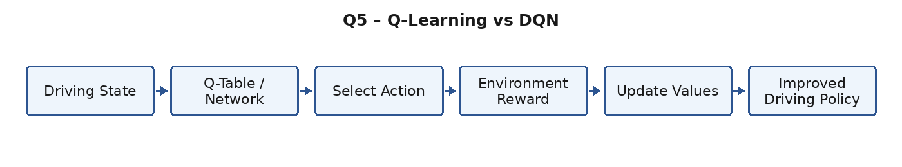
Figure 5.1: Analytical solution workflow.

Expected Output
The illustrative output shows DQN achieving a higher success rate in a complex state space. Actual performance depends on architecture, data and training settings.
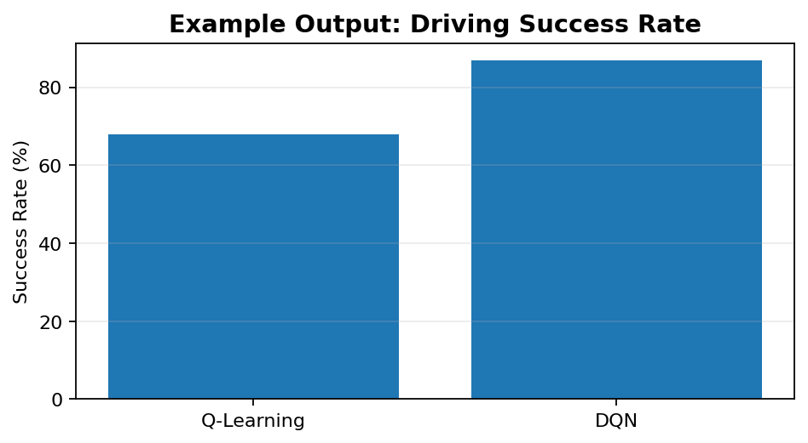
Figure 5.2: Example output/result visualization.

Result Analysis
DQN is generally more scalable for complex driving environments, while tabular Q-Learning remains useful for small simplified simulations.

Key Evaluation Points
• Correct identification of the RL problem and its states, actions and rewards.
• Correct application of the selected algorithm or analytical method.
• Logical interpretation of the expected output and performance.
• Consideration of limitations, safety, fairness or ethical issues where relevant.

6. Game AI – DQN, DDQN and Dueling DQN

Scenario Understanding
Standard DQN can overestimate action values because action selection and evaluation are coupled. This can make learning unstable or less accurate.

Analytical Solution
DDQN uses the online network to select the best action and the target network to evaluate that action, reducing overestimation bias. Dueling DQN separates state value V(s) from action advantage A(s,a), improving representation when many actions have similar value.
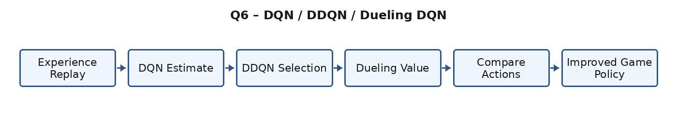
Figure 6.1: Analytical solution workflow.

Expected Output
The example output shows higher average game scores for DDQN and Dueling DQN compared with standard DQN.
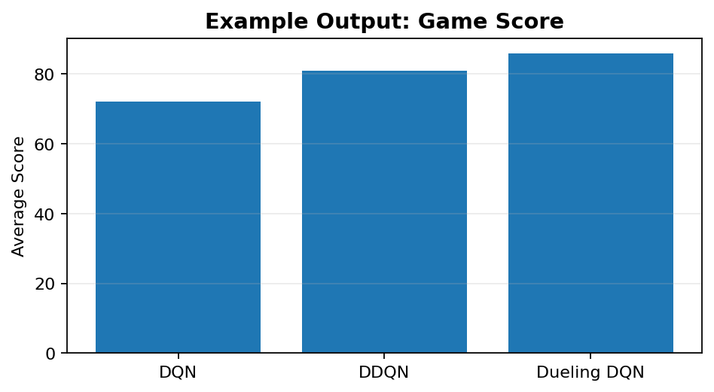
Figure 6.2: Example output/result visualization.

Result Analysis
Both architectures improve standard DQN in different ways: DDQN mainly addresses overestimation, while Dueling DQN improves value representation.

Key Evaluation Points
• Correct identification of the RL problem and its states, actions and rewards.
• Correct application of the selected algorithm or analytical method.
• Logical interpretation of the expected output and performance.
• Consideration of limitations, safety, fairness or ethical issues where relevant.

7. Smart Drone – A2C vs A3C

Scenario Understanding
A drone navigation policy must learn from many trajectories. A2C and A3C are actor-critic methods in which the actor chooses actions and the critic estimates state value.

Analytical Solution
A2C commonly collects rollouts and performs synchronized updates. A3C uses multiple asynchronous workers that interact with separate environment copies and update shared parameters. Parallel learning can improve experience diversity and wall-clock convergence.
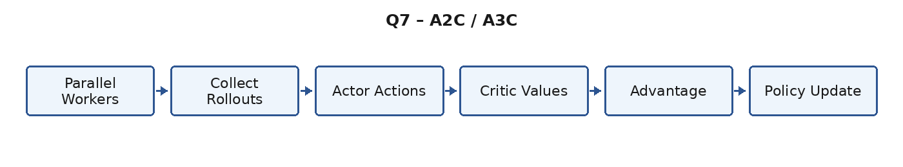
Figure 7.1: Analytical solution workflow.

Expected Output
The example output shows a lower relative training time for A3C in a parallel setting. Computational benefit depends on available CPU resources and implementation overhead.
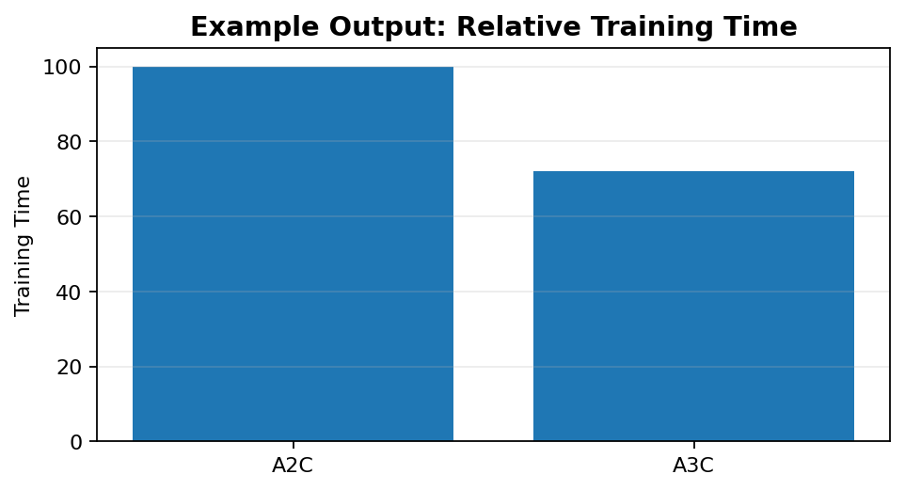
Figure 7.2: Example output/result visualization.

Result Analysis
A3C can be faster in parallel environments, while A2C is often easier to reproduce and debug because updates are synchronized.

Key Evaluation Points
• Correct identification of the RL problem and its states, actions and rewards.
• Correct application of the selected algorithm or analytical method.
• Logical interpretation of the expected output and performance.
• Consideration of limitations, safety, fairness or ethical issues where relevant.

8. Healthcare – POMDP vs MDP

Scenario Understanding
Healthcare decisions often have incomplete information. A patient’s true condition may be hidden, while the system observes symptoms, test results and vital signs with uncertainty.

Analytical Solution
A POMDP extends an MDP by introducing observations and a belief state. The belief state is a probability distribution over possible hidden states. After receiving an observation, the belief is updated and the policy chooses an action using that belief.
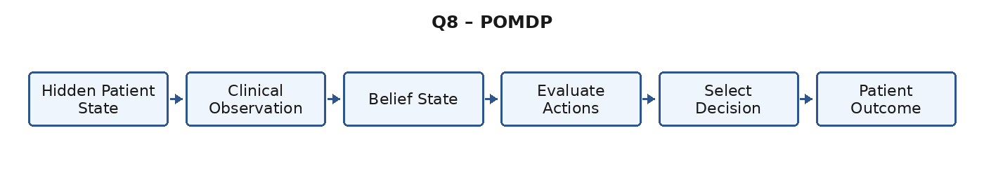
Figure 8.1: Analytical solution workflow.

Expected Output
The example output shows improved decision quality when uncertainty is explicitly represented. In real healthcare, the model must be validated clinically and used with human oversight.
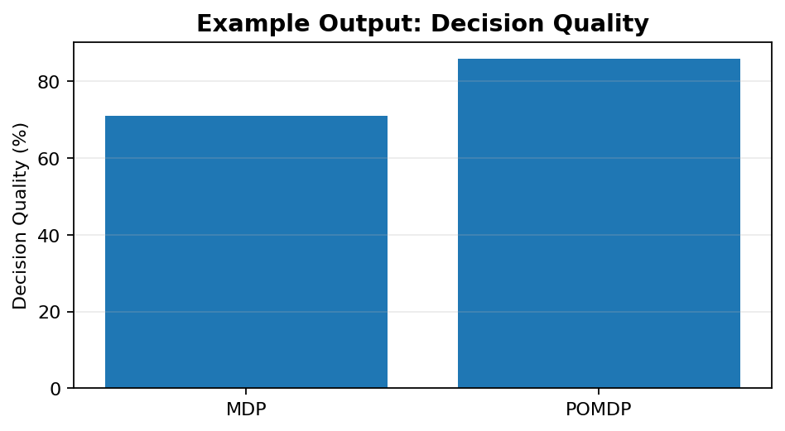
Figure 8.2: Example output/result visualization.

Result Analysis
POMDPs are more realistic than fully observable MDPs when important patient information is missing or noisy.

Key Evaluation Points
• Correct identification of the RL problem and its states, actions and rewards.
• Correct application of the selected algorithm or analytical method.
• Logical interpretation of the expected output and performance.
• Consideration of limitations, safety, fairness or ethical issues where relevant.

9. Robot Navigation – PPO, TRPO and DDPG

Scenario Understanding
Continuous robot control requires actions such as velocity, steering or joint torque. PPO, TRPO and DDPG can address continuous-control problems but have different optimization properties.

Analytical Solution
TRPO uses a trust-region constraint to make conservative policy updates. PPO uses a clipped surrogate objective and is generally simpler. DDPG is an off-policy actor-critic method using replay and deterministic actions, which can be sample-efficient but sensitive to hyperparameters.
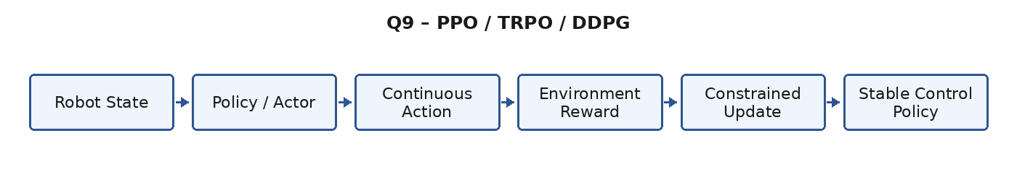
Figure 9.1: Analytical solution workflow.

Expected Output
The example output compares control performance. PPO is often a strong practical default; TRPO is useful when conservative updates are important; DDPG can be useful when replay-based sample efficiency is valuable.
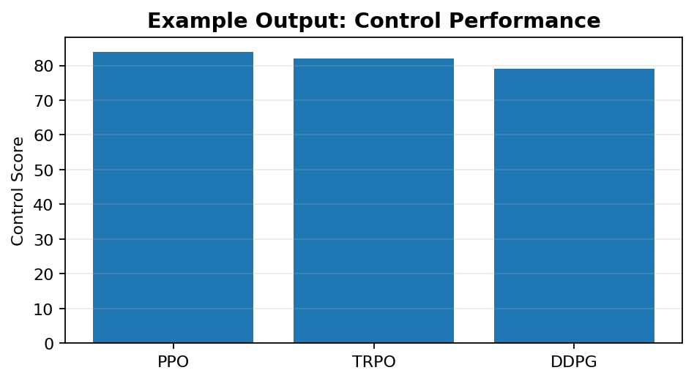
Figure 9.2: Example output/result visualization.

Result Analysis
Algorithm selection should consider stability, sample efficiency, computational cost, action space and the difficulty of exploration.

Key Evaluation Points
• Correct identification of the RL problem and its states, actions and rewards.
• Correct application of the selected algorithm or analytical method.
• Logical interpretation of the expected output and performance.
• Consideration of limitations, safety, fairness or ethical issues where relevant.
10. Smart City Traffic – MARL

Scenario Understanding
Traffic signals at multiple intersections influence each other. In Multi-Agent Reinforcement Learning, each intersection can act as an agent with observations such as queue length, waiting time and neighboring traffic.

Analytical Solution
Agents learn policies that coordinate signal phases. Shared rewards can optimize network-wide flow, while local rewards help fairness. Safety constraints should enforce pedestrian clearance, emergency priority and valid signal transitions. Scalability can be improved with parameter sharing or limited communication.
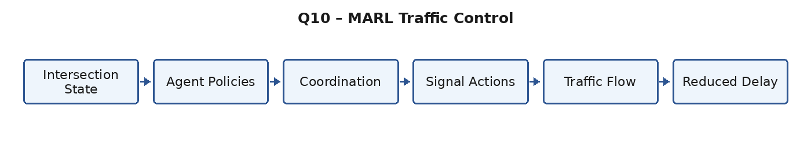
Figure 10.1: Analytical solution workflow.

Expected Output
The illustrative output shows coordinated MARL reducing average delay compared with fixed-time and independent control.
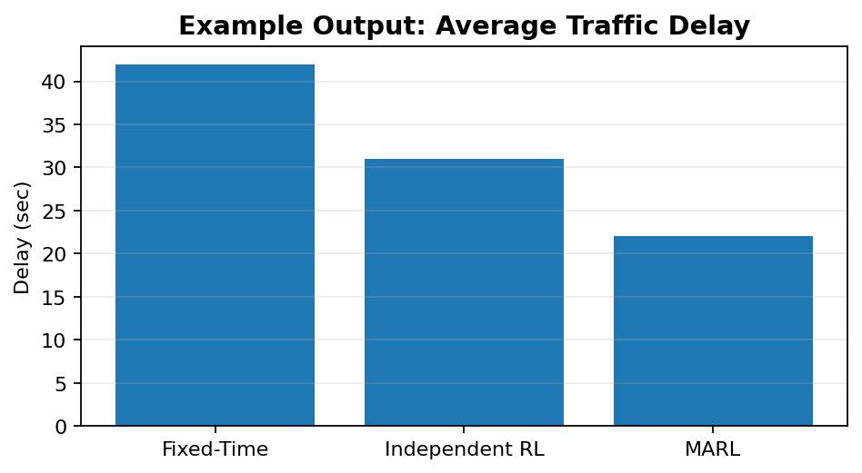
Figure 10.2: Example output/result visualization.

Result Analysis
MARL is effective for distributed traffic control, but deployment requires strong safety validation, fairness monitoring, robustness testing and human override mechanisms.

Key Evaluation Points
• Correct identification of the RL problem and its states, actions and rewards.
• Correct application of the selected algorithm or analytical method.
• Logical interpretation of the expected output and performance.
• Consideration of limitations, safety, fairness or ethical issues where relevant.
Code of Conduct
I, K. Abu hujaifa (Reg. No. 192472308), certify that this submission is my original work and that I have adhered to the guidelines specified for this assessment. I understand that any violation of academic integrity rules will result in disciplinary action.
Signature of the student: K.ABU HUJAIFA
Date: 31/08/2026

