SIMATS ENGINEERING
ASSESSMENT TOOL 1
Simulation-Based Assessment
Course Code | MLA03
Course Name | Reinforcement Learning for Environment and Agent
Course Outcome | CO5: Implement policy-based reinforcement learning methods to develop efficient solutions for complex environments. (BL2, BL3, BL6)
Student Name | V. Nagendra
Register Number | 192425091

Faculty: Dr. Dumpala Prasanth
Total Questions: 10 | Total Marks: 50 | Duration: 1 Hour

Assessment Overview
This document provides a clear, technically structured solution approach for all ten simulation-based questions. Each answer contains the objective, RL formulation, methodology, algorithm/pseudocode, implementation outline, expected output, evaluation measures, and a short conclusion. The examples are designed to be implementable in Python using common reinforcement-learning concepts such as Q-learning, policy gradients, hierarchical policies, multi-agent learning, POMDP belief states, constrained rewards, and simulation environments.

1. Hierarchical Reinforcement Learning (HRL) for Autonomous Warehouse Navigation
Objective: Build an HRL agent that navigates a warehouse while breaking a large navigation problem into smaller tasks.
Problem formulation:
State: robot position, orientation, obstacle map, target location, and battery/load information.
High-level action: select a subtask such as GO_TO_AISLE, GO_TO_SHELF, PICK_ITEM, or GO_TO_DOCK.
Low-level action: move up, down, left, right, or rotate.
Reward: positive reward for completing subtasks and reaching the final destination; negative reward for collisions, unnecessary movement, and time delay.
Method:
Use two policies. The manager selects a subgoal and the worker executes primitive movements until the subgoal is completed. This reduces the effective planning complexity because the manager reasons at a higher level while the worker handles detailed navigation.
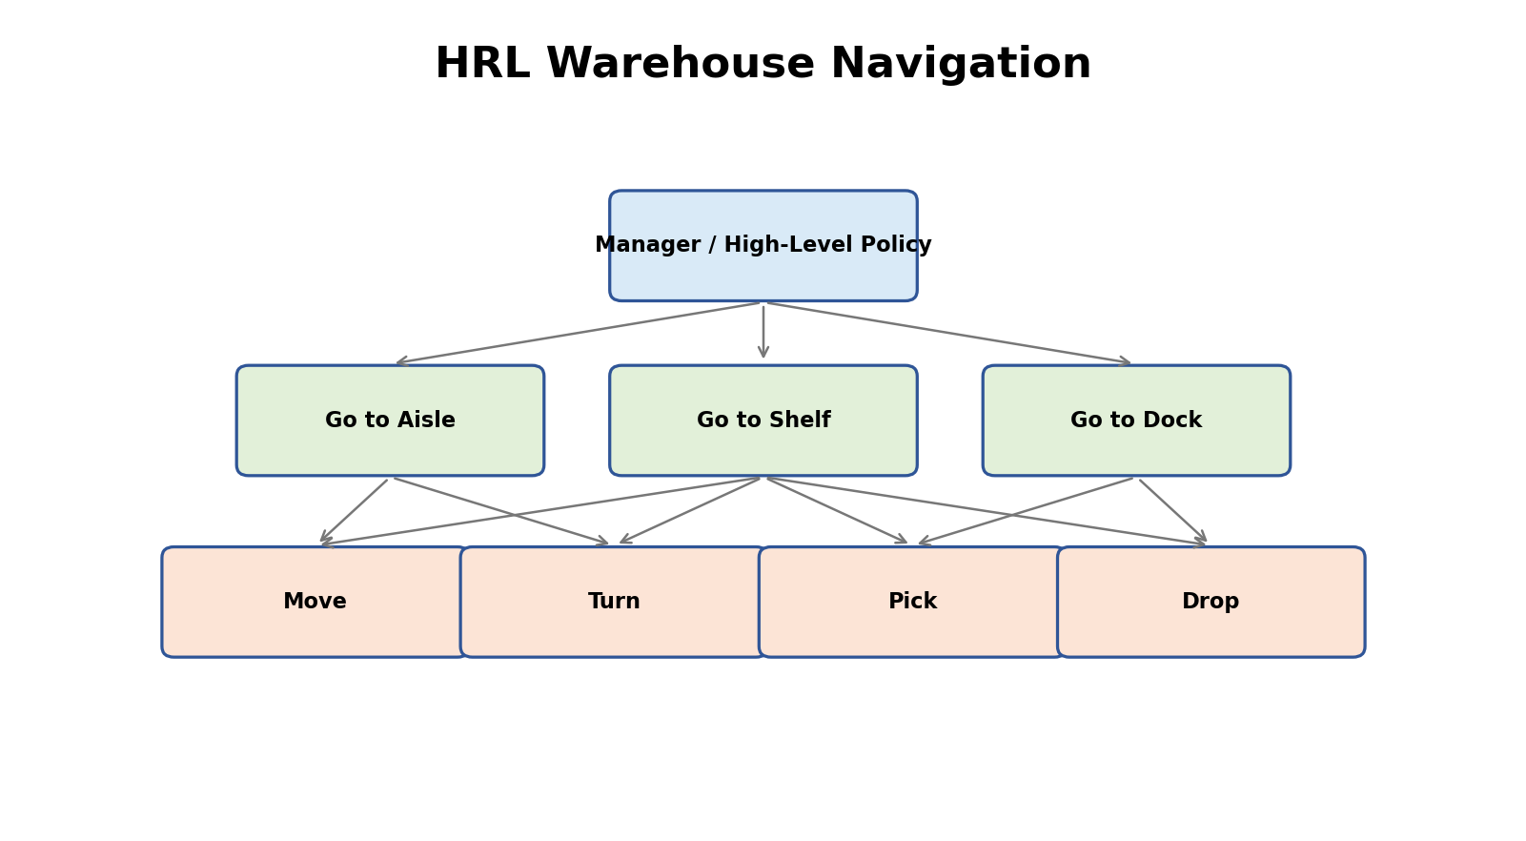
Figure 1: Visual representation of the RL simulation for Question 1.

Implementation / Simulation Steps
Pseudocode:
Initialize manager policy π_H and worker policy π_L
For each episode:
reset warehouse environment
while task is not complete:
manager observes high-level state
subgoal = π_H(state)
while subgoal is not completed:
worker observes local state
action = π_L(local_state, subgoal)
next_state, reward, done = environment.step(action)
update worker
give manager subtask reward
update manager
Evaluate success rate, collisions, travel distance and completion time.

Expected Output and Evaluation
Expected result: The hierarchical agent should learn reusable subgoals and reach warehouse destinations with fewer collisions and less search than a single flat policy. A simple grid warehouse can be used for simulation, with shelves represented as obstacles and delivery points as goals.

Suggested Python Environment
Python 3.x with NumPy, Matplotlib and a suitable RL environment framework. For custom simulations, the environment can be implemented with reset() and step(action) methods.

2. Hierarchical Abstract Machine (HAM) for Sequential Robot Tasks
Objective: Control a robot that must perform tasks in a fixed or partially constrained sequence.
HAM idea:
A Hierarchical Abstract Machine represents high-level task structure using states, task nodes, and action nodes. For example:
START → MOVE_TO_OBJECT → PICK → MOVE_TO_BIN → PLACE → END.
Problem formulation:
State contains robot position, object status, gripper status and target position.
Primitive actions are movement and gripper commands.
Reward is given for completing valid steps and penalizes collisions, invalid transitions and unnecessary actions.
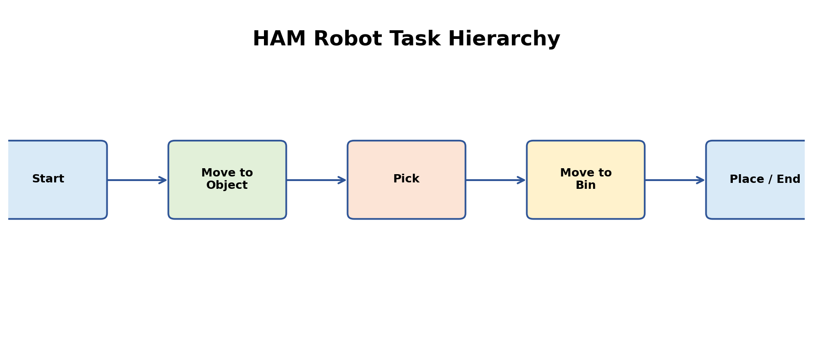
Figure 2: Visual representation of the RL simulation for Question 2.

Implementation / Simulation Steps
Implementation outline:
1. Define a task hierarchy as a state machine.
2. Create abstract states for each task.
3. Define legal transitions.
4. Attach primitive robot actions to action nodes.
5. Allow an RL policy to choose among legal actions/transitions.
6. Train using Q-learning or policy optimization.
7. Evaluate task completion and invalid-action rate.
Example transition logic:
START -> MOVE_TO_OBJECT
MOVE_TO_OBJECT -> PICK when robot reaches object
PICK -> MOVE_TO_BIN when object is held
MOVE_TO_BIN -> PLACE when bin is reached
PLACE -> END when object is released.

Expected Output and Evaluation
Expected result: HAM constrains the agent to follow a meaningful task structure while still allowing learning within the permitted actions. This can improve exploration and reduce unsafe or irrelevant actions.

3. MAXQ Value Decomposition for Taxi Navigation
Objective: Apply MAXQ hierarchical value decomposition to a taxi environment.
Taxi task:
The taxi must navigate a grid, pick up a passenger, transport the passenger to the correct destination, and drop the passenger.
MAXQ decomposes the total value into values of smaller subtasks:
ROOT
├── NAVIGATE_TO_PASSENGER
├── PICKUP
├── NAVIGATE_TO_DESTINATION
└── DROPOFF
State: taxi location, passenger location/status, and destination.
Actions: move north/south/east/west, pickup, dropoff.
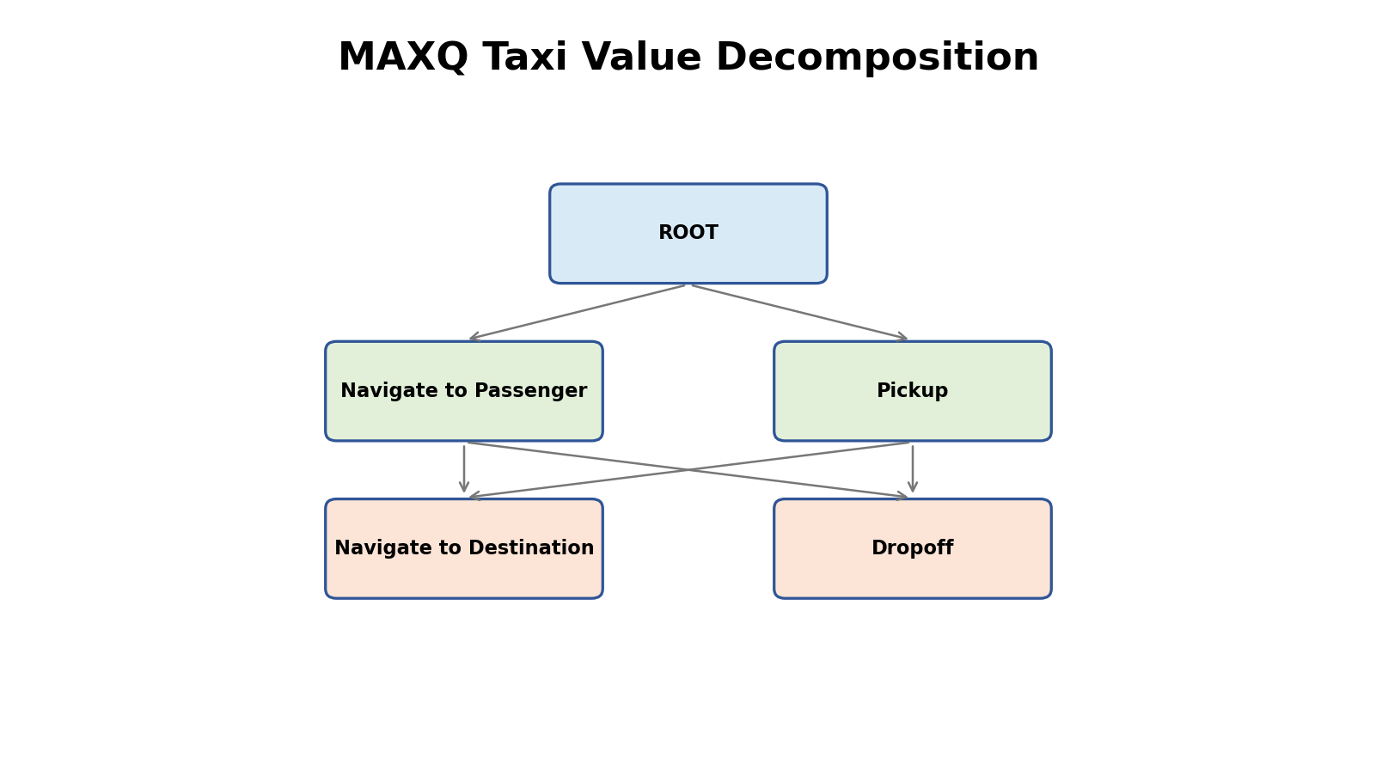
Figure 3: Visual representation of the RL simulation for Question 3.

Implementation / Simulation Steps
Implementation outline:
Define each MAXQ subtask with a termination condition.
For navigation subtasks, update Q-values for primitive movements.
For pickup/dropoff, use terminal task rewards.
Estimate:
V(parent, state) = V(child, state) + completion-value contribution.
Training loop:
reset taxi
select active subtask
select primitive action using ε-greedy
execute action
receive reward
update child value
propagate completion information to parent
repeat until episode ends.

Expected Output and Evaluation
Evaluation:
Compare average reward, episode length, illegal pickup/dropoff count, and success rate with a flat Q-learning baseline. MAXQ should make the structure of the task explicit and can improve learning by reusing subtasks.

4. Meta-Reinforcement Learning for Rapid GridWorld Adaptation
Objective: Train an agent that can quickly adapt when the GridWorld task changes.
Create multiple related environments:
- Different goal locations
- Different obstacle layouts
- Different reward locations
- Different transition dynamics
Meta-RL idea:
The agent learns not only a policy, but also a learning strategy that enables fast adaptation to a new task.
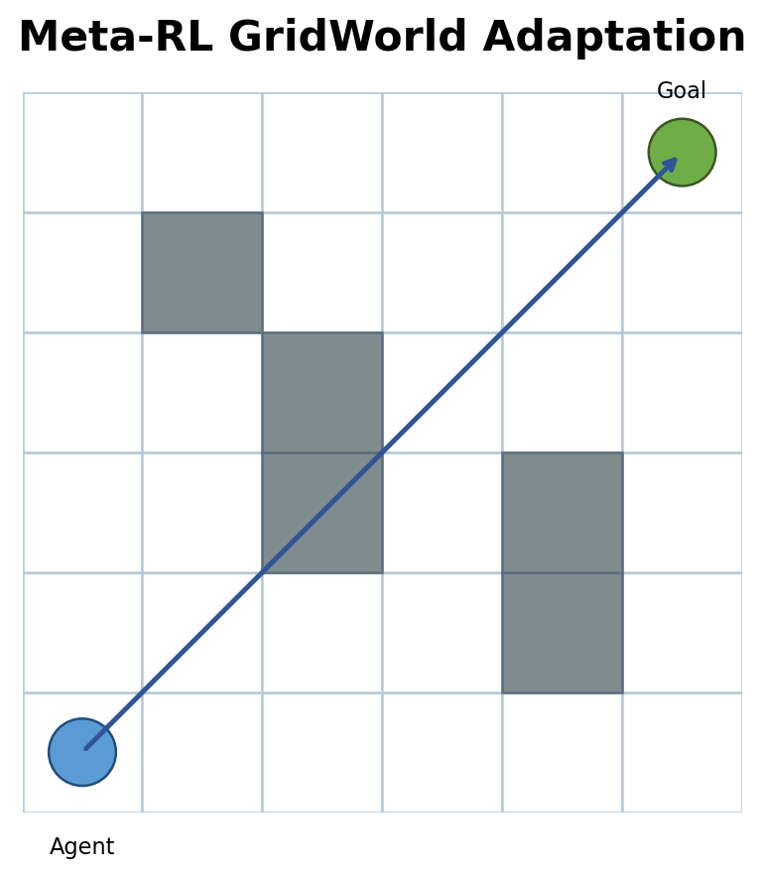
Figure 4: Visual representation of the RL simulation for Question 4.

Implementation / Simulation Steps
Implementation outline:
1. Generate a family of GridWorld tasks.
2. Train on many tasks rather than one fixed map.
3. Represent recent observations, actions and rewards as task context.
4. Use a recurrent policy or context encoder.
5. At test time, present an unseen GridWorld.
6. Allow a few interaction episodes for adaptation.
7. Measure performance before and after adaptation.
Pseudo workflow:
for task in training_tasks:
collect trajectories
encode task context
update meta-policy
new_task = unseen GridWorld
evaluate zero/low-shot performance
adapt using limited experience
evaluate again.

Expected Output and Evaluation
Expected result: After meta-training, the agent should require fewer interactions to achieve good performance on a new but related GridWorld compared with an agent trained from scratch.

5. Cooperative Multi-Agent RL for Robot Path Planning
Objective: Design multiple robots that cooperate to reach their goals without collisions.
Each robot is an agent.
Global environment contains robot positions, obstacles and goals.
Observation can include local surroundings plus nearby robot states.
Actions: move in four directions or wait.
Reward: positive for reaching the goal; negative for collision, blocking another robot, or excessive delay; optional team reward for completing all routes.
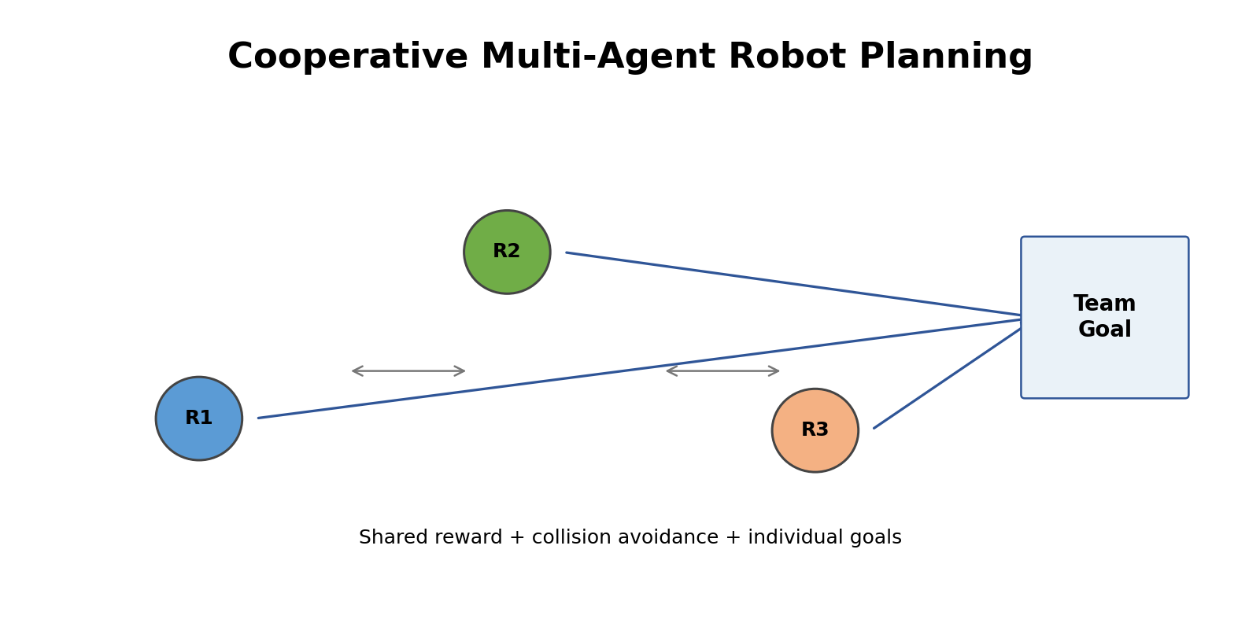
Figure 5: Visual representation of the RL simulation for Question 5.

Implementation / Simulation Steps
Recommended design: Centralized Training with Decentralized Execution (CTDE).
During training, a centralized critic can use global information while each robot's actor uses local observations.
Workflow:
Initialize N robots
for each episode:
observe local/global states
each actor selects an action
execute joint actions
calculate team and individual rewards
update centralized critic
update decentralized actors
repeat until all robots finish or time limit is reached.

Expected Output and Evaluation
Evaluation:
Measure collision rate, percentage of successful deliveries, average path length, total completion time and fairness among robots. Compare with independent single-agent policies.

6. Competitive Multi-Agent RL for Autonomous Drone Navigation
Objective: Simulate multiple drones operating competitively in a shared environment.
Example task: drones compete to reach target zones or collect limited resources while avoiding obstacles and other drones.
State: drone position, velocity, battery, nearby drones and target information.
Actions: move in 3D directions, hover, ascend/descend.
Reward: positive for reaching target/resource, negative for collision, energy waste, boundary violations and losing a competitive objective.
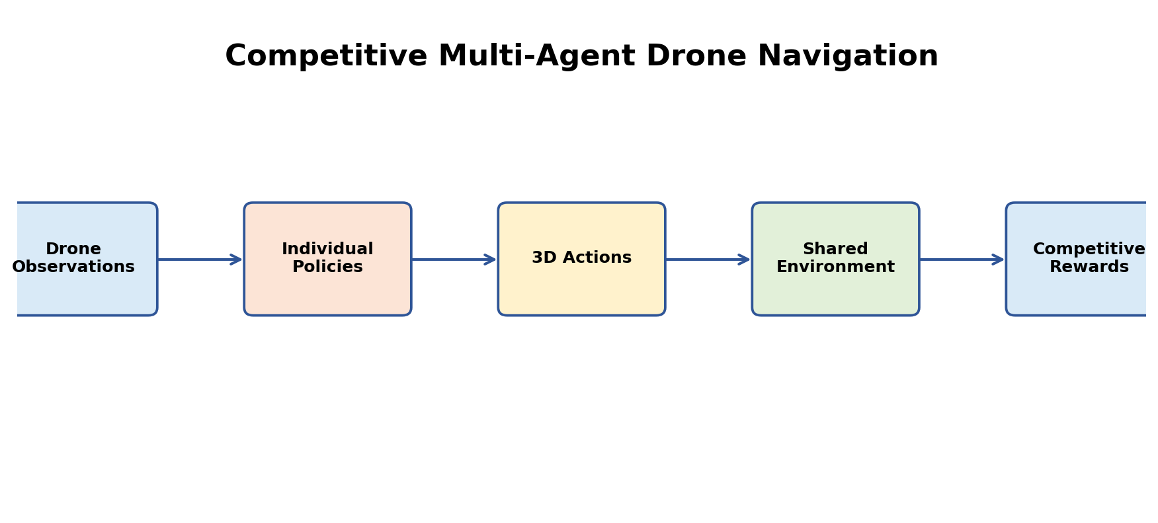
Figure 6: Visual representation of the RL simulation for Question 6.

Implementation / Simulation Steps
Implementation outline:
Create multiple drone agents with individual policies.
At every step:
1. Each drone observes its state.
2. Each policy chooses an action.
3. The environment applies all actions simultaneously.
4. Detect collisions and target/resource conflicts.
5. Assign individual rewards.
6. Store transitions and update policies.
For a simple simulation, use independent PPO-style policies or independent actor-critic agents. For more advanced experiments, use a centralized critic during training.

Expected Output and Evaluation
Evaluation:
Compare average reward per drone, collision rate, target completion rate, energy consumption and robustness as the number of drones increases. Competitive learning should demonstrate how one agent's decisions can affect the rewards available to others.

7. POMDP for Autonomous Vehicle Navigation under Limited Visibility
Objective: Simulate autonomous driving when the vehicle cannot observe the full environment because of fog, buildings, darkness or sensor limitations.
A POMDP is defined by:
States S, actions A, transition model T, observations O, observation model Z, and reward R.
The vehicle does not directly know the true state. It receives partial observations from sensors.
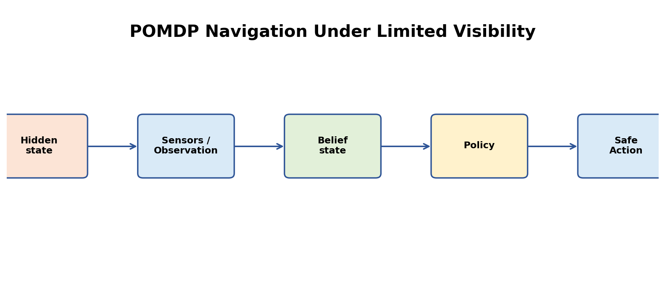
Figure 7: Visual representation of the RL simulation for Question 7.

Implementation / Simulation Steps
Belief-state approach:
Maintain a probability distribution b(s) over possible states.
After action a and observation o, update belief approximately using:
b'(s') ∝ Z(o|s') Σ_s T(s'|s,a)b(s)
Simulation:
Hidden state = actual road/obstacle configuration.
Observation = noisy camera/LiDAR-like information.
Actions = accelerate, brake, steer left/right.
Reward = safe progress toward destination, with strong penalties for collision and unsafe speed.
A practical simplified implementation can use a recurrent policy that summarizes observation history.

Expected Output and Evaluation
Evaluation:
Measure collision rate, route completion, average travel time, braking frequency and performance under increasing observation noise. The key objective is safe navigation despite incomplete information.

8. Ethical RL with Safety Constraints
Objective: Design an RL agent that maximizes task performance while respecting safety and ethical constraints.
Example: autonomous delivery robot.
Desired behavior: reach destination efficiently.
Constraints: do not collide with people, do not enter restricted zones, maintain safe speed, and stop when sensor confidence is too low.
Use a constrained objective:
maximize expected reward
subject to expected safety cost ≤ allowed limit.
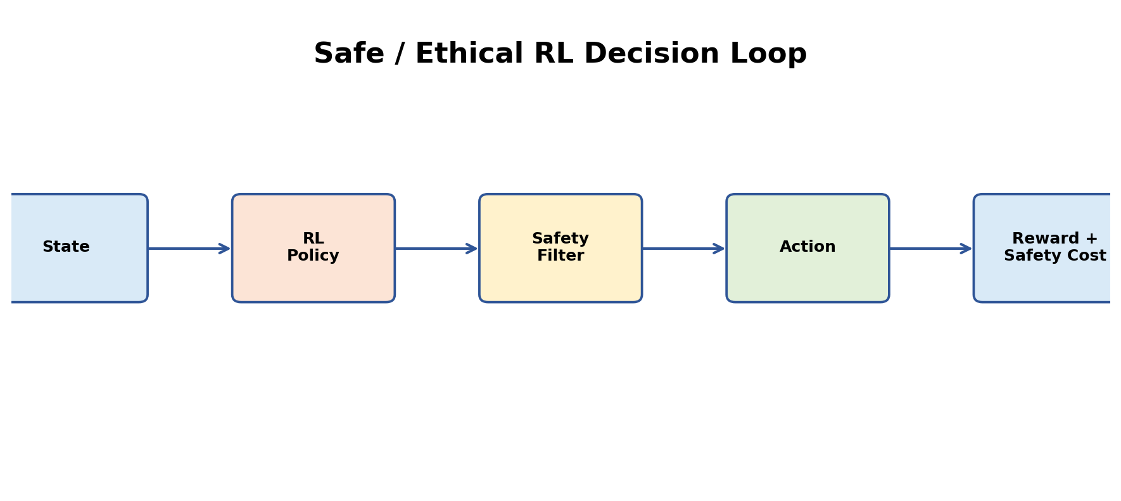
Figure 8: Visual representation of the RL simulation for Question 8.

Implementation / Simulation Steps
Implementation options:
1. Reward shaping: add strong penalties for unsafe events.
2. Action masking: remove actions known to violate hard constraints.
3. Safety layer: override an RL action when a safety rule is violated.
4. Constrained RL: optimize reward and cost separately.
Example:
total_reward = delivery_reward - λ1*collision_cost - λ2*restricted_zone_cost - λ3*unsafe_speed_cost
Training should log every safety violation separately rather than hiding it inside the total reward.

Expected Output and Evaluation
Evaluation:
Compare task reward and safety metrics together. Report collision rate, constraint violations, successful task completion and average efficiency. A model is not considered successful if it achieves high reward by repeatedly violating safety constraints.

9. RL-Based Adaptive Traffic Signal Control
Objective: Control traffic lights dynamically so that the system reduces congestion instead of using a fixed timetable.
State:
vehicle count per lane, queue length, waiting time, current signal phase, and optionally estimated arrival rates.
Actions:
keep phase, switch phase, or choose the next permitted phase.
Reward:
negative total waiting time, queue length and number of stops; positive reward can represent smooth traffic flow.
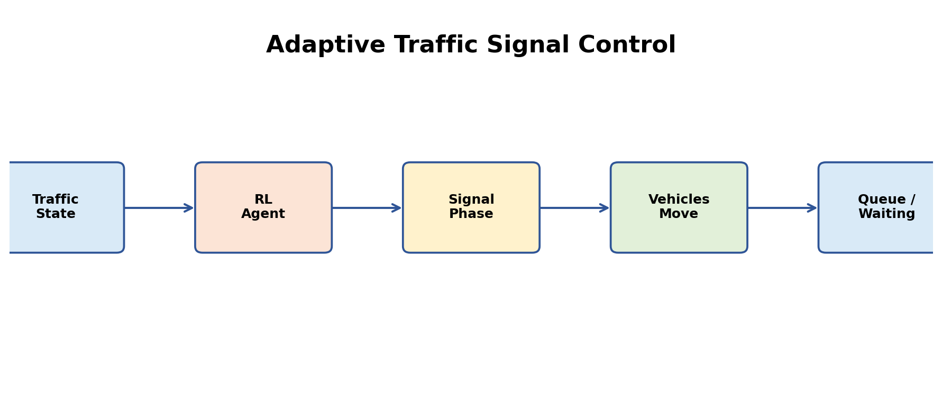
Figure 9: Visual representation of the RL simulation for Question 9.

Implementation / Simulation Steps
Simulation workflow:
Create a four-way intersection.
At each time step:
1. Generate vehicles according to traffic demand.
2. Observe queues and current phase.
3. RL agent selects signal action.
4. Update traffic simulation.
5. Calculate reward.
6. Train policy.
7. Compare with fixed-time control.
Evaluation metrics:
average waiting time, maximum queue length, throughput, number of stops, travel time and emergency-vehicle priority if included.

Expected Output and Evaluation
Expected result: An adaptive policy should learn to allocate green time according to current demand. Performance should be evaluated across low, medium and peak traffic rather than on only one traffic pattern.

10. RL-Based Smart Energy Management for a Microgrid
Objective: Optimize power distribution in a microgrid containing renewable generation, storage and loads.
State:
solar/wind generation, battery state of charge, electricity demand, grid price and time of day.
Actions:
charge/discharge battery, use grid power, curtail renewable generation, and allocate flexible loads.
Reward:
negative energy cost, peak-demand penalty and battery degradation cost; positive reward for meeting demand and using renewable energy.
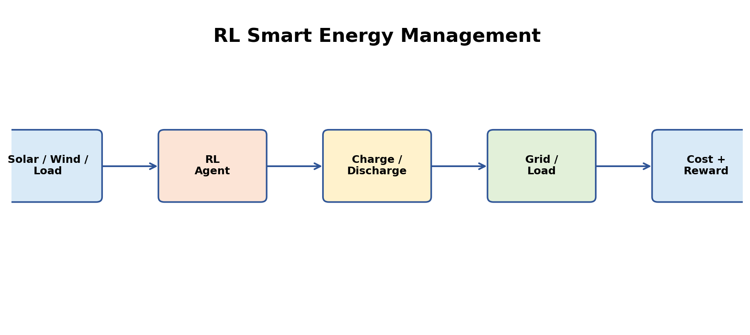
Figure 10: Visual representation of the RL simulation for Question 10.

Implementation / Simulation Steps
Simulation workflow:
Initialize microgrid state.
For each time step:
1. Read generation and demand.
2. Observe battery state and electricity price.
3. RL agent selects energy-management actions.
4. Apply power-flow constraints.
5. Calculate cost and reward.
6. Update the policy.
7. Repeat across many daily/seasonal episodes.
Important constraint:
Power balance must hold:
generation + grid_import + battery_discharge
= demand + battery_charge + losses.

Expected Output and Evaluation
Evaluation:
Compare total electricity cost, renewable utilization, peak demand, battery cycling, unmet load and grid dependency against a rule-based baseline. Test under changing weather and demand to assess robustness.

Common Implementation Structure
For all ten simulations, the following general RL software structure can be followed:
class Environment:
def reset(self):
# initialize state
return state
def step(self, action):
# apply action
# calculate next_state, reward, done, info
return next_state, reward, done, info
class Agent:
def select_action(self, state):
# policy / exploration
return action
def update(self, experience):
# update policy or value estimates
pass
for episode in range(NUM_EPISODES):
state = env.reset()
done = False
while not done:
action = agent.select_action(state)
next_state, reward, done, info = env.step(action)
agent.update((state, action, reward, next_state, done))
state = next_state

Recommended Results to Include
Include at least one visual result for each implemented simulation: environment screenshot/grid, reward-versus-episode graph, path/trajectory plot, queue-length graph, energy-cost graph, or safety-violation chart. Use a baseline wherever possible so the RL method is compared against a meaningful non-RL or simpler RL approach.

Code of Conduct
I, K. Abu hujaifa (Reg. No. 192472308), certify that this submission is my original work and that I have adhered to the guidelines specified for this assessment. I understand that any violation of academic integrity rules will result in disciplinary action.
Signature of the student : K.ABU HUJAIFA
Date: 31/08/2026

