SIMATS ENGINEERING
ASSESSMENT TOOL 2
Scenario-Based Assessment – Reinforcement Learning
Course Code | MLA03
Course Name | Reinforcement Learning
Course Outcome | CO5: Implement policy-based reinforcement learning methods to develop efficient solutions for complex environments. (BL2, BL3, BL6)
Assessment Weightage | 35%
Student Name | V. Nagendra
Register Number | 192425091
Faculty: Dr. Dumpala Prasanth | Duration: 1.5 Hours | Total Marks: 50

1. Personalized Notifications

Scenario Understanding
The notification problem is a sequential decision problem. The RL agent observes user context and chooses whether to send a notification, what type to send, or to wait. The state can include time, recent activity, notification history and engagement level. Actions are send, select content, or wait. The reward should combine useful engagement with penalties for ignored notifications, opt-outs and excessive frequency.

Solution / RL Approach
The policy is trained by repeatedly observing state → selecting action → observing response → calculating reward → updating the policy. A contextual bandit is sufficient for mostly immediate outcomes; full RL is useful when today's action affects future engagement.
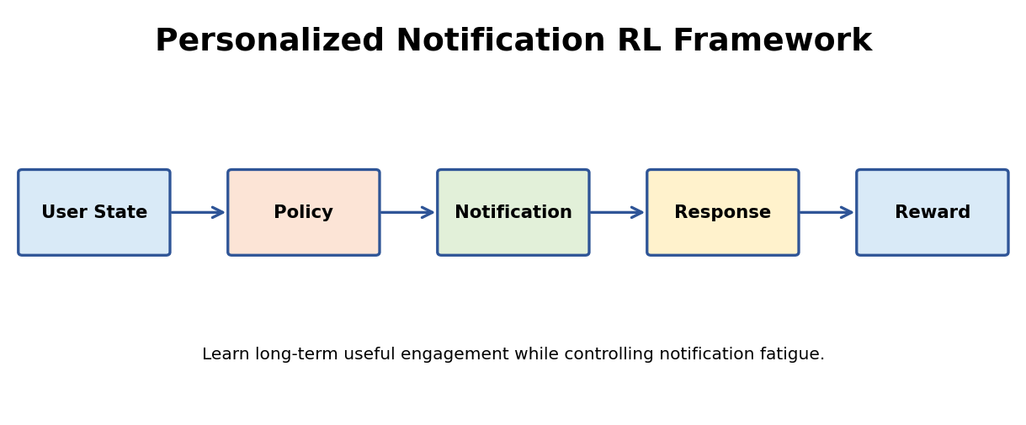
Figure 1.1: Solution framework for Question 1.

Expected Output
The expected result is higher useful engagement with lower notification fatigue. Evaluation should include engagement, retention, opt-out rate and notification frequency.
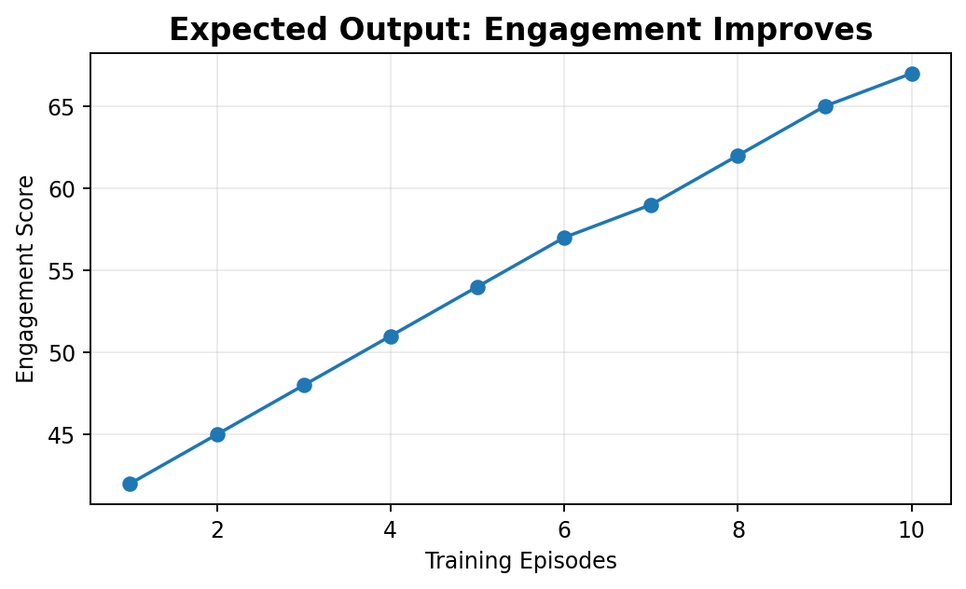
Figure 1.2: Example output/result visualization for Question 1.

Result Interpretation
The upward engagement trend indicates that the learned policy can improve useful interactions over training while reward penalties control notification fatigue.

Conclusion
The scenario demonstrates how an RL agent can be formulated using states, actions, rewards, a learning policy and evaluation metrics, while incorporating the practical constraints required for a reliable real-world solution.

2. Warehouse Robot Exploration vs Exploitation

Scenario Understanding
The robot must balance exploration of new routes with exploitation of the best route already known. Too little exploration can make it repeatedly choose a longer route. Too much exploration can increase travel time and collision risk.

Solution / RL Approach
Use decaying ε-greedy exploration, meaningful movement/collision rewards, curriculum learning and safety-constrained actions. Early training explores more; later training increasingly exploits the best safe route.
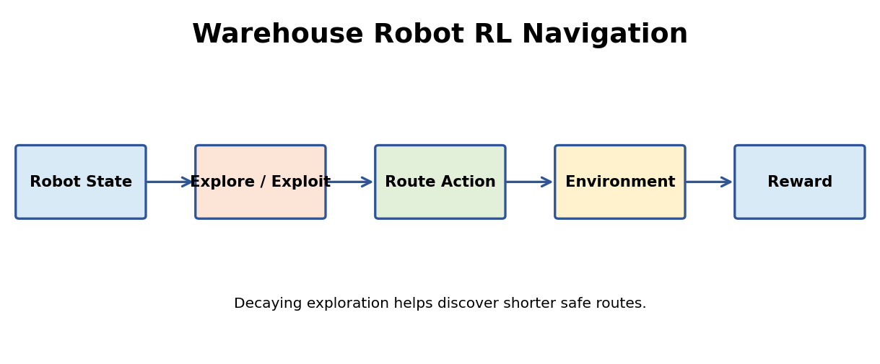
Figure 2.1: Solution framework for Question 2.

Expected Output
A successful policy should reduce average path length and preserve delivery success while keeping collisions low.
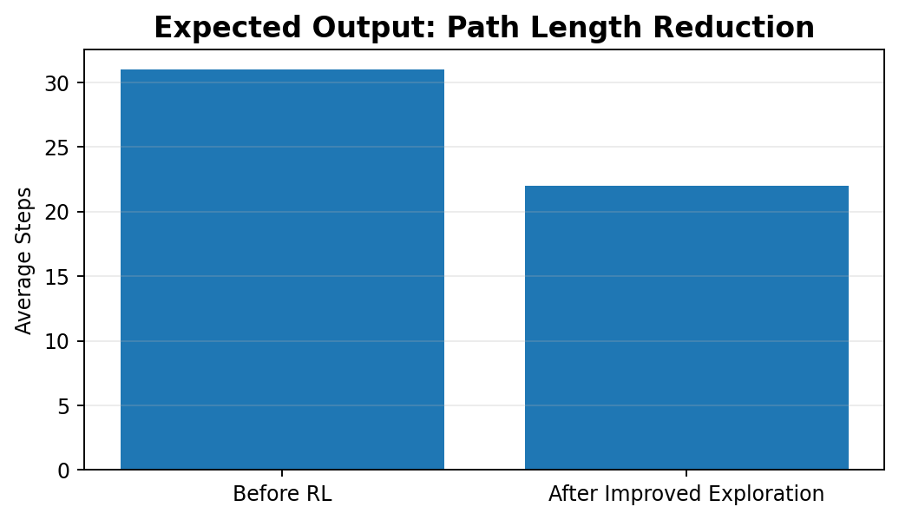
Figure 2.2: Example output/result visualization for Question 2.

Result Interpretation
The reduced path length demonstrates the value of sufficient exploration: the agent discovers a better route and later exploits it more consistently.

Conclusion
The scenario demonstrates how an RL agent can be formulated using states, actions, rewards, a learning policy and evaluation metrics, while incorporating the practical constraints required for a reliable real-world solution.

3. Hospital Appointment Scheduling

Scenario Understanding
Appointment scheduling fits RL because each scheduling decision affects future queues, waiting times and resource use. States include waiting patients, urgency, doctor/room availability and time. Actions assign patients to valid slots or resources.

Solution / RL Approach
Delayed rewards can be handled with n-step returns, eligibility traces and reward shaping. Ethical deployment requires privacy, fairness, clinical priority rules, human oversight and auditing.
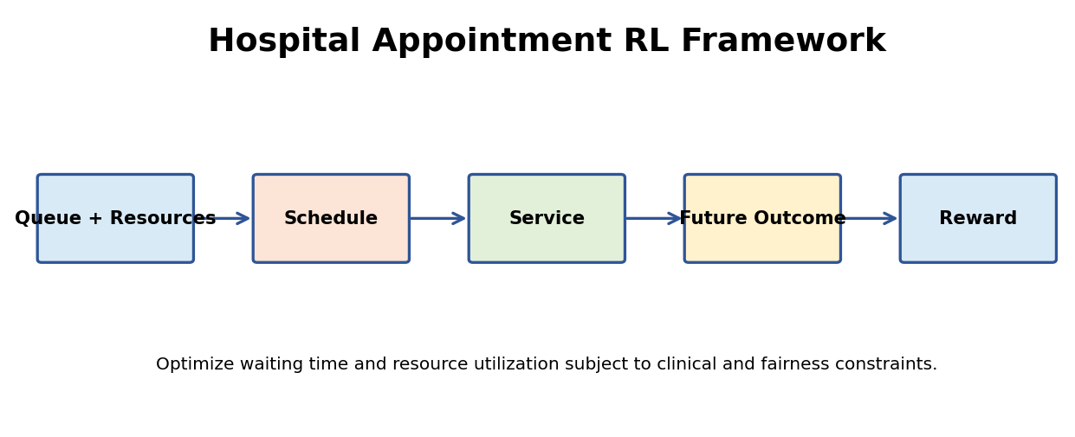
Figure 3.1: Solution framework for Question 3.

Expected Output
The RL scheduler should reduce waiting time and improve resource utilization without unfairly deprioritizing vulnerable or urgent patients.
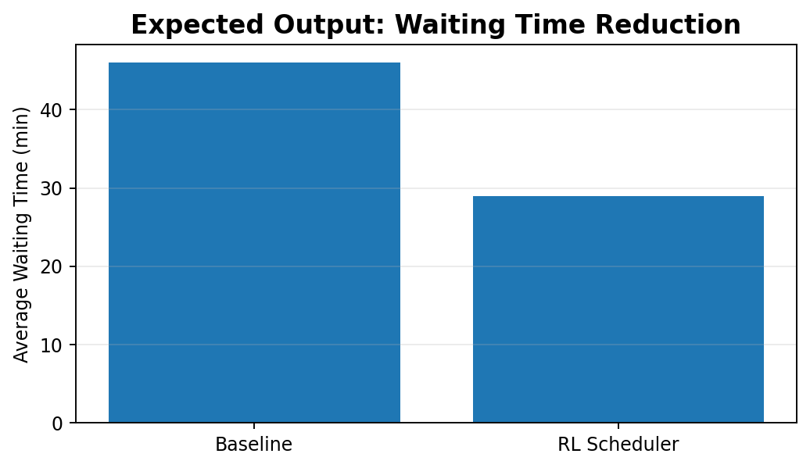
Figure 3.2: Example output/result visualization for Question 3.

Result Interpretation
The lower waiting-time result indicates better scheduling efficiency; final deployment must also verify fairness and clinical constraints.

Conclusion
The scenario demonstrates how an RL agent can be formulated using states, actions, rewards, a learning policy and evaluation metrics, while incorporating the practical constraints required for a reliable real-world solution.

4. Smart Home Energy Management

Scenario Understanding
The state can contain occupancy, indoor temperature, weather, time and current device status. Actions can switch lights/fans or adjust AC setpoints. The reward should reduce energy cost while maintaining comfort and avoiding excessive switching.

Solution / RL Approach
DQN is suitable for discrete actions; PPO or actor-critic methods can handle richer/continuous controls. Safety and comfort limits should be enforced as constraints.
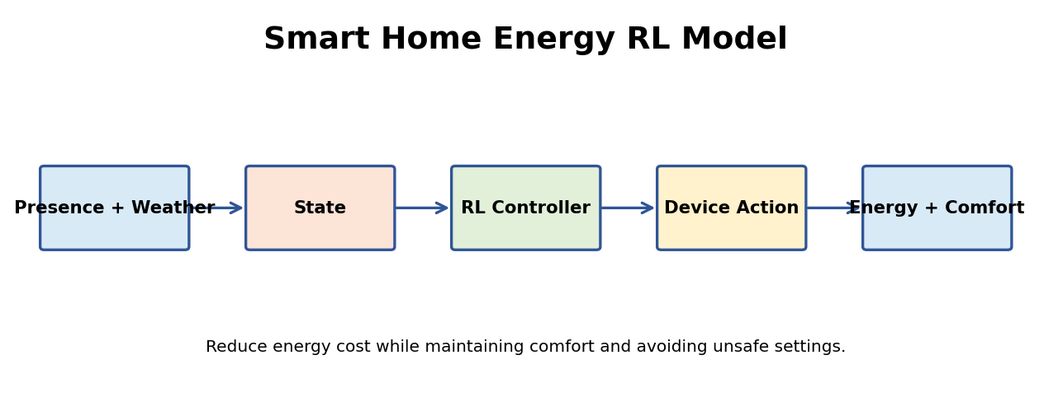
Figure 4.1: Solution framework for Question 4.

Expected Output
Expected output is lower energy use and cost with acceptable comfort. Compare against a rule-based controller.
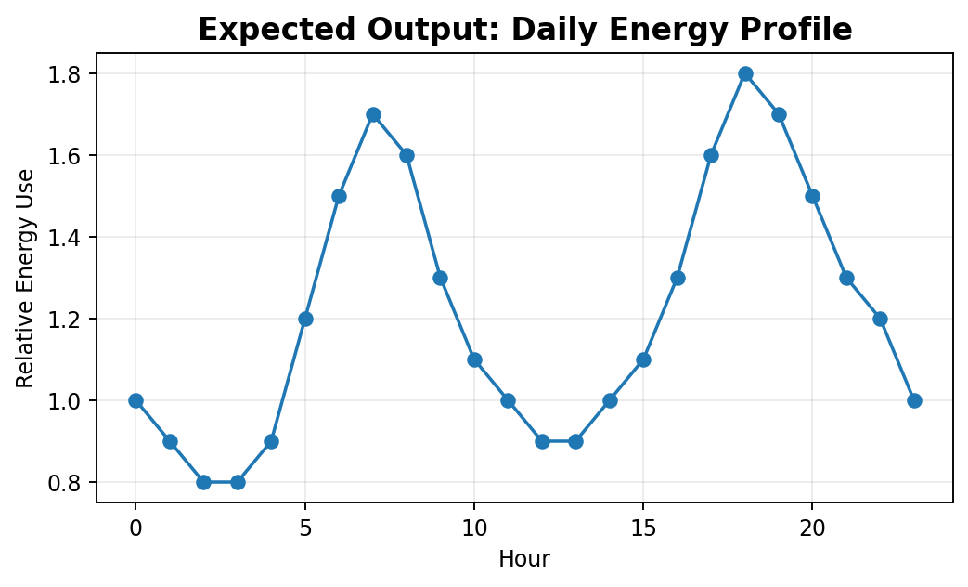
Figure 4.2: Example output/result visualization for Question 4.

Result Interpretation
The energy profile illustrates how the controller can reduce consumption during low-demand periods while maintaining comfort-related control.

Conclusion
The scenario demonstrates how an RL agent can be formulated using states, actions, rewards, a learning policy and evaluation metrics, while incorporating the practical constraints required for a reliable real-world solution.

5. RL Game Matchmaking

Scenario Understanding
The matchmaking state may include skill rating, recent performance, latency, queue time and match history. The action is selecting compatible players. The reward should favor balanced competition, reasonable waiting and long-term satisfaction.

Solution / RL Approach
A reward based only on session duration can create inefficient or unhealthy matching. A reward based only on predicted win probability can repeatedly create skill mismatches. Multi-objective reward design is preferable.
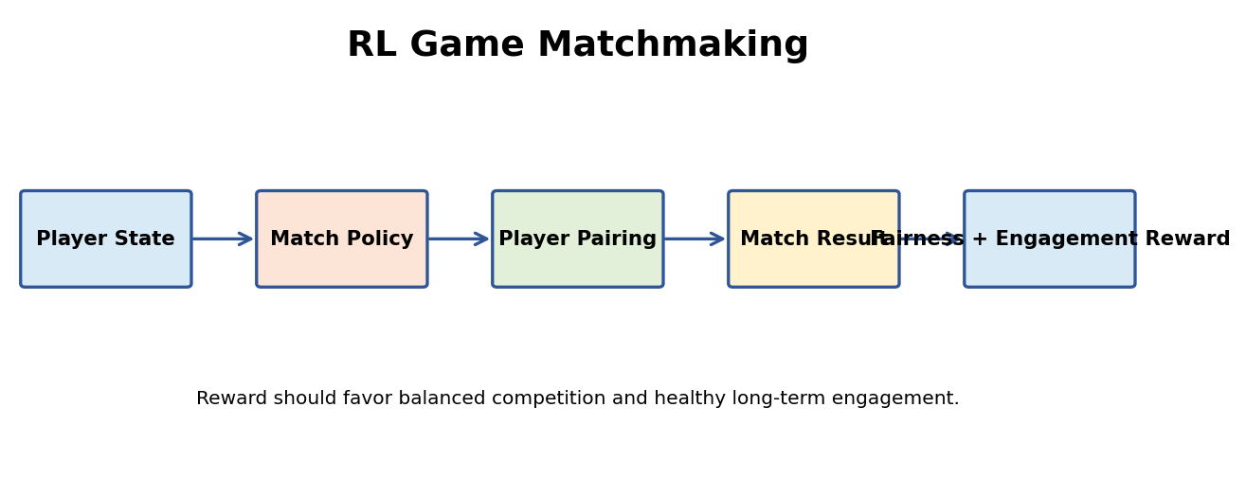
Figure 5.1: Solution framework for Question 5.

Expected Output
Evaluate skill-gap distribution, queue time, match balance, satisfaction, retention and fairness.
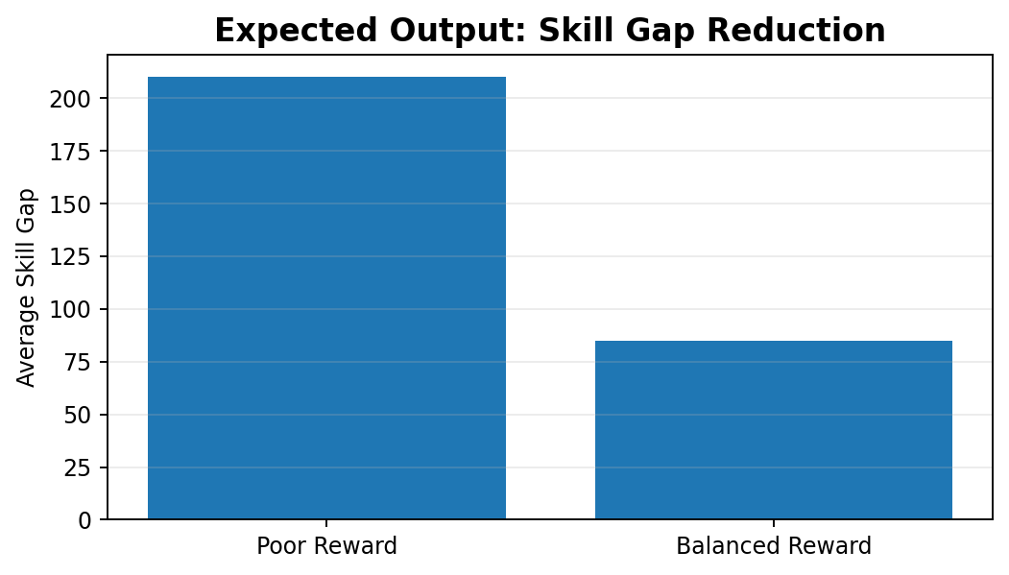
Figure 5.2: Example output/result visualization for Question 5.

Result Interpretation
The lower skill gap indicates more balanced matches; the reward should be continuously monitored for unintended player behavior.

Conclusion
The scenario demonstrates how an RL agent can be formulated using states, actions, rewards, a learning policy and evaluation metrics, while incorporating the practical constraints required for a reliable real-world solution.

6. Financial Trading

Scenario Understanding
States may include returns, volume, volatility, indicators, holdings, cash and exposure. Actions are buy, sell or hold, or target portfolio weights. Reward should be risk-adjusted portfolio return minus transaction costs and risk penalties.

Solution / RL Approach
Delayed rewards are difficult because a trade can affect portfolio value many steps later and markets are noisy/non-stationary. Use realistic transaction costs, position limits, drawdown controls, walk-forward testing and stress testing.
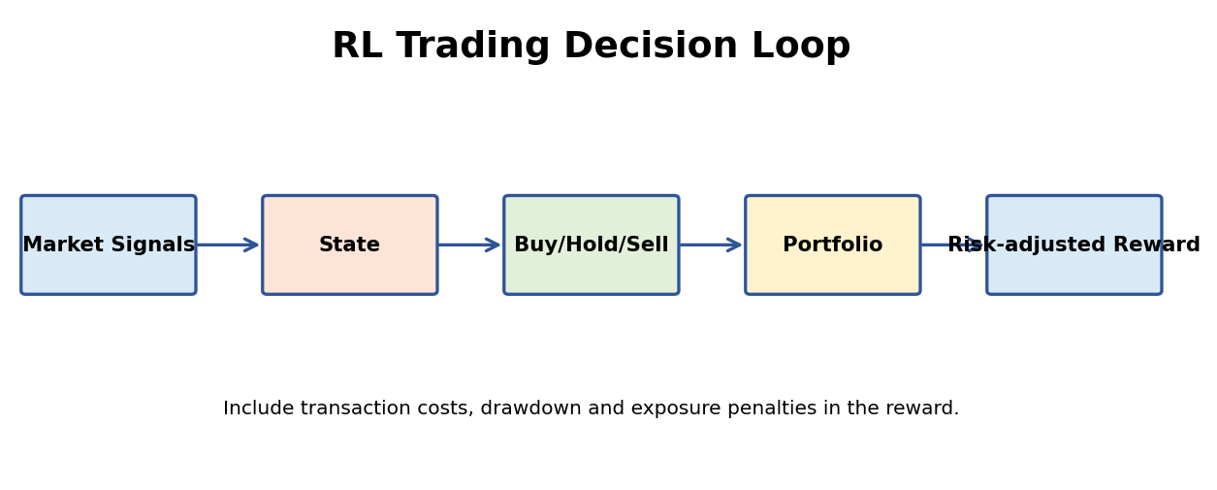
Figure 6.1: Solution framework for Question 6.

Expected Output
A useful evaluation includes return, volatility, maximum drawdown, turnover and risk-adjusted performance.
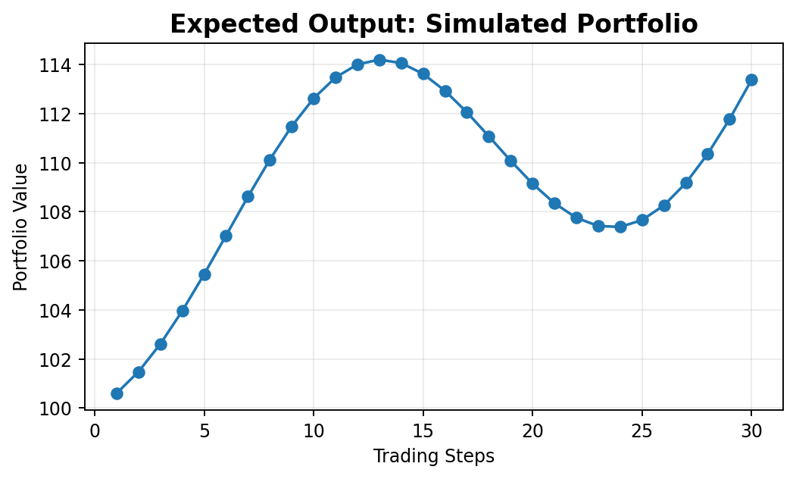
Figure 6.2: Example output/result visualization for Question 6.

Result Interpretation
The portfolio curve is only an illustrative simulation. Real trading evaluation must include costs, out-of-sample testing and risk controls.

Conclusion
The scenario demonstrates how an RL agent can be formulated using states, actions, rewards, a learning policy and evaluation metrics, while incorporating the practical constraints required for a reliable real-world solution.

7. Drone Delivery

Scenario Understanding
The state includes 3D position, velocity, battery, weather, obstacles and restricted-airspace information. Actions include allowed movements, altitude changes and route segments. Reward favors safe progress, successful delivery and energy efficiency.

Solution / RL Approach
Restricted airspace should be implemented as a hard action mask or safety filter. Large penalties can supplement this, but forbidden actions should ideally be prevented before execution.
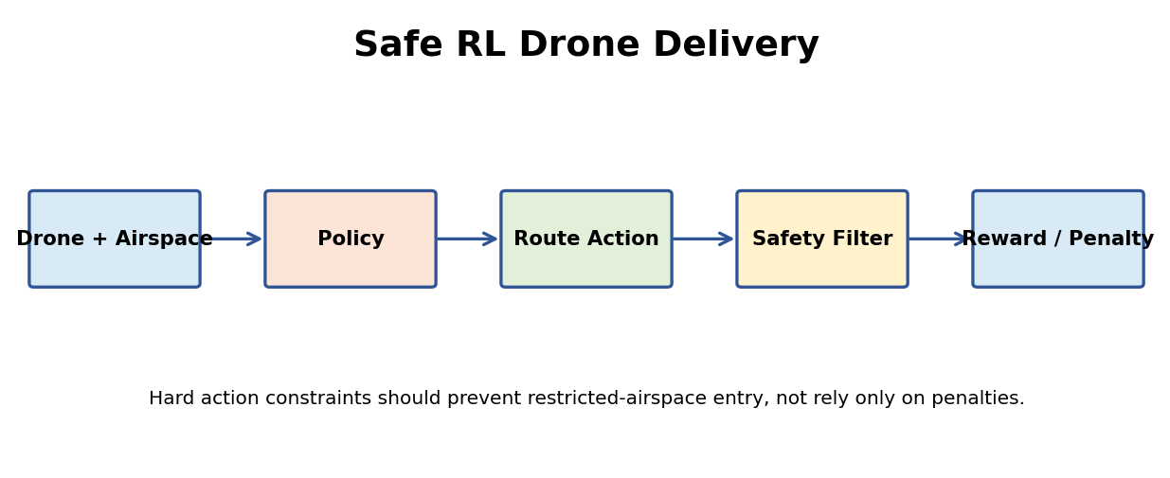
Figure 7.1: Solution framework for Question 7.

Expected Output
Expected output is a safe route that reaches the delivery point without restricted-zone violations or collisions.
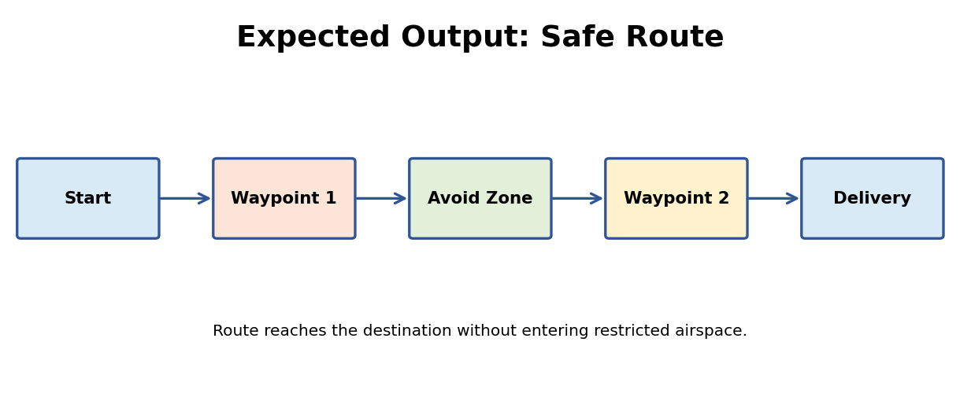
Figure 7.2: Example output/result visualization for Question 7.

Result Interpretation
The safe route output shows that route selection can be combined with a safety layer to avoid prohibited regions.

Conclusion
The scenario demonstrates how an RL agent can be formulated using states, actions, rewards, a learning policy and evaluation metrics, while incorporating the practical constraints required for a reliable real-world solution.

8. Personalized Online Learning

Scenario Understanding
The state can contain quiz scores, mastered topics, error patterns, learning pace and goals. Actions recommend the next lesson, revision or difficulty. Reward should emphasize actual learning and mastery rather than only screen time.

Solution / RL Approach
Ethical design requires transparency, student control, privacy protection, fairness and avoidance of sensitive profiling. Prevent feedback loops that permanently assign easy content.
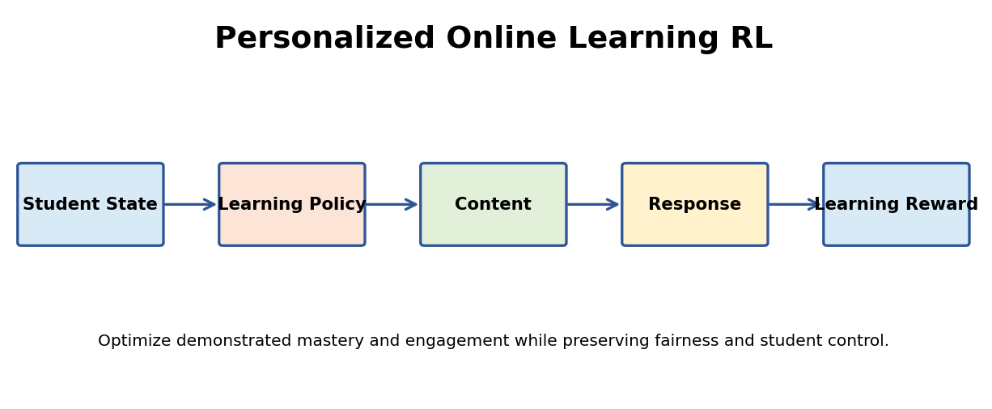
Figure 8.1: Solution framework for Question 8.

Expected Output
Expected output is improved mastery and engagement while maintaining equitable learning opportunities.
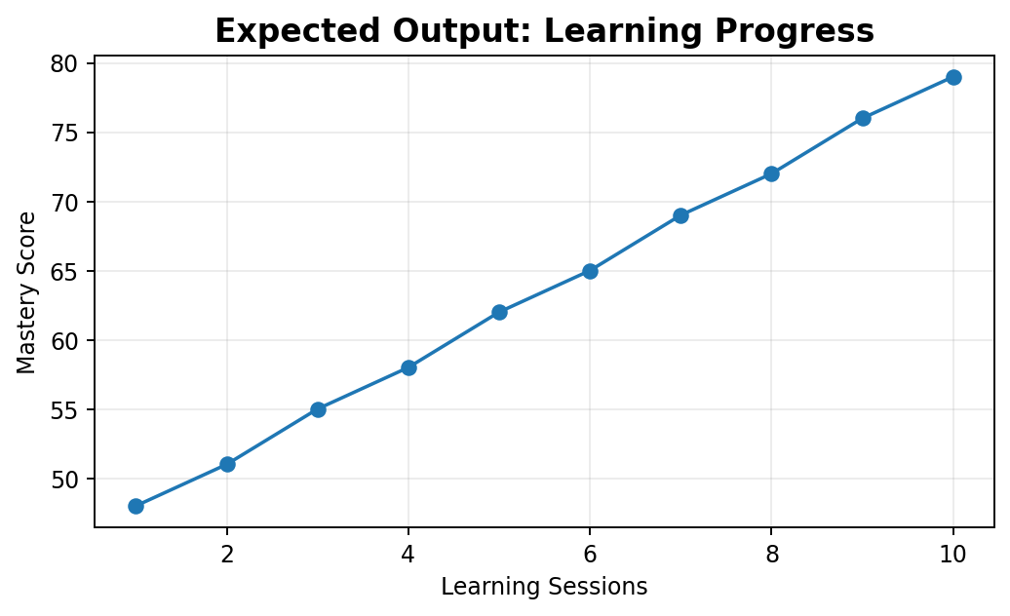
Figure 8.2: Example output/result visualization for Question 8.

Result Interpretation
The mastery trend illustrates how adaptive content can improve learning progress; actual educational experiments should measure learning gain, not only engagement.

Conclusion
The scenario demonstrates how an RL agent can be formulated using states, actions, rewards, a learning policy and evaluation metrics, while incorporating the practical constraints required for a reliable real-world solution.

9. Traffic Signal Control

Scenario Understanding
The state includes vehicle queues, waiting times, signal phase, pedestrian state and emergency vehicle detection. Actions control permitted signal phases or green duration.

Solution / RL Approach
Emergency priority, pedestrian clearance, yellow/all-red intervals and conflicting movements should be hard constraints. The reward can then optimize throughput and delay within those constraints.
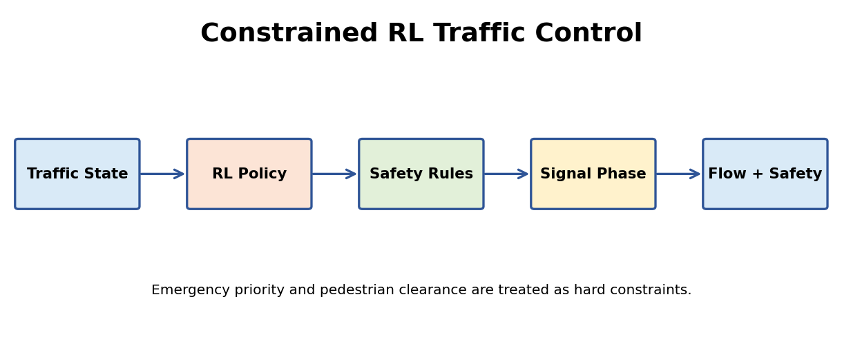
Figure 9.1: Solution framework for Question 9.

Expected Output
Expected output is lower congestion and queue length without safety violations. Compare against fixed-time signals.
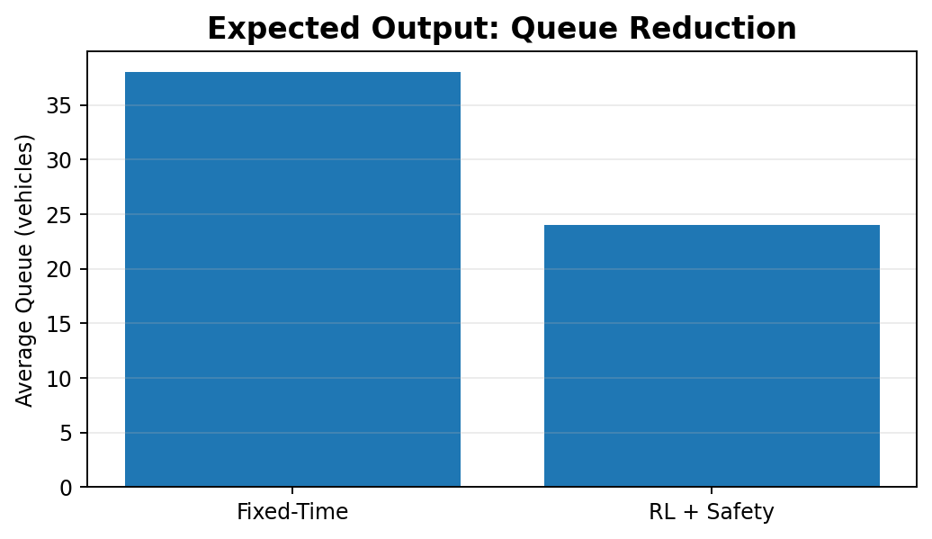
Figure 9.2: Example output/result visualization for Question 9.

Result Interpretation
The queue reduction illustrates potential congestion benefits. Safety constraints must be checked independently of the traffic reward.

Conclusion
The scenario demonstrates how an RL agent can be formulated using states, actions, rewards, a learning policy and evaluation metrics, while incorporating the practical constraints required for a reliable real-world solution.

10. Manufacturing Machine Scheduling

Scenario Understanding
Traditional optimization can solve stable, well-defined scheduling problems using mathematical programming or heuristics. Constrained RL learns a policy that can react quickly to changing demand, machine failures and resource availability.

Solution / RL Approach
For dynamic production, RL can provide adaptability after training, while optimization may need to be re-solved repeatedly. A hybrid approach is strong: optimization for baseline planning and RL for real-time adjustment, with hard constraint checks.
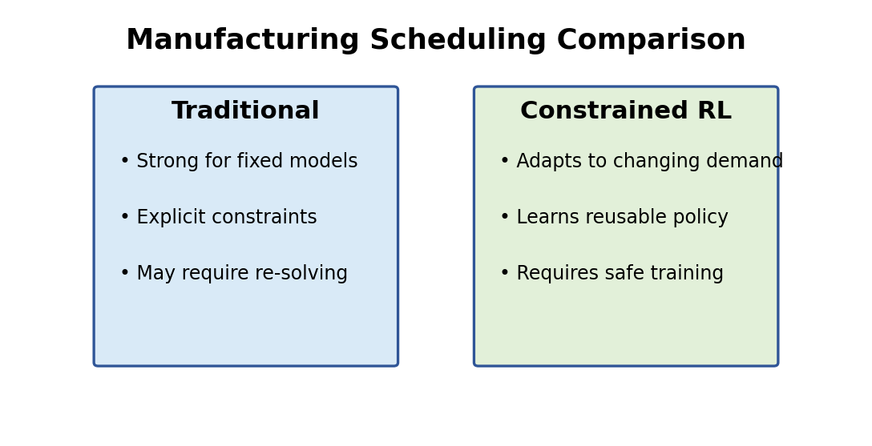
Figure 10.1: Solution framework for Question 10.

Expected Output
Evaluate makespan, tardiness, throughput, utilization, constraint violations and adaptation time.
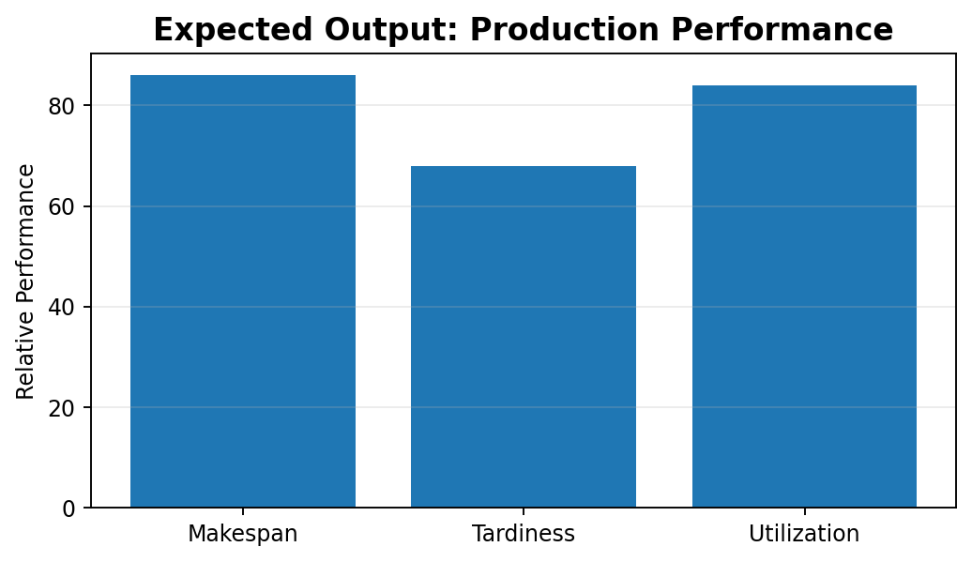
Figure 10.2: Example output/result visualization for Question 10.

Result Interpretation
The comparison illustrates why constrained RL can be more adaptable in changing production conditions, while traditional optimization remains valuable for stable planning.

Conclusion
The scenario demonstrates how an RL agent can be formulated using states, actions, rewards, a learning policy and evaluation metrics, while incorporating the practical constraints required for a reliable real-world solution.

Code of Conduct
I, K. Abu hujaifa (Reg. No. 192472308), certify that this submission is my original work and that I have adhered to the guidelines specified for this assessment. I understand that any violation of academic integrity rules will result in disciplinary action.
Signature of the student : K.Abu hujaifa
Date: 31/08/2026

