**PIZZA SALE- SQL QUERY REPORT**

**KPI’s :**

1. **Total Revenue:**

SELECT SUM(total_price) As total_revenue FROM pizza_orders

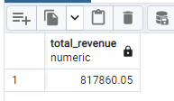

1. **Average Order Value:**

SELECT SUM(total_price)/ COUNT(DISTINCT order_id) AS Average_Order_Value from pizza_orders

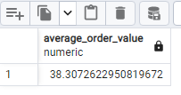

1. **Total Pizzas Sold:**

SELECT SUM(quantity) AS Toal_pizzas_sold from pizza_orders

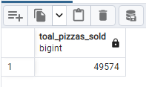

1. **Total Orders:**

SELECT COUNT(DISTINCT order_id) AS Toal_Orders FROM pizza_orders

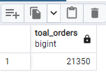

1. **Average Pizzas Per Order:**

SELECT

CAST(

CAST(SUM(quantity) AS decimal(10, 2)) /

CAST(COUNT(DISTINCT order_id) AS decimal(10, 2))

AS decimal(10, 2)

) AS Avg_pizzas_per_order

FROM pizza_orders;

**OR**

SELECT TO_CHAR(

CAST(SUM(quantity) AS decimal(10,2)) /

CAST(COUNT(DISTINCT order_id) AS decimal(10,2)),

'9999.99'

) AS Avg_pizzas_per_order

FROM pizza_orders;

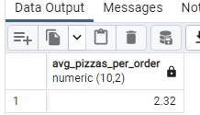

**Problem Statements:**

1. **Hourly Trend for Total Pizzas Sold:**

SELECT EXTRACT(HOUR FROM order_time) AS order_hour,

SUM(quantity) AS total_pizzas_told

FROM pizza_orders

GROUP BY EXTRACT(HOUR FROM order_time)

ORDER BY EXTRACT(HOUR FROM order_time) ASC

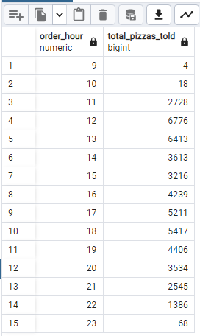

1. **Weekly Trend for Total Orders:**

SELECT EXTRACT(WEEK FROM order_date) AS order_week,

EXTRACT(YEAR FROM order_date) AS order_year,

COUNT(DISTINCT order_id) AS total_orders

FROM pizza_orders

GROUP BY EXTRACT(WEEK FROM order_date),

EXTRACT(YEAR FROM order_date)

ORDER BY EXTRACT(WEEK FROM order_date),

EXTRACT(YEAR FROM order_date)

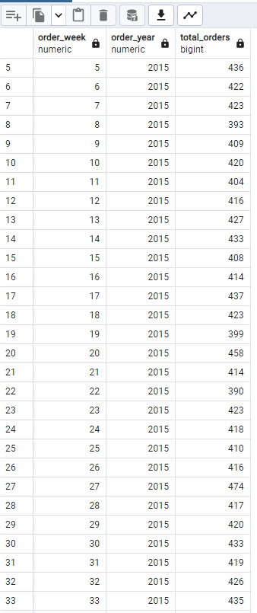 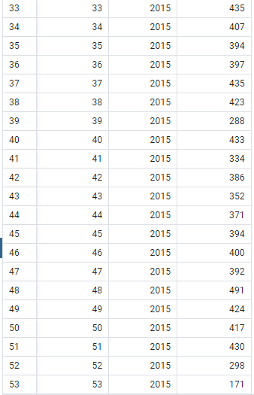

1. **Percentage of Sales by Pizza Category:**

SELECT pizza_category,

SUM(total_price) * 100 / (SELECT SUM(total_price) FROM pizza_orders) AS PCT_by_category

FROM pizza_orders

GROUP BY pizza_category;

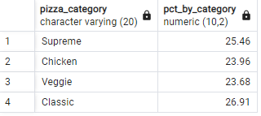

1. **Percentage of Sales by Pizza Size:**

SELECT pizza_size,

SUM(total_price) AS total_sales,

CAST(SUM(total_price) * 100 / (SELECT SUM(total_price) FROM pizza_orders) AS decimal(10,2)) AS PCT_by_size

FROM pizza_orders

GROUP BY pizza_size

ORDER BY PCT_by_size DESC

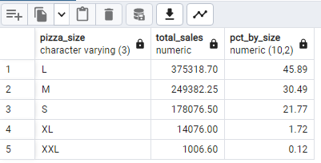

1. **Total Pizzas Sold by Pizza Category:**

SELECT pizza_category,

SUM(quantity) AS total_pizzas_sold

FROM pizza_orders

GROUP BY pizza_category

ORDER BY SUM(quantity);

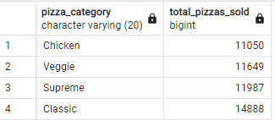

1. **Top 5 Best Sellers by Revenue, Total Quantity and Total Orders**

**Revenue**:

SELECT pizza_name, SUM(total_price) AS total_revenue FROM pizza_orders

GROUP BY pizza_name

ORDER BY total_revenue DESC

LIMIT 5;

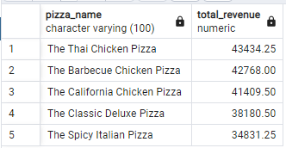

**Total_Quanity:**

SELECT pizza_name, SUM(quantity) AS total_quantity FROM pizza_orders

GROUP BY pizza_name

ORDER BY total_quantity DESC

LIMIT 5;

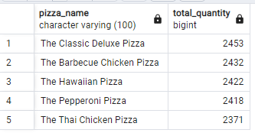

**Total_orders:**

SELECT pizza_name, COUNT(DISTINCT order_id) AS total_orders FROM pizza_orders

GROUP BY pizza_name

ORDER BY total_orders DESC

LIMIT 5;

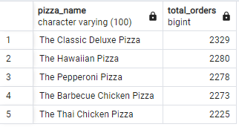

1. **Bottom 5 Best Sellers by Revenue, Total Quantity and Total Orders**

**Revenue :**

SELECT pizza_name, SUM(total_price) AS total_revenue FROM pizza_orders

GROUP BY pizza_name

ORDER BY total_revenue ASC

LIMIT 5;

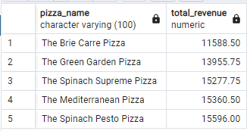

**Total_Quantity:**

SELECT pizza_name, SUM(quantity) AS total_quantity FROM pizza_orders

GROUP BY pizza_name

ORDER BY total_quantity ASC

LIMIT 5;

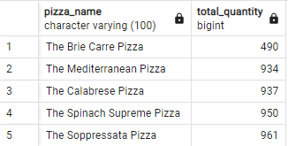

**Total _Orders:**

SELECT pizza_name, COUNT(DISTINCT order_id) AS total_orders FROM pizza_orders

GROUP BY pizza_name

ORDER BY total_orders ASC

LIMIT 5;

