ELASTICSEARCH — QUICK GUIDE (Enhanced & Restored)

1. CQRS System Design (Expanded)
CQRS (Command Query Responsibility Segregation) splits an application's data path into two distinct models:
• Command (Write) Model — handles create/update/delete actions, enforces business rules and transactions. Optimized for correctness.
• Query (Read) Model — handles reads, searches, filters, reports. Optimized for fast queries and flexible schemas.
Analogy: A restaurant with two counters — one to place orders (writes) and another to pick up prepared food (reads). Separating the counters avoids bottlenecks.
Why use CQRS?
• Different scaling requirements for reads vs writes.
• Reads benefit from denormalized, query-optimized views.
• Clean separation of concerns; business rules concentrated in writes.
• Enables specialized read stores like Elasticsearch without impacting transactional DB.
When not to use CQRS: Small/simple CRUD apps — added complexity may not be worth it. Teams without distributed systems experience should be cautious.

2. What is Elasticsearch?
• A distributed, RESTful search and analytics engine built on Apache Lucene.
• Stores JSON documents and returns search results in milliseconds.
• Designed for full-text search, analytics/aggregations, and scalable read workloads.
Layman: Like Google for your application data.

3. Why Elasticsearch with CQRS?
• Full-text search with BM25 relevance, phrase matching, and fuzzy search.
• Real-time aggregations for analytics.
• Horizontal scaling via shards and replicas.
• Flexible schema allowing read model evolution independent of write DB.
• Good fit as the read side of CQRS: fast, flexible queries, denormalized views.

4. Core Features — How it works & Why it matters (with examples)

A. Indexing
How: JSON documents are analyzed, tokenized, and stored in inverted indices and doc values. Documents become searchable after a refresh (default ~1s).
Why: Like adding a new book to a library and updating the catalogue.
Example:
curl -X POST "localhost:9200/products/_doc/1" -H 'Content-Type: application/json' -d '{
"name":"Coffee Mug",
"price":9.99,
"description":"White ceramic mug"
}'

B. Inverted Index
How: For text fields, terms map to lists of document IDs (postings).
Why: Instead of reading every document, look up the word in the index.

C. Full-Text Search
How: Queries like match, multi_match, match_phrase use analyzers and scoring (BM25).
Why: Finds relevant documents even with variants (e.g., 'smart-phone' vs 'smartphone').
Example:
curl -X GET "localhost:9200/products/_search" -H 'Content-Type: application/json' -d '{
"query": {
"multi_match": {
"query": "smart phone",
"fields": ["name^2","description"]
}
}
}'

D. Aggregations (Analytics)
How: Uses columnar doc_values for fast counting, histograms, and metrics.
Why: Quickly answer questions like 'top categories' or 'average price'.
Example:
curl -X GET "localhost:9200/products/_search" -H 'Content-Type: application/json' -d '{
"size": 0,
"aggs": {
"avg_price": { "avg": { "field": "price" } },
"by_tag": { "terms": { "field": "tags.keyword", "size": 10 } }
}
}'

E. Shards & Replicas
• Primary shards split an index for horizontal scaling.
• Replicas provide copies for fault tolerance and additional read throughput.
Why: Keep search available and fast even if nodes fail.

F. Refresh / Flush / Merge
• Refresh — makes recent changes searchable (default interval ~1s).
• Flush — persists translog to disk and clears it.
• Merge — background compaction of segments to reduce file counts and improve search speed.
Tip: Tune refresh rate based on indexing vs search latency trade-offs.

G. Aliases
How: A named pointer to one or more indices. Useful for zero-downtime reindexing and index swaps.
Example:
curl -X POST "localhost:9200/_aliases" -H 'Content-Type: application/json' -d '{
"actions": [
{ "add": { "index": "products_v2", "alias": "products_current" } },
{ "remove": { "index": "products_v1", "alias": "products_current" } }
]
}'

5. Common Query Examples (Detailed)
A. Find products mentioning 'wireless headphones':
curl -X GET "localhost:9200/products/_search" -H 'Content-Type: application/json' -d '{
"query": { "match": { "description": "wireless headphones" } }
}'
B. Exact phrase search 'noise cancelling':
curl -X GET "localhost:9200/products/_search" -H 'Content-Type: application/json' -d '{
"query": { "match_phrase": { "description": "noise cancelling" } }
}'
C. Filter price between 50 and 200:
curl -X GET "localhost:9200/products/_search" -H 'Content-Type: application/json' -d '{
"query": { "bool": { "filter": [ { "range": { "price": { "gte": 50, "lte": 200 } } } ] } }
}'
D. Text match + price filter:
curl -X GET "localhost:9200/products/_search" -H 'Content-Type: application/json' -d '{
"query": { "bool": { "must": { "match": { "description": "wireless" } }, "filter": { "range": { "price": { "lte": 200 } } } } }
}'
E. Top 5 most popular tags:
curl -X GET "localhost:9200/products/_search" -H 'Content-Type: application/json' -d '{
"size": 0, "aggs": { "top_tags": { "terms": { "field": "tags.keyword", "size": 5 } } }
}'
F. Geo search within 5 km:
curl -X GET "localhost:9200/stores/_search" -H 'Content-Type: application/json' -d '{
"query": { "bool": { "filter": { "geo_distance": { "distance": "5km", "location": { "lat": 40.7128, "lon": -74.0060 } } } } }
}'

6. AWS OpenSearch — Quick Setup (Dev)
Steps (dev-only):
1. AWS Console → OpenSearch → Create domain → Dev & testing template
2. Choose version (latest compatible)
3. Instance: t3.small.search, 1 node for dev
4. Storage: 10 GB gp3
5. Network: allow from your IP or VPC
6. Access: configure master user and password
7. Encryption: enable defaults (at rest & node-to-node)
8. Create and test with curl:
curl -u masterUser:masterPass -X POST "https://my-domain.region.es.amazonaws.com/demo/_doc" -H 'Content-Type: application/json' -d '{"message":"Hello OpenSearch"}'

7. Development Architecture Overview (CQRS + ES)
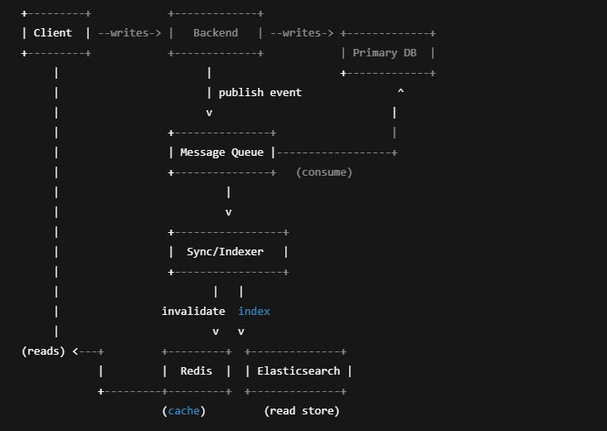
Components:
• Backend API (commands & queries)
• Primary DB (write store) — PostgreSQL / MongoDB
• Message Queue / Stream — Kafka / RabbitMQ
• Sync / Indexer Service — consumes events and indexes into ES
• Elasticsearch/OpenSearch — read store
• Redis — optional caching
Data Flow (step-by-step):
1. Client → POST /orders → Backend validates and writes to DB.
2. Backend publishes OrderCreated event to message queue.
3. Sync Service consumes event, transforms and indexes into ES; optionally updates Redis.
4. Client reads: Backend queries Redis → on miss queries ES → returns response.

8. Integration Plan — Adding Elasticsearch to Existing App (Detailed)
Phase 1 — Preparation:
• Identify slow read endpoints.
• Design document model (denormalized JSON).
• Create index mappings (text vs keyword, analyzers, date formats).
• Provision dev cluster (OpenSearch or local Docker single-node).
Phase 2 — Event Capture:
• After DB commit, publish domain events (EntityCreated/Updated/Deleted).
• Include schema_version and timestamps.
Phase 3 — Sync Service:
• Build consumer to transform events → ES documents.
• Implement idempotency (use DB primary key as ES _id).
• Dead-letter queue for failures; retry/backoff strategy.
Phase 4 — Backfill:
• Script to read DB rows and index into ES (same transform logic).
• Validate counts and sample documents.
Phase 5 — Feature Flag Rollout:
• Shadow reads: query ES in parallel and compare with DB.
• Gradually route a percentage of read traffic to ES.
Phase 6 — Monitoring & Alerts:
• Dashboards: QPS, latency, indexing lag, cluster health.
• Alerts: cluster health (red/yellow), sync lag, DLQ growth, node OOM.
Phase 7 — Clean-up:
• Retire heavy DB queries once ES is validated.
• Maintain runbooks for ES failures and rollback steps.

9. Operational Tips & Best Practices (Short)
• Mapping discipline: define mappings explicitly for fields used in aggregations/sorting. Use .keyword for exact terms.
• Index lifecycle (ILM): roll over hot indices and move older data to warm/cold nodes.
• Bulk indexing: use the bulk API for high throughput and tune refresh_interval while indexing.
• Backups: schedule regular snapshots to S3 / object storage.
• Security: use TLS, RBAC, and audit logging in production.
• Observability: track node metrics, GC, disk usage, merge times, and segment counts.

