Joint Inspection report
It is to certify that a Grid Connected Solar PV Power Plant has been installed with following details:
1. Name of the beneficiary: Mrs. Krishni Nagde
2. Address of installation with pin code: SHARDA NAGAR GAUTHANA RANIPUR ROAD GAUTHANA BETUL,460001
3. Electricity consumer number: N2317015620
4. Solar PV module capacity (DC): 4.82 kWp
5. Inverter capacity (AC) (Nominal output power): 5 kW
6. Date of installation: 15/09/2026
7. Date of Commissioning (after installation of Net meter) :_________________
8. Date of Joint inspection: ___________________
9. Metering arrangement: (Net meter/Gross meter/Net billing)
The above system is as per BIS/MNRE specifications and has been checked for its performance on__________________ and it is working satisfactorily.
DISCOM EMPANELLED AGENCY CONSUMER
Name _________ Bhim Energy Solutions Krishni Nagde
Designation _________ ________________________ _____________________
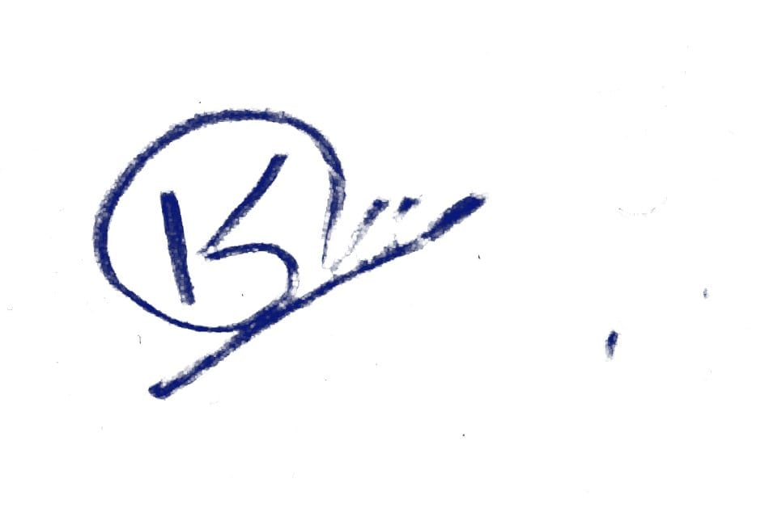

Date _________ ________________________ _____________________
Sign _________ ________________________ _____________________
Seal _________ ________________________ _____________________
It is to certify that the above system has been purchased with following details:
1. Total project cost : Rs. 2,80,000/-
2. Subsidy amount : Rs. 78,000/-
3. Amount paid by beneficiary: Rs. 2,02,000/-
EMPANELLED AGENCY CONSUMER
Name Bhim Energy Solutions Krishni Nagde
Designation _____________________
Date _____________________ _____________
Sign _____________________ _____________
Seal _____________________

