**PIZZA SALES SQL QUERIES**

1. **KPI’s**

**1. Total Revenue:**

SELECT SUM(total_price) AS Total_Revenue

FROM pizza01;

***Output:***

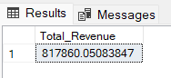

**2. Average Order Value**

SELECT (SUM(total_price) / COUNT(DISTINCT order_id)) AS Avg_order_Value

FROM pizza01;

***Output:***

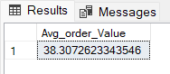

**3. Total Pizzas Sold**

SELECT SUM(quantity) AS Total_pizza_sold

FROM pizza01;

***Output:***

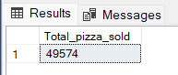

**4. Total Orders**

SELECT COUNT(DISTINCT order_id) AS Total_Orders

FROM pizza01;

***Output:***

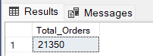

**5. Average Pizzas Per Order**

SELECT CAST(CAST(SUM(quantity) AS DECIMAL(10,2)) /

CAST(COUNT(DISTINCT order_id) AS DECIMAL(10,2)) AS DECIMAL(10,2))

AS Avg_Pizzas_per_order

FROM pizza01;

***Output:***

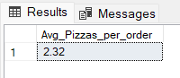

1. **Daily Trend for Orders**

SELECT Weekname, count(DISTINCT order_id) AS Total_orders

FROM pizza01

GROUP BY weekname**;**

***Output:***

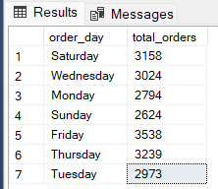

**C. Hourly Trend for Orders**

SELECT HOUR(order_time) AS order_hours,

COUNT(DISTINCT order_id) AS total_orders

FROM pizza01

GROUP BY order_hours

ORDER BY order_hours;

***Output***

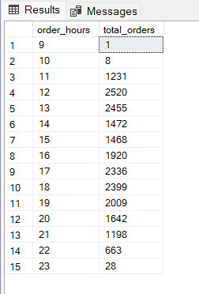

**D. % of Sales by Pizza Category**

SELECT pizza_category,

CAST (SUM (total_price) AS DECIMAL (10,2)) AS total_revenue,

CAST(SUM(total_price) * 100 / (SELECT SUM(total_price) FROM pizza01)

AS DECIMAL(10,2)) AS PCT

FROM pizza01

GROUP BY pizza_category;

***Output***

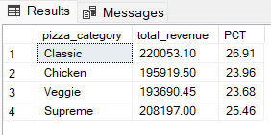

**E. % of Sales by Pizza Size**

SELECT pizza_size, ROUND( (COUNT(pizza_size) / SUM(total_price) * 100), 2) AS PPC

FROM pizza01

GROUP BY pizza_size

ORDER BY pizza_size;

***Output***

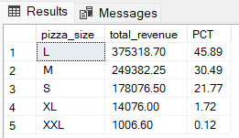

**F. Total Pizzas Sold by Pizza Category**

SELECT pizza_category, SUM (quantity) as TPSC

FROM pizza01

GROUP BY pizza_category;

***Output***

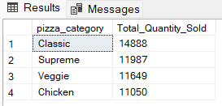

**G. Top 5 Best Sellers by Total Pizzas Sold**

SELECT pizza_name, SUM (quantity) AS Total_Pizza_Sold

FROM pizza01

GROUP BY pizza_name

ORDER BY Total_Pizza_Sold DESC

LIMIT 5;

***Output***

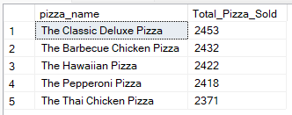

**H. Bottom 5 Best Sellers by Total Pizzas Sold**

SELECT pizza_name, SUM (quantity) AS Total_Pizza_Sold

FROM pizza01

GROUP BY pizza_name

ORDER BY Total_Pizza_Sold

LIMIT 5;

***Output***

