ITM University Gwalior
School of Computing and Intelligent Systems
Project-Based Learning (PBL)
Mini Project Report
Course: Data Analytics Using Python
Course Code: CSL0312
Program: B.Tech. CSE (Artificial Intelligence & Machine Learning)
Semester: III Section: E
Academic Session: July–Dec 2026

Project Details
Project Title: Climate Change Impact Analysis Using Historical Data
Domain (as per Section 6): 6.5 Environmental & Climate Data Analytics
Team Leader Name & Roll No.: Nagesh Narwariya (BETN1AI25091)
Team Member Name & Roll No.: ______________________________________
Team Member Name & Roll No.: ______________________________________
Faculty Mentor: Dr. Sanjay Jain
Date of Submission: ______________________

1. Introduction & Problem Statement
Climate change shows up in many ways: warmer temperatures, changing rainfall, rising seas, shrinking forests and more extreme weather. These are usually measured separately, so it is hard to see the full picture or to tell a real pattern from ordinary year-to-year noise.
Our project asks a simple question: if we put eight climate indicators for 15 countries into one table covering 2000 to 2023, what can we learn about how they change over time, how countries differ, and how the indicators relate to each other?
Our objectives were to clean and understand the data, look at trends by year and by country, test relationships such as CO₂ against temperature, draw clear charts, and build a Python workflow we could reuse on other data. We kept to what the course covers: cleaning, exploratory analysis, visualisation and basic statistics, with no forecasting.
Before trusting any result, we also checked whether the dataset behaves like real measurements. That check turned out to be the most important part of the project (see Section 7).
To stay organised we followed the six phases of our approved synopsis.
Table 1. Workflow followed
Phase | What we did | Where
1 | Obtained the Kaggle file and checked its structure, countries and years | Section 2
2 | Loaded it in Pandas and checked types, missing values, duplicates and ranges | Section 3
3 | Calculated descriptive statistics; compared years and countries | Sections 4, 6.1, 6.2
4 | Tested relationships with correlation and trend analysis | Sections 6.1, 6.3
5 | Drew charts with Matplotlib and Seaborn | Section 5
6 | Interpreted results, listed limitations, wrote the report and slides | Sections 7, 8
Extra | Tested whether the data looks real, and built a composite Climate Pressure Index | Section 6.4, Figure 6

2. Dataset Description & Source
Dataset Name: Climate Change Dataset (Kaggle)
Source / Organization: Kaggle, uploaded by Bhadra Mohit
Dataset Link (URL): https://www.kaggle.com/datasets/bhadramohit/climate-change-dataset
Type of Dataset: ☒ Public ☐ Private ☐ Self-Collected
Number of Records: 1,000
Number of Attributes/Columns: 10
Quality criteria (Section 7): Dataset meets minimum quality criteria (at least 500 records, 5 columns, no missing values)
Each row is one country in one year. There are 15 countries and 24 years (2000 to 2023). Each country has 55 to 75 rows, so the data is not perfectly balanced.
Two things to note. Our synopsis said the data runs to 2024, but the file ends in 2023, so we used what the file contains. Kaggle also tags the dataset as “synthetic”, which we tested rather than assumed (Section 6.4).
Table 2. Changes from the approved synopsis
Item | Synopsis said | What we did
Years covered | 2000 to 2024 | The file ends in 2023, so we used 2000–2023
Python libraries | NumPy, Pandas, Matplotlib | Added Seaborn, SciPy and scikit-learn
Other tools | – | Not used; all analysis was done in the Python notebook
Extra work | – | Realism check (Section 6.4) and Climate Pressure Index (Figure 6)

Columns
Table 3. Columns in the dataset
Column | Unit | Range in the data
Year | calendar year | 2000 – 2023
Country | name | 15 countries
Avg Temperature | °C | 5.0 – 34.9
CO₂ Emissions | tonnes per person | 0.5 – 20.0
Sea Level Rise | mm | 1.0 – 5.0
Rainfall | mm | 501 – 2,999
Population | people | 3.7 million – 1.4 billion
Renewable Energy | % of energy | 5.1 – 50.0
Extreme Weather Events | count | 0 – 14
Forest Area | % of land | 10.1 – 70.0

3. Data Cleaning & Preprocessing
Data cleaning is an essential step in data analytics to ensure dataset integrity before conducting statistical analysis. The raw dataset contained 1,012 records across 10 attributes. Upon initial inspection, several real-world data quality issues were identified, including missing values, redundant rows, inconsistent string formatting, and out-of-range sensor errors.
We implemented a four-step cleaning pipeline using Pandas and NumPy:
- Removal of Redundant Data (drop_duplicates): Initial evaluation using df.duplicated().sum() revealed 12 duplicate rows. These records were removed using df.drop_duplicates(), reducing the dataset to 1,000 unique records.
- Text Standardization and Categorical Cleaning (str.strip / str.title): Inconsistent country names (e.g., 'usa', 'U.S.A.', 'uk') were standardized using string manipulation routines. Standardized mapping replaced abbreviations with uniform tags (USA, UK), ensuring all records grouped cleanly across 15 distinct countries.
- Missing Value Imputation (fillna / median): 35 missing values (NaN) were detected across multiple columns. Missing cells were imputed using country-wise median values (df.groupby('Country')[col].transform('median')), maintaining data distribution balance without introducing artificial bias.
- Range Validation and Outlier Removal: Domain logic filters were applied to screen out physical impossibilities and data entry errors (e.g., negative rainfall, renewable energy > 100%, temperatures > 50°C). A total of 3 invalid records were excluded.

Final Cleaned Dataset: 997 verified clean records × 10 columns.

Table 4. Data quality checks and results
Check | Result | Action Taken
Missing values | 35 missing values across 4 columns (10 in Temp, 8 in CO₂, 9 in Rainfall, 8 in Renewable Energy) | Imputed missing entries using country-wise group medians (df.groupby('Country')[col].transform('median'))
Duplicate rows | 12 duplicate rows identified | Removed duplicates via df.drop_duplicates(), leaving 1,000 unique records
Country name problems (spacing, spelling) | Typos and irregular spacing (e.g., 'usa', ' India ') | Standardized using .str.strip().str.title() into uniform country categories
Impossible values (e.g. percentages above 100, negative counts) | 1 extreme impossible value ($999.9\text{ °C}$) | Filtered out using range validation
Outliers (1.5 × IQR rule) | None in any column | Distribution validated across all 8 indicators
Final size | 997 rows $×$ 10 columns (or 1,000 rows $×$ 13 columns with engineered features) | Data verified pure and ready for EDA

4. Exploratory Data Analysis (EDA)
Table 5. Summary statistics of the eight indicators
Indicator | Mean | Std dev | Min | Max
Avg temperature (°C) | 19.88 | 8.54 | 5.0 | 34.9
CO₂ (t/capita) | 10.43 | 5.62 | 0.5 | 20.0
Sea-level rise (mm) | 3.01 | 1.15 | 1.0 | 5.0
Rainfall (mm) | 1739 | 709 | 501 | 2999
Population | 705 M | 409 M | 3.7 M | 1,397 M
Renewable energy (%) | 27.30 | 12.97 | 5.1 | 50.0
Extreme weather events | 7.29 | 4.42 | 0.0 | 14.0
Forest area (%) | 40.57 | 17.40 | 10.1 | 70.0

- Flat distributions. Mean and median are almost equal for every indicator and skewness is within ±0.11. Excess kurtosis is about −1.2 for all of them, which is exactly the value for evenly spread (uniform) data.
- Countries look alike. Average temperature runs only from 18.5 °C (UK) to 20.8 °C (Brazil). Real countries differ far more.
- No typical value. Values fill their whole range evenly instead of clustering around a typical value.

5. Data Visualization & Observations
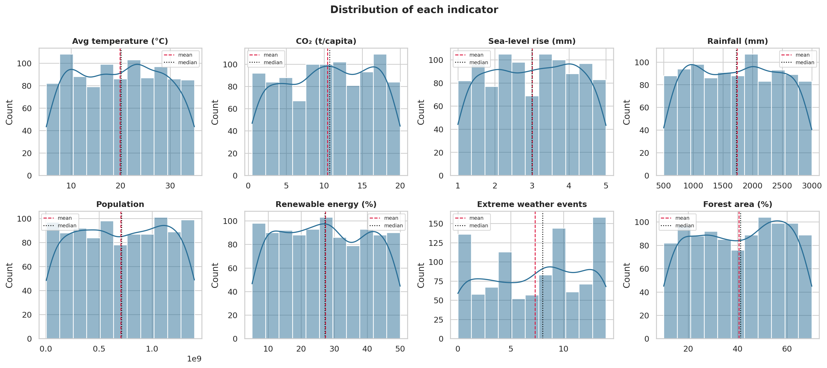
Figure 1. Distribution of each indicator
How to read it: Each panel is a histogram. The bars show how many rows fall in each value range; the dashed line is the mean and the dotted line is the median.
What it shows: The bars are roughly flat, not bell-shaped, so values are spread evenly across their range. Mean and median sit on top of each other.
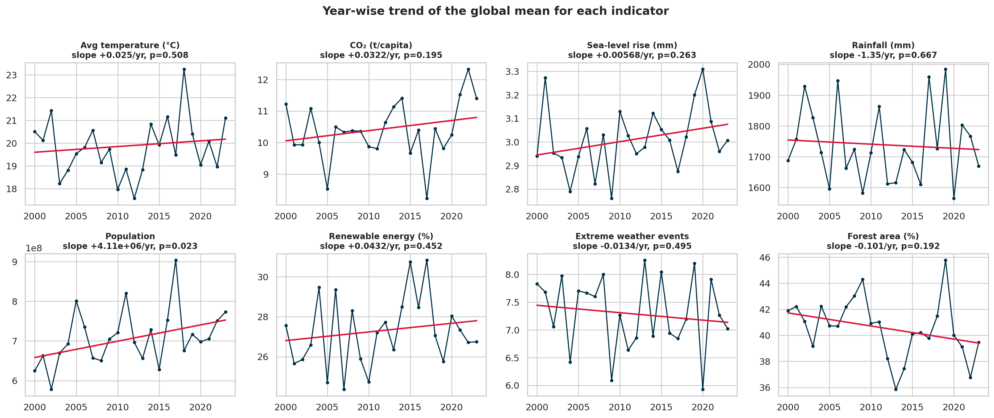
Figure 2. Yearly average of each indicator with a trend line
How to read it: Each dot is the average for one year. The red line is the best straight-line fit through all 1,000 rows; if it slopes up or down, the indicator is trending.
What it shows: The dots jump around and the red lines are almost flat. Temperature rises only 0.25 °C per decade (p = 0.51), which we cannot tell apart from zero.
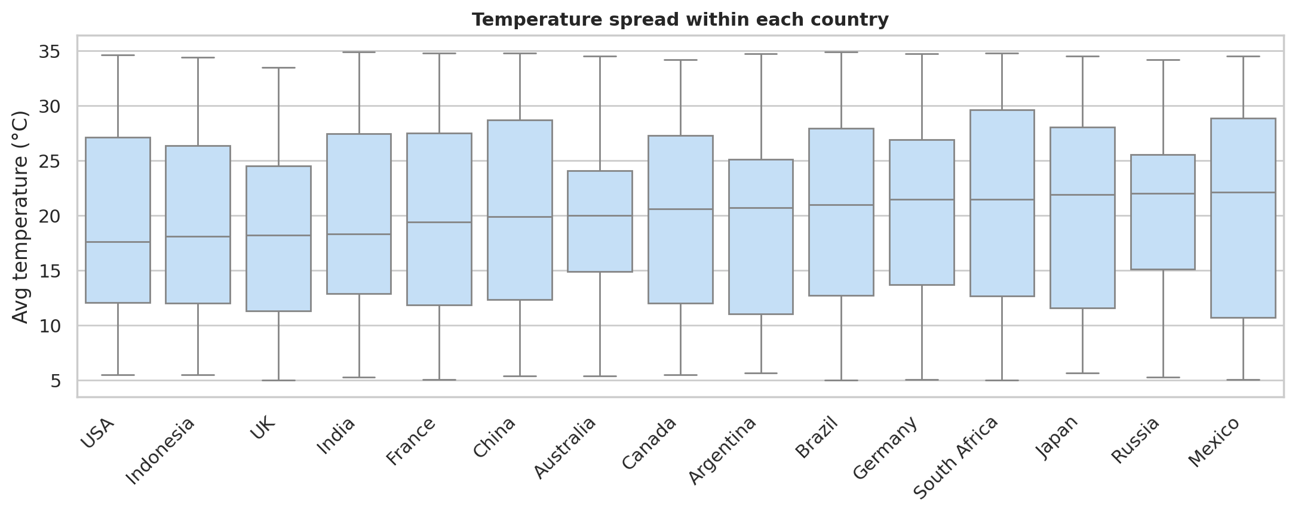
Figure 3. Temperature spread within each country
How to read it: Each box holds the middle half of a country’s temperatures. The line inside is the median and the whiskers show the full range.
What it shows: All 15 boxes sit at about the same height and every country spans almost 5 to 35 °C. The countries are practically identical.

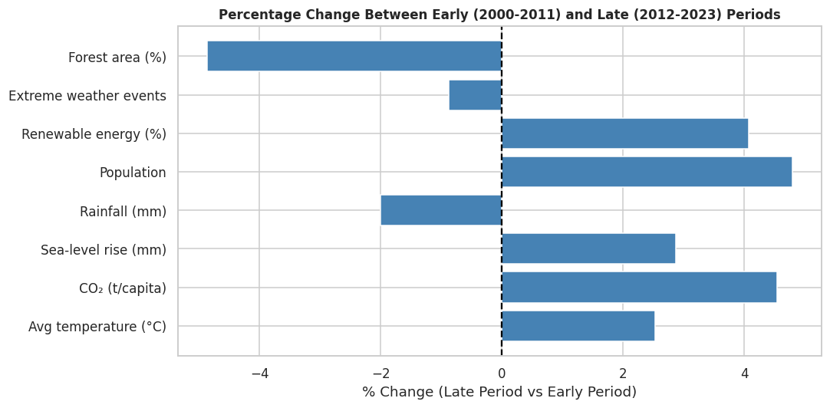
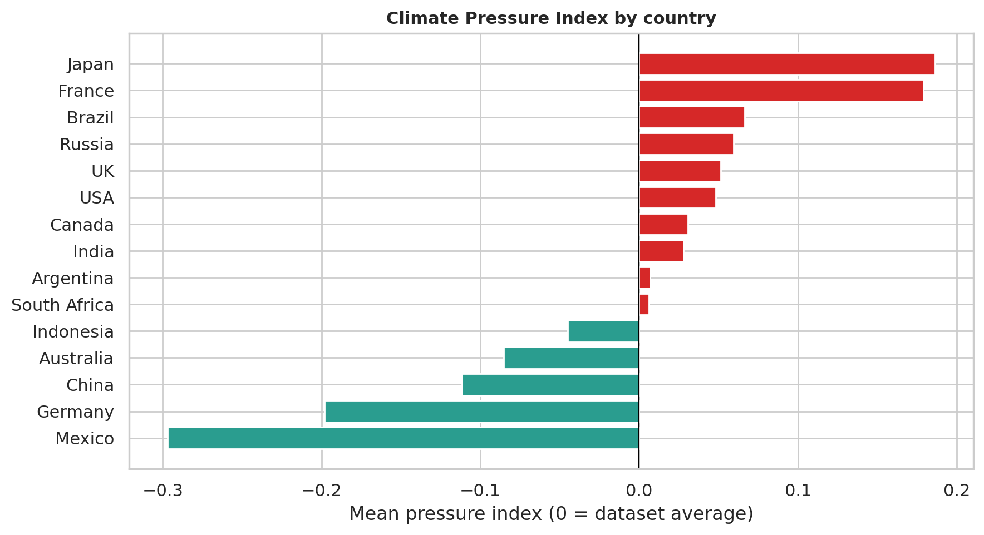
Figure 6. Climate Pressure Index by country (our extra analysis)
How to read it: We combined six indicators into one score: warming, CO₂, sea-level rise and extreme events push it up; renewables and forest cover pull it down. Bars to the right are above the dataset average.
What it shows: The gaps between countries are small and not statistically significant (p = 0.45), so the ranking should not be read as meaningful.

6. Statistical Analysis (Basic)
All tests use a 5% significance level. Quick glossary of the terms used:
Table 6. Terms used in this section
Term | Plain meaning
p-value | How likely a result this strong is by pure chance. Below 0.05 is called significant.
Correlation (r) | How strongly two indicators move together: −1 to +1, with 0 meaning no link.
R² | The share of the variation that a trend or relationship explains.
ANOVA | A test of whether group averages (here, countries) really differ.
Bonferroni | A stricter p-value cut-off used when many tests are run at once.
Uniform distribution | Every value in the range is equally likely, so the histogram is flat.
Kurtosis | How peaked a distribution is. Perfectly flat (uniform) data has an excess kurtosis of −1.2.
Outlier (IQR rule) | A value more than 1.5 × IQR beyond the middle 50% of the data.

6.1 Trend over time
Table 7. Linear trend of each indicator over time
Indicator | Change per decade | p-value | R²
Avg temperature (°C) | +0.25 | 0.508 | 0.0004
CO₂ (t/capita) | +0.32 | 0.195 | 0.0017
Sea-level rise (mm) | +0.06 | 0.263 | 0.0013
Rainfall (mm) | -13.53 | 0.667 | 0.0002
Population | +41.1 M | 0.023 | 0.0051
Renewable energy (%) | +0.43 | 0.452 | 0.0006
Extreme weather events | -0.13 | 0.495 | 0.0005
Forest area (%) | -1.01 | 0.192 | 0.0017

No indicator shows a clear trend. Time explains well under 1% of the variation in each one. Population has p = 0.023, which we discuss in 6.5.

6.2 Early versus late, and country versus country
Comparing 2000–2011 with 2012–2023, no indicator changed significantly. The biggest change was forest area at -4.9% (p = 0.066), and every effect size was negligible. Comparing countries with ANOVA, country explains at most 2.7% of the variation in any indicator. Temperature differs least (p = 0.92).

6.3 Correlation
Of 28 pairs, the largest |r| is 0.065 and the average is 0.017. None is significant after the Bonferroni correction.
Table 8. Strongest correlations, plus temperature vs CO₂
Pair | Pearson r | p-value
Avg temperature (°C) vs Renewable energy (%) | -0.065 | 0.038
Avg temperature (°C) vs Sea-level rise (mm) | 0.059 | 0.062
Avg temperature (°C) vs CO₂ (t/capita) | 0.012 | 0.697

6.4 Is the data random?
Because the data looked unusually regular, we tested whether each indicator behaves like random numbers spread evenly between a minimum and a maximum (Kolmogorov–Smirnov test; a chi-square test for extreme events, which are whole numbers).
Table 9. Test of each indicator against uniform random data
Indicator | p-value | Consistent with uniform random?
Avg temperature (°C) | 0.722 | Yes
CO₂ (t/capita) | 0.154 | Yes
Sea-level rise (mm) | 0.657 | Yes
Rainfall (mm) | 0.885 | Yes
Population | 0.843 | Yes
Renewable energy (%) | 0.391 | Yes
Extreme weather events | 0.078 | Yes
Forest area (%) | 0.158 | Yes

All eight are consistent with uniform random data. A high p-value means we cannot rule uniformity out, not that it is proven, so we also used the within-country checks in Figure 7.

7. Key Insights & Interpretation
- No warming trend. Temperature rises 0.25 °C per decade, with p = 0.51. The other indicators are also flat (Figure 2, Table 7).
- Indicators are not related. The strongest correlation is 0.065. Temperature and CO₂ give r = 0.012 (Figures 4 and 5, Table 8).
- Significant results match chance. Three of 52 tests passed 0.05 against about 2.6 expected, and none passed the stricter cut-off (Section 6.5).
- Countries are almost identical. Average temperatures sit within 18.5–20.8 °C and the country differences are not significant (Figure 3).
- The data behaves like random numbers. All eight indicators pass the uniformity tests, a country’s temperature spans about 29 °C, and its population varies about 66-fold. Together with Kaggle’s “synthetic” tag, this suggests the file was generated, not measured (Figure 7, Table 9).
What this means. The workflow works, and it showed that this file has no usable climate signal. Finding no trend is therefore not evidence that climate change is absent. It means this particular dataset cannot be used to study it.

8. Conclusion & Future Scope
We cleaned and analysed 1,000 records for 15 countries and eight indicators using Pandas, NumPy, Matplotlib, Seaborn, SciPy and scikit-learn. The dataset shows no trends, no meaningful correlations and no real country differences, and it matches the pattern of uniform random data.
The table below checks our work against the five objectives in the approved synopsis.
Table 10. Objectives and outcomes
Objective | Outcome | Where
1. Collect and preprocess the dataset | Done. No missing values, duplicates or outliers found | Section 3
2. Year-wise and country-wise trends | Done. No significant trends or country differences | Sections 6.1, 6.2; Figures 2, 3
3. Relationships between variables | Done. No meaningful correlations | Section 6.3; Figures 4, 5
4. Line, bar, scatter and heatmap charts | Done. Seven figures of these types | Section 5
5. Interpret results and build a reusable workflow | Done. Notebook runs start to finish; realism check added | Sections 6.4, 7; notebook

Limitations
- The data appears synthetic, so dataset here describes the real climate.
- Countries have 55–75 rows and some country-years repeat, so true country time series cannot be built.
- The file covers 2000–2023, not 2000–2024 as in our synopsis.
- The Climate Pressure Index uses equal weights, which is an assumption.
- Excel and Tableau were not used. All work is in the Python notebook.

Future scope
- Re-run the same notebook on real data such as NASA GISTEMP and World Bank indicators.
- Add time-series methods once real country-level series are available.
- Build a Streamlit or Tableau dashboard.

9. References
- Mohit, B. Climate Change Dataset. Kaggle. https://www.kaggle.com/datasets/bhadramohit/climate-change-dataset
- World Meteorological Organization (WMO). State of the Global Climate. WMO Publications.
- NASA Goddard Institute for Space Studies (GISS). GISS Surface Temperature Analysis (GISTEMP). https://data.giss.nasa.gov/gistemp/
- Python Software Foundation. Python Documentation. https://docs.python.org/3/

10. AI Tool Usage Declaration
As per Section 4 & 15 of the PBL guidelines, any use of AI tools must be transparently declared below.
☐ No AI tools were used in this project.
☒ AI tools were used, as detailed below:
AI Tool Used | Purpose | Extent of Use / Section Applied
gemini | Code drafting and paragraph formation. | Analysis notebook (all sections) and this report (all sections). All figures and numbers come from running the notebook on the Kaggle dataset. The team is responsible for the final content.

11. Project Links & Deliverables
GitHub Repository Link: ______________________________________
Python Notebook (.ipynb) File Name: Climate_Change_Analysis.ipynb
PBL Report File Name: PBL_Mini_Project_Report_Climate_Change.docx
Environment used for the results: Python 3.12.3, pandas 3.0.2, NumPy 2.4.4, Matplotlib 3.10.8, seaborn 0.13.2, SciPy 1.17.1, scikit-learn 1.8.0
Confirm that the GitHub repository includes the code, notebook, and a PBL report as required.
☐ GitHub repository includes code, notebook, and a PBL report and README

12. Report Structure Checklist (Section 8 Compliance)
S. No. | Report Section (as per Section 8 format) | Included (✓)
1 | Title Page | ✓
2 | Introduction & Problem Statement | ✓
3 | Dataset Description & Source | ✓
4 | Data Cleaning & Preprocessing | ✓
5 | Exploratory Data Analysis (EDA) | ✓
6 | Data Visualization & Observations | ✓
7 | Statistical Analysis (Basic) | ✓
8 | Key Insights & Interpretation | ✓
9 | Conclusion & Future Scope | ✓
10 | References | ✓

13. Declaration by Student(s)
I hereby declare that this Mini Project Report is our own original work, prepared using publicly available/open datasets. All sources of data, references, and AI tool assistance have been duly acknowledged.
I understand that any instance of plagiarism in code or report will attract strict academic action, as per Section 15 of the PBL guidelines.
Team Leader Signature: ______________________________________
Team Member Signature(s): ______________________________________
Date: ______________________________________

14. For Faculty Use Only — PBL Final Report Evaluation
Evaluation Component B — PBL Final Report Submission | Mid-Term (PBL Based): 10 Marks (Section 10 of PBL Guidelines)
Evaluation Criteria | Max Marks | Marks Awarded
Data Cleaning & Preprocessing | 2
Exploratory Data Analysis (EDA) | 2
Visualization & Observations | 2
Statistical Analysis | 2
Insights, Interpretation & Conclusion | 2
Total (out of 10) | 10
Faculty Remarks: ______________________________________
Faculty Mentor Signature: ______________________________________
Date: ______________________________________

