Final Variable Pgm:

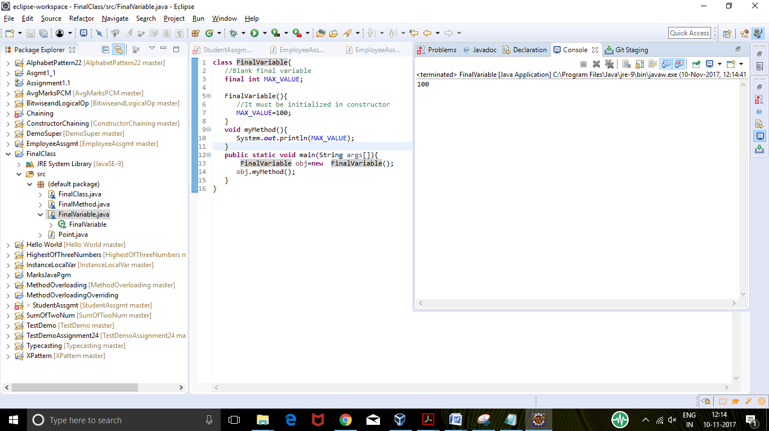

Final Method Pgm:

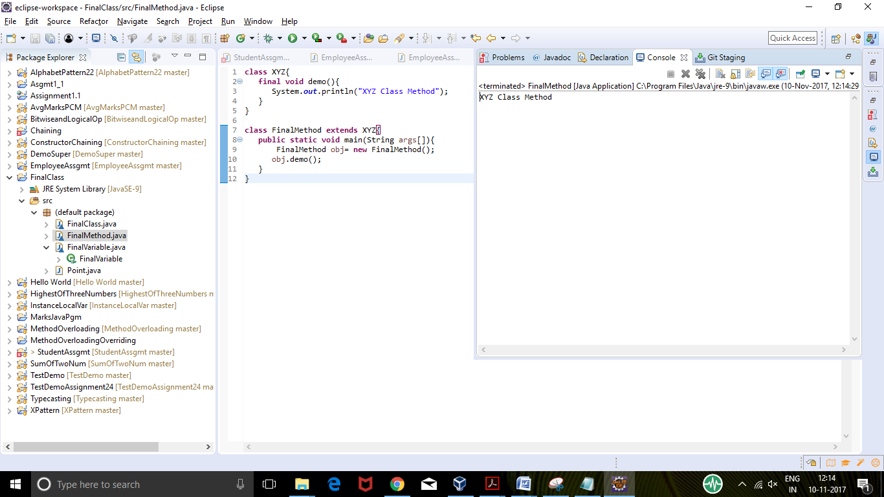

Final Class Pgm:

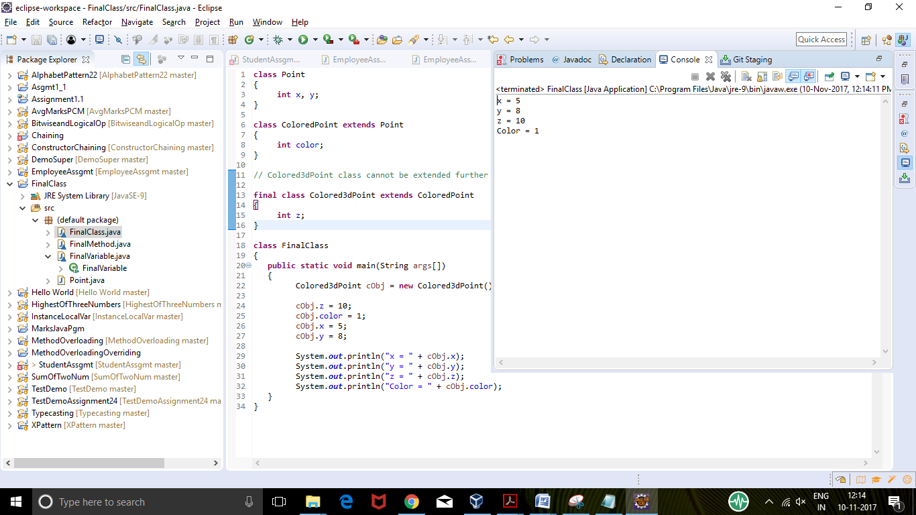

Constructor with final is not possible , hence no program created for it.