[BOOK](https://nap.nationalacademies.org/read/9254/chapter/5)

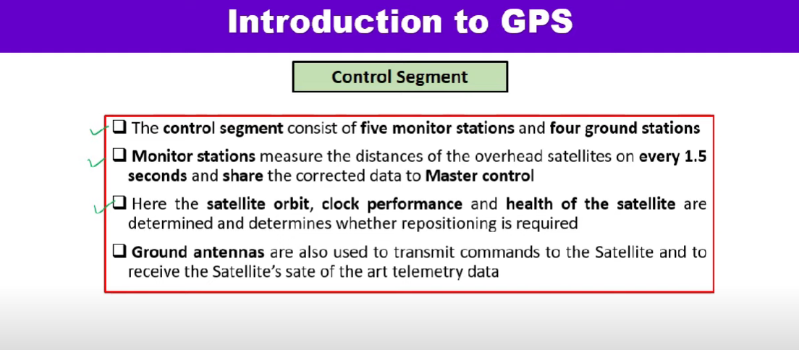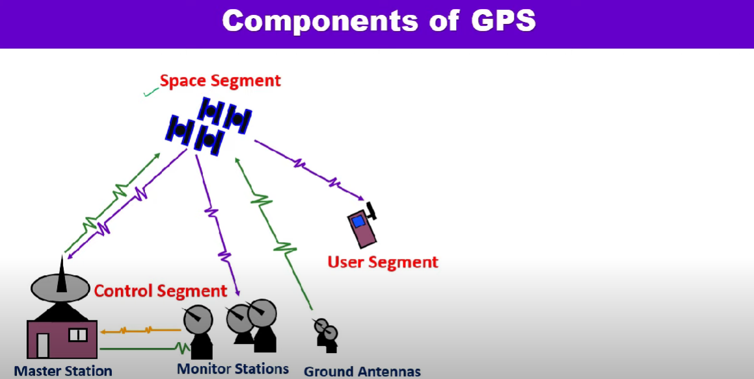

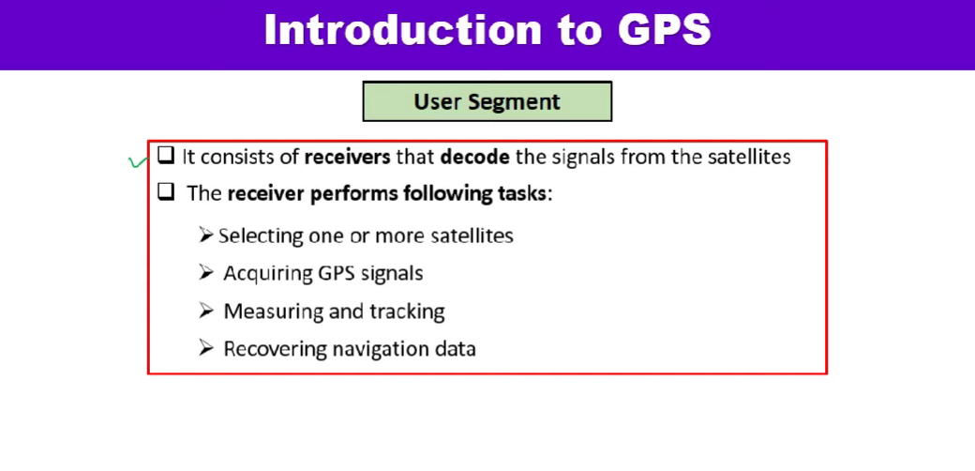

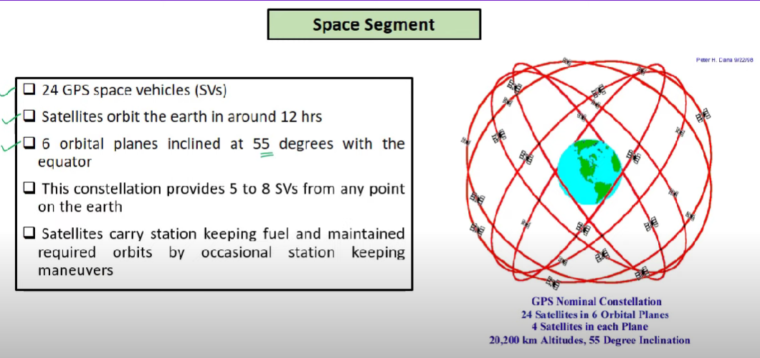

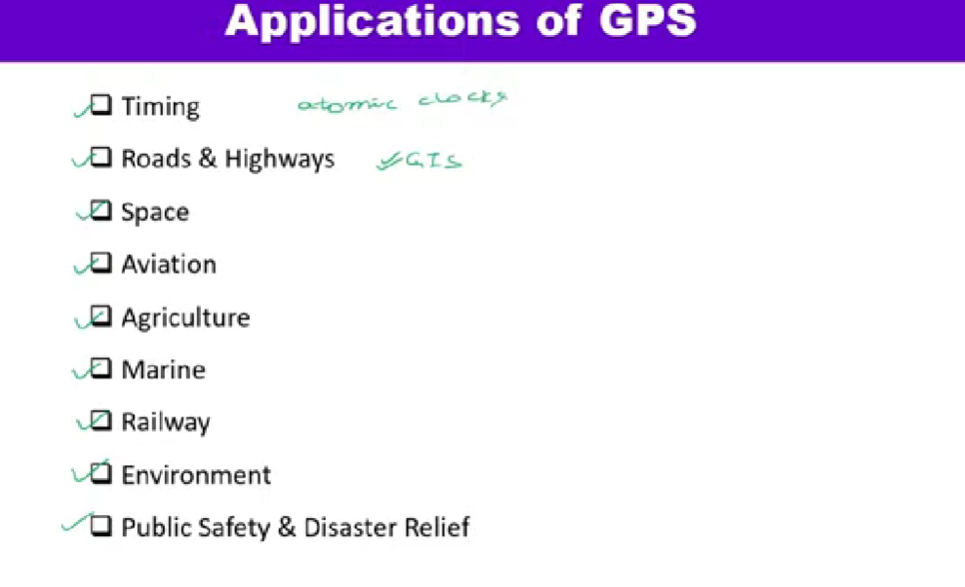

Surveying and mapping

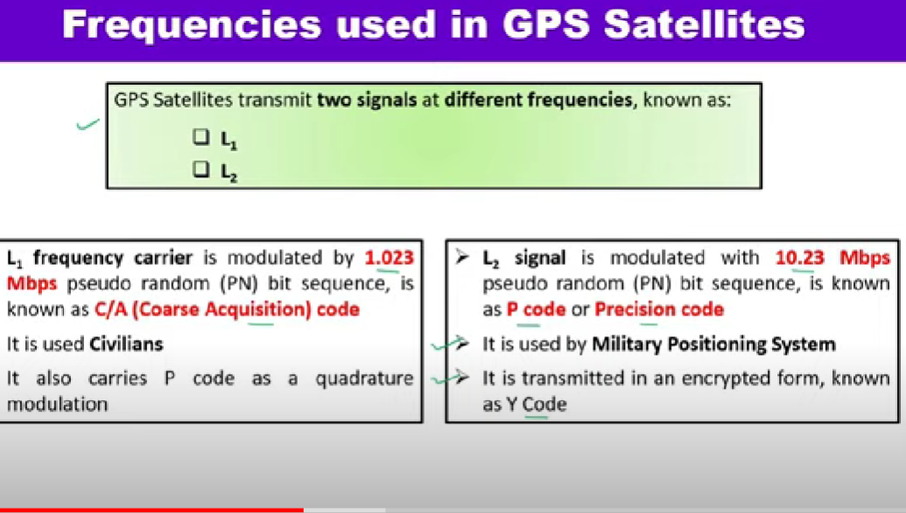

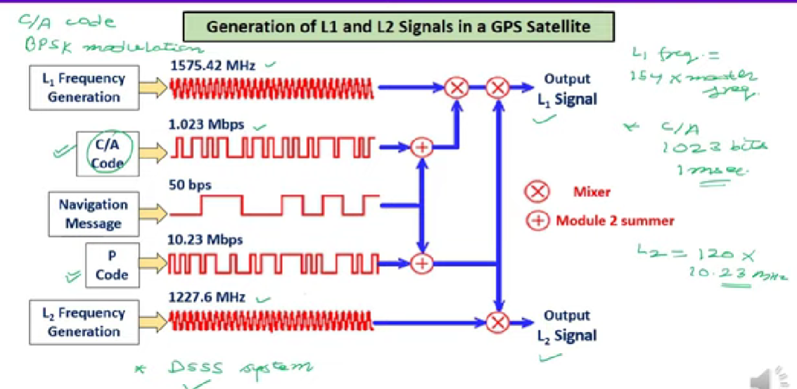

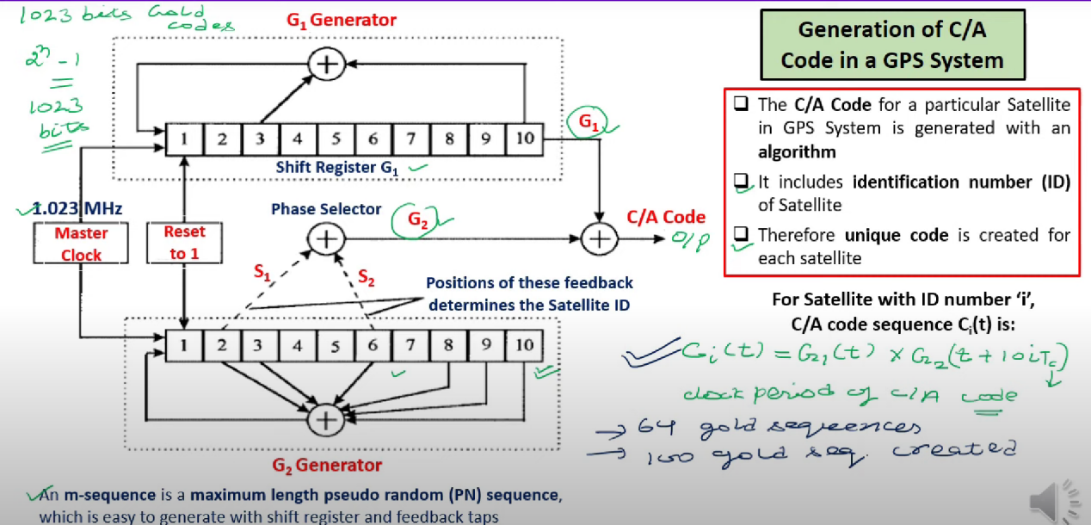

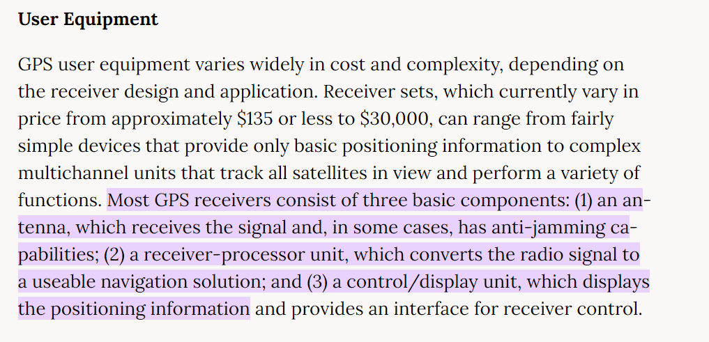

**About GPS of PHANTOM :**

The DJI Phantom 3 GPS Module has Dual **GPS/GLONASS modules**, an operating voltage of **3.6 V**, and is compatible with the Phantom 3 Professional and Phantom 3 Advanced.

[GPS MODULE](https://dronesmadeeasy.com/phantom-3-gps-module/)

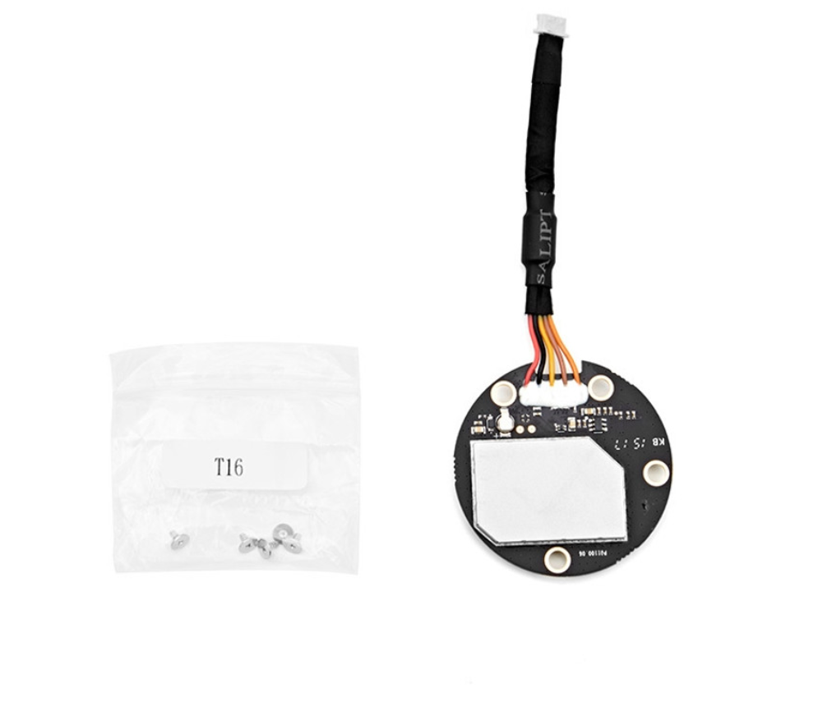

**Functions of 5-pins:**

Pin 0 (red): +3.3V

Pin 1 (black): GND

Pin 2(yellow): TX (3.3V)

Pin 3(brown): RX (3.3V)

Pin 4(orange): interrupt (5Hz)

**Board View:**

Top view (antenna visible)

<https://github.com/o-gs/dji-firmware-tools/wiki/P3X-photos/P3X-GPS-Module-boardv6-top.png>

<https://github.com/o-gs/dji-firmware-tools/wiki/P3X-photos/P3X-GPS-Module-boardv3-top.png>

Bottom View (SMD components visible)

<https://github.com/o-gs/dji-firmware-tools/wiki/P3X-photos/P3X-GPS-Module-boardv3-btm.png>

**About GPS Pins of PiXhawk :**

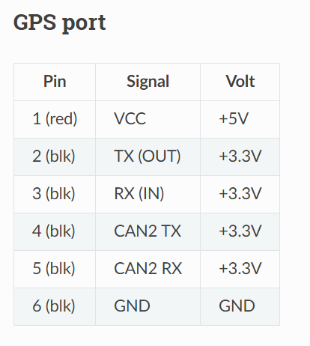

**Wire details:**

Red = VCC

White =TX (out)

Orange = RX(in)

Black = GND

Useful sites :  
[UART communication](https://www.analog.com/en/analog-dialogue/articles/uart-a-hardware-communication-protocol.html)

TO read :

I2C Communication

UART Communication