Screenshot for credit<650

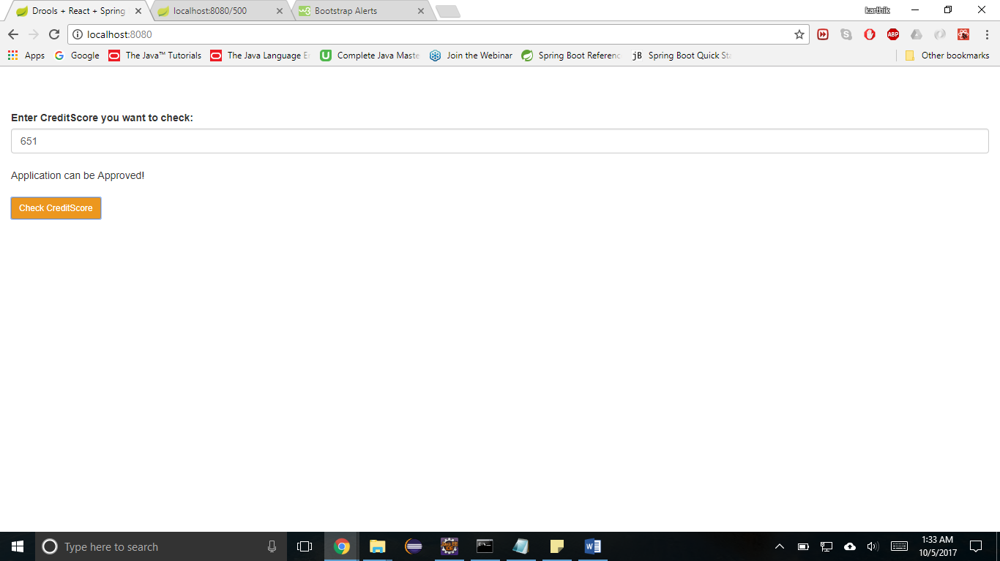

Screenshot for credit > 650