**Mercedes-Benz Greener Manufacturing**

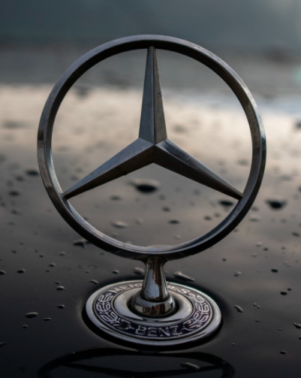

Building a machine learning model to choose the best features for a car, through that we can reduce the test time and cost. Which will be a very big deal.

Using PCA for dimensionality reduction and build a model on PCA.