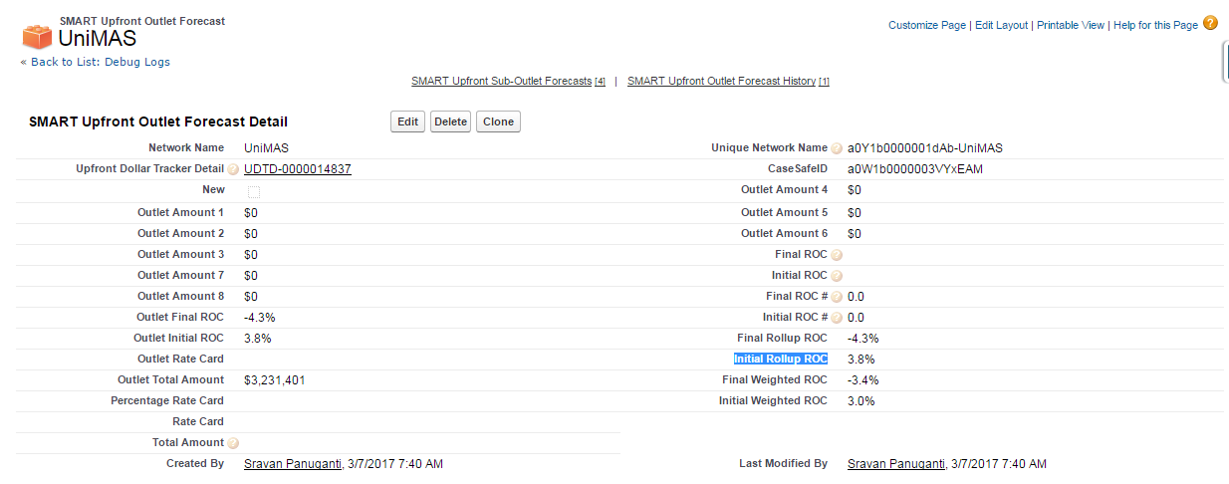

Highlighted Initial Rollup ROC (Initial_Rollup_ROC__c) is the rollup summary in Network_Quarter_Mapping__c object

All sub outlet Initial Weighted ROC values are summing up