## **MongoDB CRUD Operations – Culinary Skills Academy**

### **1.users Collection**

**Create**

db.users.insertOne({

user_id: "u301",

name: "Deepa Rao",

email: "deepa@example.com",

skill_level: "Beginner",

enrolled_courses: ["c101", "c102"],

progress: [

{ course_id: "c101", modules_completed: 2, certified: false }

]

})

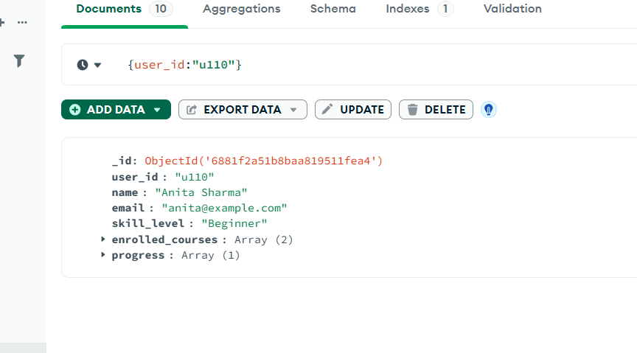

**Read**

db.users.find({ skill_level: "Beginner" })

**Update**

db.users.updateOne(

{ user_id: "u301" },

{ $set: { skill_level: "Intermediate" } }

)

**Delete**

db.users.deleteOne({ user_id: "u301" })

**2.courses Collection**

**Create**

db.courses.insertOne({

course_id: "c201",

title: "Dessert Special",

level: "Intermediate",

modules: ["Cakes", "Pies", "Plating"],

duration: "4h"

})

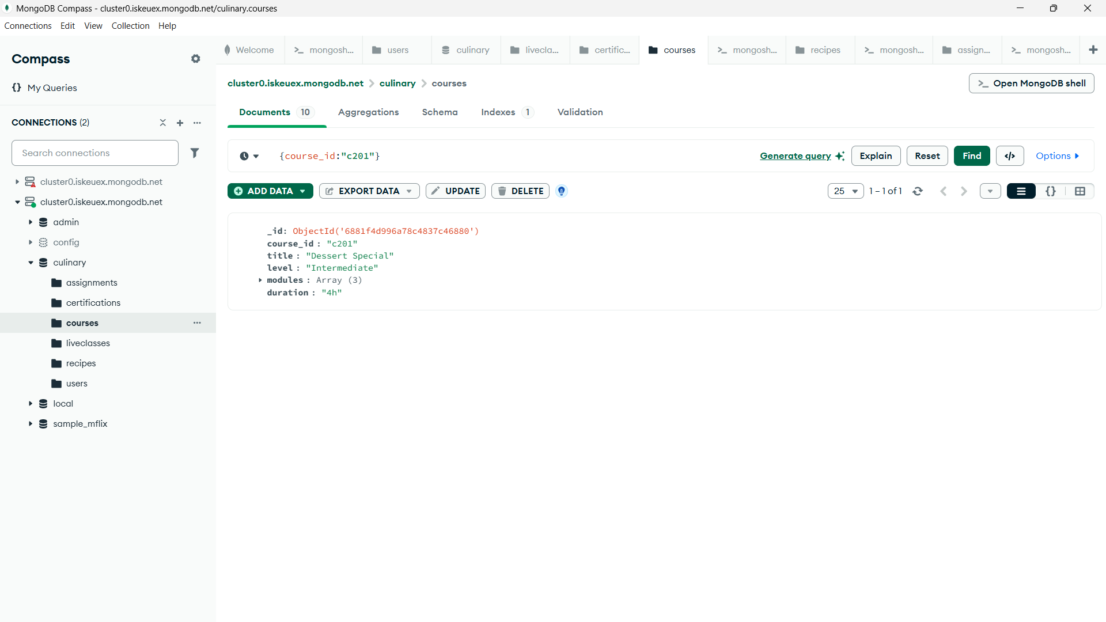

**Read**

db.courses.find({ level: "Intermediate" })

**Update**

db.courses.updateOne(

{ course_id: "c201" },

{ $set: { duration: "5h" } }

)

**Delete**

db.courses.deleteOne({ course_id: "c201" })

**3.recipes Collection**

**Create**

db.recipes.insertOne({

recipe_id: "r201",

title: "Vegan Stir Fry",

cuisine: "Asian",

difficulty: "Easy",

ingredients: ["Tofu", "Vegetables", "Soy Sauce"],

steps: ["Chop ingredients", "Stir fry", "Serve hot"],

linked_course: "c101"

})

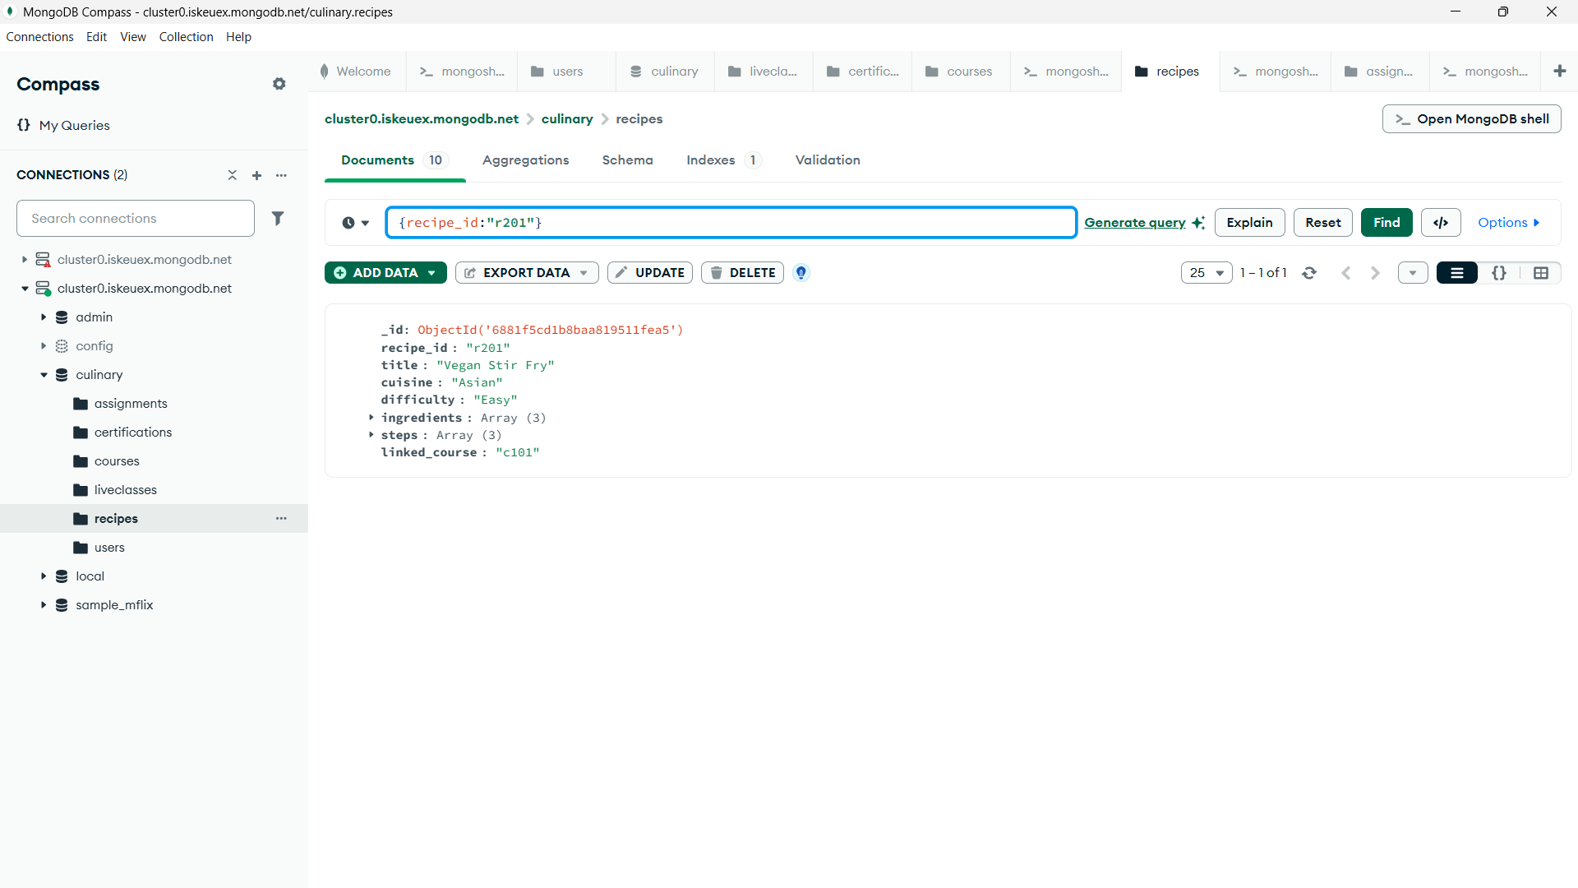

**Read**

db.recipes.find({ cuisine: "Asian" })

**Update**

db.recipes.updateOne(

{ recipe_id: "r201" },

{ $set: { difficulty: "Medium" } }

)

**Delete**

db.recipes.deleteOne({ recipe_id: "r201" })

### **4.assignments Collection**

**Create**

db.assignments.insertOne({

assignment_id: "a301",

user_id: "u301",

course_id: "c101",

submitted_video: "assignment301.mp4",

feedback: { score: 8, comments: "Well done!" }

})

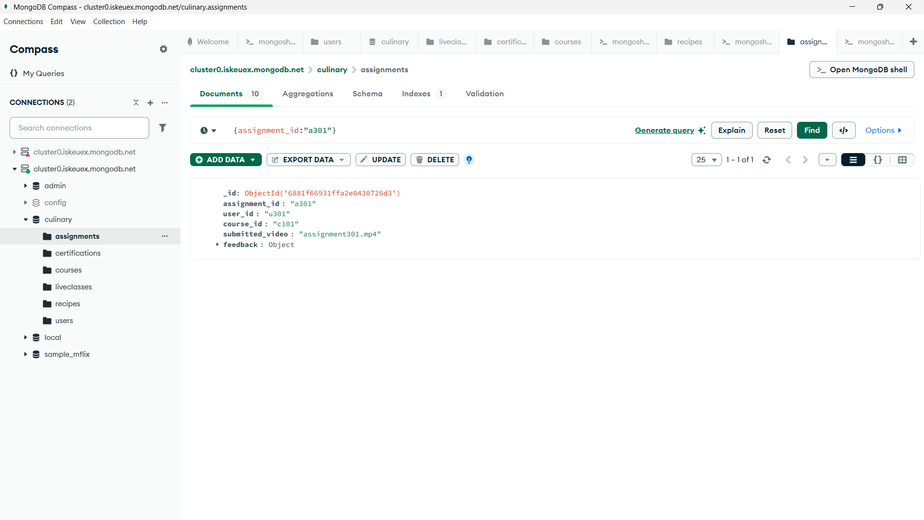

**Read**

db.assignments.find({ "feedback.score": { $gt: 7 } })

**Update**

db.assignments.updateOne(

{ assignment_id: "a301" },

{ $set: { "feedback.comments": "Excellent improvement!" } }

)

**Delete**

db.assignments.deleteOne({ assignment_id: "a301" })

### **5.certifications Collection**

**Create**

db.certifications.insertOne({

cert_id: "cert301",

user_id: "u301",

course_id: "c101",

date_issued: "2025-07-23"

})

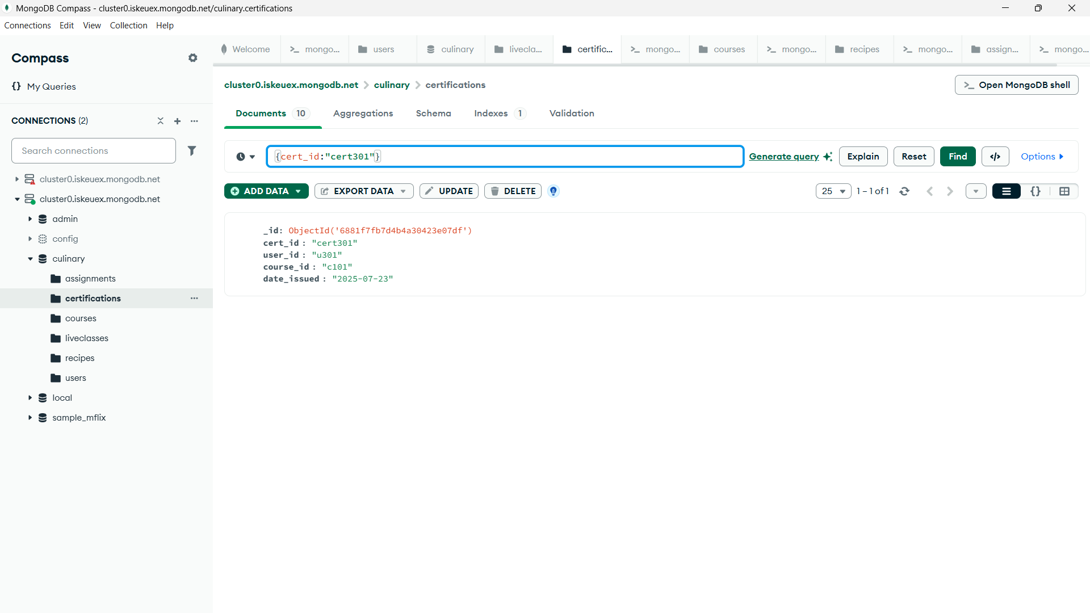

**Read**

db.certifications.find({ user_id: "u301" })

**Update**

db.certifications.updateOne(

{ cert_id: "cert301" },

{ $set: { date_issued: "2025-08-01" } }

)

**Delete**

db.certifications.deleteOne({ cert_id: "cert301" })

### **6.liveclasses Collection**

**Create**

db.liveclasses.insertOne({

class_id: "lc301",

topic: "Healthy Salads",

chef: "Chef Mitali",

date: "2025-08-05",

participants: ["u301", "u302"]

})

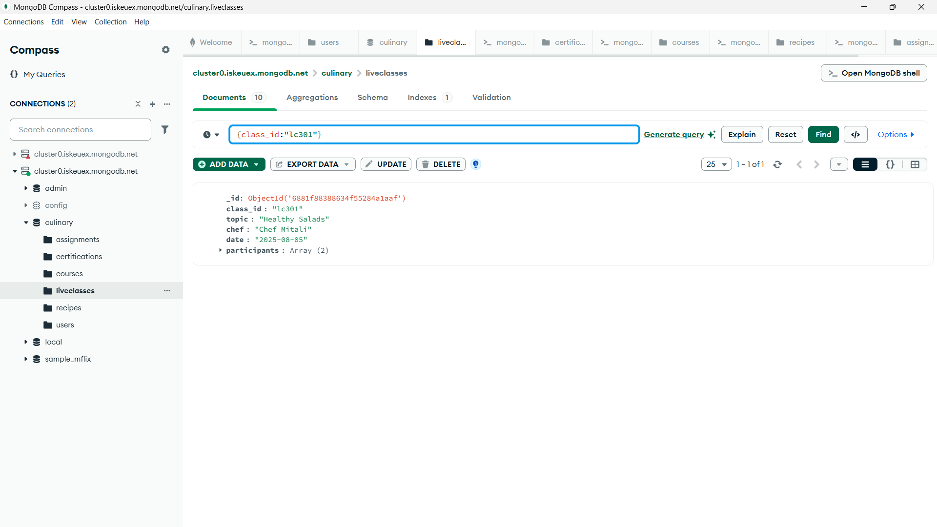

**Read**

db.liveclasses.find({ topic: "Healthy Salads" })

**Update**

db.liveclasses.updateOne(

{ class_id: "lc301" },

{ $push: { participants: "u303" } }

)

**Delete**

db.liveclasses.deleteOne({ class_id: "lc301" })