MindCanvas
How We Built With Claude

1. What We Built and Why Claude Is Central to It

MindCanvas is a daily emotional journaling companion designed for the 300 million people living with anxiety who either cannot access therapy or have long gaps between sessions. The product turns journaling — something clinically proven but notoriously hard to stick with — into a meaningful, rewarding, and clinically connected daily habit.

Claude is not a feature bolt-on here. It is the engine. Every meaningful user interaction in the product is powered by Claude. Without it, MindCanvas is a blank notes app. With it, it becomes something a person might actually open every morning.

Below is an honest account of where and how we used Claude — from the API calls we designed to the creative prompts we agonised over to the safety architecture we built around it.

2. The Core API Integrations

2a. Emotional interpretation of journal entries

The most fundamental call we make to Claude is asking it to read a journal entry and understand what the person was feeling — not what they literally wrote, but the emotional texture of the moment. We pass in the raw entry and ask Claude to return a structured emotional profile: dominant mood, secondary mood, intensity level, and a brief narrative reflection the user sees back.

Prompt design note
We spent a lot of time making sure Claude didn't therapise the user or tell them how they felt. The instruction was: 'Reflect back what you sense in the writing. Do not diagnose. Do not advise. Respond as a thoughtful reader, not a clinician.' That single framing shift made the outputs feel human rather than clinical.

2b. Generating personal artwork from emotional state

After reading the entry, Claude produces a description of the artwork that will be generated to represent that emotional moment. We use a structured output call that returns a visual scene description — mood, palette, compositional feel — which is then passed downstream to an image generation model.

Claude is doing two things here: interpreting the emotion accurately and translating it into an aesthetic language that a generative image model can act on. We found that having Claude sit in the middle — rather than going directly from raw text to image prompt — produced dramatically better outputs. Claude understands nuance. A direct prompt-to-image pipeline produced generic results; routing it through Claude gave us outputs that felt personally resonant.

Entry tone | Described as
High anxiety / fragmented | "Turbulent geometry, fractured planes, deep indigo and electric white"
Quiet grief | "Still water, muted greys, single point of warm amber light at the horizon"
Cautious hope | "Soft dawn palette, one open window, light entering diagonally"

2c. Surfacing evidence-based guidance (RAG + Claude)

This is the most technically involved integration. We built a RAG layer on top of Claude, grounded in peer-reviewed psychology literature and anonymised treatment data. When Claude identifies a mood pattern, it queries this retrieval layer and surfaces the most relevant evidence-based intervention — a grounding exercise, a behavioural activation prompt, a breathing technique.

We were deliberate about one constraint: every suggestion had to cite its source. The prompt explicitly instructs Claude to only recommend interventions it can attribute to the retrieved context, and to flag uncertainty if the retrieved material is a weak match. No free-form suggestions. No hallucinated techniques. If Claude cannot ground its recommendation in a retrieved source, it says so and offers a more general reflection instead.

Why this mattered
We could have had Claude suggest techniques freely from its training knowledge. We chose not to. For a mental health product, traceability is non-negotiable. The RAG + citation constraint was not a technical nicety — it was the difference between a product we could stand behind and one we couldn't.

2d. Monthly therapist report generation

At the end of each month, we ask Claude to synthesise 30 days of journal data into a clinician-readable summary. This is a structured generation task: Claude receives the full month's emotional profiles, keywords, and patterns and produces a two-page report covering mood trajectory, recurring triggers, and notable turning points.

The prompt was designed with therapists in mind — we interviewed three practitioners during development. Their feedback shaped the structure: they wanted trajectory first, then triggers, then raw highlights. They did not want Claude to make clinical interpretations or suggest diagnoses. The report ends with a section titled 'Questions to explore' — open prompts the user can bring into session, not conclusions.

3. The Safety Architecture — Where Claude Does Its Most Important Work

Most apps treat safety as a single content filter. We designed MindCanvas around a multi-agent safety system because a single model doing both companionship and crisis detection creates conflicts — the companion role rewards openness and warmth, while the safety role requires vigilance and precision. We separated them.

Agent | Role
Companion Agent | Handles all journaling interactions, reflections, guidance suggestions, and artwork briefs. Optimised for warmth and emotional resonance.
Safety Agent | Runs in parallel on every entry. Monitors for sustained distress signals, self-harm language, and escalating crisis indicators. Never surfaces to the user unless a threshold is crossed.
Escalation Agent | Triggered by the Safety Agent. Handles the handoff moment — acknowledges the person's courage, surfaces crisis resources immediately, and routes a direct alert. Does not attempt therapy.

The prompts for the Safety Agent were the hardest to write. The tension is between sensitivity and false positives. An overly cautious system escalates at the wrong moments and erodes trust. An under-cautious one misses real signals. We iterated extensively on the threshold prompts, testing against a range of synthetic entries from mild anxiety through to acute distress.

Design principle
When in doubt, the Safety Agent flags rather than ignores. But the Escalation Agent is designed to acknowledge with warmth before routing to resources — never as an alarm, always as a bridge to someone who can help more than the app can.

4. How We Approached Prompting

Prompting is the craft layer of this product. The same API call can produce output that feels hollow or output that feels like someone genuinely understood you — the difference is almost entirely in how you instruct the model.

A few principles we landed on through iteration:

- Give Claude a role, not just a task. Rather than asking Claude to 'analyse this journal entry', we told it: 'You are a thoughtful reader who has known this person for a long time. You are not a therapist. You do not give advice. You reflect what you sense in the writing and offer it back with care.'
- Constrain the output format tightly. Every call that returns structured data (emotion profile, artwork brief, report) specifies the exact JSON schema expected. Claude is better when it knows exactly what shape the output needs to take.
- Negative instructions matter. 'Do not diagnose. Do not use clinical terminology. Do not express concern unless you are certain.' These turned out to be as important as the positive instructions.
- Keep chain-of-thought for the complex calls. For the RAG-grounded guidance, we ask Claude to reason through its recommendation before producing it. The visible reasoning step improved accuracy and made the output easier to debug.

5. Claude Code in the Development Process

We used Claude Code throughout the build — not just for boilerplate, but for substantive architectural work.

- Building the RAG pipeline. We used Claude Code to scaffold the retrieval and re-ranking logic, and to write the integration layer between the vector store and the Claude API calls. What would have taken three days took a morning.
- Prompt testing harness. We built a lightweight eval harness to test our prompts across a range of synthetic entries. Claude Code wrote the test runner, the synthetic data generator, and the scoring heuristics.
- Structured output parsing. Getting consistent JSON from model outputs requires careful error handling and retry logic. Claude Code wrote the parsing layer and handled the edge cases we hadn't thought to anticipate.
- Multi-agent orchestration. The three-agent safety system required a coordination layer — logic to run the Companion and Safety agents in parallel and route the output appropriately. Claude Code drafted the orchestration logic which we then refined and tested.

The honest summary: Claude Code collapsed the gap between product thinking and working code. Ideas that would have sat in a backlog got built in hours. That changed what was possible within the hackathon timeline.

6. What Worked Well — and What Was Hard

What worked

- Claude's emotional intelligence is genuinely impressive when prompted well. The gap between a generic 'analyse sentiment' call and a carefully crafted reflection prompt is enormous.
- Structured outputs were reliable. Once we locked in the JSON schemas, Claude rarely produced malformed responses.
- The multi-agent separation of concerns worked architecturally. Having a dedicated Safety Agent meant we could tune its behaviour independently without affecting the warmth of the Companion.

What was hard

- Calibrating the Safety Agent threshold was the most difficult part of the build. Too sensitive and it becomes paternalistic. Too lenient and it fails its core purpose. This required the most iteration and is the part of the product we would invest in most post-hackathon.
- The artwork brief generation requires careful prompt engineering to avoid generic outputs. 'Sad' tends to produce dark and stormy. Getting Claude to produce genuinely nuanced aesthetic interpretations required specific examples in the prompt — few-shot was necessary here.
- Latency. Running the Companion and Safety agents in parallel adds inference time. We handled this with streaming on the Companion side so the user experience does not feel blocked, but it remains something to optimise.

7. Screenshots

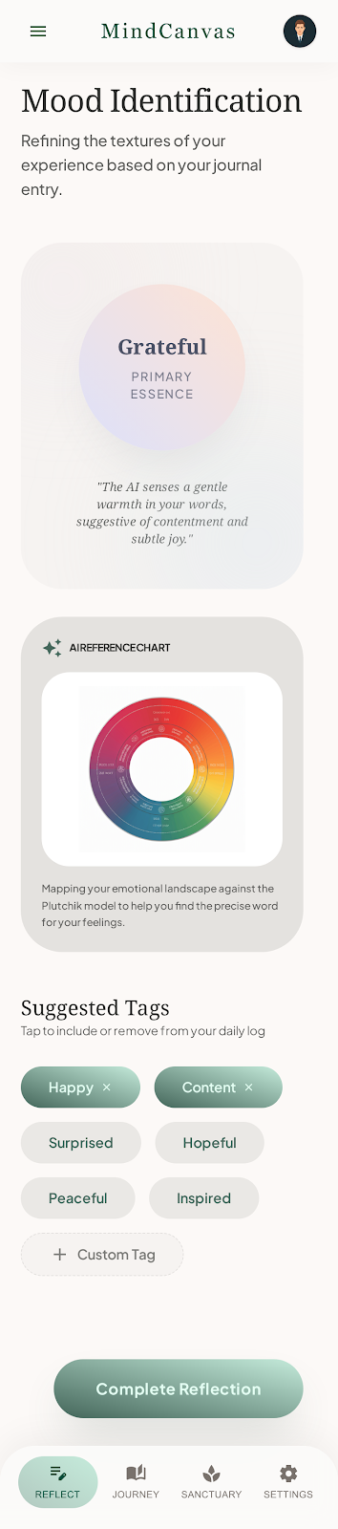

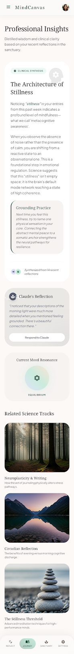



8. Closing

MindCanvas exists because of the combination of Claude's emotional intelligence, the quality of its structured generation, and the speed at which Claude Code let us build. The product is genuinely different because of Claude — not just faster to ship, but possible to ship in a way that we'd be proud to put in front of someone having a hard day.

The people MindCanvas is built for deserve tools that take their experience seriously. That is the standard we held our Claude integration to, and we believe it shows in every layer of the product.

S

MindCanvas | Confidential | 2025

