

Course code

Course Name

Phase 2: Software Design Document Team Name

Nagham nabil abdalmoeim 20181497327

Dec 2020

Month & Year

Contents

Instructions [To be removed] ............................................................................................................................. 3

Team ................................................................................................................................................................... 3

Document Purpose and Audience ...................................................................................................................... 3

System Models ................................................................................................................................................... 4 I. System Decomposition ................................................................................ Error! Bookmark not defined.

1. Class diagrams ............................................................................................................................................ 4
2. Sequence diagrams .................................................................................................................................... 5

Class - Sequence Usage Table ..................................................................................................................... 7 IV. Physical Entity-Relationship Diagram ........................................................................................................ 8

1. User Interface Design ................................................................................................................................. 8
2. Algorithms and Data Structures .............................................................................................................. 10

Ownership Report ............................................................................................................................................ 10

Policy Regarding Plagiarism: ............................................................................................................................. 10

References ........................................................................................................... Error! Bookmark not defined. Authors ................................................................................................................ Error! Bookmark not defined.

# 

# Team

|  |  |  |  |
| --- | --- | --- | --- |
| ID | Name | Email | Mobile |
| 20181497327 | Nagham nabil abdalmoniem | Sci.naghamnabil97327@alexu.edu.eg |  |
|  |  |  |  |
|  |  |  |  |

# Document Purpose and Audience

learning management system is a software application that provides the framework that handles all aspects of the learning process. learning is where teachers and students meet physically, but the LMS is used to support learning by providing a space where materials can be stored and organized, assessments can be given, and students and teachers can interact using blogs, forums, and so on.  
**Educational agencies is important for the data secured** operate independent systems either because of customer data privacy or webpage design alignment.

# System Models

## I. Class diagrams

|  |  |  |  |
| --- | --- | --- | --- |
| Class ID | Class Name | Subsystem ID | Description & Responsibility |
|  | Elearning System |  | A Learning Management System (LMS) is an online system or software which is used to plan, execute, and assess a specific learning process. In simple words, software used in ELearning programs and which helps in administration, documentation, tracking, and recording |
|  | sudentRecord |  | Used to store all the students information like name,ID,grade,year. |
|  | CourseRecord |  | Used to store any information which is related to course |
|  | courseMaterial |  | Is a class which includes each and every detail about the materials and subjects of the course. are powerful indicators of an instructor's approach to teaching and learning. They are important in supporting in–class experiences, as well as experiences outside the classroom. |
|  | secureElearningSystem |  | One of the concerns about Elearning management system is data safety the security features to keep viruses, hackers away. |
|  | Admin |  | Someone which has the authorization to access to the system and give the authorized to candidate to enter such a system |
|  | Candidate |  | Someone who want to register In such a system ignored o know some information about himself or the course or the course materials if there is any updates |
|  | EncryptionFile |  | It is used to protect your information online The technology enables files to be transparently encrypted to protect confidential data from attackers with physical access to the computer. |
|  | DecryptionFile |  | The conversion of encrypted data into its original form is called Decryption. |

## I. Sequence diagrams

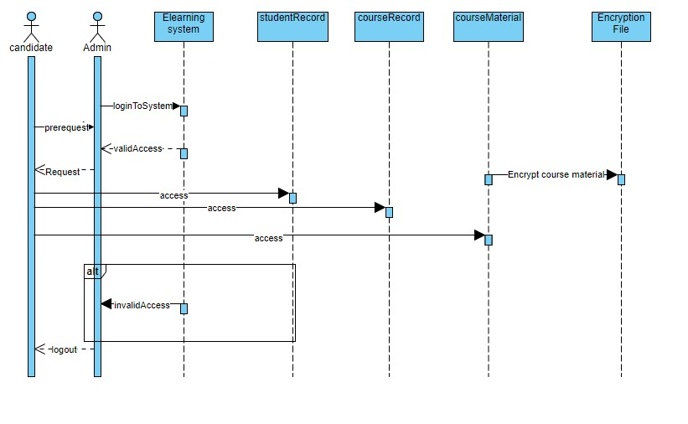

### Class - Sequence Usage Table

|  |  |  |
| --- | --- | --- |
| Class Name | Sequence Diagrams | Overall used methods |
| candidate |  | Prerequisite, access to Elearning system ,register to course |
| Admin |  | Access to the system |

## Physical Entity-Relationship Diagram

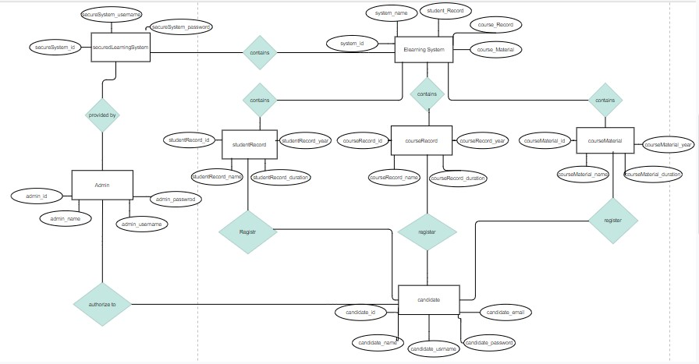

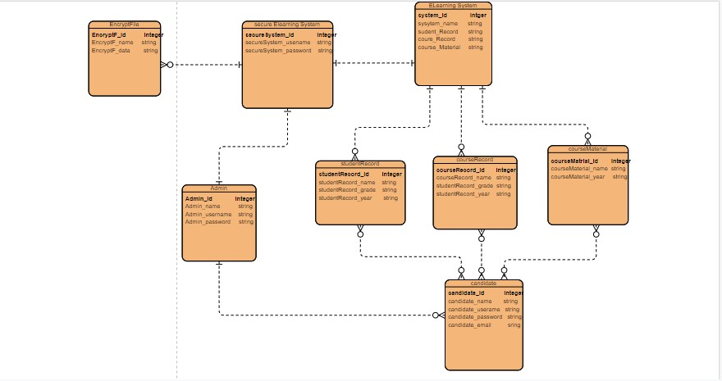

1. Dataflow diagram (DFD)

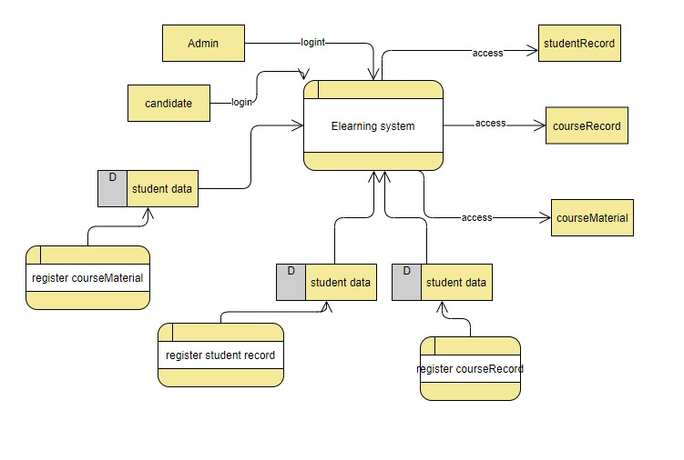

## Algorithms and Data Structures

## 

Register()

method to add a new course material when the student login into the system he is going to search for the course he wanted to register the student’s data and the courseMaterial’s data is stored in queue prepared statement

# Ownership Report

|  |  |
| --- | --- |
| Item | Owners |
|  |  |
|  |  |

# Policy Regarding Plagiarism:

Students have collective ownership and responsibility of their project. Any violation of academic honesty will have severe consequences and punishment for ALL team members.

1. تشجع الكلية على مناقشة الأفكار و تبادل المعلومات و مناقشات الطلاب حيث يعتبر هذا جوهريا لعملية تعليمية سليمة 2. ساعد زملاءك على قدر ما تستطيع و حل لهم مشاكلهم فى الكود و لكن تبادل الحلول غير مقبول و يعتبر غشا.

1. أى حل يتشابه مع أى حل آخر بدرجة تقطع بأنهما منقولان من نفس المصدر سيعتبر أن صاحبيهما قد قاما بالغش.
2. قد توجد على النت برامج مشابهة لما نكتبه هنا أى نسخ من على النت يعتبر غشا يحاسب عليه صاحبه.
3. إذا لم تكن متأكدا أن فعلا ما يعد غشا فلتسأل المعيد أو أستاذ المادة. 6. فى حالة ثبوت الغش سيأخذ الطالب سالب درجة المسألة ، و فى حالة تكرار الغش سيرسب الطالب فى المقرر.