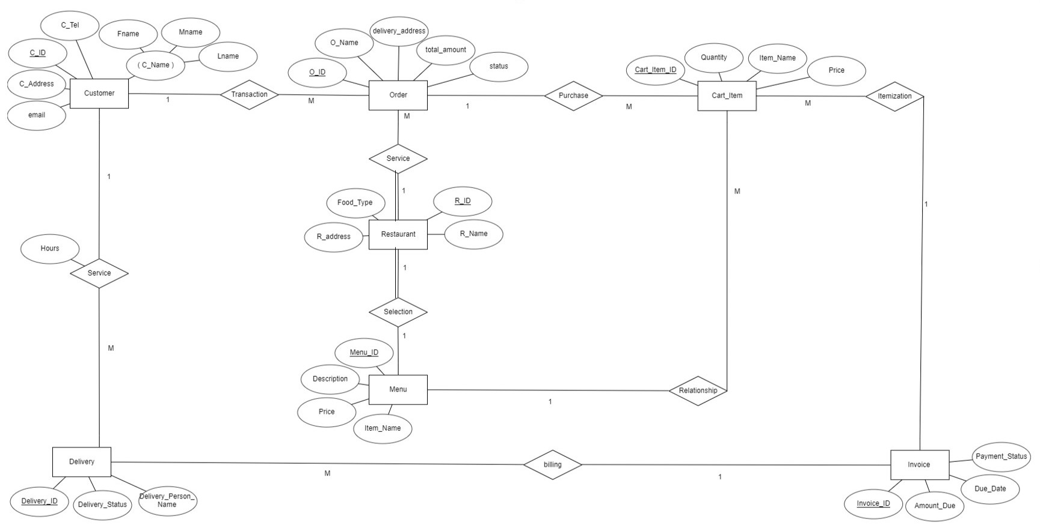

**ER diagram**

**Customer**

**Mapping**

|  |  |  |  |  |  |  |
| --- | --- | --- | --- | --- | --- | --- |
| C_ID | Fname | Mname | Lname | C_Address | Email | C_Tel |

**Order**

|  |  |  |  |  |  |  |
| --- | --- | --- | --- | --- | --- | --- |
| O_ID | O_Name | Delivery_Address | Total_Amount | Status | R_ID | C_ID |

**Restaurant**

|  |  |  |  |  |
| --- | --- | --- | --- | --- |
| R_ID | R_Name | Food_Type | R_Address | Menu_ID |

**Cart_Item**

|  |  |  |  |  |  |  |
| --- | --- | --- | --- | --- | --- | --- |
| Cart_Item_ID | Price | Item_Name | Quantity | O_ID | Menu_ID | Invoice_ID |

**Invoice**

|  |  |  |  |  |
| --- | --- | --- | --- | --- |
| Invoice_ID | Amount_ID | Due_Date | Payment | Status |

**Delivery**

|  |  |  |  |  |  |
| --- | --- | --- | --- | --- | --- |
| Delivery_ID | Delivery_Status | Delivery_Person_Name | C_ID | Invoic_ID | Hours |

**Menu**

|  |  |  |  |
| --- | --- | --- | --- |
| Menu_ID | Item_Name | Price | Description |