

**Arabic_TalkBot**

**Natural Language Processing**

Prepared by:

Kinda Sulaiman: 202110811

Nagham Thamer Al-Otaibi: 202110560

Supervised by:

Dr. Hossam M.Mustafa

# **Arabic TalkBot**

## **Introduction:**

In our project, our objective is to create an interactive chatbot tailored for aiding users in learning and honing their Arabic language skills. Central to this endeavor is the integration of the Google Text-to-Speech (gTTS) library within Python, enabling the chatbot to deliver precise pronunciations of Arabic letters, words, and phrases. By harnessing this technology, users can actively engage with spoken Arabic, listening to and practicing pronunciation with confidence. Moreover, our chatbot utilizes the speech_recognition library to seamlessly convert user speech into text. This crucial functionality allows the chatbot to evaluate the user's pronunciation against the correct pronunciation, providing immediate feedback on accuracy. Through this feedback loop, users can iteratively refine their pronunciation skills, fostering a dynamic and effective learning experience in Arabic language acquisition.

## **Challenges:**

* Dialect and Language Variability: Arabic has many dialects and regional variations. Ensuring TalkBot can understand and respond accurately to different dialects is complex and requires extensive training data.
* Accurate Speech Recognition: Converting audio input into accurate text (speech-to-text) in Arabic can be challenging due to pronunciation, accent, and background noise variations. High accuracy in speech recognition is crucial for effective communication.
* Natural Language Understanding: Comprehending the nuances, context, and idiomatic expressions in Arabic is difficult. The system needs to interpret meaning accurately to provide relevant and meaningful responses.

## **Files:**



## **Code:**

* This Python script defines a chatbot programmed to assist in learning Arabic. It utilizes a lemmatizer for word normalization and a set of regular expressions to match user inputs with appropriate responses. Each pattern corresponds to a user query, covering greetings, well-being inquiries, learning topics, skill improvement strategies, lesson requests, translation assistance, grammar, conversation practice, pronunciation, literature, culture, history, and economics related to Arabic. The bot offers tailored assistance based on user queries, ensuring effective support for Arabic language learners.

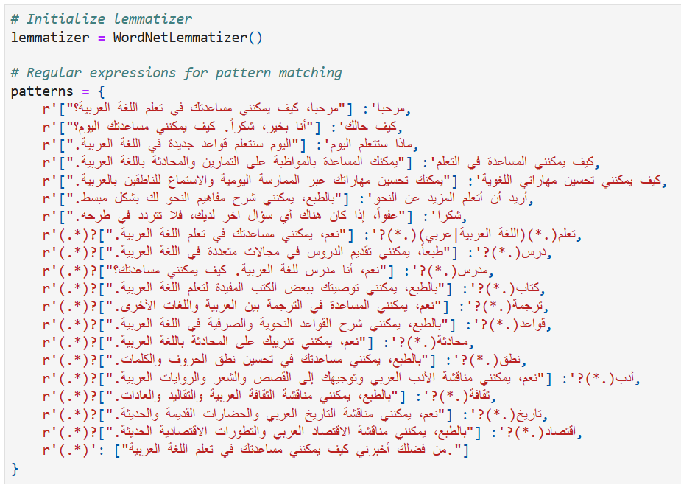

* This Python function preprocesses user input for the Arabic language. Initially, it tokenizes the input using the `word_tokenize` function from the NLTK library. Subsequently, it removes stopwords using a predefined list of Arabic stopwords from NLTK. Then, it lemmatizes each token using the initialized lemmatizer. Finally, it rejoins the tokens into a string and returns the preprocessed user input. This preprocessing enhances the chatbot's ability to understand and respond appropriately to user queries by standardizing and simplifying the input text.

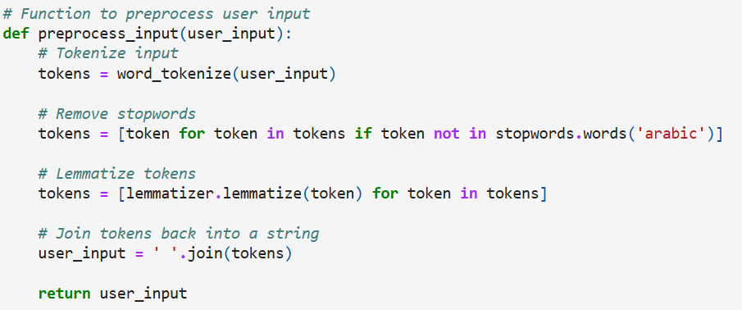

* The provided function text_interaction() facilitates interaction with the chatbot by continuously prompting the user for input, preprocessing it, and then generating appropriate responses based on predefined patterns or semantic similarity. If the user inputs "الوداع" (goodbye), the chatbot bids farewell and terminates the interaction loop. This function enables streamlined communication with the Arabic language chatbot, aiding users in learning the language effectively.

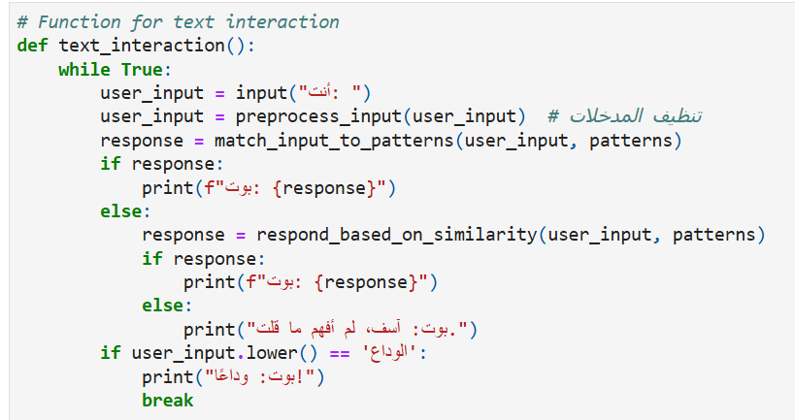

* The `match_input_to_patterns` function compares user input to predefined patterns and returns corresponding responses. It iterates through the patterns dictionary, searching for a match using regular expressions. If a match is found, it returns the associated response; otherwise, it returns `None`. This function is pivotal for the chatbot's ability to understand user queries and provide appropriate replies.

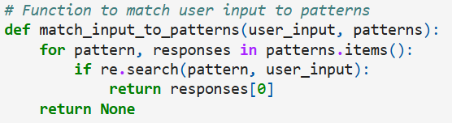

* This code segment generates audio files for a list of Arabic words using the Google Text-to-Speech (gTTS) API and saves them to a specified directory. It first checks if the directory exists, and if not, it creates it. Then, it iterates through each word in the list of Arabic words, generates an audio file for each word if it doesn't already exist, and saves it to the directory. Lastly, it defines a function `play_audio` to play the audio file. This code enables the creation and playback of audio pronunciations for Arabic vocabulary, aiding in language learning and pronunciation practice.

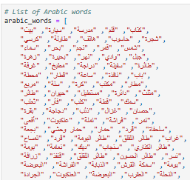 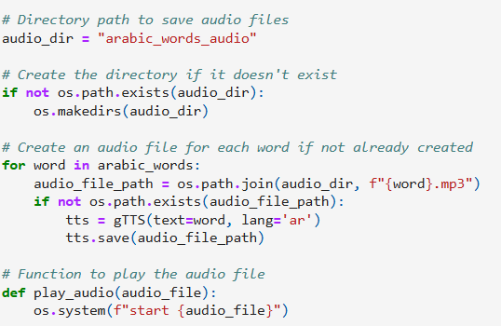

* These functions help the chatbot generate responses based on the similarity between user input and predefined patterns. `calculate_similarity` computes the similarity between two strings, while `respond_based_on_similarity` selects the best response from predefined patterns based on similarity scores. This approach enhances the chatbot's ability to understand and respond effectively to diverse user inputs.

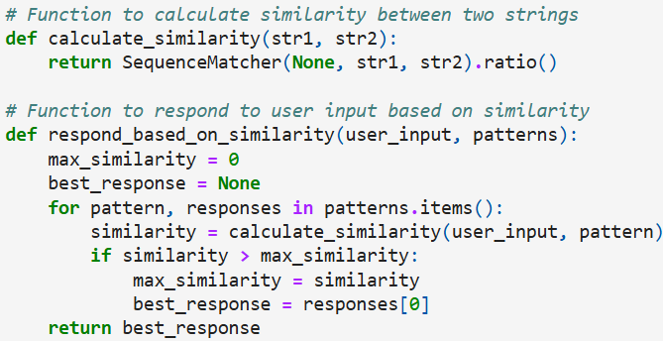

* This function allows users to check the pronunciation of Arabic words. It prompts the user to input a word and plays its audio pronunciation. Then, it continuously recognizes the user's speech input, calculates the pronunciation accuracy compared to the correct word, and provides feedback. The function terminates when the user inputs "الوداع" (goodbye).

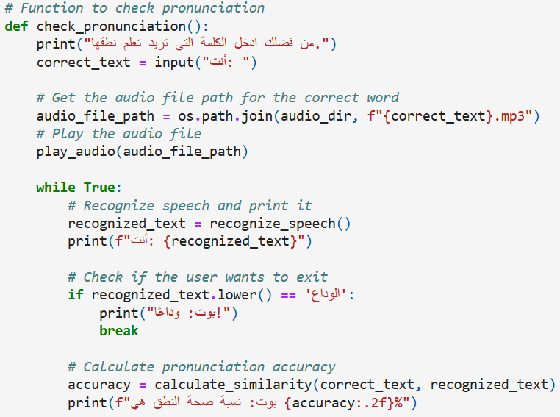

* This function enables voice interaction with the chatbot. It continuously recognizes speech input from the user and prints it. If recognition fails or encounters an error, it notifies the user accordingly. The function preprocesses the user input, matches it to predefined patterns, and generates responses. If no direct match is found, it attempts to respond based on similarity with existing patterns. If the user inputs "الوداع" (goodbye), the chatbot bids farewell and terminates the interaction loop. This function provides a seamless way for users to engage with the chatbot through voice commands, facilitating natural language interaction.

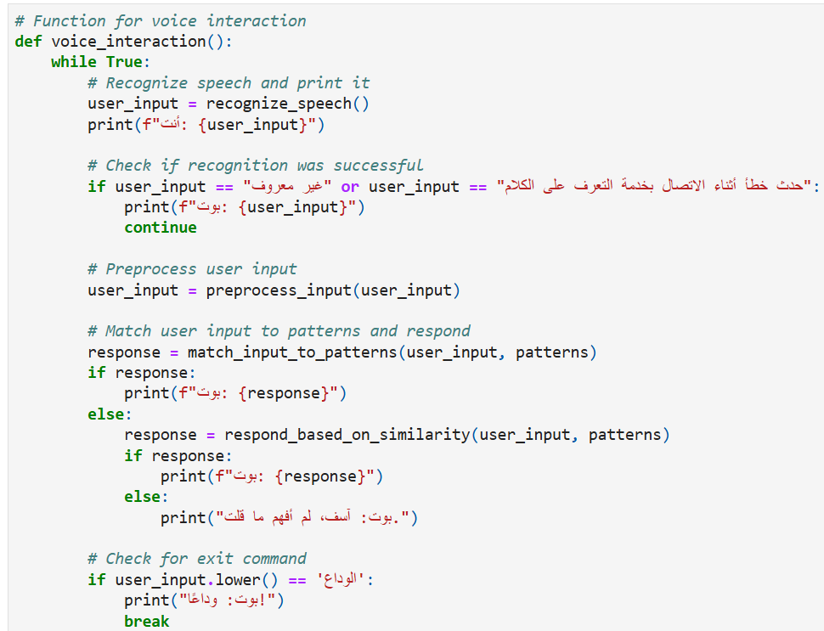

* This function utilizes the SpeechRecognition library to recognize speech input from the user through the microphone. It initializes a recognizer object, captures audio input, and processes it using the Google Speech Recognition service with Arabic as the language. If the recognition encounters errors like unknown values or request errors, it returns corresponding error messages. Otherwise, it returns the recognized text, facilitating the chatbot's understanding of spoken Arabic inputs and enhancing user experience.

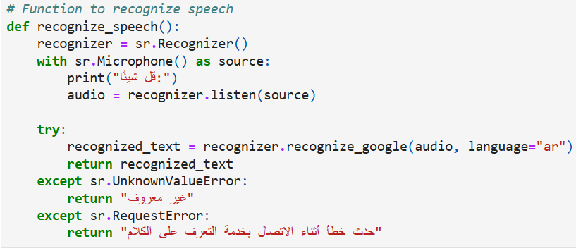

* This main function offers users three options: regular text interaction (0), checking pronunciation (1), or voice interaction (2). It prompts the user to input their choice and executes the corresponding function based on the input. If an invalid option is selected, the bot informs the user. This structure provides users with flexibility in how they interact with the chatbot, whether through text or voice, enhancing their experience and accommodating different preferences.

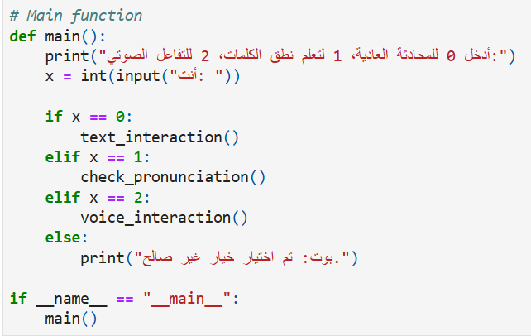

## **Conclusion:**

In conclusion, our exploration delved into evaluating the efficacy of a compact code snippet tailored to facilitate language learning and pronunciation refinement. Leveraging libraries for text-to-speech conversion, speech recognition, and string similarity comparison, the code orchestrates a user-friendly interface for Arabic learners. By prompting users to input Arabic sentences, playing corresponding correct pronunciations, and assessing users' pronunciation similarity, the code fosters an interactive platform for pronunciation practice. While the code exhibits fundamental functionality, there remains scope for enhancement, particularly in bolstering speech recognition accuracy and enriching user feedback mechanisms. Nevertheless, as a foundational tool for language learners, it provides a stepping stone for honing Arabic speaking skills through engaging practice sessions and iterative improvement efforts.

THANK YOU