|  |  |  |
| --- | --- | --- |
| **University of Petra** | شعار جامعة البترا5 - |  |
| **Faculty of Information Technology** | **كلية تكنولوجيا المعلومات** |

**Software Engineering Project**

**Learning Management System**

**Prepared By:**

**Leen Arnous - 202110657**

**Ahmad Aldweik - 202110034**

**Sarah shawawreh - 202110317**

**Nawras Abunassr - 202110637**

**Nagham Alotaibi - 202110560**

**Supervisor:**

**Prof Nuha El-Khalili**

**Date:**

**2024/2025**

**Use Case Diagram**

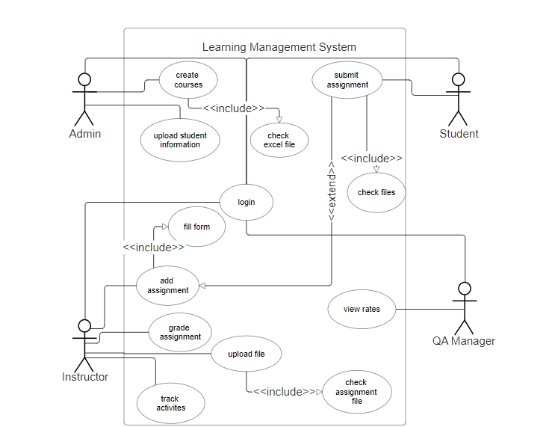

**Domain Model (class diagram)**

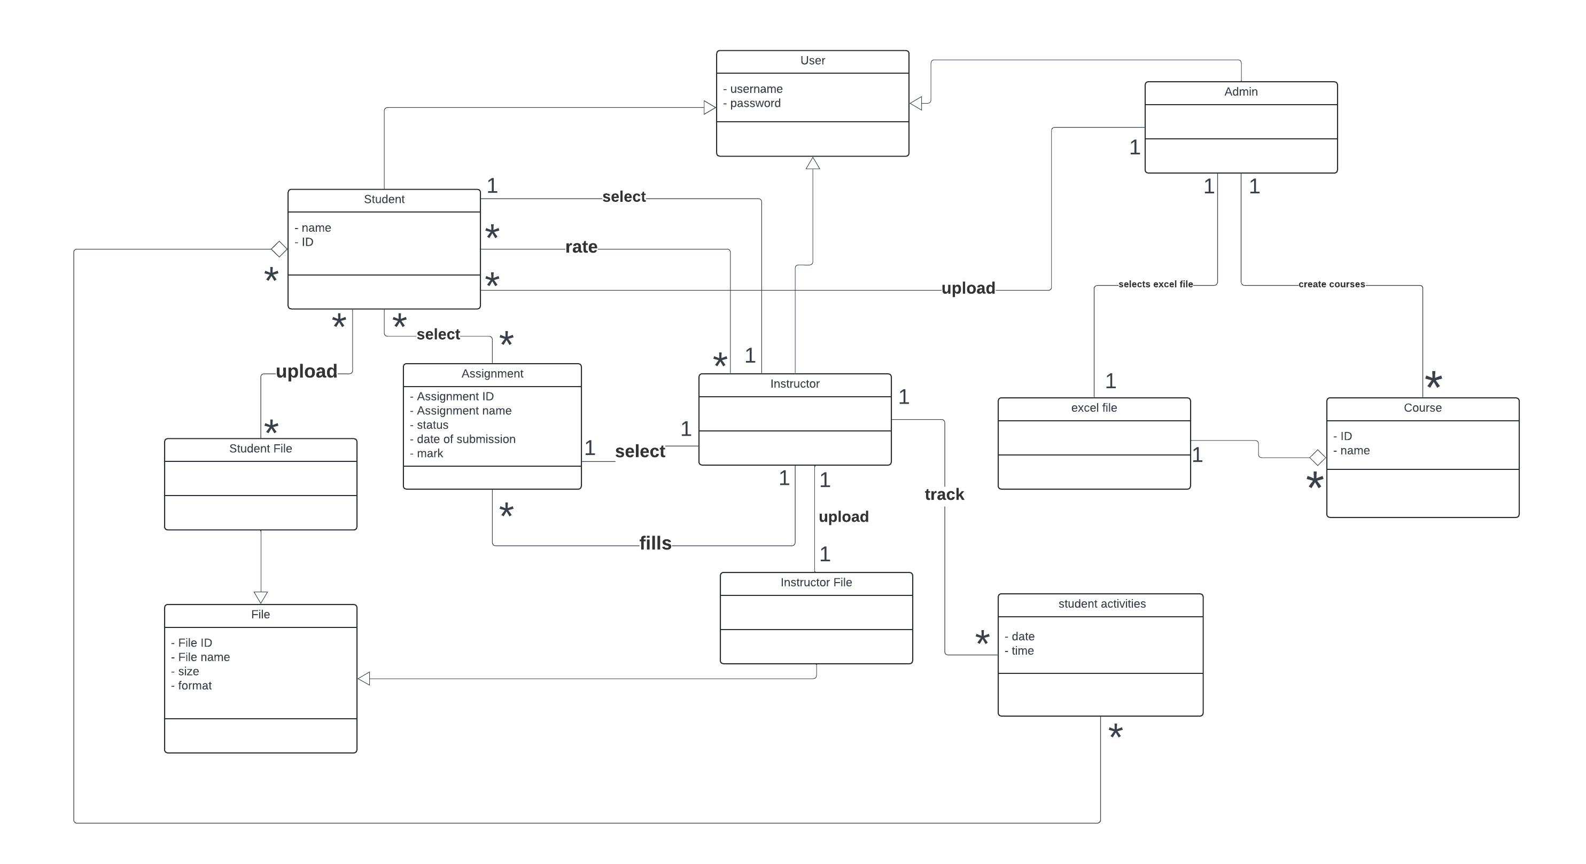

1

