**Forest area**

Nagendra Subray Hegde

Department of Applied Machine Intelligence

College of Professional Studies, Northeastern University, Boston

ALY6060 - Decision Support and Business Intelligence

Dr. Michael Cavallo

03-12-2023

The forest is one of the most important parts of nature on earth. Forests are the heart and soul of this world. Forest land covers about one-third of the land area across the globe which makes it a significant factor influencing climate change. The forest land area is home to many land animal species, rare plant species, many other insects, and many unknown living beings. Forests not only absorb the carbon from the atmosphere they also reduce the impact of floods, and landslides, and are one of the key factors for causing rain.

Even though we are aware of the importance of forests, we eventually have succumbed to urbanization and industrialization causing the depletion of forests in most of the bigger nations or smaller nations. When we compare the growth of the forest area to the deforestation it's huge.

This report will have insights into several countries across the globe which have had changes in their forest area and what are the factors that are causing these changes. Also, what will be the future if the same trend continues with either deforestation or reforestation?

**World Forest Data:**

We collected "Environmental, Social and Governance Data" (ESG) on Kaggle which had selected the data set of Forest area (% of land area) in several countries over the past 3 decades from **1990** to **2016**. **Fig. 1** shows the geographic location of the countries in the data.

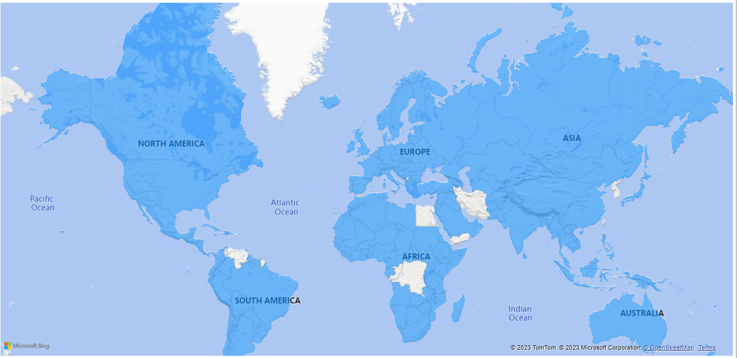

**Fig. 1**

The data is noted in the source file in 2 ways one specific to regions like e.g. Europe & Central Asia, Middle East & North Africa, South Asia, etc. Also similarly it is divided across the countries as well.

Now let us see the average change in the forest area around the world over the past decades in the below Table.1

|  |  |  |
| --- | --- | --- |
| **World** | **Forest area (% of land area)** | **Change between decades** |
| 1990s Average | 31.45812 | 1.38095% decrease from 1990s to 2000s |
| 2000s Average | 31.0237 | 0.739886% decrease from 2000s to 2010s |
| 2010s Averages | 30.79416 | 2.87147% decrease from 1991 to 2016 |

Even though the change looks minimal it is highly impactful that almost **3%** of the overall forest area has decreased and with the same rate over the next 100 years there will be around a **9% – 10%** decrease which is not at all a good sign.

The visuals of the above data clearly let us understand the gradual decrease in the forest area over the years. Below **fig. 2 and Fig 2.1** can be seen for the same

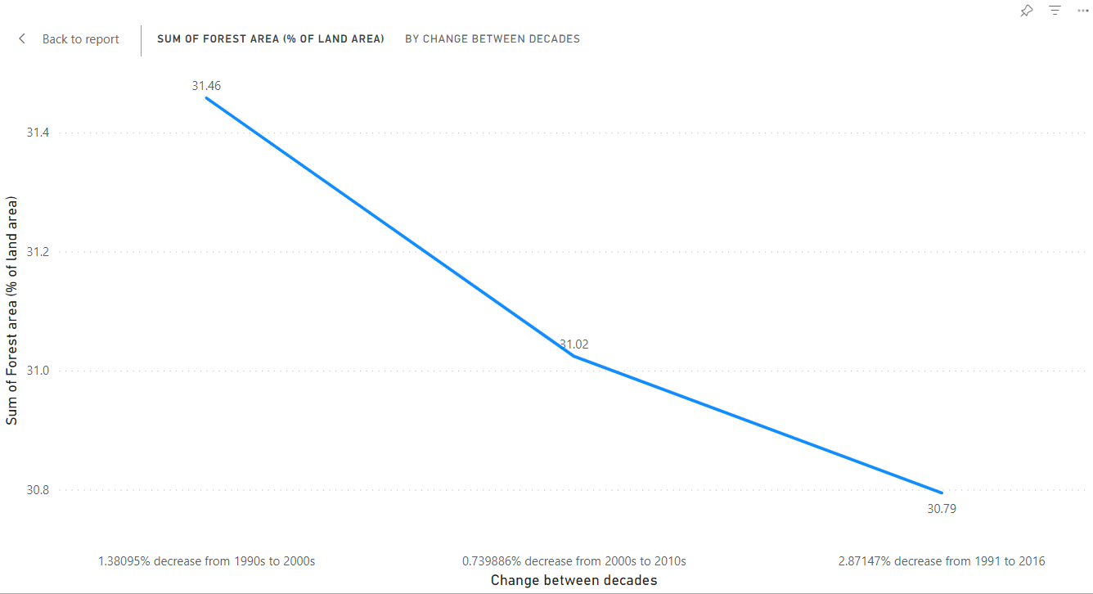

**Fig. 2**

So as we know there are different vegetation across the globe and It is not possible to expect every place to have a good amount of forest as many of them are desert areas and are not fit for the growth of forest. So as per the data, we can consider several countries which are having some of the highest land area occupation across the globe and are fit for forest vegetation to survive.

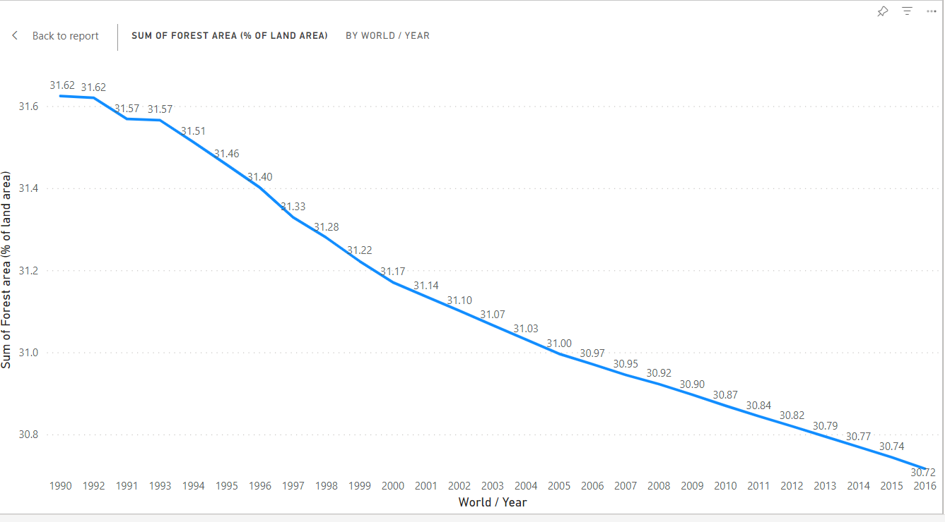

**Fig 2.1**

So for our initial analysis of a country, we chose Brazil the home of the Amazon. Brazil is rich in forest area more than **50%** of the land area is covered by forests. In Brazil it has been mostly deforestation over these years causing in the decline of forest area.

First, let us see the changes between years from **1990 – 2016** over the below visuals.

* From **65.40988785 %** of forest land in **1990** to **62.67149076 %** of forest land in **1999** there has been **4.18652%** decrease. **(Fig. 3)**

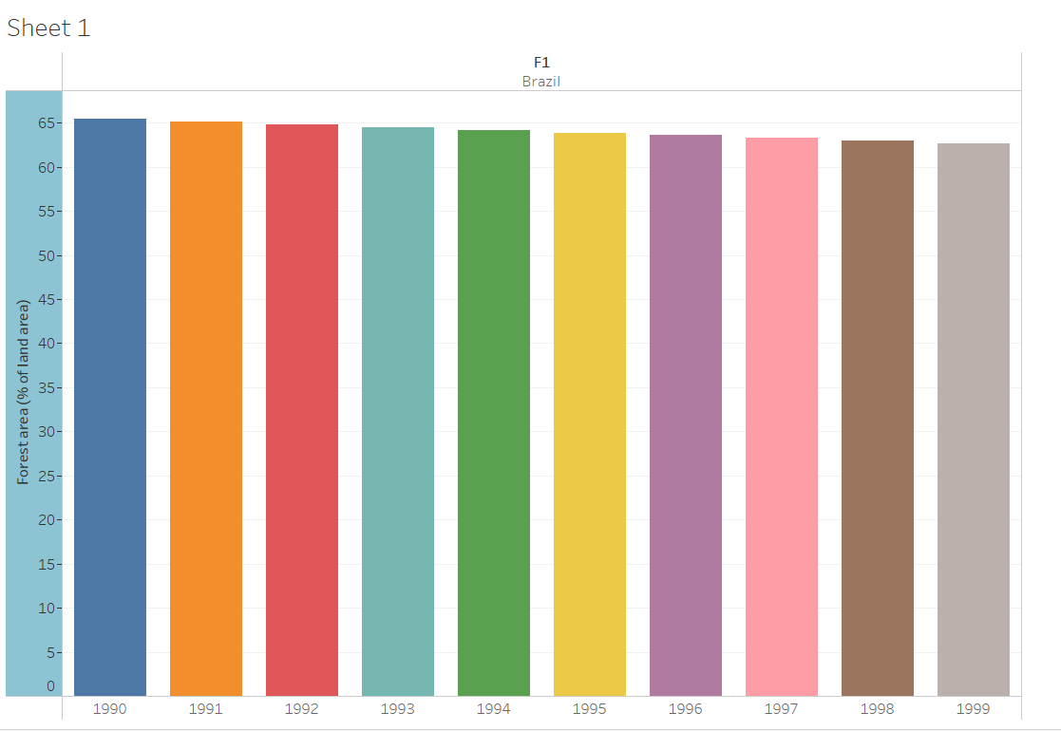

**Fig. 3**

* From **62.67149076 %** of forest land in **1999** to **59.83546429 %** of forest land in **2009** there has been a **4.52523%** decrease. **(Fig. 4)**

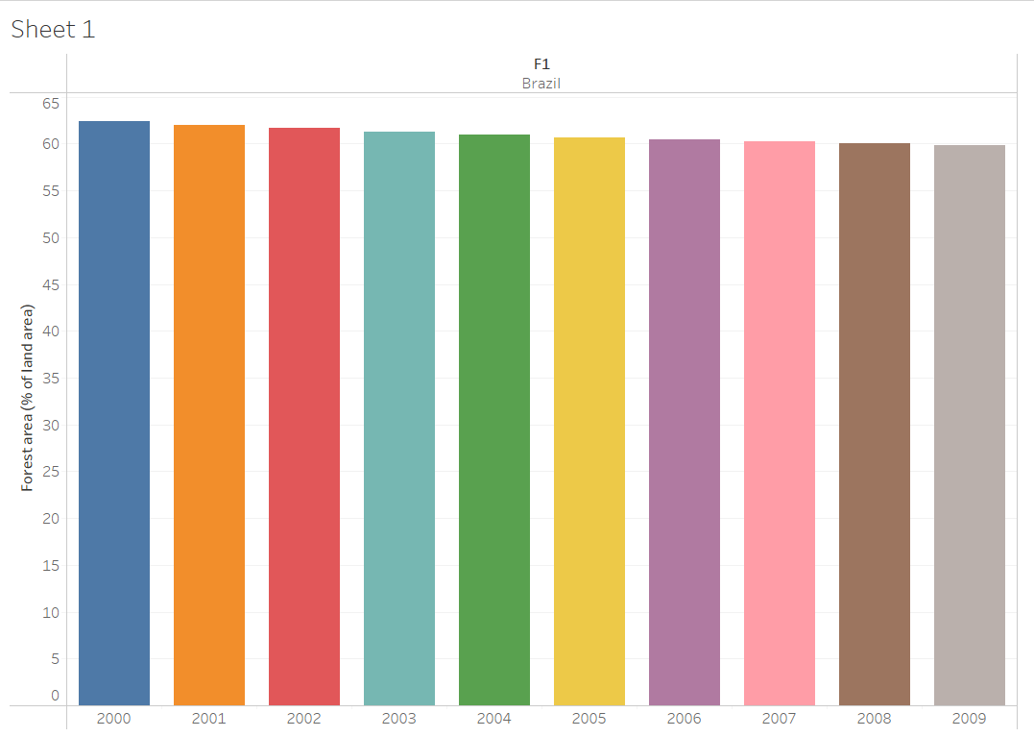

**Fig. 4**

* From **59.83546429 %** of forest land in **2009** to **58.93105404 %** of forest land in **2016** there has been a **1.5115%** decrease. **(Fig.5)**

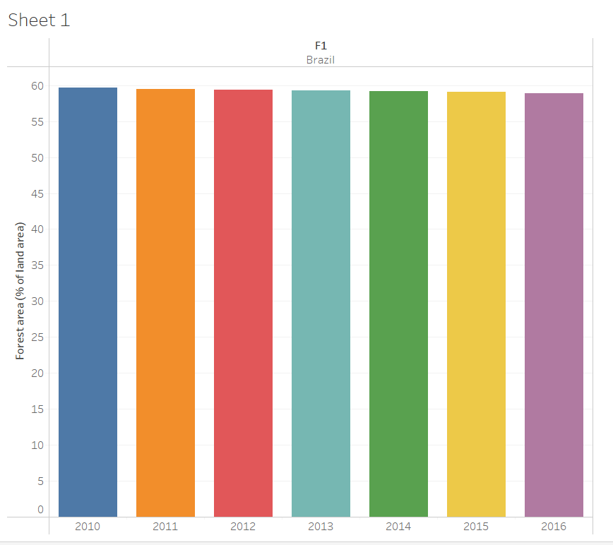

**Fig. 5**

Now this seems the overall change has been slow and significant which might not seems concerning to the eye at first glance but when we look at this as a whole over the years this is a concerning matter. **Fig. 6** shows the same over the years

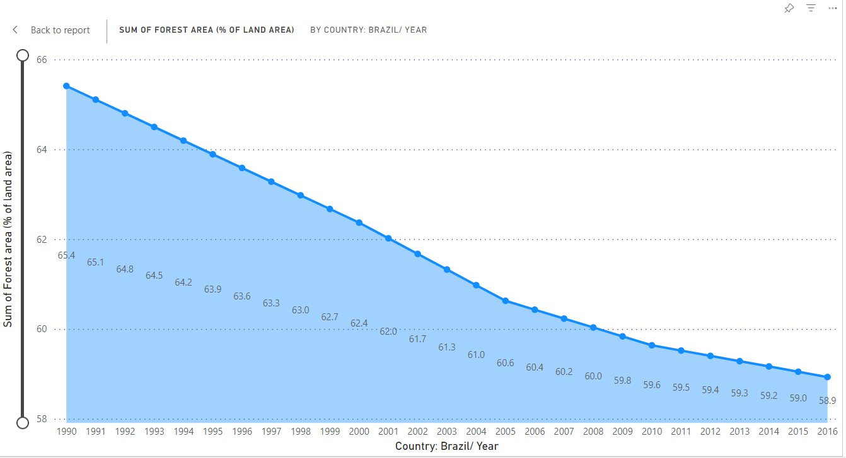

**Fig. 6**

﻿﻿***At 65.41, 1990 had the highest Sum of Forest area (% of land area) and was 10.99% higher than 2016, which had the lowest Sum of Forest area (% of land area) at 58.93.*** ﻿

Here you can see that the change is observable and drastic over these years with the same rate if it continues then there will be less than 50 % of forest land left after the next 25 years.

Now let us talk about another country with a lot of land area in the Asian continent i.e. China. China's case is similar to Brazil but it’s about reforestation. Let us see how change has happened in the Chinese land area over the years.

First, let us see the changes between 10 years from 1990 – 2016.

* From **16.73800695 %** of forest land in **1990** to **18.64190754 %** of forest land in **1999** there has been an **11.3747%** increase.
* From **18.64190754 %** of forest land in **1999** to **21.20712991 %** of forest land in **2009** there has been a **13.7605%** increase.
* From **21.20712991 %** of forest land in **2009** to **22.35394181 %** of forest land in **2016** there has been a **5.40767%** increase.

Below **Fig. 7** shows the overall change from 1990 – 2016 in the Chinese region

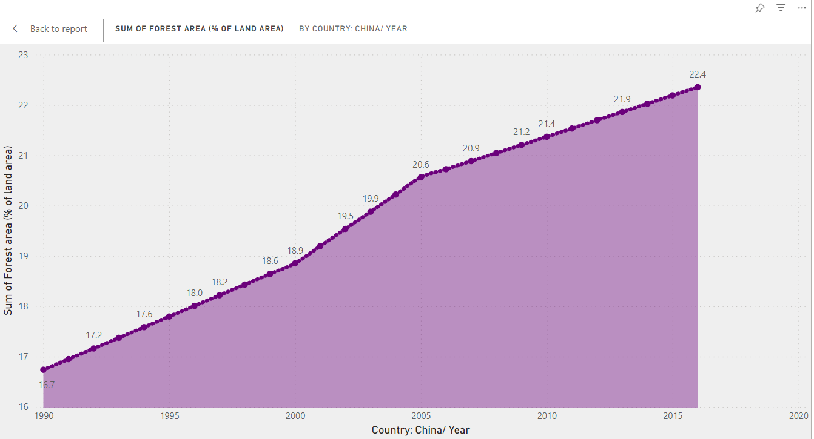

**Fig. 7**

***At 22.35, 2016 had the highest Sum of Forest area (% of land area) and was 33.55% higher than 1990, which had the lowest Sum of Forest area (% of land area) at 16.74. ﻿﻿***

Now if we compare Brazil and China side by side we can see the change in them as below **Fig. 8**

So we can clearly see that there is difference among both the countries where one is going towards growth in the forest area and other one is going in totally opposite direction.

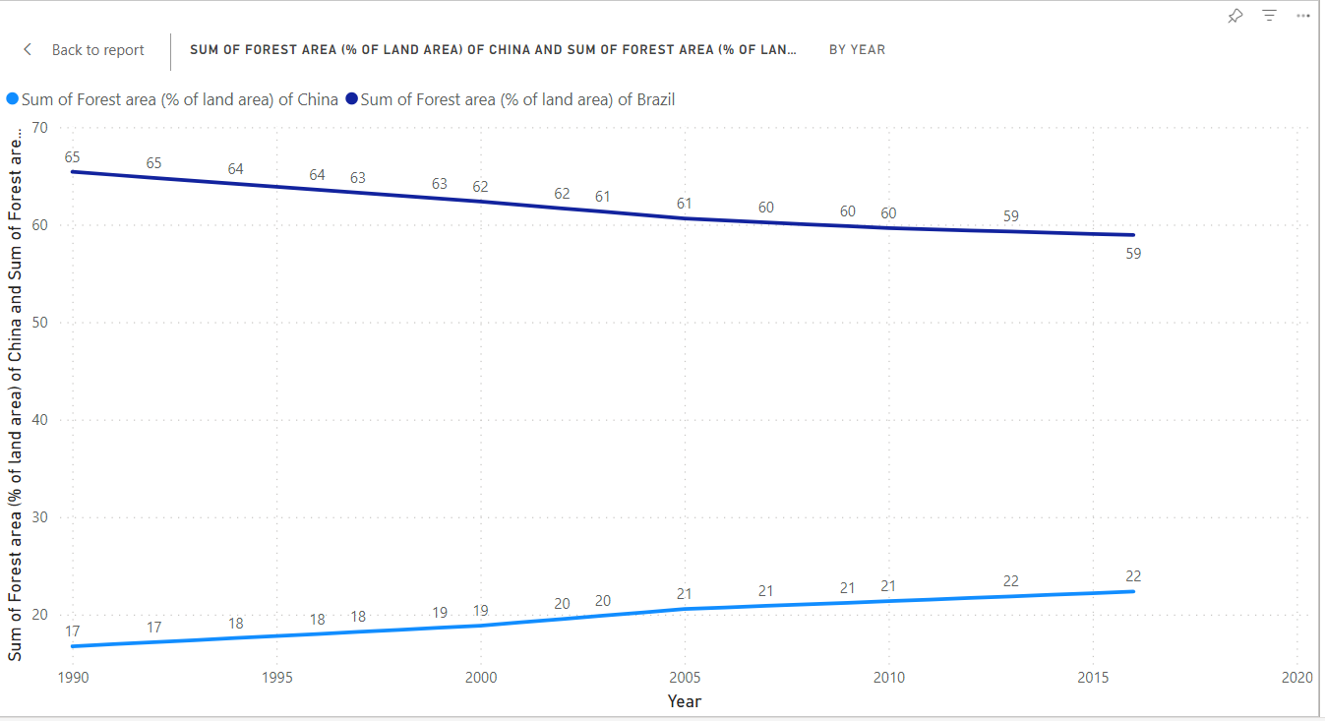

**Fig. 8**

What did China do to gain the forest area? What did Brazil do to go down this path? This is not only the case with Brazil it is with most of the countries across the globe. Urbanization and industrialization are some of the key factors for this.

Is this report about comparing China and Brazil? No, the bigger picture has been spoken in the initial part where the world index was considered. This comparison is an example to show that a great change can be made by taking reforestation steps.

This is not only about Brazil there are several countries with far worse deforestation like Indonesia, Paraguay, Myanmar, Argentina, and the list goes on. Similarly, there are a few countries that are doing reforestation like New Zealand, Italy, Uruguay, and a few more. There are several more countries with gradual increases like India, the United Nations, etc. This is also an important aspect which can be beneficial in the future.

**Why is there a decrease in the forest area?**

As per the resources referred, there are many reasons and some are more significant than others

* Deforestation due to food needs is one of the main reasons why the forest is getting depleted. As per the data it caused a certain 27% of the forest got cut down over the years.
* Due to industry needs there has been huge deforestation as well around 26% percent of the forest to supply wood for paper.
* Wildfire has been a bigger concern for a lot of countries. Canada and Russia have lost a lot of trees due to this wildfire over the past years.
* As mentioned earlier urbanization and industrialization give a lot of reasons for deforestation where the trees are cut down to make way for highways, new buildings, parks, etc.

There are several more reasons which can’t signify. A small piece of wood cut by anyone over the years can eventually lead to a big forest being cut down. Even though this seems a small portion it almost has depleted the overall 1/3rd area of the forest land across the globe.

**How Some countries can grow forest areas?**

* Countries like China, India, and the United States have pledged a lot of money in the field. United Nations has declared 2021- 2030 as a decade of reforestation.
* Some big organizations of the sporting community have pledged to plant trees for every success they achieve which eventually fills the fans with the need to plant trees.
* Also it is important to plant different species according to the area of the plantation. The same species across the globe can cause global imbalance.
* Local should be made aware of the need and asked to plant more trees. Small farmlands can be created between the bigger forest areas until the trees grow ide so that livelihood can be covered.

These are some ways that we can make sure that the reforestation process continues. Even though there is reforestation the need for plant-based food, timber, and other supplies will remain. This will eventually cause some of the trees to be cut down. Also, people must understand how to plant the proper species in particular areas so that they grow. Planting the wrong saplings in the wrong vegetation will have no use.

Eventually, it all comes down if we want to restore our ecosystem and bring back the balance to nature. It is in our hands to bring back the balance and make a healthier ecosystem to live with. We would not want to live in a world to is a terrible place for our upcoming generation. Planting forests will not only increase the greenery it will also help in the absorption of carbon gases and will reduce the soil erosion and make the climate calmer. Forests are an important asset to our nature and we should be able to preserve and protect them until we can grow them in the need of the hour.

Reference:

Einhorn, C. (2022, March 14). *Tree planting is booming. here’s how that could help, or harm, the planet.* The New York Times. <https://www.nytimes.com/2022/03/14/climate/tree-planting-reforestation-climate.html>

J. R., & Luoma →, M. about J. (n.d.). *China’s reforestation programs: Big Success or just an illusion?* Yale E360. <https://e360.yale.edu/features/chinas_reforestation_programs_big_success_or_just_an_illusion>

Jones, B. (2023, June 27). *The alarming decline of Earth’s forests, in 4 charts*. Vox. <https://www.vox.com/down-to-earth/23766056/deforestation-amazon-rainforest-palm-oil-cattle>

Melhart Slay, C., & Curtis, P. (2023, December 1). *Global Forest Loss: 5 reasons why forests are disappearing*. One Earth. <https://www.oneearth.org/global-forest-loss-whos-in-the-drivers-seat/#:~:text=1)%20Deforestation%20for%20large%2Dscale,these%20forests%20are%20lost%20forever>.

Ritchie, H., & Roser, M. (2023, October 2). *Deforestation and forest loss*. Our World in Data. <https://ourworldindata.org/deforestation>

Environment, U. (n.d.). *Why do forests matter?*. UNEP. <https://www.unep.org/explore-topics/forests/why-do-forests-matter>

*Brazil - forest area (% of land area)2023 data 2024 forecast 1990-2021 historical*. Brazil - Forest Area (% Of Land Area) - 2023 Data 2024 Forecast 1990-2021 Historical. (n.d.). <https://tradingeconomics.com/brazil/forest-area-percent-of-land-area-wb-data.html>

PENNISI, E. (2022, November 22). *Reforestation means more than just planting trees - science*. www.science.org. <https://www.science.org/content/article/reforestation-means-just-planting-trees>