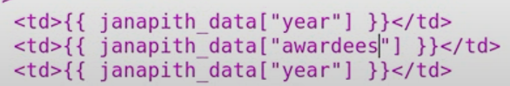

Janapith_data – dictionary

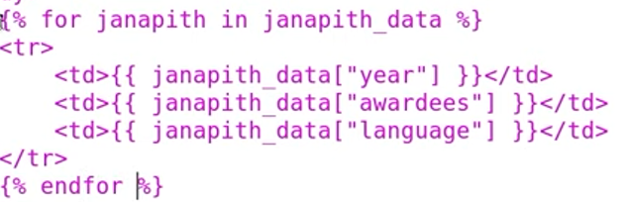

Here janapith is array of dictionaries

