Evaluation

1.Overview of the total visualization
At first, we list some questions to aim to solve the problems that related to the reality.And we set them as our goals for evaluation.
Questions:
1.Seasonal effects on the US flight network (best times to travel)
2.Visualization of best performing airport and the US flight network
3.Identify the best/worse airports and airlines
4.Effect of y2k on the network
5.Effect of 911 on the network
6.Overall visual/aesthetic quality of the VA
7.Effectiveness of the VA System

Q1
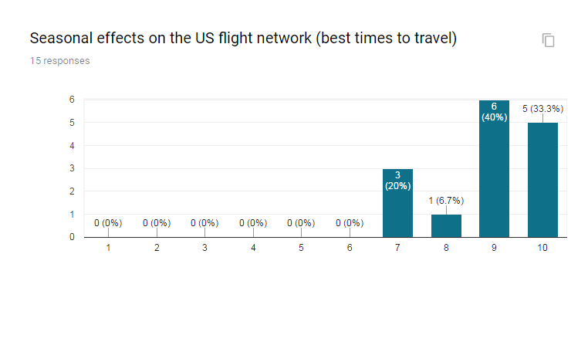
Q2: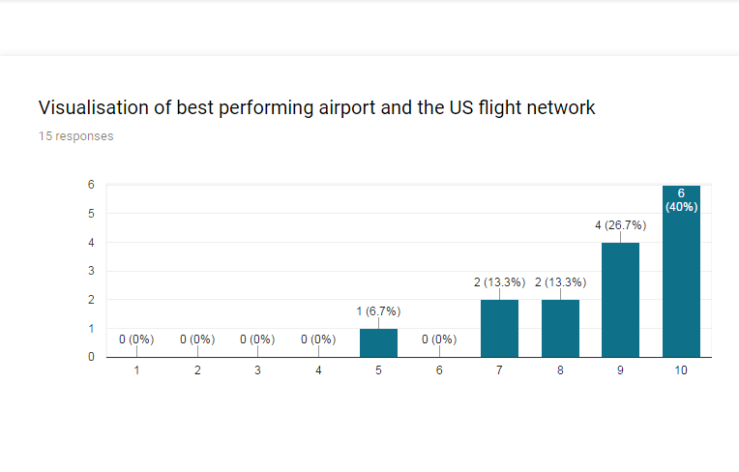
Q3:
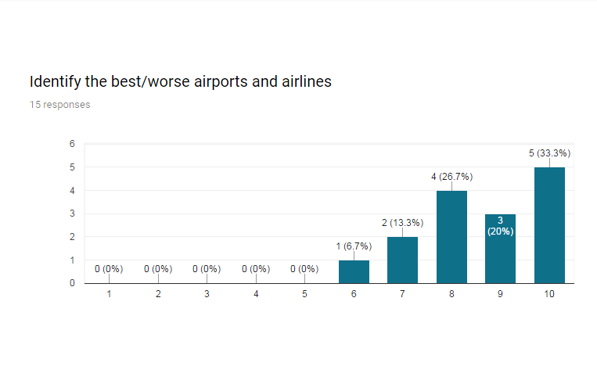
Q4:

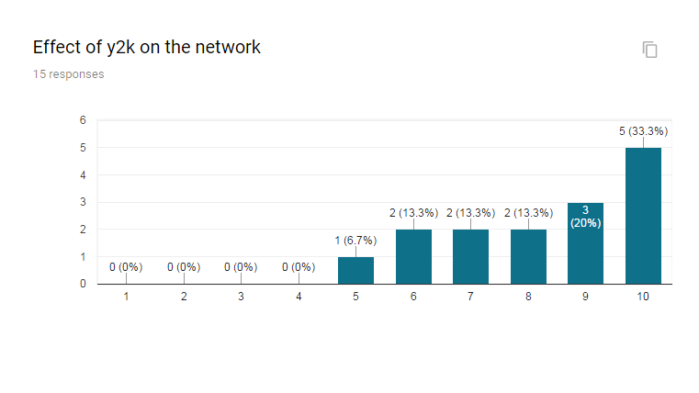
Q5:
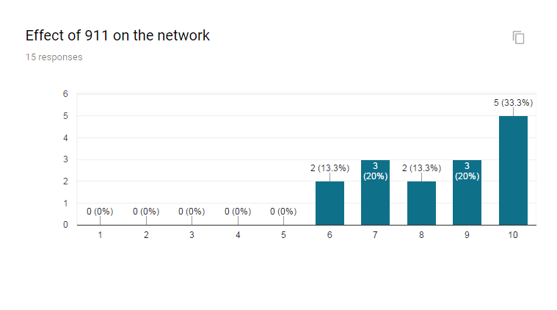
Q6: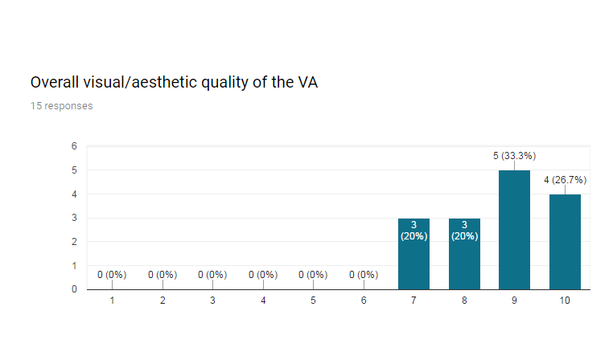
Q7:
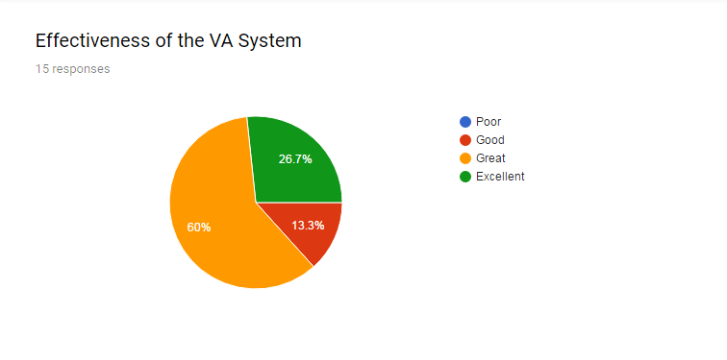
Result:
We get the evaluation result mainly from our friends and family members.Most people think our visualization can solve the problems properly that we gave before.According to this graph,most people consider that the Visualization system perform well.The level of elegance,effectiveness and efficiency of the whole visualization system is great,even excellent.

- Evaluation of the single visualization
Visualization A1
According the visualization,efficiency is excellent,due to the K core and Betweenness centrality.The running time of algorithms should be reasonably fast.
Because of the visualization method,the visualization shows a different way to show the data.The final drawing is beautiful.
Most people firstly saw this visualization,they could say the visualization is easy to understand and the overall relationship of the 21 years of US domestic flight network for flight delay could be known.The data is visualized quickly and correctly.However,visualization lacks the world map,so the detailed information can’t be caught at first glance.
Figure.A1 Graph visualization
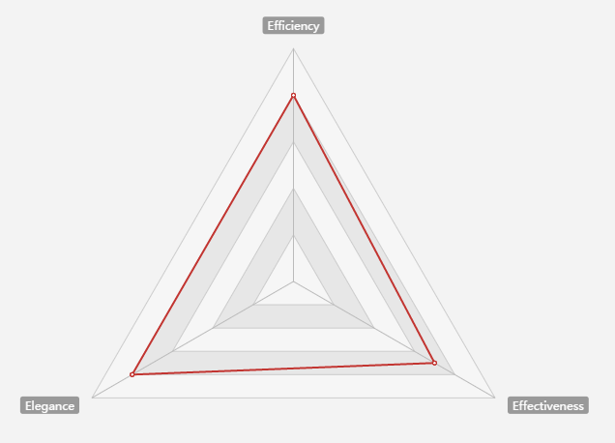

Visualization A2
According A2,efficiency is good,due to the Out-degree Centrality method.The running time of algorithms could be slower than A1.It contains the networks of each airports / airlines by flight delay for year from 1987 to 2008.
Because of the visualization method,the visualization shows the each line and each airport clearly.The final drawing is also beautiful.However,the visualization contain more information than A1.Moreover,the size of airports also is mentioned in the visualization by the different sizes of circle one by one.With the detailed air line,the visualization A1 and A2 are both good.A1 offers the relationship first,and then A2 gives the detailed information in the US map.

Figure.A2 Graph visualization
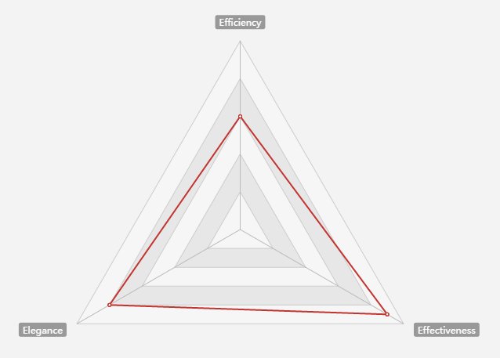

Visualization B
Visualization B is a heat map.Efficiency is excellent,due to the features of heat map.Because of the visualization method,you can acquire the flight delay information from heat map directly.The final drawing is beautiful,due to the different colors based on the different flight delay levels.The heat map method is not so new,and the information is too much in one graph.So it could be not so beautiful.
The flight delay data in 21 years day by day is visualized quickly and correctly.The effectiveness of this visualization is excellent.Most people can understand the meaning and find the flight delay information easily.

Figure.B Graph visualization
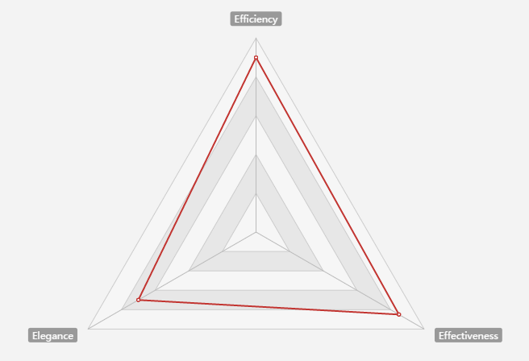

Visualization C
In visualization C,the best or worst performance airports are visualized by tableau.The method to use different colors is a very good way to show the difference,especially in a bar chart.The Efficiency is excellent,due to the features of the bar chart.The running time of algorithms should be reasonably fast.The final drawing is beautiful.The information about the airport performance is useful actually.
The different level of airports performance information is easy to understand.Most people can catch the point of the visualization.

Figure.C Graph visualization
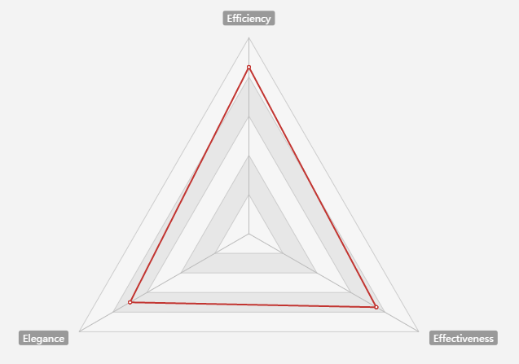

Visualization D
According the visualization,it is a line chart involving the information about best performance airports during a period.The line chart is efficient.The graph is so clear.The algorithm should be reasonably easy.It won’t take long time.
Because of the visualization method,the top performance airports was be introduced.The clear information about them is mentioned.The final drawing is clear and beautiful,but usual.
Most people firstly saw this visualization,they could easily understand the meaning of the visualization.The top performance airports are visualized quickly and correctly.

Figure.D Graph visualization
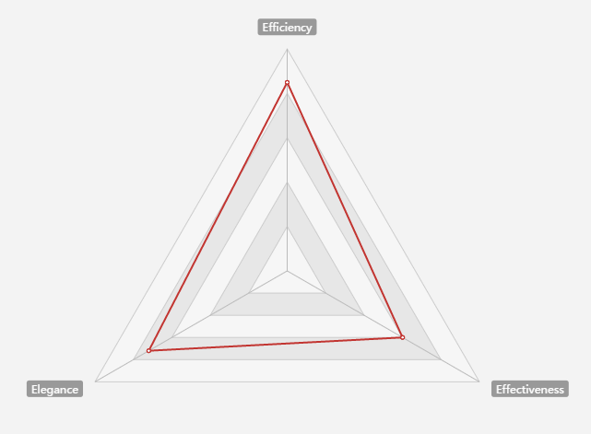
Visualization E
According the visualization,it shows a totally different method to show the best or worst performance airline or carriers.The bubble chart is new,it contains the carrier information and is sorted by month.Efficiency is good,due to Force Directed algorithm.
Because of the bubble chart,the visualization method is a new way to show the data.The final drawing is more beautiful than others.
Most people firstly saw this visualization,they may say what it is.But the visualization is easy to understand actually.And the network of the carrier is also showed between the bubble chart month by month.

Figure.E Graph visualization
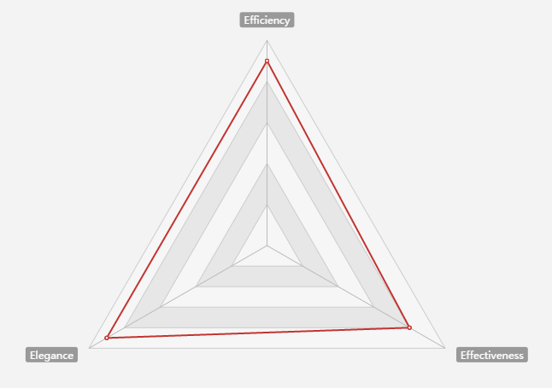

Visualization F
In visualization F,efficiency is excellent,due to the Correlation Matrix.
Because of the visualization method,the visualization shows a different way to show the data.The visualization is beautiful.It contains the relationship between delay reasons and the overall arrival delays. Correlation Matrix is generated for various dimensions.
However,it is not so easy to understand by most people at first glance.

Figure.F Graph visualization
