1.Homepage of your web site that is containing a navigation bar.

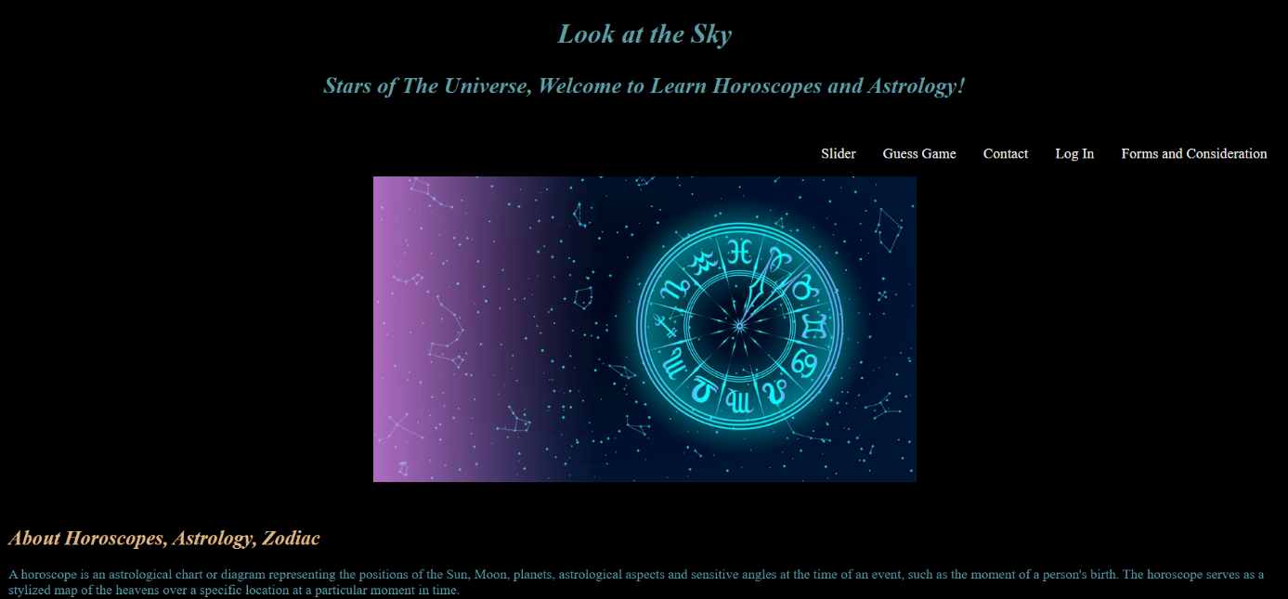

2. Each component must be routed via navigation bar.

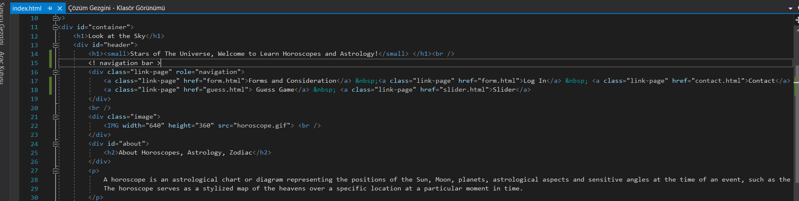



-footnote: I didn't know exactly what you wanted, sir.

3. A slider(carousel) must exist in one of your components.

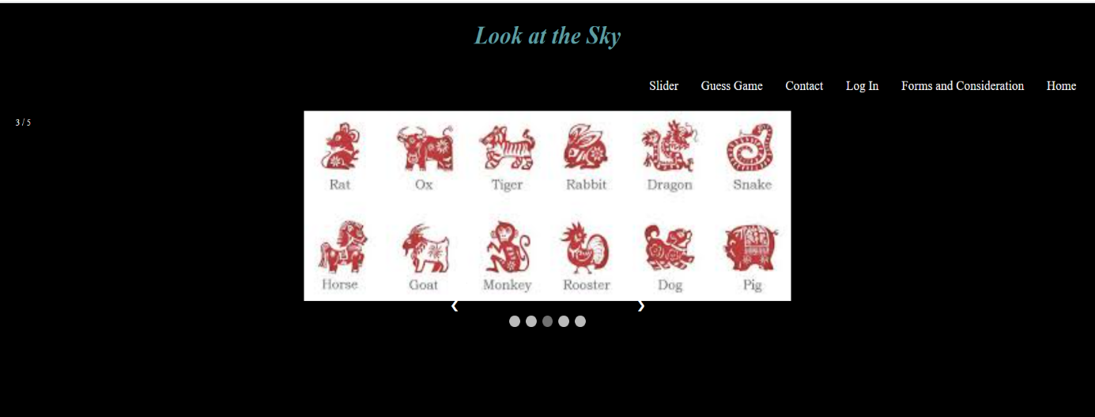

4. Guess game UI.



4.1.

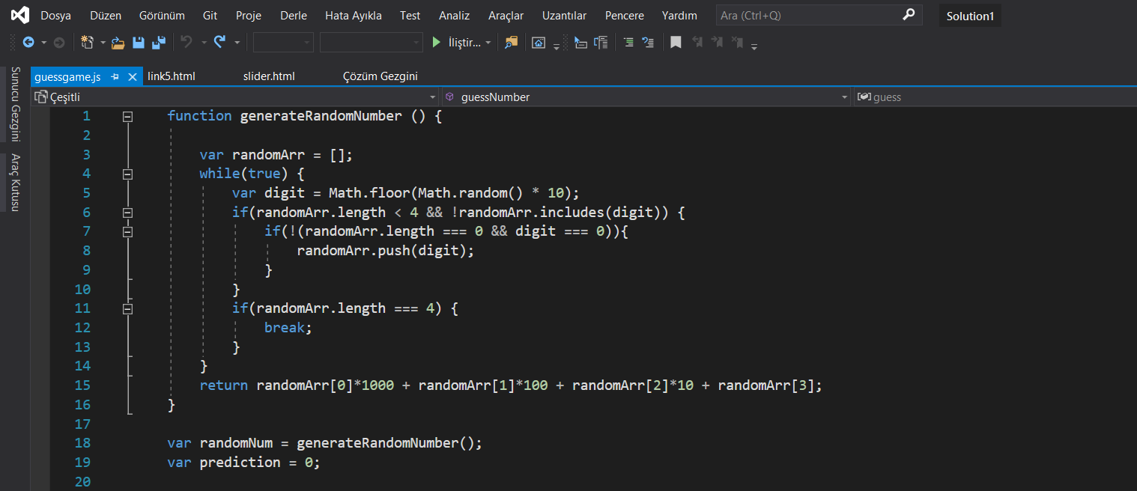

4.2.

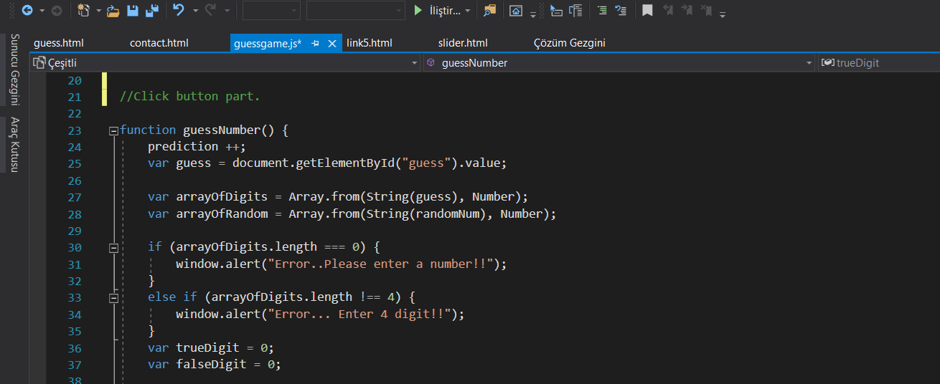

4.3.

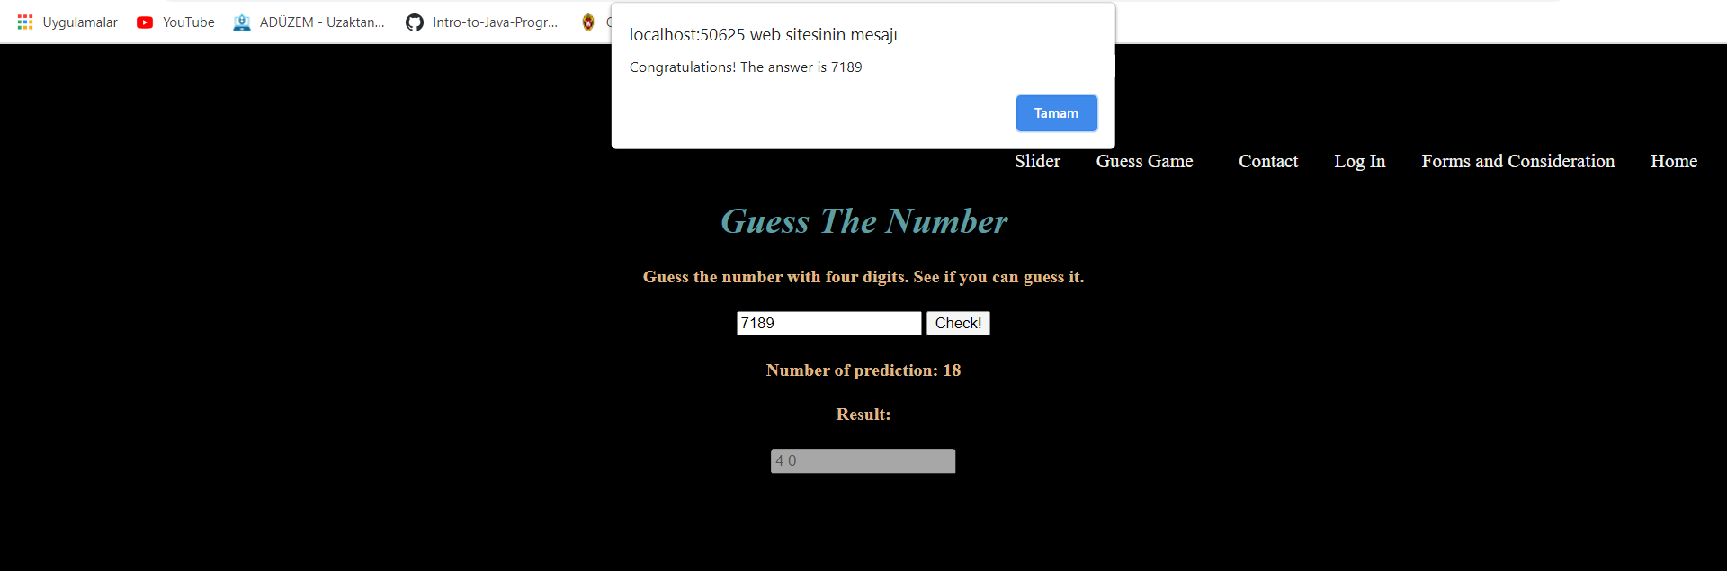

4.4

