GIS-Based Topographic Wetness Index (TWI) Analysis
for Watershed Characterization
Detailed ArcGIS 10.8 Workflow and Map Preparation Procedure
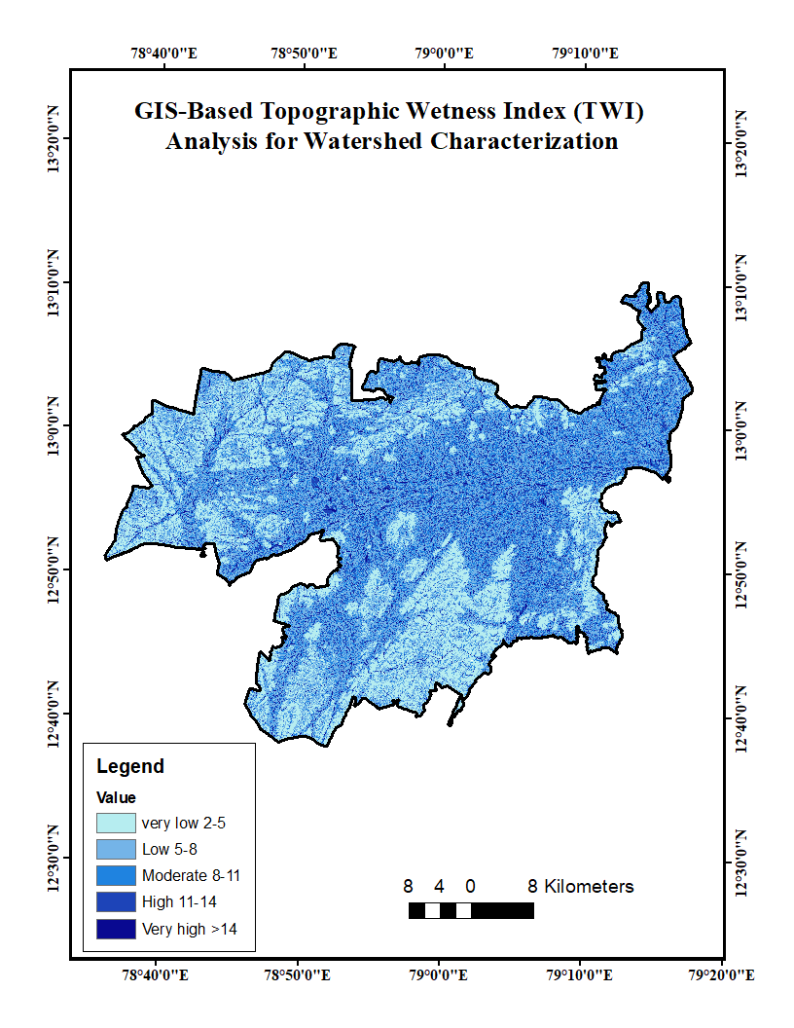
Figure: Final TWI thematic map used as the reference output.

1. Objective
The objective of this workflow is to derive the Topographic Wetness Index (TWI) from Digital Elevation Model (DEM) data and prepare a thematic map showing the spatial distribution of wetness conditions within the watershed. The final map shown above contains five TWI classes: very low (2–5), low (5–8), moderate (8–11), high (11–14), and very high (>14).

2. Overall Workflow
DEM acquisition
↓
Add DEM and watershed boundary to ArcGIS
↓
Project / define coordinate system
↓
Clip DEM to watershed boundary
↓
Fill DEM sinks
↓
Flow Direction
↓
Flow Accumulation
↓
Slope calculation
↓
TWI calculation using Raster Calculator
↓
TWI classification into five classes
↓
Calculate class area and statistics
↓
Symbology and thematic map preparation
↓
Map layout, scale bar, north arrow, legend and coordinate grid
↓
Export final TWI map

3. Data Required
Data / Tool | Purpose
Digital Elevation Model (DEM) | Elevation raster covering the complete watershed.
Watershed boundary | Polygon boundary used to clip the DEM and define the analysis area.
Coordinate reference system | A projected coordinate system suitable for distance and area calculations.
ArcGIS software | ArcGIS 10.8 with Spatial Analyst tools enabled.

4. Step-by-Step ArcGIS Procedure

Step 1 – Start the ArcGIS project
Open ArcMap 10.8 and create a new map document. Add the DEM raster and watershed boundary polygon using Add Data. Confirm that both datasets cover the same study area and that the watershed boundary is correctly displayed.

Step 2 – Check the coordinate system
Right-click Layers → Properties → Coordinate System and check the coordinate reference system. For quantitative terrain analysis, a suitable projected coordinate system is preferred because cell size, distance and area should be expressed in meaningful linear units. If necessary, use ArcToolbox → Data Management Tools → Projections and Transformations → Raster → Project Raster.

Step 3 – Clip the DEM to the watershed
Use Spatial Analyst Tools → Extraction → Extract by Mask. Select the DEM as the input raster and the watershed polygon as the mask. Save the output as 'DEM_Clipped'. This limits the terrain analysis to the study watershed.

Step 4 – Fill sinks in the DEM
Use Spatial Analyst Tools → Hydrology → Fill. Set 'DEM_Clipped' as the input surface raster and save the output as 'DEM_Filled'. This step removes small artificial depressions that may interrupt the continuous flow-routing process.

Step 5 – Generate Flow Direction
Use Spatial Analyst Tools → Hydrology → Flow Direction. Select 'DEM_Filled' as the input surface raster and save the result as 'Flow_Direction'. The output identifies the direction in which water flows from each raster cell toward downslope neighbouring cells.

Step 6 – Generate Flow Accumulation
Use Spatial Analyst Tools → Hydrology → Flow Accumulation. Select 'Flow_Direction' as the flow-direction raster. Save the output as 'Flow_Accumulation'. Higher values indicate locations receiving flow from a larger upslope contributing area.

Step 7 – Calculate slope
Use Spatial Analyst Tools → Surface Analysis → Slope. Select 'DEM_Filled' as the input raster. Set the output measurement to Degree when using a Raster Calculator expression that explicitly converts degrees to radians. Save the result as 'Slope_Degree'. The slope raster represents the local terrain gradient.

Step 8 – Calculate TWI
Use Spatial Analyst Tools → Map Algebra → Raster Calculator. A commonly used formulation is TWI = ln(a / tan β), where 'a' is the specific upslope contributing area and β is the local slope angle in radians. When using flow accumulation, a practical raster expression can incorporate flow accumulation and cell size to represent contributing area. For example: Ln(((Flow_Accumulation + 1) * CellSize) / Tan(Slope_Degree * 0.0174533)). The exact expression should be matched to the DEM resolution and the method adopted in the study. Save the output as 'TWI_Raster'.

Step 9 – Inspect TWI values
Open Layer Properties → Symbology or the raster attribute/statistics information and inspect the minimum, maximum, mean and distribution of TWI values. Check for NoData areas and unrealistic values before classification.

Step 10 – Classify TWI values
Use Spatial Analyst Tools → Reclass → Reclassify, or use Classified Symbology if a non-destructive visualization is preferred. For the map shown, use the following five classes: 2–5 = Very Low; 5–8 = Low; 8–11 = Moderate; 11–14 = High; and >14 = Very High. Save the classified raster as 'TWI_Classified' if a permanent classified dataset is required.

Step 11 – Calculate area of each TWI class
Use the classified raster attribute table to obtain the cell count for each class. Multiply the number of cells by the area represented by one raster cell to obtain class area. Alternatively, use Tabulate Area or appropriate raster-to-polygon and field-calculation tools where required. Report area in square metres or square kilometres.

Step 12 – Prepare the TWI thematic map
Apply a sequential colour scheme in which lower TWI classes are visually separated from higher TWI classes. Edit the class labels so the legend reads: Very Low 2–5, Low 5–8, Moderate 8–11, High 11–14, and Very High >14. Avoid unnecessary visual clutter and ensure that the watershed boundary is clearly visible.

Step 13 – Add map elements
Switch to Layout View and add the map title, legend, north arrow, scale bar, coordinate grid/graticule and data-source information. Use the title 'GIS-Based Topographic Wetness Index (TWI) Analysis for Watershed Characterization'. Check that coordinate labels are readable and that the scale bar corresponds to the map's coordinate system.

Step 14 – Export the final map
Use File → Export Map and export the final layout as PNG or TIFF at high resolution. A PDF version can also be exported for reports and manuscripts. Use a suitable resolution such as 300 dpi or higher for publication-quality output.

5. TWI Classification Used in the Reference Map
TWI Class | Value Range
Very Low | 2–5
Low | 5–8
Moderate | 8–11
High | 11–14
Very High | >14

6. Quality-Control Checks
- Confirm that the DEM has the correct projection and cell size.
- Ensure the DEM completely covers the watershed boundary.
- Check that the DEM has been hydrologically conditioned before flow modelling.
- Confirm that Flow Direction and Flow Accumulation outputs are generated from the filled DEM.
- Use consistent raster cell size, extent and snap raster throughout the analysis.
- Check the TWI raster for NoData areas and abnormal values.
- Verify that class intervals used in the legend match the classification applied to the raster.
- Ensure the final map contains a clear title, legend, scale bar, north arrow and coordinate information.

7. Recommended ArcGIS Output Files
- DEM_Clipped.tif
- DEM_Filled.tif
- Flow_Direction.tif
- Flow_Accumulation.tif
- Slope_Degree.tif
- TWI_Raster.tif
- TWI_Classified.tif
- TWI_Map.png
- TWI_Map.pdf
- ArcGIS project (.mxd)

8. Recommended GitHub Workflow Structure
TWI-Watershed-Analysis/
├── README.md
├── Data/
│ ├── DEM/
│ └── Watershed_Boundary/
├── Processing/
│ ├── DEM_Filled.tif
│ ├── Flow_Direction.tif
│ ├── Flow_Accumulation.tif
│ ├── Slope_Degree.tif
│ └── TWI_Raster.tif
├── Results/
│ └── TWI_Classified.tif
├── Maps/
│ ├── TWI_Map.png
│ └── TWI_Map.pdf
└── ArcGIS_Project/
└── TWI_Analysis.mxd

9. Final Interpretation
The final TWI map represents the spatial variability of topographic wetness across the watershed. Lower TWI values generally correspond to relatively well-drained or steeper terrain, whereas higher TWI values indicate areas with greater potential for water accumulation due to contributing area and local topographic conditions. The TWI map should therefore be interpreted together with terrain, soil, rainfall, land-use/land-cover and drainage information when conducting a comprehensive watershed assessment.

10. Important Methodological Note
The reference image provides the final map title, extent, legend classes and cartographic layout, but it does not contain the original DEM processing settings or the exact TWI calculation expression used to produce the map. Therefore, the workflow above documents a reproducible standard ArcGIS procedure. Before using it in a journal paper or thesis, replace the generic processing details with the exact DEM source, spatial resolution, coordinate system, cell size and TWI equation used in the actual analysis.

