PROJECT DOCUMENT
Supervised Land Use and Land Cover Classification of Vellore District
GIS and Remote Sensing Project

1. Project Overview
This project presents a supervised Land Use and Land Cover (LULC) classification of Vellore District, Tamil Nadu, using geospatial and remote sensing techniques. The classification map represents the major land-cover categories identified within the district, including fallow land, built-up area, agricultural land, water bodies, cloud shadow, and vegetation. The resulting thematic map provides a spatial overview of the distribution and pattern of different land-cover classes across Vellore District.
2. Study Area
The study area is Vellore District, Tamil Nadu, India. The mapped area extends approximately between 78°40′E and 79°10′E longitude and 12°30′N and 13°20′N latitude, as represented by the map coordinates. Vellore has a tropical climate and contains a heterogeneous landscape comprising agricultural areas, vegetation, settlements, fallow land, and surface-water features. The spatial characteristics of these land-cover classes are important for regional planning, environmental assessment, natural-resource management, and sustainable development.
3. Aim
To prepare a supervised Land Use and Land Cover classification map of Vellore District using remote sensing and GIS techniques.
4. Objectives
• To identify and classify the major land-use and land-cover categories within Vellore District.
• To apply supervised image-classification techniques for generating the LULC map.
• To visualize the spatial distribution of agricultural land, vegetation, built-up areas, fallow land, water bodies, and cloud-shadow areas.
• To prepare a cartographically suitable thematic map with geographic coordinates, north arrow, legend, and scale bar.
• To provide a spatial dataset that can support environmental and land-management studies.
5. LULC Classes
S. No. | LULC Class | Description
1 | Fallow land | Agricultural or other land temporarily left uncultivated.
2 | Built-up area | Residential, commercial, industrial, transport, and other constructed surfaces.
3 | Agricultural land | Land primarily used for crop cultivation and agricultural activities.
4 | Water bodies | Rivers, ponds, reservoirs, tanks, and other mapped surface-water features.
5 | Cloud shadow | Areas affected by shadows associated with cloud cover in the source imagery.
6 | Vegetation | Areas dominated by natural or planted vegetation and green cover.
6. Methodology
The LULC map was developed using a supervised classification approach in a GIS and remote sensing environment. The general workflow involves acquisition and preprocessing of satellite imagery, selection of representative training samples for each land-cover class, execution of the supervised classification, post-classification checking, and preparation of the final map. The classified raster was symbolized using distinct class categories and incorporated with cartographic elements such as the legend, coordinate grid/ticks, north arrow, and scale bar.
→ Satellite image/data acquisition
→ Image preprocessing and preparation
→ Selection of training samples for representative LULC classes
→ Supervised classification
→ Classification checking and refinement
→ Map layout preparation
→ Final LULC map generation and interpretation
7. Final LULC Map
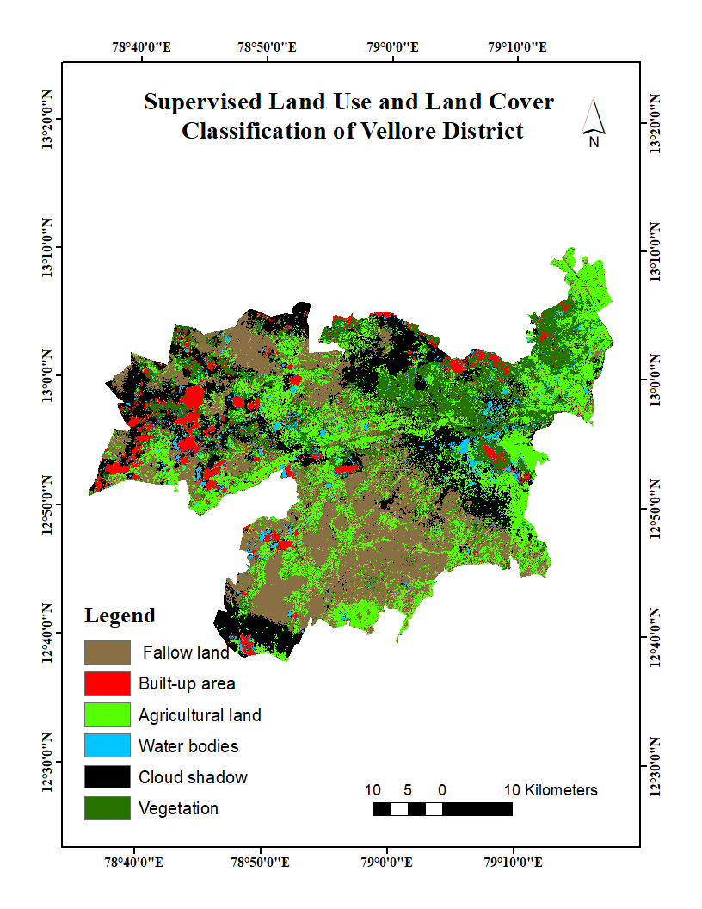
Figure 1. Supervised Land Use and Land Cover Classification of Vellore District
8. Map Interpretation
The classified map shows a heterogeneous spatial pattern of land use and land cover across Vellore District. Agricultural land and vegetation occupy substantial portions of the mapped area, while built-up areas occur as concentrated and dispersed settlement clusters. Fallow land is distributed across several parts of the district, reflecting areas that are not under active cultivation at the time of image acquisition. Water bodies appear as localized features, mainly associated with drainage and surface-water systems. Cloud-shadow areas represent portions of the satellite scene influenced by cloud conditions and should therefore be interpreted separately from actual land-cover classes.
9. Cartographic Elements
The final map includes geographic coordinate labels, a north arrow, a legend identifying the six mapped classes, and a kilometre-based scale bar. The coordinate labels are presented in degrees, minutes, and seconds along the map margins, while the scale bar provides a visual reference for estimating distances within the study area.
10. Applications
• Land-use planning and regional development
• Agricultural-resource assessment
• Vegetation and environmental monitoring
• Water-resource and watershed management
• Urban expansion and settlement analysis
• Baseline information for environmental impact and sustainability studies
11. Conclusion
The supervised LULC classification provides a spatial representation of the major land-cover categories of Vellore District. The resulting map can serve as a baseline spatial dataset for environmental assessment, land-resource management, agricultural planning, and further GIS-based analysis. The project demonstrates the usefulness of remote sensing and GIS for mapping and interpreting spatial patterns of land use and land cover at the district scale.

