Using Yelp Data to Estimate Business Demand and Identify Key Drivers for Location-Based Decision Support

Sunghoon Ahn, Eun Soo Park, Thiri Htet Oo, Jayanthi Muthuselvan
University of Niagara Falls, Canada
Master’s Data Analytics
Capstone Project – DAMO-699-1
Touraj BaniRostam
June 14, 2026

Using Yelp Data to Estimate Business Demand and Identify Key Drivers for Location-Based Decision Support
1. Introduction
Digital review platforms generate large-scale customer data, including online reviews, star ratings, business attributes, geographic information, and check-in activity. For local businesses, these data can support demand estimation and location-based decision-making. However, many prior Yelp-based studies have focused mainly on customer satisfaction, review sentiment, or star ratings. These indicators are useful, but they do not fully represent actual customer engagement.
This study developed a predictive analytics framework using the Yelp Open Dataset to estimate business demand and identify key demand drivers. Business demand was measured using customer check-in activity as a proxy for real-world engagement and visit frequency. Review-based features, business attributes, sentiment measures, spatial variables, and temporal activity patterns were integrated into machine learning models. The final model was then interpreted using feature importance and SHAP-based driver analysis to explain which factors contributed most strongly to predicted demand.
2. Literature Review
The rapid growth of online review platforms and user-generated content has transformed business analytics, customer behavior analysis, and predictive decision-making. Platforms such as Yelp provide large-scale datasets containing review text, ratings, business attributes, geographic information, and customer activity records, allowing researchers to examine customer opinions and business characteristics together. Previous studies show that online reviews influence customer purchasing decisions, business reputation, and restaurant demand. Luca (2016) argued that Yelp ratings and reviews significantly affect restaurant revenue by shaping consumer trust and business visibility. Similarly, Tian et al. (2020) showed that Yelp review text provides meaningful insight into customer dining sentiment and emotional responses.
As Yelp datasets have become larger and more complex, researchers have increasingly applied machine learning and natural language processing (NLP) techniques to sentiment analysis and business prediction tasks. Traditional models such as Logistic Regression, Naïve Bayes, and Support Vector Machines (SVM) have been widely used, while recent studies have also applied deep learning models such as LSTM, BiLSTM, BERT, and RoBERTa to improve contextual language understanding (Belaroussi, 2025). Beyond sentiment classification, Yelp-based studies have expanded into customer satisfaction analysis, review helpfulness prediction, churn analysis, and restaurant survival prediction. For example, Li et al. (2023) demonstrated that aspect-based sentiment from online reviews improved restaurant survival prediction, supporting the use of review data as an indicator of business performance.
More recently, explainable artificial intelligence (XAI) has become important because high-performing ensemble models often lack interpretability. Lundberg et al. (2020) introduced SHAP, which provides transparent interpretation for tree-based ensemble models such as Random Forest, XGBoost, and LightGBM. These developments support the design of this study, which integrates Yelp review, business, spatial, temporal, and check-in features to estimate business demand and identify key demand drivers using interpretable machine learning.
2.1 Yelp Dataset Analytics and Business Intelligence
Researchers have increasingly used Yelp datasets for large-scale business analytics and customer behavior analysis. Alam et al. (2021) showed that Yelp review, business, and check-in data can support geo-spatial analysis, temporal analysis, and customer activity analysis. This is relevant to this study because our final dataset also combines review-based features, business attributes, location variables, and check-in activity to estimate demand. Similarly, Korada (2025) suggested that Yelp-based sentiment analysis and predictive modeling can support business strategy and data-driven decision-making. These studies show that Yelp data can be used not only for review analysis but also for broader demand prediction and location-based business intelligence.
  - Sentiment Analysis and Machine Learning Evolution
Sentiment analysis is a common topic in Yelp-related machine learning research. Liu (2020) compared several sentiment classification models using Yelp restaurant reviews, including Logistic Regression, SVM, Gradient Boosting, LSTM, and BERT. The study found that simpler models such as Logistic Regression and SVM achieved competitive performance compared with more complex deep learning models. More recent studies have applied BERT and other transformer-based models to improve contextual sentiment analysis (Wu et al., 2024; Belaroussi, 2025). Puh and Bagić Babac (2023) also showed that deep learning models can perform well in tourism review sentiment prediction.
These studies are useful for this capstone because they support the use of review text and sentiment-related variables as predictive features. However, most of them focus on sentiment classification accuracy itself. In contrast, this study uses sentiment measures as part of a broader business demand prediction model, together with review volume, business attributes, location variables, temporal activity patterns, and check-in activity.
  - Customer Satisfaction, Review Helpfulness, and Consumer Behavior Analysis
Several studies have extended Yelp analytics beyond sentiment classification to customer satisfaction, review helpfulness, and behavioral analysis. Review sentiment has been shown to relate to restaurant ratings and dining experience topics such as food and service (Tian et al., 2020). Alikhani et al. (2025) also found that review content, service quality, and ambience were related to customer satisfaction. In review helpfulness prediction, food-related aspects and emotional content improved prediction performance (Luo & Xu, 2019). Peng et al. (2024) further showed that sentiment categories were significantly associated with user retention and churn behavior.
These studies are relevant because they show that Yelp review data can explain customer experience and engagement. However, most of them focus on separate outcomes such as satisfaction, helpfulness, or churn. This study extends that direction by combining review sentiment, business attributes, location features, temporal activity, and check-in activity into one demand prediction model.
2.4 Business Outcome Prediction and Restaurant Survival Analytics
Recent research increasingly connects online review analytics with business outcome prediction. Li et al. (2023) proposed an aspect-based sentiment analysis (ABSA) framework for restaurant survival prediction using online reviews. The study categorized review sentiment into multiple operational dimensions including location, tastiness, price, service, and atmosphere. Using Conditional Survival Forest models, the authors found that aspect-based sentiment analysis significantly improved restaurant survival prediction compared with overall sentiment analysis alone.
The findings also highlighted that different restaurant attributes contribute differently to business survival outcomes, suggesting that customer-generated content can function as an early operational indicator of business performance and failure risk. This research is particularly important because it moves Yelp analytics beyond sentiment classification toward business performance prediction and operational decision support.
2.5 Explainable AI and Interpretable Machine Learning
As machine learning models become more complex, model interpretation becomes important in business analytics. Lundberg et al. (2020) introduced SHAP and TreeExplainer, which explain tree-based ensemble models by measuring how each feature contributes to a prediction. This approach is relevant to this study because the final demand prediction model uses LightGBM, and SHAP is applied to identify the main demand drivers.
Sarker (2021) also emphasized the importance of machine learning methods for real-world predictive analytics using large and heterogeneous datasets. Together, these studies support the use of ensemble machine learning and SHAP-based interpretation in this Yelp-based demand prediction project.
2.6 Research Gap
Although previous studies have applied Yelp data to sentiment analysis, customer satisfaction, review helpfulness, churn analysis, and restaurant survival prediction, most of these studies focused on separate analytical tasks. Fewer studies have combined review-based features, business attributes, spatial variables, temporal activity patterns, and check-in behavior into one demand prediction framework. In addition, many predictive studies reported model performance but provided limited interpretation of the main factors driving business demand.
To address this gap, this study uses Yelp check-in activity as a demand proxy and combines review, sentiment, business, spatial, and temporal features in machine learning models. SHAP-based interpretation is then applied to identify the key drivers of predicted business demand.
Table 1
Comparative Summary of Previous Yelp-Based Studies
Study | Main Focus | Methods | Key Findings
Alam et al. (2021) | Yelp dataset analytics | Geo-spatial and temporal analytics | Demonstrated scalable Yelp analytics
Korada (2025) | Business strategy analytics | Predictive analytics, sentiment analysis | Yelp analytics supports business decisions
Liu (2020) | Yelp sentiment classification | LR, SVM, GBM, LSTM, BERT | Traditional ML models remained competitive
Wu et al. (2024) | Deep learning sentiment analysis | BERT, transformer models | Fine-tuned BERT improved classification
Belaroussi (2025) | Yelp polarity classification | BERT vs LSTM | Transformer models outperformed RNNs
Puh & Bagić Babac (2023) | Tourism review prediction | CNN, LSTM, BiLSTM, BERT | Deep learning outperformed traditional ML
Tian et al. (2020) | Dining sentiment analysis | Sentiment analysis, topic analysis | Service strongly influenced sentiment
Alikhani et al. (2025) | Customer satisfaction analysis | Textual analysis | Review content influenced satisfaction
Luo & Xu (2019) | Review helpfulness prediction | LDA, sentiment analysis, SVM | Emotional content improved helpfulness prediction
Peng et al. (2024) | User churn analysis | Sentiment analysis, Chi-square test | Sentiment related to churn behavior
Li et al. (2023) | Restaurant survival prediction | ABSA, Conditional Survival Forest | Aspect-based sentiment improved prediction
Lundberg et al. (2020) | Explainable AI | SHAP, TreeExplainer | SHAP improved model interpretability
Sarker (2021) | Machine learning overview | ML algorithm review | Ensemble ML useful for predictive analytics
Luca (2016) | Online review impact | Reputation analysis | Online reviews affected business demand

3. Data Description
This project used the Yelp Open Dataset released in April 2024. The dataset is a publicly available large-scale dataset provided for academic use under the Yelp Dataset User Agreement. It contains approximately 10 million records, with an uncompressed size of about 9.2 GB, and includes multiple JSON files related to customer reviews, business information, and check-in activity.
Three main datasets were used in this study: review.json, business.json, and checkin.json. The review dataset contains review text, star ratings, engagement counts such as useful, funny, and cool, and timestamps. These data were used to create review-based features such as review volume, average rating, sentiment scores, review length, and engagement metrics. The business dataset contains business categories, geographic coordinates, and operational attributes, which were used to create business-level and location-based features. The check-in dataset contains timestamped customer activity records and was used to construct the target variable.
Business demand was measured using aggregated check-in counts at the business level. Because the raw review dataset is large, review-level records were aggregated into business-level features before modeling. The three datasets were integrated using business_id, and the cleaned feature table was saved in Parquet format for modeling and analysis.
4. Methodology
4.1 Data Collection and Integration
This study used three main files from the Yelp Open Dataset: business.json, review.json, and checkin.json. These files were selected because they contain the business information, customer reviews, and check-in activity needed for demand prediction. The datasets were integrated using the common business_id key.
The original JSON Lines files were converted into Parquet format to support faster filtering and large-scale processing. Data cleaning and aggregation were conducted using PySpark on Databricks. The user.json file was excluded because user social network information was outside the scope of business demand prediction.
Before integration, exploratory data analysis was conducted to check review counts, ratings, check-in activity, missing values, and inconsistent records. Review-level data were aggregated into business-level summaries before merging so that all features matched the final unit of analysis.
4.2 Target Variable Construction
The target variable is defined as the aggregated check-in count per business, constructed from timestamped records in the checkin.json file. Because the Yelp dataset does not include direct measures of revenue, transactions, or foot traffic, check-in activity is used as a proxy for customer demand. The distribution of check-in counts is highly right-skewed, with a small number of high-traffic businesses dominating the dataset. To address this issue and improve model stability, a log(1 + check-in count) transformation is applied prior to model training. This transformation reduces the influence of extreme values and helps the models capture relative differences more effectively.
4.3 Feature Engineering
Feature engineering transformed raw Yelp data into structured predictors at the business level. Review-level data were aggregated before modeling to match the target variable. Review-based features included review count, average star rating, average review length, and engagement metrics such as useful, funny, and cool counts.
Sentiment features were generated from review text and included average sentiment score, positive review ratio, and negative review ratio. Business attribute features included indicators such as delivery, takeout, outdoor seating, credit card availability, good for kids, price range, category counts, and operating-hour variables. Location-related features included coordinate-missing indicators and nearby business density. Temporal features were derived from check-in timestamps and included peak-hour ratio, weekend ratio, and monthly activity.
Categorical and missing-value issues were handled through encoded indicator variables and missingness flags where needed. After feature engineering, all predictors were stored in a business-level modeling table.
4.4 Model Development
This study adopted a staged model comparison framework to evaluate predictive performance across different machine learning approaches. Linear Regression was used as a baseline model because of its simplicity and interpretability. Random Forest was included as a bagging-based ensemble method, while Support Vector Regression (SVR) represented kernel-based learning.
Gradient boosting models, including XGBoost and LightGBM, were also evaluated because they are well suited for structured tabular data and can effectively capture nonlinear relationships and feature interactions. LightGBM provides efficient histogram-based learning and scalable tree growth, while XGBoost is widely used for predictive analytics and business intelligence applications.
All models were trained using the same training, validation, and test splits to ensure fair comparison. Hyperparameters for Random Forest, XGBoost, and LightGBM were optimized using randomized search and cross-validation. Support Vector Regression was tuned using selected parameter configurations. A Multi-Layer Perceptron (MLP) was additionally evaluated as an optional neural network model for the regression task only. In addition to the primary regression task, a classification-based robustness check was conducted to evaluate the ability of the models to distinguish high-demand businesses from low- and medium-demand businesses.
4.5 Model Evaluation
The primary modeling task was defined as a regression problem because the study aimed to estimate business demand using log-transformed check-in counts. Regression performance was evaluated using Root Mean Squared Error (RMSE), Mean Absolute Error (MAE), and R². RMSE gives more weight to larger errors, MAE shows the average prediction error, and R² indicates how much variance in business demand is explained by the model.
In addition to regression evaluation, a classification robustness check was conducted by grouping businesses into high-demand and low/medium-demand classes. Classification performance was evaluated using accuracy, precision, recall, F1-score, and the confusion matrix. This check was used to test whether the models could also separate high-demand businesses from the rest.
4.6 Model Interpretation
To improve model transparency and interpretability, SHAP (SHapley Additive exPlanations) was applied to the best-performing model. SHAP quantifies the contribution of each feature to individual predictions and provides both global and local interpretability. Global interpretation identifies the most important features influencing predicted demand across all businesses, while local interpretation explains individual predictions. Dependence plots were used to analyze nonlinear relationships between key features and predicted demand. Because SHAP computation can be resource-intensive for large datasets, a stratified sample was used to ensure representative interpretation while maintaining computational efficiency.
4.7 Limitations and Future Work
This study used check-in counts as a proxy for business demand because the Yelp dataset does not provide actual revenue, transaction, or foot-traffic data. Therefore, the results should be interpreted as demand estimation based on customer activity, not direct sales prediction. Future work could include external revenue or transaction data to improve target validity. Additional models such as CatBoost or transformer-based sentiment features could also be tested in future research. Finally, this study identifies associations between Yelp features and predicted demand, but it does not establish causal relationships.
5. Results
5.1 Experimental Setup
The final modeling dataset produced by the feature engineering pipeline contained 52,286 restaurant businesses, each represented by 34 numeric predictors and a log-transformed check-in demand target. The data were divided into a training set of 41,828 businesses (80%) and a held-out test set of 10,458 businesses (20%) using a fixed random seed for reproducibility. Every model was trained on the same split, and all performance figures reported below are computed on the held-out test set unless noted otherwise. The continuous target, log(1 + check-in count), was used for all regression models, and predictions were evaluated using Root Mean Squared Error (RMSE), Mean Absolute Error (MAE), and the coefficient of determination (R²).
5.2 Regression Model Performance
Table 2 summarizes the test-set performance of the seven regression models evaluated in this study. Tuned LightGBM achieved the strongest result, with an R² of 0.945, an RMSE of 0.3849, and an MAE of 0.2948. Tuned XGBoost followed closely with an R² of 0.942. Both boosting models, in their default and tuned forms, outperformed the Random Forest benchmark, the MLP neural network, and the Linear Regression baseline.
The Linear Regression baseline explained 78.9% of the variance in demand, while the best ensemble reached 94.5%, a gap of roughly 15 percentage points. This difference indicates that business demand is governed by nonlinear relationships and feature interactions that a linear model cannot capture, which supports the methodology's decision to adopt gradient-boosted ensembles as the primary models. The MLP neural network reached an R² of 0.913, below all tree-based ensembles. This outcome is typical for moderate-sized tabular datasets, where gradient boosting generally outperforms neural architectures.
Table 2
Regression Model Performance on the Held-Out Test Set
Model | RMSE | MAE | R²
LightGBM (tuned) | 0.3849 | 0.2948 | 94.50%
XGBoost (tuned) | 0.3967 | 0.3018 | 94.16%
LightGBM | 0.4096 | 0.3170 | 93.77%
XGBoost | 0.4151 | 0.3206 | 93.60%
Random Forest | 0.4383 | 0.3334 | 92.87%
MLP Neural Network | 0.4845 | 0.3688 | 91.29%
Linear Regression | 0.7466 | 0.5739 | 79.31%

Figure 1
Regression Model Performance (R² by Model)
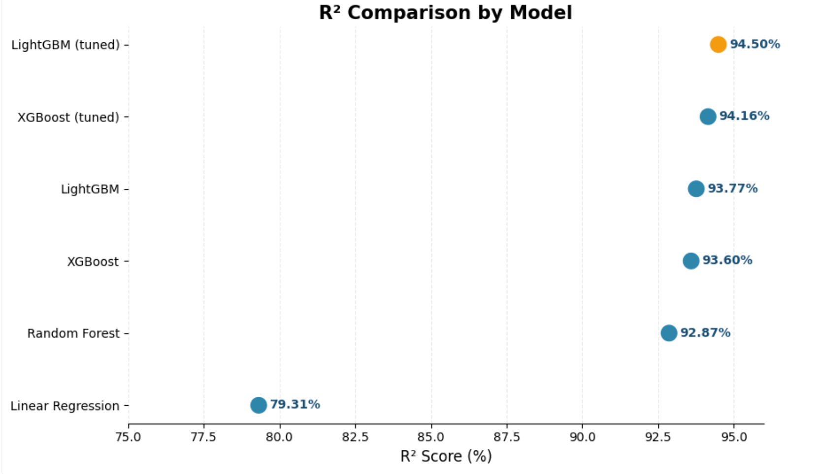

5.3 Hyperparameter Tuning
Both boosting models were tuned with randomized search over 30 parameter combinations under 5-fold cross-validation, following the procedure described in Section 4.4. Table 3 lists the selected hyperparameters. Tuning improved the cross-validated RMSE for both models, with LightGBM reaching 0.396 and XGBoost reaching 0.408. The gains over the default configurations were modest but consistent across runs, which indicates that the default settings were already near-optimal for this feature set and that tuning provided incremental refinement rather than a structural change in performance.
Table 3
Selected Hyperparameters from 5-Fold Randomized Search
Model | Selected Hyperparameters | CV RMSE
XGBoost (tuned) | n_estimators=800, max_depth=9, learning_rate=0.03, subsample=0.9, colsample_bytree=0.9, reg_alpha=0, reg_lambda=10 | 0.4079
LightGBM (tuned) | n_estimators=800, num_leaves=63, max_depth=7, learning_rate=0.05, subsample=0.8, colsample_bytree=0.7, reg_alpha=0, reg_lambda=0 | 0.3961

5.4 Classification Robustness Check
To test whether the models also separate high-demand restaurants from the rest, the continuous target was converted into a binary high-demand label using the top 25% of the training target as the threshold, which corresponds to a log check-in value of approximately 5.00. Table 4 reports accuracy, precision, recall, and F1-score for the seven classifiers. F1-score is emphasized because the high-demand class is the minority by construction, so accuracy alone can be inflated by the majority class.
The two tuned boosting models achieved nearly identical classification performance. Tuned XGBoost achieved the highest F1-score (0.8782), while tuned LightGBM achieved slightly higher precision (0.8980). Both models reached the same overall accuracy of 94.06%, demonstrating strong and consistent performance in distinguishing high-demand restaurants from the rest. The two non-ensemble baselines, SVM (F1 = 0.855) and Linear Regression (F1 = 0.794), trailed the ensemble models on both the regression and classification tasks. Because both modeling perspectives identified the same boosting-model family as the strongest performer, the interpretation analysis in Section 6 focuses on the demand drivers identified from the best-performing ensemble framework.
Table 4
Classification Robustness Check (High-Demand vs. Low/Medium-Demand)
Model | Accuracy | Precision | Recall | F1-score
LightGBM (tuned) | 94.06% | 89.80% | 85.91% | 87.81%
XGBoost (tuned) | 94.06% | 89.77% | 85.94% | 87.82%
XGBoost | 93.57% | 88.80% | 84.91% | 86.81%
LightGBM | 93.56% | 88.98% | 84.64% | 86.75%
Random Forest | 93.50% | 89.01% | 84.29% | 86.59%
SVM | 93.05% | 88.73% | 82.57% | 85.54%
Linear Regression | 90.51% | 86.44% | 73.43% | 79.40%

The confusion matrix for the tuned XGBoost classifier (Table 5) shows strong separation between the two demand classes. The model correctly identified 86% of the true high-demand restaurants (recall) at 90% precision, while classifying the low/medium-demand majority with 95% precision and 97% recall.
Table 5
Confusion Matrix Summary for the Tuned XGBoost Classifier
Class | Precision | Recall | F1-score | Support
Low/Medium Demand | 0.95 | 0.97 | 0.96 | 7,854
High Demand | 0.90 | 0.86 | 0.88 | 2,604
Overall accuracy |  |  | 0.94 | 10,458

Figure 2
Confusion Matrix for the Tuned XGBoost Classifier
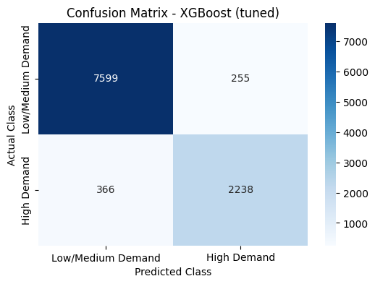
5.5 Prediction Diagnostics
The actual-versus-predicted scatter plot showed most businesses clustered along the diagonal reference line, which is consistent with the high R². The prediction band widened modestly at the upper end of the demand range, indicating that the model captures the demand ordering well but loses some precision for the busiest restaurants. This behavior is expected for a heavy-tailed count target even after the log transform. The residual distribution was approximately symmetric and centered near zero, with no systematic over- or under-prediction across the demand range. The residual tail at high demand reflects the use of check-in count as a demand proxy rather than direct revenue, a point addressed in Section 8.
Figure 3
Actual vs. Predicted Business Demand
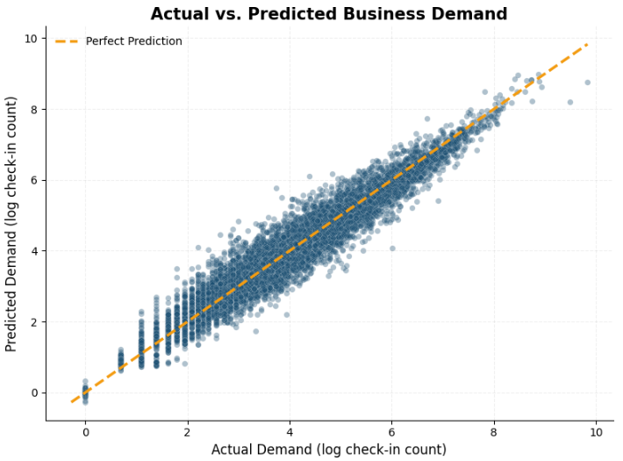
Figure 4
Residual Distribution of the Best Model
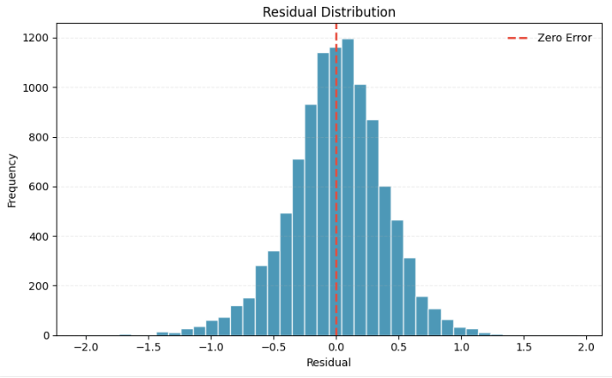
6. Model Interpretation and Demand Drivers
6.1 Feature Importance
The feature importance values from the best model, tuned LightGBM, indicate which predictors the model relied on most. Table 6 lists the ten most important features. The ranking is dominated by three feature families. Temporal features occupy the top three positions: monthly check-in activity, weekend check-in ratio, and peak-hour check-in ratio. Review-volume and engagement features follow, including review count, average review length, and the sums of useful, funny, and cool votes. Business attributes such as average stars and operating hours, together with one spatial feature, nearby business density, complete the top group.
Three features received zero importance: is_restaurant, coord_missing, and sentiment_missing. These results are structural rather than substantive. The dataset was filtered to restaurants during cleaning, so is_restaurant is constant; the cleaning rules removed out-of-range coordinates, so coord_missing has no variation; and the full-review VADER pass left no business without a sentiment value. Their zero importance confirms that the data-preparation pipeline delivered the data quality the modeling stage assumed.
Table 6
Top 10 Feature Importance Values (Tuned LightGBM)
Rank | Feature | Driver Family | Importance
1 | monthly_activity | Temporal | 5,305
2 | weekend_ratio | Temporal | 4,575
3 | peak_hour_ratio | Temporal | 4,353
4 | review_count | Review | 3,200
5 | avg_review_length | Review | 2,636
6 | avg_stars | Business | 2,428
7 | sum_useful | Review | 2,343
8 | nearby_business_density | Spatial | 2,160
9 | hours_total_week | Temporal | 2,035
10 | sum_funny | Review | 2,026

Figure 5
Top Feature Importance (Tuned LightGBM)
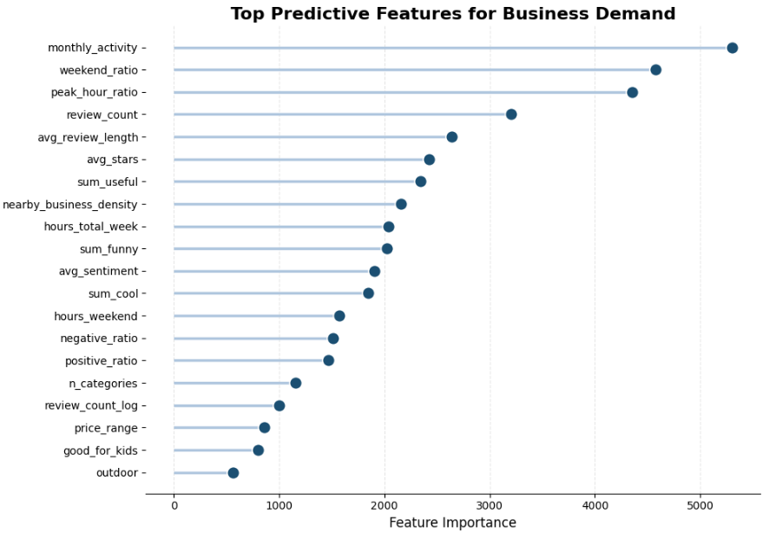
6.2 SHAP Global Interpretation
SHAP (SHapley Additive exPlanations) was applied to the tuned LightGBM model using a TreeExplainer on a 2,000-business sample of the test set, following Section 4.6 of the methodology. The SHAP analysis confirmed the feature importance ranking and added the direction of each effect. Higher monthly activity, weekend ratio, and peak-hour ratio pushed predicted demand upward, establishing temporal intensity as the strongest positive driver. Higher review count and longer average review length also raised predicted demand, which reflects the link between review volume and customer attention documented by Luca (2016). Among the sentiment features, a higher average sentiment and positive ratio increased predicted demand while a higher negative ratio decreased it, and the three sentiment measures pointed in mutually agreeing directions. Nearby business density contributed in both directions, reflecting the dual role of local density as either competition or beneficial spillover.
Figure 6
SHAP Summary Plot of Global Feature Effects on Predicted Demand
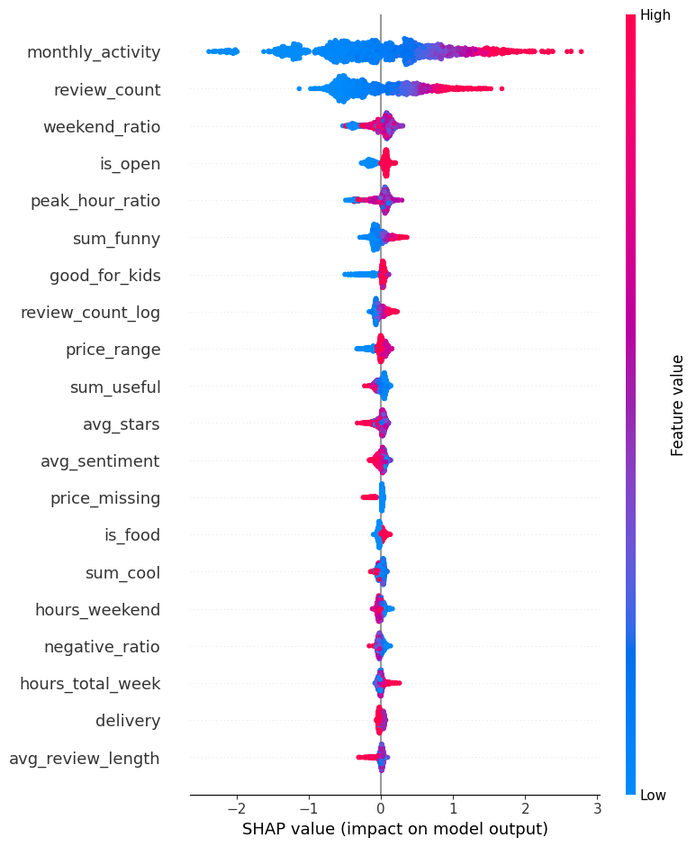
6.3 Demand Driver Analysis
To connect the feature-level results to the proposal hypotheses, the predictors were grouped into four business-meaningful driver families. At the individual-feature level, the three most important predictors are all temporal: monthly check-in activity, weekend ratio, and peak-hour ratio. When the features are aggregated into families, temporal and review-based features form the two largest groups, followed by business attributes, then sentiment, and finally spatial features.
Temporal drivers cover monthly activity, the weekend and peak-hour ratios, and operating hours. This family contains the single most important predictor, monthly activity, and all three of the top-ranked features overall. This is the central empirical finding of the study: on Yelp, restaurant demand is primarily a timing phenomenon, driven by when customers visit rather than by static attributes alone. The result is consistent with Alam et al. (2021), who demonstrated that Yelp check-in data can support temporal and customer activity analysis. In this study, temporal features such as monthly activity, weekend ratio, and peak-hour ratio emerged as the strongest predictors of business demand.
Review-based drivers, covering review count, length, and engagement votes, formed the second-largest group, which supports the role of review activity as a measure of sustained customer attention (Luca, 2016; Luo & Xu, 2019). Business attributes such as stars, price range, and service flags contributed a smaller but meaningful share, acting as refinements rather than primary drivers. Sentiment features carried real signal but ranked below review volume, which echoes Tian et al. (2020) and Luo and Xu (2019), who found that sentiment is informative but secondary to engagement volume on review platforms. The spatial group was the smallest among the model-visible features, because high-cardinality location fields such as city and state were excluded from the model to prevent leakage and retained only for visualization.
6.4 Temporal and Geographic Patterns
The temporal features correlated positively with predicted demand at the population level, with the strongest correlations coming from monthly activity, peak-hour ratio, and weekend ratio, in the same direction as the SHAP analysis. Operating hours correlated only weakly on their own, which indicates that being open longer is an enabling condition rather than a direct demand driver. Geographically, the predicted high-demand restaurants clustered in the metropolitan areas the Yelp Open Dataset documents in depth, with uneven concentration inside each metro that matches the role of nearby business density as a spatial signal. These patterns address RQ2 by showing that temporal factors are the dominant source of demand variation, with spatial context contributing a secondary effect.
Figure 7
Predicted Demand by Business Location
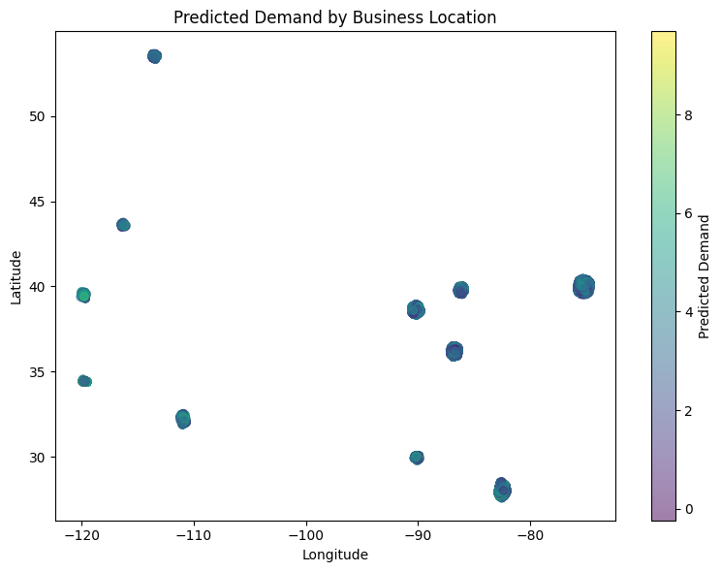
7. Discussion
7.1 Hypothesis Evaluation
The empirical results allow a direct evaluation of the four research hypotheses, summarized in Table 7. H1 is supported, because the best model explained 94.5% of the variance in log check-in demand on held-out data. H2 is supported by the roughly 15-percentage-point R² gap between the best ensemble and Linear Regression. H3 is supported, because review, business, and temporal variables all appear among the leading feature importance and SHAP rankings. H4 is supported, with particularly strong evidence for the temporal dimension, since temporal features occupy the top three positions in every importance and SHAP ranking. The spatial dimension shows a weaker but present effect through nearby business density, because high-cardinality location fields such as city and state were excluded from the model to prevent leakage.
Table 7
Evaluation of the Research Hypotheses
Hypothesis | Result | Key Evidence
H1: Demand can be estimated with meaningful accuracy | Supported | Best model R² = 0.945 on the held-out test set
H2: Ensembles outperform a linear baseline | Supported | About a 15-point R² gap (94.5% vs. 79.3%)
H3: Review, business, and temporal features are key drivers | Supported | All three families lead the importance and SHAP rankings
H4: Demand varies across location and temporal factors, with peak periods | Supported (strong for temporal, weaker for spatial) | Temporal features hold the top three positions; spatial effect limited to nearby business density

7.2 Answers to the Research Questions
RQ1 is answered by the model performance: Yelp-derived features estimate restaurant demand with strong predictive accuracy, reaching an R² of 0.945. RQ2 is answered by the driver analysis: temporal factors are the dominant source of demand variation, followed by review activity, with spatial density contributing a smaller secondary effect. RQ3 is answered by the model comparison: tuned LightGBM and XGBoost outperformed Random Forest, the MLP neural network, SVM, and Linear Regression on both regression and classification. RQ4 is answered by the SHAP interpretation: temporal activity, review engagement, and business attributes were identified as the model's primary demand drivers, with consistent directions across the global SHAP summary, the dependence analysis, and the population-level correlation.
7.3 Comparison with Prior Literature
The results align with several patterns in the cited literature while extending them to a new task. Prior Yelp studies have focused mainly on sentiment classification (Liu, 2020; Belaroussi, 2025), review helpfulness prediction (Luo & Xu, 2019), or restaurant survival (Li et al., 2023), whereas this study framed demand as a check-in regression problem, which is comparatively under-explored. The superiority of ensemble models over the linear baseline matches the methodological trend reported by Liu (2020) and Puh and Bagić Babac (2023). The secondary role of sentiment relative to review volume echoes Tian et al. (2020) and Luo and Xu (2019). The use of SHAP for interpretation follows Lundberg et al. (2020) and the interpretable-machine-learning emphasis of Sarker (2021), which places the study within the growing focus on explainable predictive analytics.
8. Limitations
Several limitations bound the interpretation of these results. First, check-in count is a proxy for demand, not a direct measure of revenue or transactions. The Yelp Open Dataset does not contain sales data, so businesses with high revenue but low check-in activity, or the reverse, cannot be distinguished. The residual tail at high demand partly reflects this proxy gap.
Second, the analysis identifies predictive associations, not causal effects. Feature importance and SHAP describe how the model uses each feature, not whether changing that feature would change real demand. Causal claims would require experimental or quasi-experimental data beyond the scope of this study.
Third, the data have coverage limits. Yelp users are not representative of all customers, and the dataset concentrates on a small set of large U.S. metropolitan areas, so the findings may not transfer directly to other markets without recalibration. The dataset is also a single April 2024 snapshot, so seasonal and longer-term dynamics are not modeled.
Fourth, the modeling has methodological limits. High-cardinality categorical fields such as city, state, and the full category string were excluded to prevent leakage, which narrowed the spatial feature set. Sentiment was computed with the lexicon-based VADER method, which is efficient and reproducible but does not capture sarcasm, multilingual text, or aspect-level nuance; transformer-based methods such as BERT report higher polarity accuracy (Belaroussi, 2025; Wu et al., 2024). Finally, gradient-boosted trees do not extrapolate beyond the training range, so predictions for extreme-demand businesses warrant additional caution. These limitations point to the future-work directions outlined in Section 4.7, including aspect-based sentiment analysis, transformer-based sentiment features, richer spatial encodings, and external validation against real demand outcomes.
9. Conclusion
This study developed and interpreted a predictive analytics framework for estimating restaurant demand from Yelp data, using customer check-in activity as a demand proxy. After cleaning and feature engineering produced a business-level dataset of 52,286 restaurants, seven models were trained and compared. Tuned LightGBM achieved the best regression performance, explaining 94.5% of the variance in log check-in demand on the held-out test set and substantially outperforming the linear and neural baselines. The classification robustness check showed similarly strong performance from the tuned boosting models, with tuned XGBoost achieving the highest F1-score by a very small margin.
SHAP-based interpretation identified temporal activity as the leading demand driver, followed by review engagement, with business attributes, sentiment, and spatial density contributing secondary effects. These findings support all four research hypotheses and answer the four research questions, confirming that Yelp-derived features can estimate business demand with strong accuracy and that the key drivers can be identified through model-based interpretation. The driver taxonomy and the explainable-AI approach provide an evidence base for location-based decision support, while the acknowledged limitations, particularly the check-in proxy and the non-causal nature of the findings, define the boundaries within which the results should be applied.

References
Alam, M., Cevallos, B., Flores, O., Lunetto, R., Yayoshi, K., & Woo, J. (2021). Yelp dataset analysis using scalable big data processing techniques. arXiv. https://arxiv.org/abs/2104.08396
Alikhani, E., Gholipour, H. F., Abbasinejad, H., & Rafat Nezhad, R. (2025). Review content and customer satisfaction: A textual analysis of Yelp restaurant reviews. British Food Journal. https://doi.org/10.1108/BFJ-05-2025-0636
Belaroussi, R., Noufe, S. C., Dupin, F., & Vandanjon, P.-O. (2025). Polarity of Yelp reviews: A BERT–LSTM comparative study. Big Data and Cognitive Computing, 9(5), 140. https://doi.org/10.3390/bdcc9050140
Korada, M. (2025). Leveraging Yelp data for business strategy and predictive analytics. https://doi.org/10.31274/cc-20251215-164
Li, H., Yu, B. X. B., Li, G., & Gao, H. (2023). Restaurant survival prediction using customer-generated content: An aspect-based sentiment analysis of online reviews. Tourism Management, 96, 104707. https://doi.org/10.1016/j.tourman.2022.104707
Liu, S. (2020). Sentiment analysis of Yelp reviews: A comparison of techniques and models. arXiv. https://arxiv.org/abs/2004.13851
Luca, M. (2016). Reviews, reputation, and revenue: The case of Yelp.com. Harvard Business School NOM Unit Working Paper No. 12-016. https://doi.org/10.2139/ssrn.1928601
Lundberg, S. M., Erion, G., Chen, H., DeGrave, A., Prutkin, J. M., Nair, B., Katz, R., Himmelfarb, J., Bansal, N., & Lee, S.-I. (2020). Explainable AI for trees: From local explanations to global understanding. Nature Machine Intelligence, 2, 56–67. https://doi.org/10.1038/s42256-019-0138-9
Luo, Y., & Xu, X. (2019). Predicting the helpfulness of online restaurant reviews using different machine learning algorithms: A case study of Yelp. Sustainability, 11(19), 5254. https://doi.org/10.3390/su11195254
Peng, S., Chen, J., Chen, C., & Dai, M. (2024). Sentiment and user churn analysis for online platform business using Yelp studies. In Proceedings of the 2024 International Conference on Algorithms, Data Mining, and Information Technology. https://doi.org/10.1145/3701100.3701105
Puh, K., & Bagić Babac, M. (2023). Predicting sentiment and rating of tourist reviews using machine learning. Journal of Hospitality and Tourism Insights, 6(3), 1188–1204. https://doi.org/10.1108/JHTI-02-2022-0078
Sarker, I. H. (2021). Machine learning: Algorithms, real-world applications and research directions. SN Computer Science, 2(160). https://doi.org/10.1007/s42979-021-00592-x
Tian, G., Lu, L., & McIntosh, C. (2020). What factors affect consumers’ dining sentiments and their ratings: Evidence from restaurant online review data. Food Quality and Preference, 85, 104060. https://doi.org/10.1016/j.foodqual.2020.104060
Wu, X., Zhang, Y., & Liu, R. (2024). Research on the application of deep learning-based BERT model in sentiment analysis. arXiv. https://arxiv.org/abs/2403.08217
Yelp Inc. (2024). Yelp Open Dataset. https://www.yelp.com/dataset/

