**Info 1113 – System analysis and design (a10)**

**FINAL PROJECT (Group G)**

**Submission Date: December 1, 2021**

**Group members:**

**Name:** Abdul Muiz

**Student Id:** 100414959

**KPU email:** [abdul.muiz@email.kpu.ca](mailto:a%62%64%75l%2e%6d%75%69z@%65%6d%61%69%6c%2e%6b%70%75%2e%63%61)

**Name:** Vaibhav Kanojia

**Student Id:** 100412207

**KPU email:** [vaibhav.kanojia@email.kpu.ca](mailto:v%61%69%62%68a%76%2e%6b%61%6e%6fj%69%61@e%6d%61%69%6c%2ekp%75%2eca)

**Name:** Gagandeep Kaur

**Student Id:** 100409806

**KPU email:** [gagandeep.kaur37@email.kpu.ca](mailto:%67ag%61%6e%64%65%65%70%2ekau%7237@%65%6d%61%69%6c%2ek%70u%2ec%61)

**Name:** Jasleen Kaur

**Student Id:** 100411328

**KPU email:** [jasleenkaur8@email.kpu.ca](mailto:%6a%61s%6c%65enk%61u%72%38@e%6dai%6c%2e%6b%70%75%2e%63%61)

**TABLE OF CONTENTS**

* **Group Links**
* **Github of Group Members**
* **Website of group members**
* **Introduction**
* **Executive Summary for Communication App**
* **Project Requirements**
* **Use case diagram**
* **Use case descriptions**
* **Class Diagram**
* **Interface prototype**
* **Relational Database**
* **Project Experience**
* **Conclusion**
* **Work Cited**

**Group links**

**Trello board for group** - [Assignment 3 | Trello](https://trello.com/b/TtXfcPZI/assignment-3)

**Group Github** - [AMMESTER/group-G-assigment-3 · GitHub](https://github.com/AMMESTER/group-G-assigment-3)

**Group website** – <https://sites.google.com/view/project-for-group>

**Github of Group Members**

**Gagandeep Kaur:**

<https://github.com/nagragagan15>

**Jasleen Kaur:**

<https://github.com/jasleen0623>

**Abdul Muiz:**

<https://github.com/AMMESTER>

**Vaibhav Kanojia:**

<https://github.com/vaibhav8607/testproject>

**Website of group members**

**Gagandeep Kaur:**

<https://sites.google.com/view/myfirst1site>

**Jasleen Kaur:**

<https://sites.google.com/view/info1113systemanalysisa10>

**Abdul Muiz:**

<https://sites.google.com/d/1ddJZloEnVNwoVNkivJasqrtDLs9IblV1/p/1HZ0RvnZYweji910L14KkN4ZsGZws0V3G/edit>

**Vaibhav Kanojia:**

<https://sites.google.com/view/info1113kpu>

**Executive Summary**

Two-way communication apps are simple but are very important in modern society. Most jobs require that you have a phone and can use the companies chosen communication app. Apps like messenger whatsapp and Instagram are examples of communication apps. These apps allow for messages to be sent via the internet or data to anywhere in the world. You can leave voice messages, send pictures, talk in real-time and face-time other people with these apps.

Some apps prioritize giving extra features for communication while others provide more security to your messages so that you can use more sensitive information that you do not want external groups or people getting their hands on. Outside of work 2-way communication apps are the easiest way to keep connected with friends. These apps also allow you to use chat groups which is very good for coordination if working on major projects as everyone can communicate quickly and see what everyone else is seeing.

Communication apps have a lot going on behind the scenes and they usually take just 1-2 seconds to go through this large process. First off everyone makes an account that is connected to a server that keeps the data of the user’s account. Each account has a username and password associated with it if you fill the field of the password and username anywhere in the world then you can log onto your account with any device in the world. You can type in the username of your friends and colleagues and send a friend request to them. Once they accept it then you can easily message them.

In a 2-way communications app the message is sent from your phone to an internet tower then to a server, or directly to the server. After it reaches the server it sends it to a satellite or directly to the intended recipient. This communication is simple, easy to access and very effective at communicating to a specific person or group.

**Introduction**

Communication apps are fundamental in the modern era, in almost all jobs it is required that you have a communications app. The reason they are important is that they can allow simple, instant communication from 1 individual person or a group. If you are getting late to work, you can tell your boss immediately. If you need to send a specific message and data to a group for a project for proper coordination you can use the app. If you do not use a communication app then it would take either days or weeks to send a message, however, if you are calling them on phone, it would be instantaneous, but you would still not be able to send files like pictures or videos in a matter of seconds. It is a proven fact that if you can communicate with your team quickly and efficiently it is much more likely that they will produce quicker and more high-quality products. Teams that are not able to communicate quickly or effectively usually work slower and make more mistakes due to confusion.

**Project Requirements**

**Functional Requirements**

* Welcome Page function: This welcome page will be displayed when the application is downloaded by the user. This will include the logo of the application and will ask the user to click on “Get Started” button to continue with the application.
* Login and Registration function: This function allows the user to create a unique account. The user needs to fill up his or her phone number and an email address to make their account.
* Account Verification function: This function will verify the mobile number and e-mail address provided by the user. It will send a code on the mobile number and email and will ask the user to fill up that code on the application within a time period of 20 seconds.
* Username function: This function would ask the user to type a username. This would be the name shown to other people using the application.
* Profile Picture function: This function will ask the user to add a profile picture. However, it would not be mandatory to add one.
* Add Contacts function: This function would enable the user to add or invite their contacts on the application to connect to them.
* Chat function: This function allows the user to chat with their added contacts via text and emojis.
* Send media function: This function allows the user to send media such as pictures, songs, voice notes, documents with their added contacts.
* Calling function: This function enables the user to call their added contacts. Both voice and video call can be made.
* Create group function: The user can create or get added in groups and interact with several people at the same time that is send text and voice message.
* Add status function: The user can add a picture, song or video on their account which can be viewed by their added contacts.
* Privacy Settings function: The user can change the settings of who can see their profile picture and status and can block certain users from their account**.**

**Non-Functional Requirements**

* Account creation: The app requires users to create accounts to access it. The accounts store data and view profiles of users. A security system would authorise the accounts to access the application when users enter the correct username and password.
* Password generation: An application would require the user to create a strong password to access the application.
* Portability: The application would be highly portable that is it would work efficiently on multiple devices.
* Compatibility: The application would be highly compatible that is it would function properly with different operating systems.
* Localization: The application would be localized that is it would match the geographical location of the user and automatically adjust the date and time.
* Speed: The application would be able to function properly even when the user uses other applications simultaneously. The messages would be sent in no time. However, the speed would also depend on the strength of network available.
* Less power Consumption: The app would be designed in a manner that it would consume less battery of the device.
* Less Data Consumption: The app would be designed in a manner that it would consume less data of the user.

**Use Case Diagram** (<https://lucid.app/lucidchart/193b55a8-8f08-4990-8ec1-43ce64a2283a/edit?invitationId=inv_46d4414b-2e93-407c-a661-ef6c2d58f20e>)

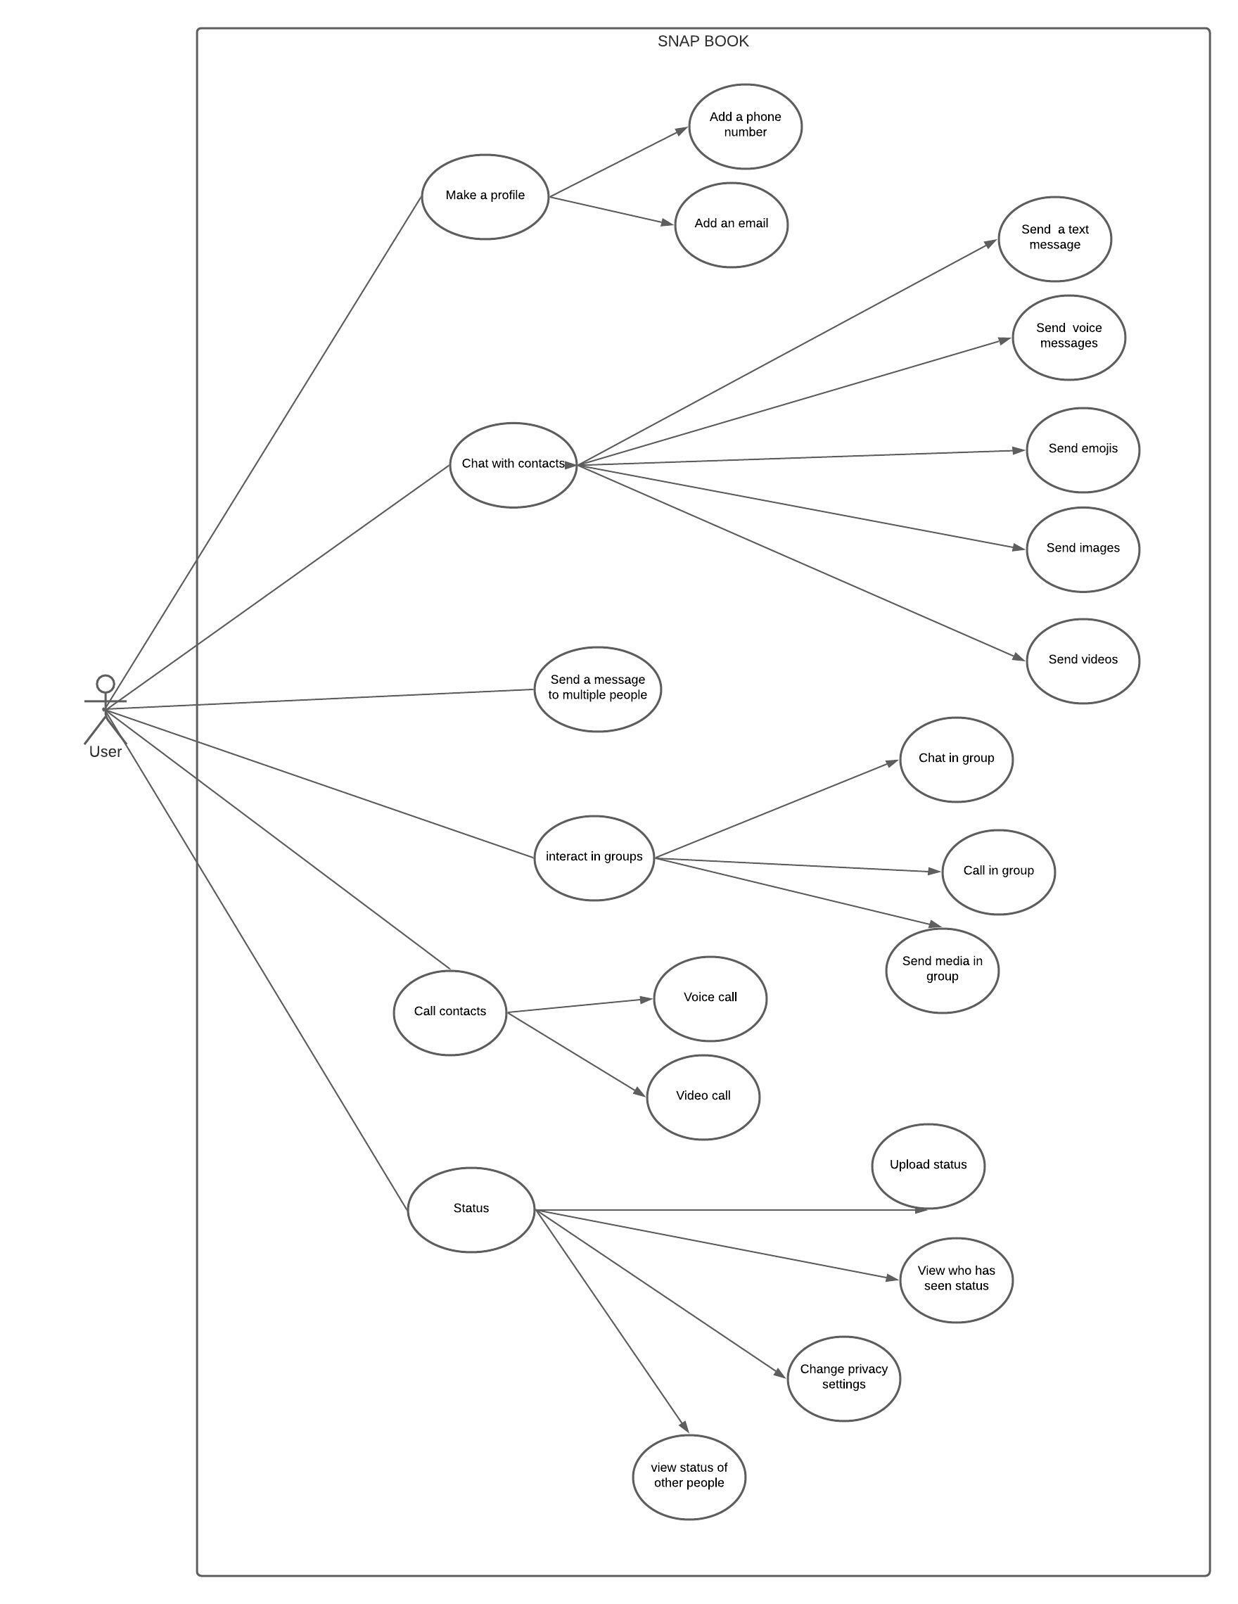

**USE CASE DISCRIPTIONS OF USERS**

**Gagandeep Kaur (Go Fit App)**

The actor who is the user provides data such as age, height, gender and weight. The app in turn creates and provides a workout plan based on the data given by the user.

The app asks the user for a time when he or she would like to work out and remind him or her at that time.

The app helps the users keep a track of their diet and calorie intake.

The app reminds the users to drink water and ask them to input the number of glasses each time they drink water.

**Jasleen Kaur (Edu-Unite)**

The user log ins into the app and then provide the information about their age, class, and the subjects they are studying.   
Then the user enters or scans the question they are doubtful about, and they get the answer to the question.

The app even provides the user with the weekly tests, in the form of quizzes and one-word questions. App even keeps a record of the marks and the progress you make every week and even encourages you to study and ask questions.

**Abdul Muiz (Snap-Book)**

The users make an account by entering in a phone number, email , username and password, as well as their real name and location. You then add your contacts. You can directly message them, or you can add them to a group chat.

This app makes communicating with people easy and effective, you don’t just have to send messages though you can also send files like videos and images.

**VAIBHAV KANOJIA (Pack’n’Ship)**

Users sign up by entering username and password and complete their profile by entering their name, address, phone number and email. Then the user selects the service he/she want from the list of services to continue with. There are various payment options (PayPal, visa, Mastercard, bank transfer, etc) to pay easily on the go. This app also provides real time package tracking for assured and safe delivery of their package.

**Class diagram**

(https://lucid.app/lucidchart/923019ee-9424-407e-b9cd-1020843db00e/edit?invitationId=inv_1fdc8e0f-15c2-483b-be83-19120a984bcc)

**INTERFACE PROTOTYPE**

**Relational Database**



**PROJECT EXPERIENCE**

Initially, the project was planned and discussed among the group members, and tasks were assigned. We then created a trello board to keep track of the work that each member needs to complete, as well as a separate list for completed tasks. Due to our hectic schedules, however, it was difficult to contact with each other.

We had a tough time getting started on the project because there was so much to do, and some of the tasks were difficult and time-consuming, but we managed to complete them as a group. We encountered issues with GitHub because it was our first time using it and making changes to the repository, so we just made changes and added items to our group git.

It was great working with everyone as all were so supportive and generous. We should have started the project earlier, but we made it work in the end.

**Conclusion**

Our application was designed for the users to message or call their family and friends. The primary purpose of the application is to make the communication easier. This project has been planned in a very simple way to communicate between 2 personal devices. Through this project the users should not worry about their data to be accessed though other devices. As their personal data and their information or messages are end-to-end encrypted. Which means that their data is safe between just two persons. Through this application the users can chat, make voice calls, and video calls. The users can even do group video calls.

This is a very handy application, easier to handle. Especially, for new users and even beginners. This application also allows the users to update their profile like; enter your name, enter a quote or status you want. And even add something about yourself, so that the other people you communicate with would know about you.

A detailed description of our application, including functional and non-functional requirements, a completely created use case diagram and a class diagram, are all included in our project. It also includes a user interface prototype for our programme, which depicts how the app would appear to users if it were to be implemented.

**Work cited**

[www.dailyinfographic.com/communication-evolution](http://www.dailyinfographic.com/communication-evolution).

[www.business2community.com/communications/4-ways-technology-has-revolutionized-communication-02348837#:~:text=Money%20and%20speed,that%20we%20connect%20with%20others](http://www.business2community.com/communications/4-ways-technology-has-revolutionized-communication-02348837#:~:text=Money%20and%20speed,that%20we%20connect%20with%20others).

[www.forbes.com/sites/solrogers/2019/10/15/the-role-of-technology-in-the-evolution-of-communication/?sh=37dc975c493b](http://www.forbes.com/sites/solrogers/2019/10/15/the-role-of-technology-in-the-evolution-of-communication/?sh=37dc975c493b).

<https://www.geeksforgeeks.org/functional-vs-non-functional-requirements/>