GraphCodeRAG
AST-Aware GraphRAG Developer Assistant
Final Project — AI for Engineering

Subject: | AI for Engineering
Industry: | Software Engineering / DevTools
Date: | April 2026

Table of Contents

1. Executive Summary
GraphCodeRAG is an AST-aware GraphRAG developer assistant designed to solve a fundamental limitation of standard Retrieval-Augmented Generation (RAG) systems when applied to source code. Standard RAG pipelines use naive text-splitting methods that destroy the logical structure of code, severing class definitions from their methods and losing critical cross-file dependencies. This leads to incomplete context retrieval and hallucinated LLM responses.
Our system addresses this by combining Abstract Syntax Tree (AST) analysis for intelligent code chunking with a Knowledge Graph for dependency mapping, creating a hybrid retrieval architecture that delivers structurally complete, multi-hop context to the LLM. The project targets Python-only repositories and focuses on function-level and class-level nodes with cross-file import edges.
The expected outcome is a functional prototype that can ingest a mid-sized GitHub repository, build a semantic graph of its dependencies, and demonstrate quantifiable improvement in retrieval quality and answer accuracy over a standard baseline RAG pipeline.

2. Problem Statement

2.1 The limitations of standard RAG for code
Retrieval-Augmented Generation has become the industry-standard approach for grounding LLM responses in external knowledge. The typical RAG pipeline involves splitting documents into chunks, embedding them into vectors, storing them in a vector database, and retrieving the most semantically similar chunks at query time. For natural language documents, this works well.
However, source code is fundamentally different from prose. Code has rigid syntactic structure, where a function's behavior depends on its class context, its imported dependencies, and the call chain that reaches it. When standard text splitters (such as recursive character chunking at 512 tokens) are applied to code, they routinely:
- Sever class definitions from their methods, leaving retrieved chunks without their parent class context.
- Split functions mid-body, producing syntactically invalid and semantically meaningless chunks.
- Lose import relationships, making it impossible to trace cross-file dependencies.
- Miss the call graph, so the LLM cannot follow the chain of logic across multiple functions and files.

2.2 The multi-hop reasoning gap
Understanding a codebase often requires reasoning across multiple interconnected files. For example, answering the question "Why does the save() method in Model sometimes skip validation?" requires traversing from save() to full_clean() to individual field validators, each potentially in different files. Standard vector similarity search retrieves chunks that are semantically similar to the query but has no mechanism for following these structural connections. This results in the LLM receiving isolated code fragments without the broader context needed for accurate answers.

2.3 Industry-scale challenge
The alternative approach of using massive context windows to ingest entire codebases is neither scalable nor cost-effective for enterprise repositories with millions of lines of code. What is needed is a targeted retrieval strategy that understands code structure and can efficiently extract the precise, interconnected context required for each query.

3. Proposed Solution

3.1 Core concept
GraphCodeRAG replaces naive text splitting with AST-aware code chunking and augments vector-based semantic search with knowledge graph traversal. The system parses Python source code using Tree-sitter to extract logical units (functions and classes), maps their dependencies (imports, function calls, class inheritance) into a Neo4j knowledge graph, and uses a hybrid retriever that combines both vector similarity and graph traversal to assemble structurally complete context for the LLM.

3.2 Key innovations
AST-aware chunking: Instead of splitting code at arbitrary character boundaries, the system uses Abstract Syntax Tree analysis to identify natural code boundaries. Each function definition and class definition becomes its own chunk, preserving syntactic completeness and semantic meaning.
Knowledge graph for dependencies: The system constructs a directed graph where nodes represent code entities (functions, classes, modules) and edges represent relationships (imports, function calls, class containment, inheritance). This graph enables multi-hop traversal to discover connected code across file boundaries.
Hybrid retrieval: At query time, the system first performs semantic vector search to find topically relevant code chunks, then uses the knowledge graph to expand the result set by traversing dependency edges outward from the initial results. The two result sets are merged, deduplicated, and ranked before being passed to the LLM.

3.3 Scope and constraints
For the scope of this course project, the system is constrained to Python-only repositories, function-level and class-level nodes in the graph, and cross-file import edges. The evaluation is performed against established academic benchmarks (SWE-bench Lite) to ensure rigor and reproducibility.

4. Industry Relevance
This project is closely aligned with one of the fastest-growing segments in the software industry. The AI code assistant market was valued at approximately $4.7 billion in 2025 and is projected to reach $14.6 billion by 2033. Tools like GitHub Copilot, Claude Code, and Cursor have already crossed the $1 billion ARR mark, and over 84% of developers now use or plan to use AI-powered coding tools.
The core challenge these tools face at scale is accurately retrieving the right context from large, multi-file repositories. Current approaches either rely on massive context windows (which are expensive and not scalable) or basic semantic search (which misses structural relationships). The AST-aware GraphRAG approach explored in this project represents a more targeted and cost-effective retrieval strategy that directly addresses this industry-wide bottleneck.
Approach | Strengths | Limitations
Large context windows | Simple, no preprocessing needed | Expensive, not scalable for millions of LOC
Basic semantic search (RAG) | Fast, good for topical similarity | Misses structural relationships
AST + GraphRAG (ours) | Structure-aware, multi-hop context | Requires parsing and graph construction

5. System Architecture
The system is organized into six distinct layers, each with clear responsibilities and interfaces. Data flows unidirectionally through the ingestion pipeline and is stored in dual databases, then queried through the hybrid retriever at inference time. The following diagram illustrates the complete architecture:

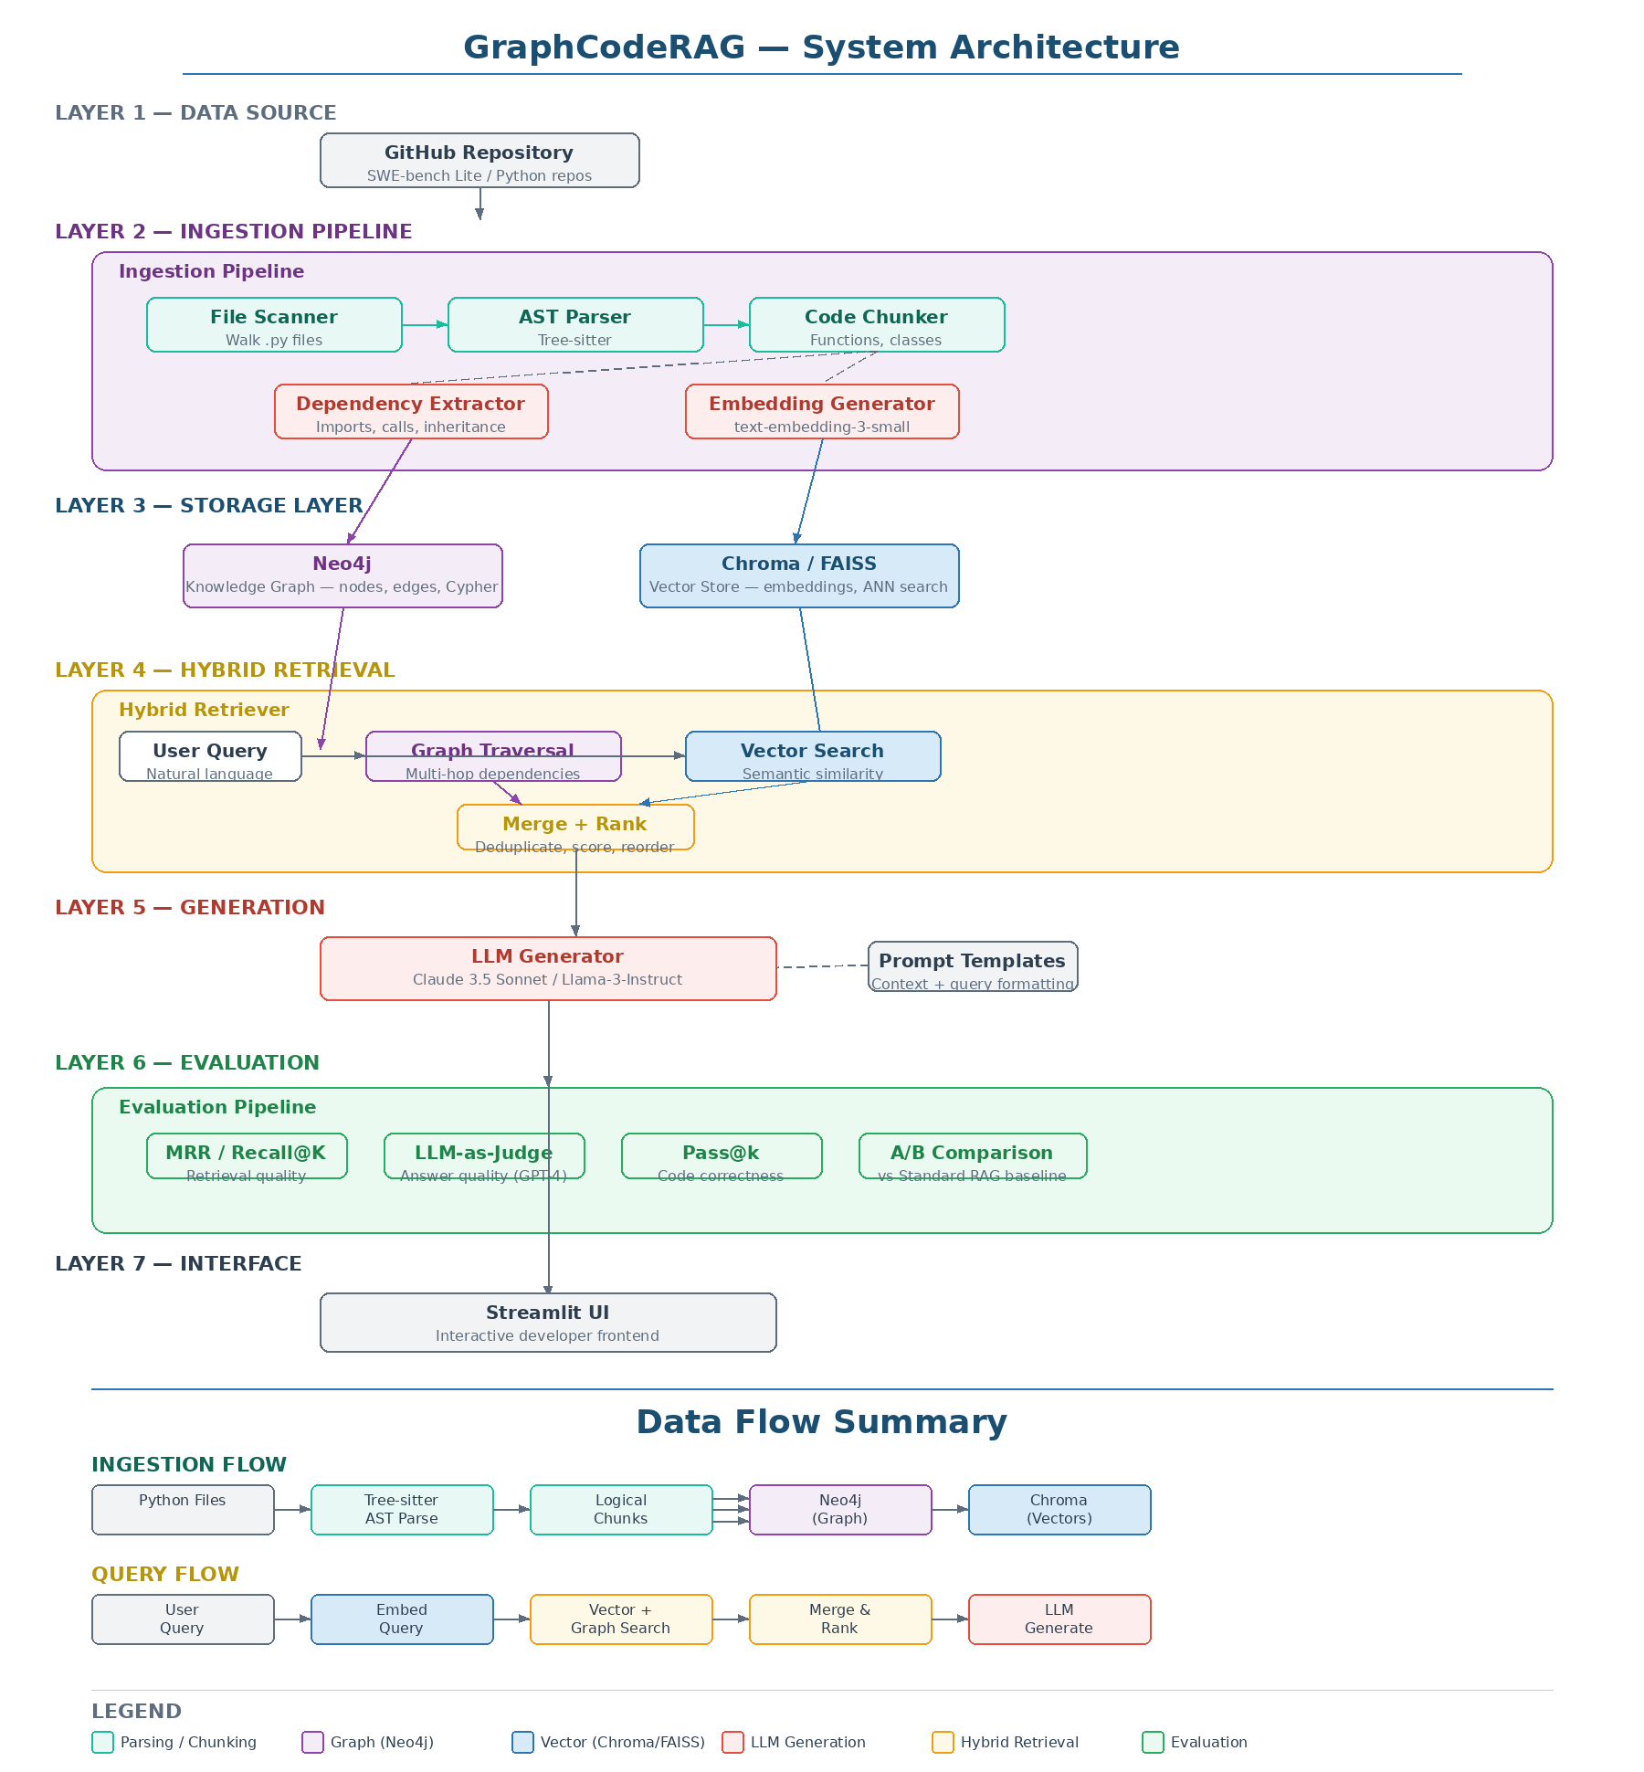
Figure 1: GraphCodeRAG System Architecture

5.1 Data source layer
The system ingests Python repositories from the SWE-bench Lite dataset (alternatively, CodeRAG-Bench). These datasets provide real-world GitHub issues, complex Python repositories such as Scikit-learn and Django, and the actual pull requests used to resolve them. This offers a rigorous, pre-labeled academic benchmark for repository-level comprehension.

5.2 Ingestion pipeline
The ingestion pipeline consists of four sequential stages that transform raw Python files into structured, searchable data:

5.2.1 File scanner
Recursively walks the repository directory structure and identifies all Python (.py) files. Filters out test files, configuration files, and other non-essential files based on configurable rules. Produces a list of file paths with their relative positions in the repository hierarchy.

5.2.2 AST parser (Tree-sitter)
Each Python file is parsed using Tree-sitter, a fast and robust incremental parser that produces concrete syntax trees. Tree-sitter is preferred over Python's built-in ast module because it handles partial or syntactically broken files gracefully (common in real-world repos), operates at very high speed, and supports multiple languages for future extensibility. The parser produces a full syntax tree for each file, identifying every function definition, class definition, import statement, and their hierarchical relationships.

5.2.3 Code chunker
The AST is walked to extract logical code chunks. Each function definition becomes one chunk. Each class definition becomes one chunk (including all its methods). Module-level code (imports, constants, global assignments) becomes a separate chunk. Each chunk retains metadata: file path, line range, parent class (if any), docstring, function signature, and the raw source code. This ensures that no chunk is ever syntactically incomplete or severed from its logical context.

5.2.4 Dependency extractor
The AST is analyzed a second time to extract relationships between code entities. The extractor identifies import edges (which module imports which function or class from which file), call edges (which function calls which other function), containment edges (which class contains which methods), and inheritance edges (which class extends which parent class). These relationships are stored as directed edges in the knowledge graph.

5.3 Storage layer
The system uses two complementary databases to store different aspects of the codebase:

5.3.1 Neo4j knowledge graph
Neo4j stores the structural representation of the codebase as a property graph. Nodes represent code entities (functions, classes, modules) with properties such as name, file path, line range, docstring, and signature. Edges represent typed relationships (IMPORTS, CALLS, CONTAINS, INHERITS) with properties such as the source file and line number. The graph supports Cypher queries for multi-hop traversal, such as: "Starting from function X, find all functions it calls and all functions that call those functions, up to 3 hops."

5.3.2 Chroma/FAISS vector store
The code chunks are embedded using OpenAI text-embedding-3-small (or BGE-m3 as an alternative) and stored in Chroma or FAISS. Each vector is associated with the chunk's metadata (file path, function name, class name, line range). The vector store enables fast approximate nearest-neighbor search for semantic similarity queries.

5.4 Hybrid retrieval layer
This is the core innovation of the system. When a user submits a query, the hybrid retriever performs two parallel searches:
Vector search: The query is embedded and the top-K most semantically similar code chunks are retrieved from the vector store. This captures code that is topically relevant to the query, even if it uses different terminology.
Graph traversal: The code entities identified in the vector search results are used as starting nodes in the Neo4j graph. The retriever traverses outward along dependency edges (imports, calls, inheritance) up to a configurable depth (default: 2-3 hops). This discovers structurally connected code that the vector search alone would miss.
Merge and rank: The results from both paths are combined, deduplicated by chunk ID, and re-ranked using a scoring function that weights both semantic similarity and graph proximity (number of hops from the initial results). The final ranked context is assembled and passed to the LLM.

5.5 Generation layer
The assembled context is formatted into a structured prompt using carefully designed templates. The prompt includes the user's question, the retrieved code chunks (ordered by relevance), the dependency relationships between them (from the graph), and instructions for the LLM to reason about the code in context. The LLM (Claude 3.5 Sonnet or Llama-3-Instruct) generates a grounded response that references specific functions, files, and line numbers from the retrieved context.

5.6 Evaluation layer
The evaluation pipeline runs both the proposed system and a standard RAG baseline on the same set of benchmark questions and compares their performance across multiple metrics (detailed in Section 7).

6. Technical Stack
Component | Technology | Purpose
Orchestration | LlamaIndex / LangChain | Data pipeline routing, RAG framework
Code parsing | Tree-sitter | AST-aware code chunking
Knowledge graph | Neo4j | Dependency mapping, multi-hop traversal
Vector database | Chroma / FAISS | Semantic similarity search
Embedding model | OpenAI text-embedding-3-small | Code chunk vectorization
LLM | Claude 3.5 Sonnet / Llama-3 | Answer generation
Frontend | Streamlit | Interactive developer UI
Language | Python 3.10+ | Primary implementation language

7. Project Structure
The project follows a modular architecture where each layer of the system maps to a dedicated Python package. This ensures clean separation of concerns, testability, and the ability to swap individual components without affecting the rest of the system.
Directory / File | Purpose
config.py | Central configuration: paths, model names, DB URIs
data/repos/ | Cloned GitHub repositories for ingestion
data/swebench/ | SWE-bench Lite dataset files
ingestion/file_scanner.py | Walks repo, finds all .py files
ingestion/ast_parser.py | Tree-sitter parsing into AST nodes
ingestion/code_chunker.py | AST to logical chunks (functions, classes)
ingestion/dependency_extractor.py | Extracts import edges, call edges, inheritance
storage/graph_store.py | Neo4j: create nodes, edges, Cypher queries
storage/vector_store.py | Chroma/FAISS: embed, store, and search chunks
retrieval/vector_retriever.py | Semantic similarity search over vectors
retrieval/graph_retriever.py | Graph traversal for multi-hop dependencies
retrieval/hybrid_retriever.py | Merges and ranks both result sets
generation/prompt_templates.py | Prompt templates for different query types
generation/generator.py | Calls LLM with assembled context
evaluation/metrics.py | MRR, Recall@K calculations
evaluation/llm_judge.py | GPT-4 based answer grading
evaluation/baseline_comparison.py | A/B comparison: standard RAG vs GraphRAG
app/streamlit_app.py | Main Streamlit UI entry point
tests/ | Unit tests for all modules
notebooks/ | Jupyter notebooks for exploration

8. Data Flow

8.1 Ingestion flow
The ingestion pipeline processes a repository through four sequential stages. First, the file scanner walks the repository directory and collects all Python files. Second, each file is parsed by Tree-sitter to produce an Abstract Syntax Tree. Third, the code chunker walks the AST to extract logical chunks (one per function, one per class). Fourth, the dependency extractor analyzes the AST to identify relationships between code entities. At the end of ingestion, the code chunks are embedded and stored in the vector database, while the dependency relationships are written as edges in the Neo4j graph.

8.2 Query flow
At query time, the user's question enters the hybrid retriever. The retriever first embeds the query and performs a vector similarity search in Chroma/FAISS to find the top-K most semantically relevant code chunks. It then takes the code entities identified in those chunks and uses them as starting nodes for a graph traversal in Neo4j, following import, call, and inheritance edges outward for 2-3 hops. The results from both searches are merged, deduplicated, and re-ranked by a scoring function that considers both semantic similarity and graph proximity. The final context is formatted with a prompt template and sent to the LLM, which generates a grounded answer.

8.3 Evaluation flow
The evaluation pipeline takes a set of benchmark questions from SWE-bench Lite, runs each question through both the proposed GraphRAG system and a standard RAG baseline (using the same embedding model, same LLM, and same prompt template), and computes comparative metrics across retrieval quality and generation quality.

9. Evaluation Metrics

9.1 Retrieval metrics
Mean Reciprocal Rank (MRR): Measures how high the correct file or function appears in the retrieval results. An MRR of 1.0 means the correct result is always ranked first. This metric captures whether the system retrieves the right code and surfaces it prominently.
Recall@K: Out of all the code pieces needed to fully answer the question, what fraction did the system actually retrieve in the top K results? This metric captures coverage: even if the system finds some relevant code, does it find all of it?

9.2 Generation metrics
LLM-as-a-Judge: A strong model (GPT-4) is used to evaluate the accuracy, completeness, and helpfulness of the generated answers on a structured rubric. This provides a scalable and reproducible alternative to human evaluation.
Pass@k: For queries that require code generation, the generated code snippets are executed against test cases. Pass@k measures the probability that at least one of k generated samples passes all tests. This is the gold standard for code generation evaluation.

9.3 Baseline comparison
The evaluation uses a controlled A/B comparison. Both systems share the same embedding model (text-embedding-3-small), the same LLM (Claude 3.5 Sonnet), the same prompt template, and the same dataset. The only difference is the retrieval strategy: the baseline uses recursive character chunking with vector-only search, while the proposed system uses AST-aware chunking with hybrid graph+vector retrieval. This isolation ensures that any performance delta is attributable solely to the retrieval innovation.
Metric | What it measures | Why it matters
MRR | Rank of the correct result | Does the right code appear at the top?
Recall@K | Coverage of needed code in top K | Does the system find all relevant code?
LLM-as-Judge | Answer accuracy and helpfulness | Is the final answer actually correct?
Pass@k | Generated code correctness | Does generated code actually run?

10. Conceptual Foundations

10.1 What is an Abstract Syntax Tree (AST)?
When Python executes source code, the first step is parsing the text into a tree structure that represents the logical hierarchy of the program. This tree is the Abstract Syntax Tree. Unlike the raw text, the AST ignores whitespace and comments, focusing entirely on the structural elements: function definitions, class definitions, assignments, control flow statements, and expressions.
For this project, the AST is the key to intelligent chunking. By walking the tree and identifying function_definition and class_definition nodes, the system can extract each code entity as a complete, self-contained chunk. No function is ever cut in half, and no class is ever separated from its methods.
Tree-sitter is the parsing library used because it is fast (can parse a large file in milliseconds), robust (handles partial or broken syntax gracefully), and language-agnostic (the same tool can be extended to other languages in the future).

10.2 What is a knowledge graph?
A knowledge graph is a database that stores information as nodes (entities) and edges (relationships between entities). Unlike relational databases (which use tables) or document databases (which use JSON documents), graph databases are optimized for traversing relationships efficiently.
In GraphCodeRAG, the nodes represent code entities such as functions, classes, and modules. The edges represent typed relationships: IMPORTS (module A imports function B from module C), CALLS (function X calls function Y), CONTAINS (class P contains method Q), and INHERITS (class R extends class S). Neo4j's Cypher query language allows the system to express powerful traversals such as: "Starting from function X, find all functions within 3 hops that X depends on, following CALLS and IMPORTS edges."

10.3 What is RAG and why does it fail for code?
Retrieval-Augmented Generation is a pattern where an LLM's response is grounded in externally retrieved documents. The standard RAG pipeline splits documents into chunks, embeds them as vectors, and retrieves the most similar chunks at query time. This works well for prose because sentences and paragraphs are natural semantic units.
Code is different. A function's meaning depends on its class context, its imports, and the functions it calls. Naive character-based splitting destroys these relationships. A 512-character chunk might contain the second half of one function and the first half of another, creating a semantically meaningless fragment. Vector similarity search compounds the problem by retrieving chunks that use similar words but miss the structural dependencies needed for accurate understanding.

10.4 What is hybrid retrieval?
Hybrid retrieval combines two complementary search strategies. Vector search finds code that is semantically similar to the query (good for matching intent and terminology). Graph traversal finds code that is structurally connected to the initial results (good for discovering dependencies and call chains). By merging both, the system delivers context that is both topically relevant and structurally complete, giving the LLM the full picture it needs to generate accurate, grounded responses.

11. Implementation Roadmap
Phase | Tasks | Deliverables | Duration
Phase 1 | Setup, file scanner, AST parser, code chunker | Working ingestion pipeline for .py files | Week 1-2
Phase 2 | Dependency extractor, Neo4j schema, graph construction | Populated knowledge graph for a test repo | Week 3-4
Phase 3 | Vector store integration, hybrid retriever, merge/rank logic | End-to-end retrieval working | Week 5-6
Phase 4 | LLM integration, prompt engineering, Streamlit UI | Working prototype with UI | Week 7-8
Phase 5 | Baseline RAG, evaluation pipeline, metric computation | Comparative results and final report | Week 9-10

12. Expected Outcomes
- A functional prototype capable of ingesting a mid-sized GitHub repository (such as scikit-learn or Django) and building both a vector index and a knowledge graph of its code structure.
- Accurate multi-hop retrieval that successfully follows cross-file dependencies to assemble complete context for complex codebase questions.
- Quantifiable improvement in MRR and Recall@K over a standard recursive-chunking RAG baseline, demonstrating the value of structure-aware retrieval.
- Higher-quality LLM responses as measured by LLM-as-Judge and Pass@k, showing that better retrieval directly translates to better generation.
- An interactive Streamlit interface where users can load a repository, explore its dependency graph, and ask natural language questions about the codebase.

13. References
- SWE-bench: Can Language Models Resolve Real-World GitHub Issues? (Jimenez et al., 2024)
- GraphRAG: Unlocking LLM Discovery on Narrative Private Data (Microsoft Research, 2024)
- Tree-sitter: An Incremental Parsing System for Programming Tools (Brunsfeld et al.)
- Retrieval-Augmented Generation for Knowledge-Intensive NLP Tasks (Lewis et al., 2020)
- CodeRAG-Bench: Can Retrieval Augment Code Generation? (Wang et al., 2024)
- Neo4j Graph Database Documentation (neo4j.com)
- LlamaIndex Documentation (docs.llamaindex.ai)

