**The purpose of this project is to verify the weather before embarking on a holiday**

To run the project from maven, use the “mvn verify” command from the command line tool.  
  
Below is the generated sample cucumber html report:

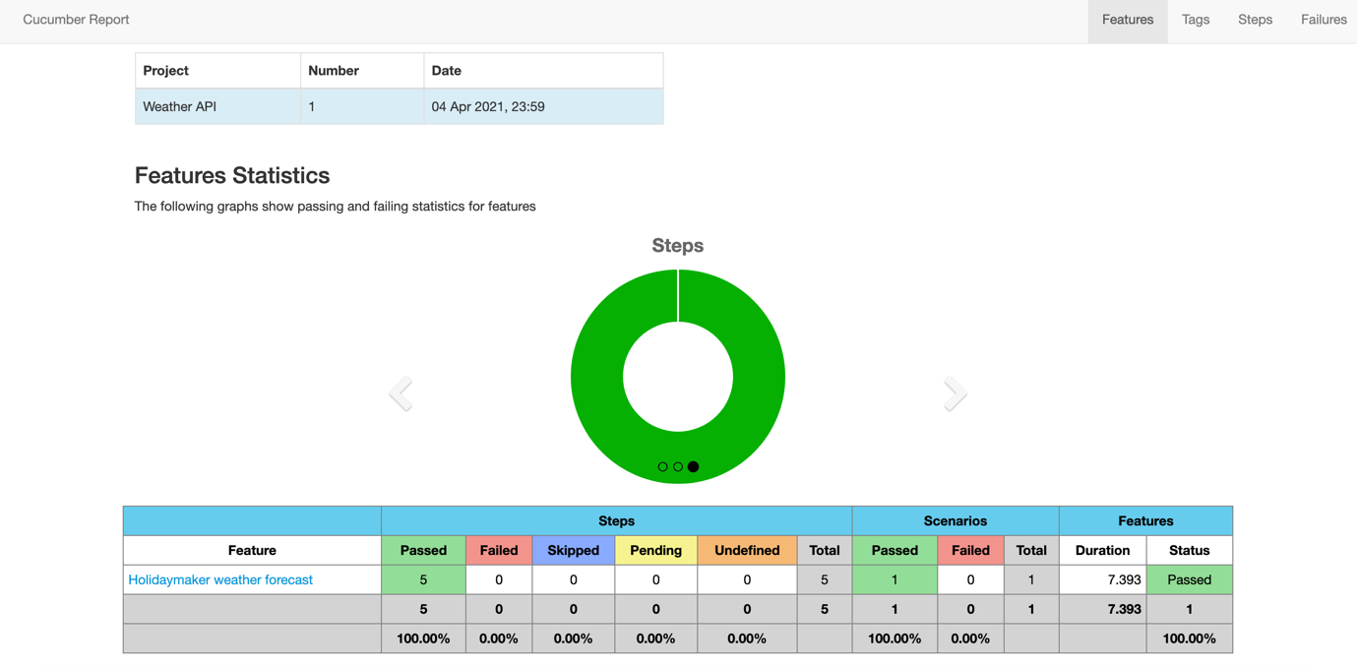

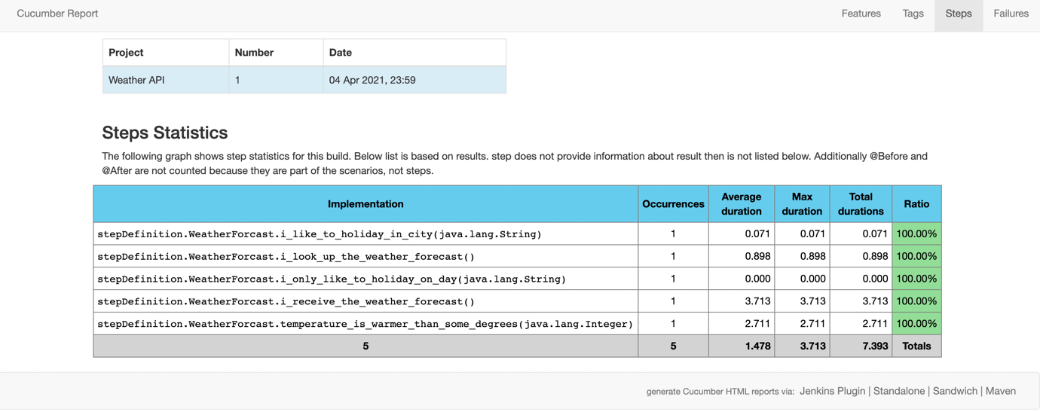

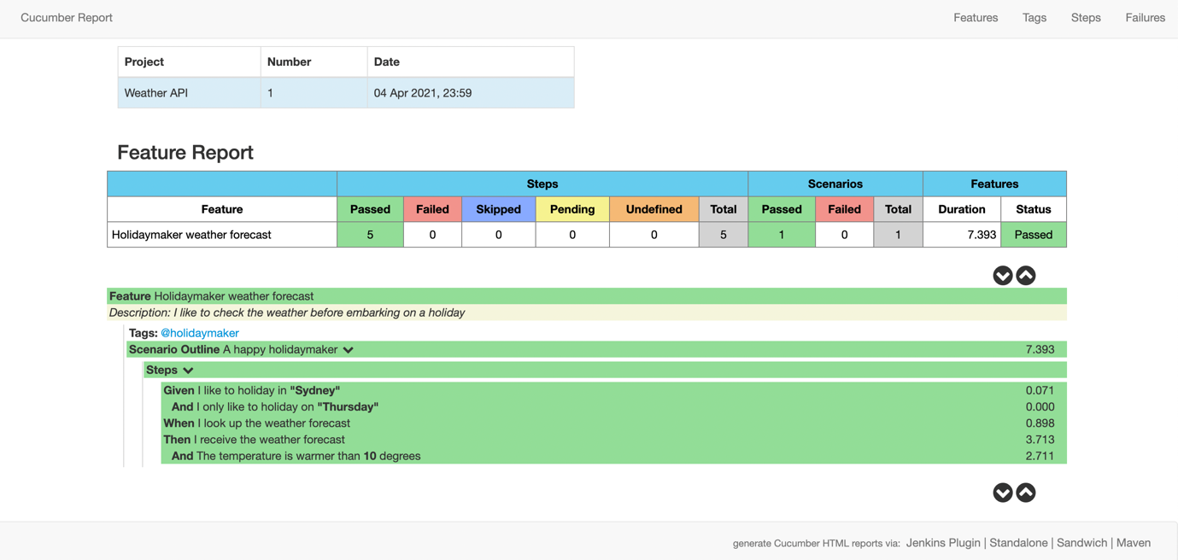

Logs are generated as below in the log folder:

