The latest stable release of WordPress (Version 4.9.6)

WordPress is a free and open-source content management system based on PHP and MySQL Features include a plugin architecture and a template system

With WordPress, you can create:

* Business websites
* eCommerce stores
* Blogs
* Portfolios
* Resumes
* Forums
* Social networks
* Membership sites

In Multi languages Plugin we have to check below things :

List of supported languages

Which version will support

* [Posts vs Pages](https://www.wp101.com/tutorial/posts-vs-pages/)
* Pages
* These are your static pages. Those that don’t change unless they  are edited. Examples of your pages would be: About, Services, Contact, etc.

## Posts

Posts typically appear in a blog. They are written on a regular schedule and one of their key purposes is to keep your site fresh with new content. Posts can also be post types. For example,  if you are running an event plugin, the event pages you create are post types and therefore are technically considered posts.

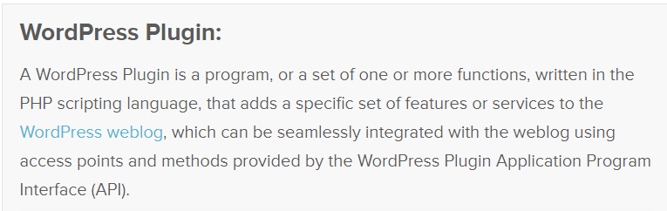

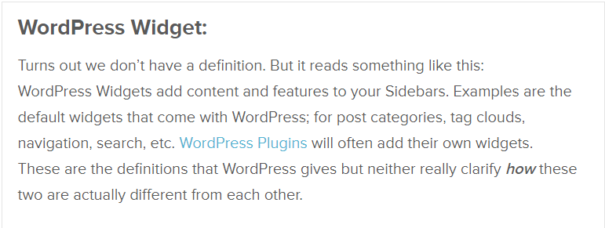

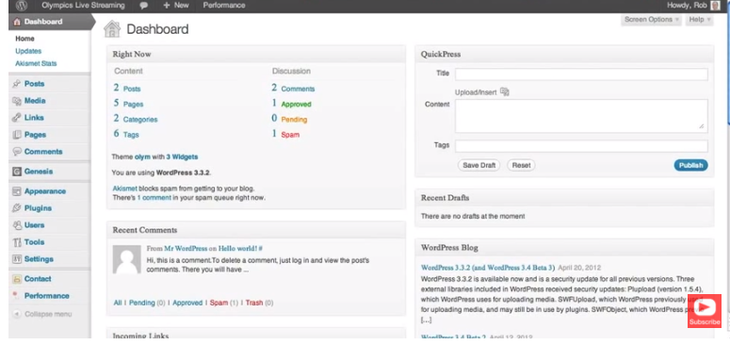

difference between drupal and wordpress :

Drupal’s functionality goes much deeper than WordPress.

WordPress has a wide variety of free and paid themes and plugins that can get you started building your website. There are starter themes available for Drupal as well, but the majority of Drupal is designed for custom development.

Many people chose to work with WordPress because of their available plugins

Drupal isn’t hard to use, but it can be hard to learn how to use it. It requires more technical experience than WordPress, but it is capable of producing more advanced sites. If you have limited knowledge of website development, WordPress is easier to understand. Many times a developer will build and customize a WordPress site and then hand over to the client for site management. You can set up a blog in minutes on WordPress with only basic knowledge.