Data Acquisition, Cleaning and Exploratory Data
Analysis of Mauna Loa Atmospheric CO₂ Data

1. Introduction
This project acquires the public Mauna Loa atmospheric CO₂ series, validates and cleans its time index and measurements, and uses descriptive analysis and visualizations to characterize its temporal behavior. All reported values are computed from the Statsmodels dataset during the reproducible run.

2. Dataset Selection
The selected dataset is a regularly sampled weekly series of atmospheric carbon dioxide concentration. The measurements are expressed in parts per million (ppm).

3. Dataset Source
Statsmodels public dataset interface: statsmodels.datasets.co2. Documentation: https://www.statsmodels.org/devel/datasets/generated/co2.html

4. Data Acquisition Method
The source was loaded directly with statsmodels.datasets.co2.load_pandas().data.copy(). The unmodified measurements, including their original missing entries, were saved as data/co2_raw_acquired.csv.

5. Initial Data Inspection
Property | Raw dataset
Rows × columns | 2284 × 1
Date range | 1958-03-29 to 2001-12-29
Column / source dtype | co2 / float64
Missing CO₂ observations | 59
Duplicate date records | 0
Raw descriptive statistics (pandas excludes missing values):
Statistic | Value
count | 2225.0000
mean | 340.1422
std | 17.0039
min | 313.0000
25% | 324.8000
50% | 338.3000
75% | 354.8000
max | 373.9000

6. Data Cleaning

6.1 Missing Values
WHAT: 59 missing CO₂ values were identified in the 2284-row source. Interior gaps were filled with pandas time-based interpolation. WHY: observations are ordered in time, so this estimates a missing point using nearby values and their elapsed time; a global mean would flatten local behavior and ignore chronology. WHAT CHANGED: 59 missing values were filled; 0 remain. The interpolation is an estimate, not a newly observed measurement.

6.2 Duplicate Records
Duplicate dates were checked as duplicate observations. 0 duplicate date rows were removed (keep first, after chronological sorting). Equal CO₂ readings on different dates were retained because repeated values do not identify duplicate records.

6.3 Data Type Validation
The index was explicitly converted and validated as a DatetimeIndex, and CO₂ was passed through pandas.to_numeric(..., errors='coerce'). Invalid numeric entries would therefore be treated as missing and included in the subsequent gap handling.

6.4 Time-Series Ordering
Observations were sorted chronologically before duplicate-date handling and interpolation, ensuring that the time-based operation follows the measurement sequence.

6.5 Cleaning Validation
Validation | Result
Final rows | 2284
Final date range | 1958-03-29 to 2001-12-29
Missing CO₂ values after cleaning | 0
Duplicate dates after cleaning | 0
Index / value dtype | DatetimeIndex / float64

7. Exploratory Data Analysis

7.1 Descriptive Statistics
Statistic | CO₂ (ppm)
count | 2,284.000
mean | 339.652
median (50%) | 337.700
std | 17.104
min | 313.000
25% | 323.975
75% | 354.500
max | 373.900
The count includes interpolated values; summary statistics describe the cleaned series and should be interpreted with that in mind.

7.2 CO₂ Time-Series Trend
An ordinary least-squares straight-line fit across elapsed time estimates a trend of 1.335 ppm per year (R² = 0.974). This is a descriptive association over this period, not evidence of causation, and a linear fit does not represent all seasonal or nonlinear variation.

7.3 Annual Mean Analysis
The annual mean increased from 315.19 ppm in 1958 to 370.87 ppm in 2001, a difference of 55.68 ppm across the available endpoints. The 1958 group is partial because observations begin in March, and the final group ends on December 29; annual endpoint means reflect the available weeks rather than identical full-calendar coverage. Annual aggregation reduces within-year seasonal fluctuations.

7.4 Distribution Analysis
Across the cleaned observations, the median is 337.70 ppm and the interquartile range is 30.52 ppm. The histogram combines multiple decades, so its shape reflects both long-term change and seasonal variability rather than a stationary single-period distribution.

7.5 Seasonal Analysis
The calendar-month means range by 5.48 ppm, from October to May. These means pool years with different background concentrations; they summarize recurring seasonal shape but are not seasonally adjusted estimates.

8. Visualizations
Figure 1. Missing weekly observations before cleaning
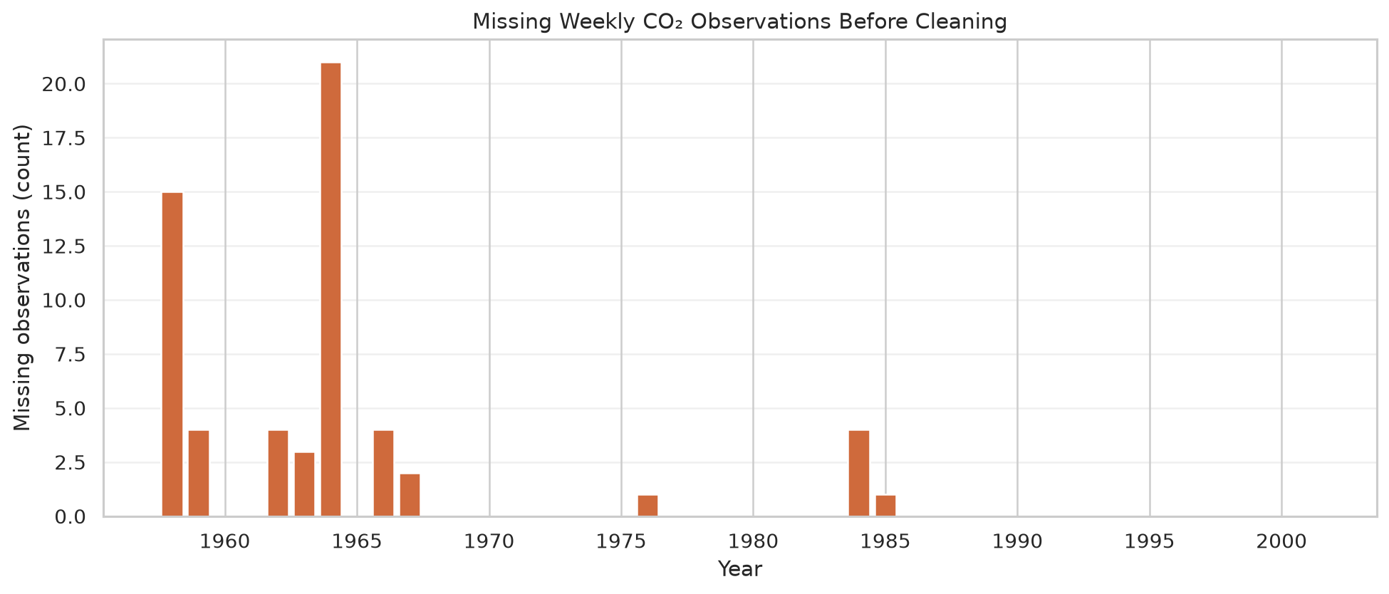
Annual counts locate when source CO₂ readings are absent. Missing observations are not the same as duplicate dates; only missing measurement values are visualized.
Figure 2. Complete weekly CO₂ time series
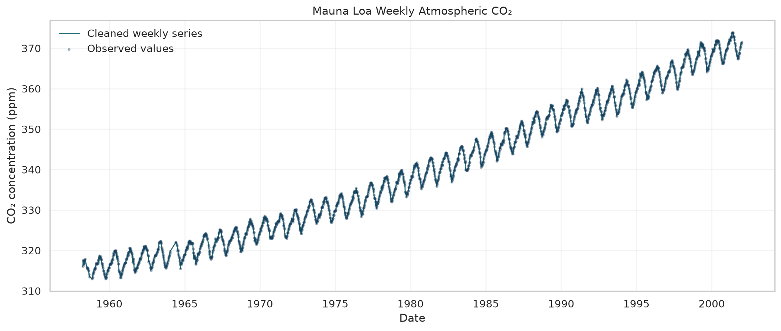
The continuous line shows the cleaned series and points identify original observed values. The sustained upward pattern and repeating short-term oscillations are visible; interpolated points should not be mistaken for direct observations.
Figure 3. Annual mean CO₂
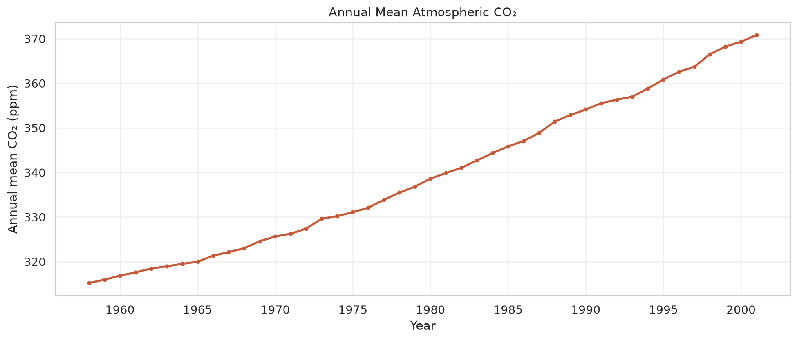
Annual averaging emphasizes the long-term direction while reducing the within-year cycle. The observed increase is descriptive and does not establish cause.
Figure 4. Distribution of weekly CO₂ measurements
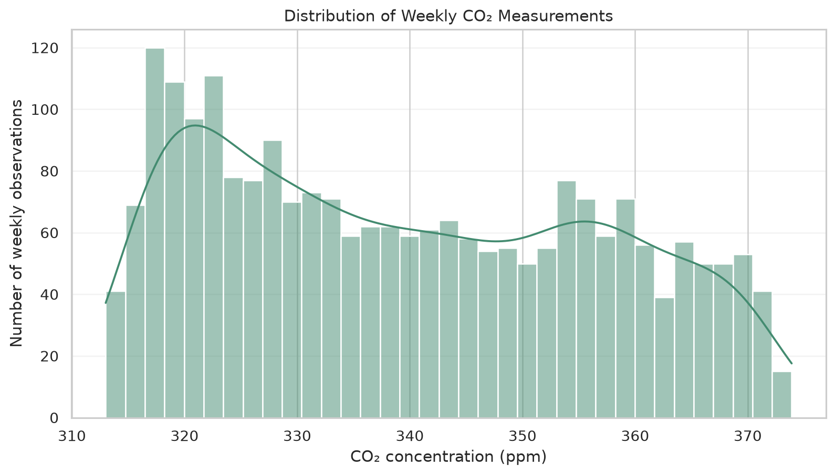
The histogram and density estimate summarize the pooled values. Because the time series trends over decades, this pooled distribution is not a snapshot of one stable population.
Figure 5. Average CO₂ by calendar month
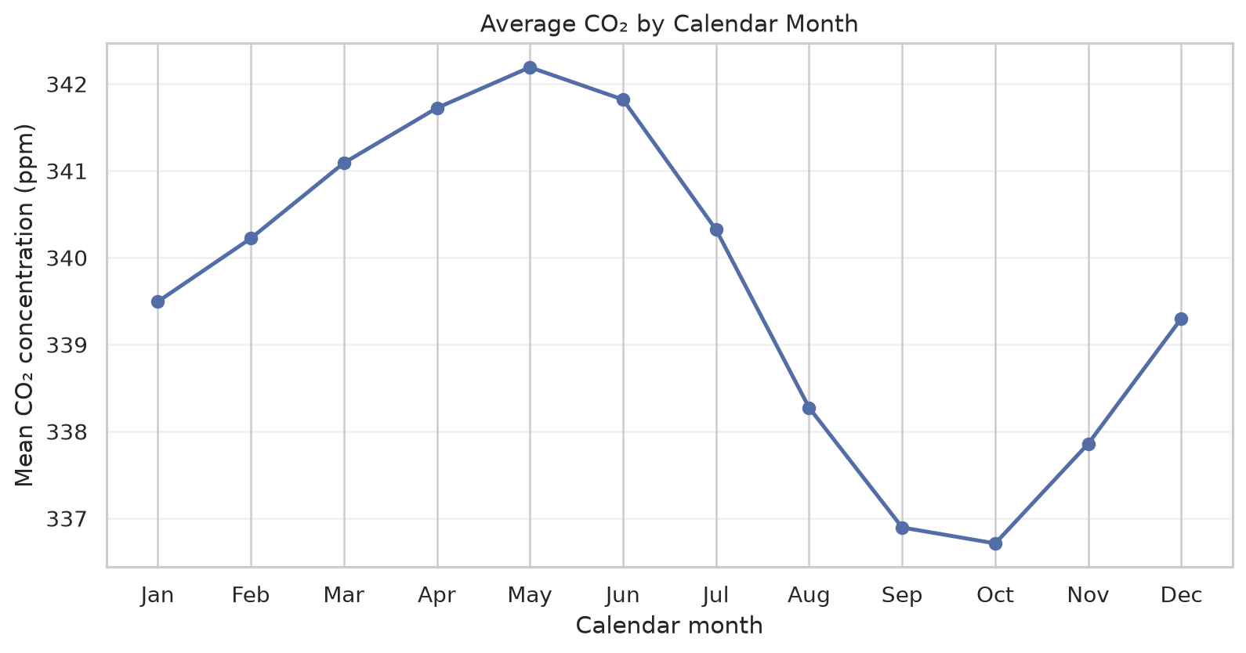
Month-of-year means reveal the average seasonal profile across the whole record. Pooling years may blend seasonal behavior with the long-term trend.

9. Key Insights
- The cleaned record contains 2284 weekly observations from 1958-03-29 through 2001-12-29.
- The source had 59 missing measurement values; time interpolation filled the interior gaps, leaving 0 missing values.
- The fitted linear trend is 1.335 ppm per year across the complete observed period; it summarizes association over time, not causation.
- The annual endpoint means differ by 55.68 ppm (1958 to 2001).
- Calendar-month averages span 5.48 ppm from the lowest-mean month to the highest-mean month.
- The cleaned distribution has a mean of 339.65 ppm, median 337.70 ppm, and standard deviation 17.10 ppm.

10. Limitations
This is one monitoring record at Mauna Loa and should not be treated as a complete representation of every location or source of atmospheric variation. Interpolated values are estimates that can smooth short-lived fluctuations. The first calendar-year group is partial (the series begins in March 1958), and the final group ends on December 29, so endpoint annual means do not have exactly equal calendar coverage. Aggregated annual and calendar-month means hide some weekly structure, and the pooled histogram combines a changing series. The straight-line trend is descriptive, omits explicit seasonal terms, and does not identify causation.

11. Future Work
Possible extensions include comparing this series with other monitoring sites, modeling trend and seasonal components separately, quantifying uncertainty around fitted trends, and testing sensitivity to excluding rather than interpolating missing observations.

12. Conclusion
The source data were acquired reproducibly, checked for date and numeric validity, cleaned with time-aware interpolation, and summarized with five complementary figures. The observed series rises over the sampled decades while showing recurring within-year variation; these are descriptive findings from the dataset, not causal conclusions.

13. Code Summary
The reusable implementation in src/analysis.py performs acquisition, validation, cleaning, statistics, visualization, CSV export, and DOCX generation. The core operations are:
raw = sm.datasets.co2.load_pandas().data.copy()
clean['co2'] = pd.to_numeric(clean['co2'], errors='coerce')
clean['co2'] = clean['co2'].interpolate(method='time', limit_area='inside')

14. Dataset Citation
Statsmodels Developers. CO2 dataset (statsmodels.datasets.co2). Statsmodels documentation. https://www.statsmodels.org/devel/datasets/generated/co2.html

