💰
WealthPulse
Personal Finance Tracker
Product Overview & Feature Guide

Platform  Android | Stack  React 18 + Capacitor | Version  v3.4 | Storage  On-device only

May 2026

1. What Is WealthPulse?
WealthPulse is a fully offline, privacy-first personal finance app built for Android. It automatically captures transactions from bank SMS messages, lets you split group expenses, and turns your spending data into actionable insights — all without any server or cloud subscription.

The Core Idea
Most finance apps require you to manually enter every transaction. WealthPulse eliminates that friction by reading your bank SMS automatically — you just review and approve in one tap.

Everything runs on your device. No account required. No data leaves your phone.

Who Is It For?
WealthPulse is built for anyone who:
- Receives bank transaction alerts via SMS (HDFC, SBI, ICICI, Axis, Kotak, PhonePe, GPay, Paytm)
- Wants to track personal income and expenses without manual effort
- Splits bills with friends, flatmates, or travel groups
- Wants to understand their spending patterns without paying for a cloud service

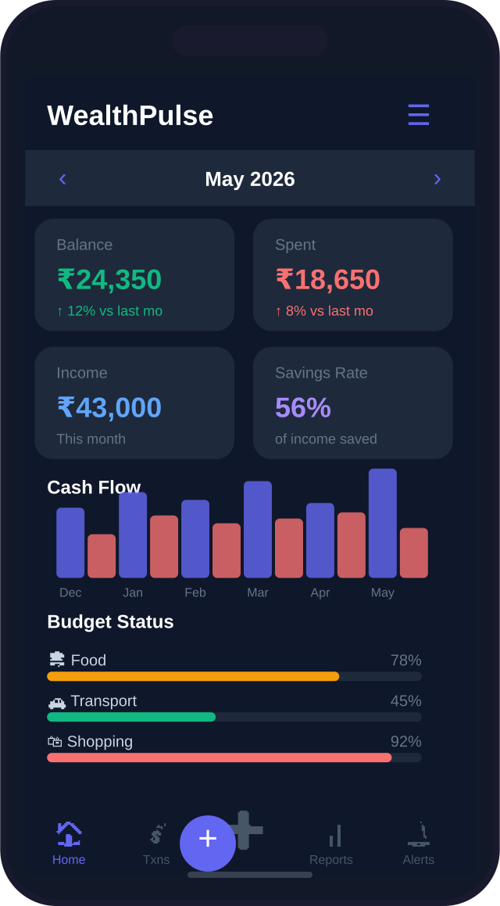
Dashboard — your complete financial snapshot at a glance

2. Key Features

2.1 SMS Auto-Capture
The standout feature. WealthPulse monitors incoming bank SMS messages in real time — even when the app is closed — and surfaces them as one-tap review cards.

📲 | Works when closed | SmsReceiver queues transactions to SharedPreferences. Delivered on next app open.
🔁 | Dual capture | Direct SMS via SmsReceiver + NotificationListener as fallback for bank app push notifications.
🧠 | Payee memory | Remembers which category you assigned to each merchant. Auto-applies next time.
🔗 | Quick Split | Detected expense can be instantly split across group members without leaving the review card.
🔍 | Smart dedup | Stable transaction IDs prevent the same SMS from being captured twice.

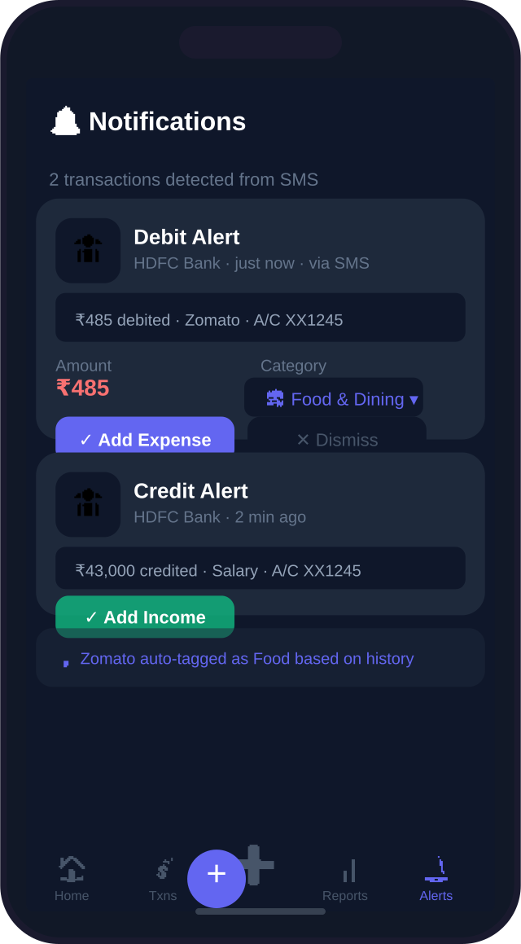
SMS Auto-Capture — review and approve transactions in one tap

2.2 Dashboard
The home screen gives you a complete picture of your financial health at a glance — without scrolling through transactions.

💰 | Balance Card | Net balance for the selected month with % change vs last month.
📊 | Cash Flow Chart | 6-month bar chart showing income vs expenses side by side.
🍩 | Spending Donut | Category breakdown donut chart updated in real time.
📅 | Month Navigation | Swipe between months to review historical data.
⚡ | Budget Status | Quick progress bars per category with colour-coded alerts.
👥 | Group Balances | Pending settlements and group activity visible on home screen.

2.3 Transactions
A full searchable ledger of all income and expenses across all months.

🔍 | Search | Full-text search by description or category name.
🏷️ | Filter | Filter by All, Income, or Expenses with a tab strip.
✏️ | Edit & Delete | Tap any transaction to edit or delete with confirmation.
📂 | 14 Categories | 9 expense + 5 income categories with emoji icons.
📝 | Notes | Add custom notes to any transaction for context.

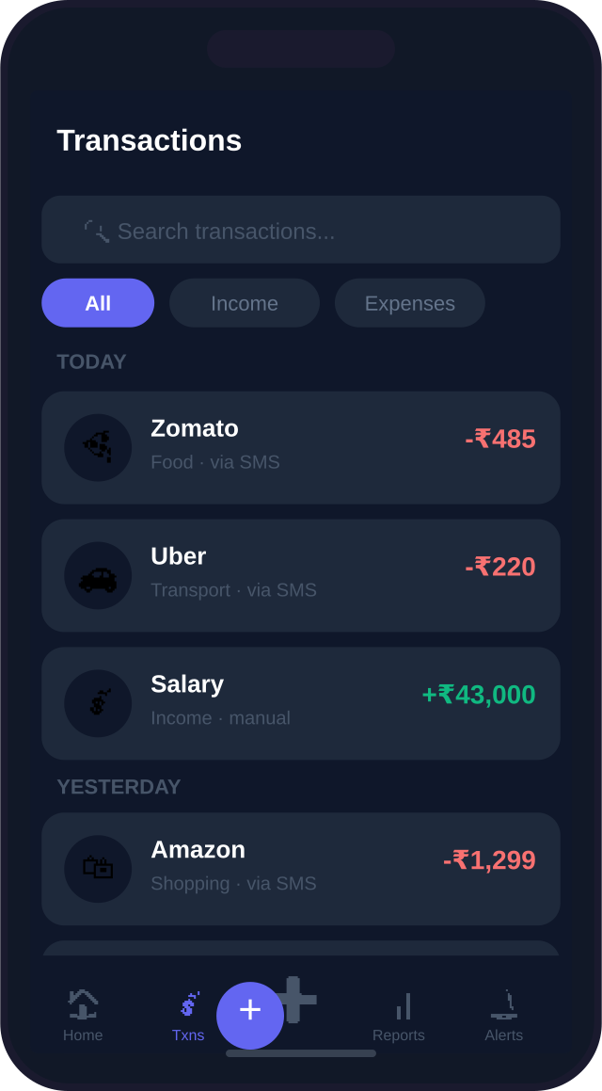 | 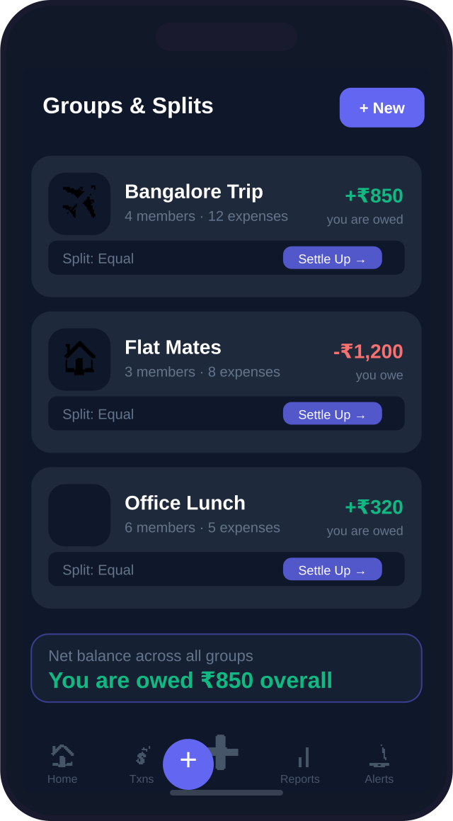
Transaction List — searchable, filterable ledger | Groups & Splits — manage shared expenses

2.4 Groups & Splits
A built-in Splitwise-style expense splitter for trips, flatmates, office lunches — any shared spending.

👥 | Groups | Create named groups with member avatars and colour codes.
⚖️ | Split Methods | Equal split, by amount, or by percentage — per expense.
🧮 | Smart Settle | Simplified settlement algorithm minimises the number of transactions needed.
🔄 | Auto-Sync | Group expenses paid by you sync automatically to your personal transactions.
💸 | Settle Up | Global settle page across all groups with one-tap payment recording.

2.5 Budget Management
Set monthly spending limits per category. WealthPulse tracks your progress and alerts you before you overshoot.

🎯 | Per-Category Limits | Set a monthly budget for Food, Transport, Shopping, Bills, and more.
📊 | Progress Bars | Green → Yellow → Red as you approach and exceed the limit.
🔔 | One-Time Alert | Push notification fires once when a category hits 100%. Never nags again.
📅 | Month-by-Month | Budget resets each month — track whether you improved over time.

3. Reports & Smart Insights
WealthPulse turns raw transaction data into actionable advice. The Reports & Insights page combines a monthly financial report with four AI-style analysis engines — all running on-device with no server required.

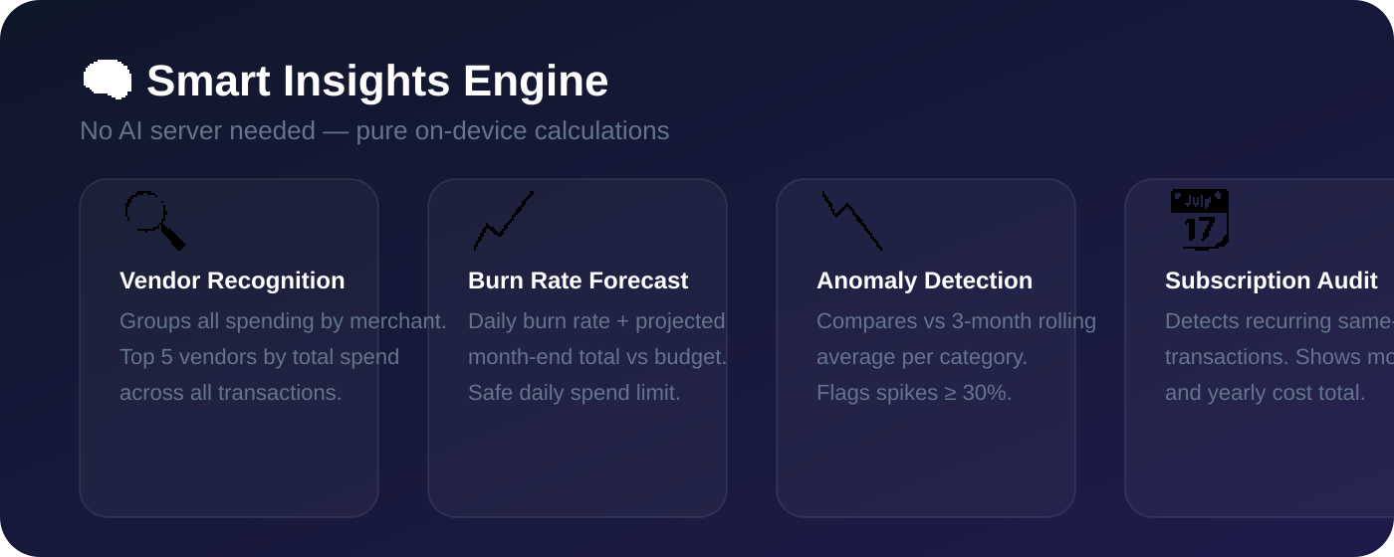
Smart Insights Engine — four analysis pillars running entirely on-device

3.1 Monthly Report
💸 | Total Spent | Actual net expenses with month-over-month comparison.
💰 | Income | Total income with average daily spend.
🏦 | Savings Rate | Percentage of income saved, as a headline number.
📊 | Category Breakdown | Horizontal progress bars per category with budget % consumed.
💡 | Top Spend Insight | Calls out the largest spending category with a plain-English sentence.

3.2 Vendor Recognition
Groups all transactions by normalized merchant name (strips bank SMS noise like "PVT LTD", "IMPS", "NEFT"). Shows your top 5 merchants by total spend, transaction count, and percentage of monthly income.

3.3 Burn Rate Forecast
Available for the current month only. Calculates your daily burn rate and projects whether you will overshoot your total budget by month end. Shows:
- Daily burn (actual)
- Safe daily limit to stay within budget
- Projected month-end total vs budget
- Estimated date budget runs out (if overspending)

3.4 Anomaly Detection
Compares current month spending per category against your 3-month rolling average. Flags:
- Spikes — spending 30%+ above average (e.g. unusually high Utilities bill)
- Sharp drops — spending 40%+ below average (possible deferred payment)
- Missing — category had regular spend but nothing logged this month

3.5 Subscription Audit
Scans all transactions for recurring patterns — same merchant, amount within ±10%, monthly cadence. Builds a list of active subscriptions with monthly and yearly cost totals.

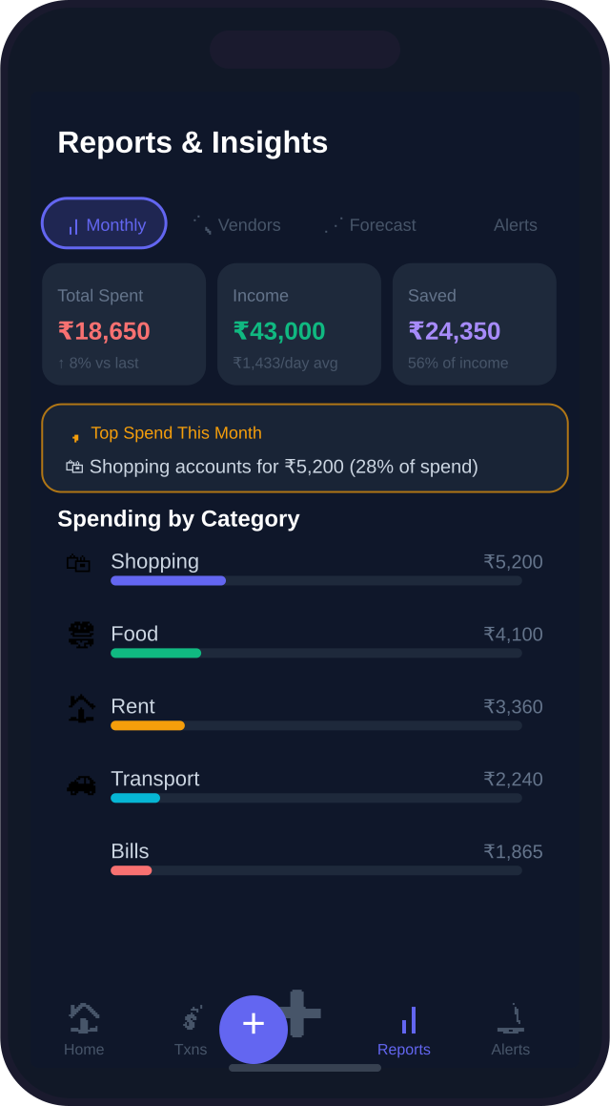
Reports & Insights — 5 tabs covering monthly report through subscription audit

4. Smart Push Notifications
WealthPulse sends push notifications that are genuinely useful — not irritating. Three channels, each with strict rate limits.

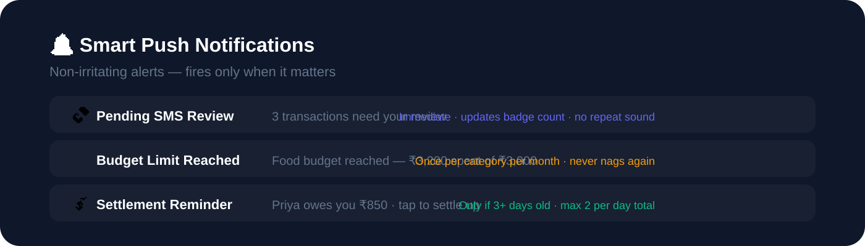
Three notification channels with strict rate limits

Type | Trigger | Rate Limit
💸 Pending SMS | New bank SMS detected and unreviewed | Updates count badge. No repeated sound.
🟡 Budget Alert | A spending category hits 100% of limit | Once per category per month. Never repeats.
💰 Settlement | Group debt is 3+ days old and unsettled | Max 2 per day. Once per person per day.

Design Philosophy
Every notification fires at most once per event. Budget alerts never remind you again after the first fire. Settlement reminders are capped at 2 per day total across all people. The SMS badge updates silently without re-alerting on count changes.

5. Privacy & Security
WealthPulse was built with a privacy-first philosophy from day one. Your financial data never leaves your device.

🔐 | 4-Digit PIN Lock | SHA-256 hashed PIN with security question recovery. Auto-locks on app background.
👆 | Biometric Login | Fingerprint or Face ID via Android BiometricPrompt API. Optional toggle in Settings.
👁️ | Privacy Mode | One tap blurs all amounts app-wide. Useful in public spaces.
📱 | Fully Offline | No account, no server, no cloud sync. All data stored in device localStorage.
📤 | Export / Import | Full JSON backup and restore. You own your data completely.
🗑️ | Full Reset | One-tap wipe of all data from Settings. Clean slate.

No Account Required
WealthPulse requires zero sign-up. There is no backend server, no API calls to external services, and no analytics or tracking. All processing — including the Smart Insights calculations — happens entirely on your device.

6. Technical Architecture
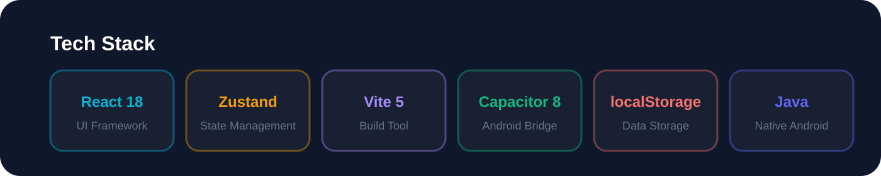
Technology stack — React frontend, Capacitor Android bridge, Java native layer

Frontend
⚛️ | React 18 | Component-based UI with hooks. No class components.
⚡ | Vite 5 | Sub-second HMR in development. Optimised production builds.
🐻 | Zustand | Lightweight global state. All app state in a single store.
🛣️ | React Router v6 | Client-side routing for all views.
📈 | Recharts | Bar charts and donut charts for the dashboard and reports.

Android Native Layer
📱 | Capacitor 8 | Bridge between React WebView and native Android APIs.
📨 | SmsReceiver.java | Receives SMS_RECEIVED broadcasts. Queues to SharedPreferences when app is closed.
👂 | NotificationListener.java | Reads bank app push notifications as a fallback capture path.
⚙️ | ForegroundService.java | Keeps the process alive in the background. User can toggle in Settings.
🔔 | AlertsPlugin.java | Capacitor bridge for all push notification logic. Rate limits enforced in Java.
👆 | BiometricPlugin | @capgo/capacitor-native-biometric for fingerprint / Face ID.

Data Flow — SMS to Transaction
1. Bank SMS arrives on device
2. SmsReceiver.java intercepts → queues to SharedPreferences (works even if app is closed)
3. On next app open, MainActivity drains the queue → calls dispatchToWebView()
4. useSmsListener.js hook receives the raw SMS text
5. smsParser.js extracts: amount, type (debit/credit), payee, date, dedup ID
6. addPendingSms() adds to Zustand store (dedup checked)
7. PendingSmsCard appears in Notifications tab
8. User reviews → taps "Add Expense" → transaction saved to localStorage

7. Settings & Customisation
🔑 | Change PIN | Update your lock PIN with current-PIN verification.
❓ | Security Question | Set a recovery question in case you forget your PIN.
👆 | Biometric Login | Enable fingerprint / Face ID. Toggle visible only if hardware supports it.
🌙 | Theme | Dark, Light, or Auto (follows system preference).
📲 | SMS Auto-capture | Enable or disable automatic SMS transaction detection.
⚙️ | Background Tracking | Keep app process alive for continuous SMS monitoring.
🔔 | Push Notifications | Toggle budget alerts and settlement reminders on/off.
📤 | Export Data | Download full JSON backup of all transactions, budgets, groups.
📥 | Import Data | Restore from a previously exported JSON backup.
🗑️ | Reset All | Wipe everything and start fresh.

8. Supported Banks & UPI Apps
WealthPulse recognises transaction SMS from all major Indian banks and UPI apps:

🏦 Banks | 📱 UPI Apps | 💳 Others
• HDFC Bank  • SBI  • ICICI Bank  • Axis Bank  • Kotak Mahindra  • IndusInd Bank  • Yes Bank  • Canara Bank  • Federal Bank  • DCB Bank | • PhonePe  • Google Pay (GPay)  • Paytm  • Amazon Pay  • CRED  • FreeCharge  • MobiKwik | • Any bank with SMS alerts  • Custom sender filtering  • Notification fallback for apps without SMS  • Manual text sharing via Share Sheet

Built with ❤️ · React 18 + Vite + Zustand + Capacitor Android
v3.4 · May 2026 · All data stays on your device

