Virtual Account Transaction Posting API Flow
- Client will developed a web services and share with IDBI Bank.
- IDBI Bank would invoke Client’s API (web service) to push the virtual account transactions to Client.
- Client will get virtual account transaction through web services and update into their database.
- A positive or negative response would be sent back to Bank

Pre-requisites for UAT
- Finalize the approach
- Corporate to share their UAT server Public IP and web services URL address to be white listed at IDBI
- Corporate to agree on the same
- share SSL certificate and installation process
- UAT to be done in time bound manner.
- Corporate to give UAT signoffs.

Pre-requisites for GO LIVE
- Corporate to share their Production server Public IP address to be white listed at IDBI
- IDBI to share their Production server IP address to be white listed at Corporate side
- GO LIVE date to be finalized.
- GO LIVE

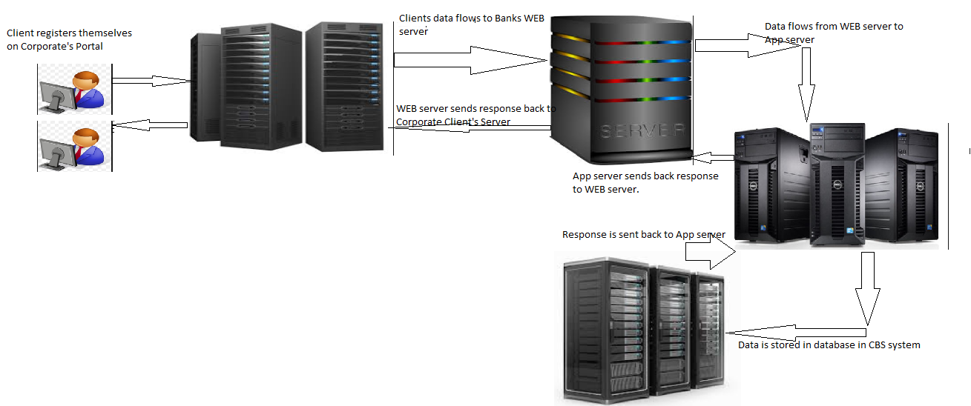
Client will developed a web services as per below mention parameters and share the URL with IDBI

We are sharing below information through web services for transaction MIS.
- Parent account number(Mandatory ,16 char)
- Virtual account number(Mandatory,16 char )
- Amount(Rs.) (Mandatory,20 char )
- Transaction date (Mandatory ,10 char)
- Remitter name(Mandatory ,100 char)
- Remitter name RBI(Optional, 100 char )
- UTR(Mandatory,35 char )
- Transaction type(Mandatory ,15 char)
- Sender to receiver information (optional ,200 char)
- IFSC code(optional,15 char)
- Remitter Acct Num(Optional,35 char)

Service Details.
- Web service should be developed in REST.
- Port should be standard (ex.443)
- URL should be https
- Request and response should be in json format.
- Implement user id and password concept in header.
- Data should be travel in encrypted format.(please use base 64 encryption logic for java developer)

Sample request:

{"pan":"V000110583000002",
"van":"UTR12545878",
"tranAmt":"500",
"trandate":"DD-MM-YYYY HH:MM:SS",
"Rem_name":"AVCD",
"Rem_name_rbi":"XYZ",
"utr":"IBKL45458",
"mode":"RTGS",
"Sender_receiver_info":"Money send by Xyz for product B",
"ifsc":"SBI245878",
"RemitterAcctNo":"01247885444"}

Sample Response:

- {"status":"success","utr":"UTR12545878","reason":"NA"}
- {"status":"duplicate","utr":"UTR12545878","reason":"All ready transaction is received"}
- {"status":"failed","utr":"UTR12545878”,"reason":"failed reason"}

Note:-Please provide response message against every request.

